

**School of Computer Science and Information**

**Technology**

**Department of Computer Science and Information**

**Technology**

**Semester: III**

**Specialization: CTIS and B.Com**

**Activity 2**

***Group No: 1***

**Date of Submission: 3rd August, 2023.**

**Submitted by:**

|  |  |
| --- | --- |
| NAMES | USN |
| RAMAN KUMAR | 22BCAR0184 |
| RANJANA RAJU | 22BCAR0185 |
| EKTA S. | 22BCR00112 |
| HABEL JOHN VARGHESE | 22BCR00120 |
| GAURAV KUMAR | 22BCR00116 |

**Faculty Incharge**:

Dr. Nagraj S.

Dr. Deepak Mehta

Signature:

________________

|  |  |  |
| --- | --- | --- |
| **SL NO.** | **TOPIC** | **PAGE NUMBER** |
| 1 | INTRODUCTION | 3 |
| 2 | BACKGROUND | 4 |
| 3 | OBJECTIVES | 4 |
| 4 | LITERATURE REVIEW | 5 |
| 5 | METHODOLOGY | 6 |
| 5 | How to create GUI? | 7 |
| 6 | FEATURES OF GUI | 8 |
| 7 | CHARACTERISTIC SOF FRDS | 9 |
| 8 | RESULT | 10 |
| 9 | COMMERCIALISATION | 11 |
| 12 | CONCLUSION | 13 |

**INDEXINTRODUCTION**

Facial recognition is a technology that has become increasingly popular in recent years and is now used in a variety of applications, including security, marketing, and law enforcement. It is a biometric technology that analyzes digital images or live video footage to identify individuals based on their facial features. Facial recognition algorithms are able to detect and measure various facial characteristics, such as the distance between the eyes, the shape of the jawline, and the contours of the cheeks and nose.

The development of facial recognition technology has been driven by a range of factors, including the need for increased security and the desire for more efficient and automated processes. For example, it is being used to identify potential threats in real-time, automate certain processes, and streamline operations. It has also been used to help locate missing persons and identify suspects in criminal investigations.

However, the use of facial recognition technology has also raised concerns about privacy, civil liberties, and accuracy. There are concerns that the technology could be used to track individuals without their knowledge or consent, and that it could be used for discriminatory purposes. There have also been concerns raised regarding the accuracy of the technology, particularly with regards to identifying individuals from minority groups.

Despite these challenges, facial recognition technology is likely to continue to be an important area of development and implementation, with new applications and uses emerging all the time. The purpose of this report is to provide an overview of facial recognition technology, including its benefits, drawbacks, and potential future developments, in order to inform and educate interested parties on this important technology.

**BACKGROUND**

The background of our website and product displays about how the plants that can be grown inside the houses without any sunlight and much water can be used as a home décor for the public. We have been planning to bring out such a creative way of home décor in the society.

Our team is trying to figure out the possible ways of getting the benefits from such plants and converting them into something very useful. The website that we have created “Soul Garden” makes the customer user-friendly and they can be connected with our products through the website.

**OBJECTIVES**

* More amount of availability to the customers in the form of products and service.
* Creativity and a feeling life.
* Customization is also what we are mainly focusing upon.
* Door to door facility and developed website so that our customers can reach us online as well.
* Our GUI is also based upon few features such as header section, navigation menu, product listing, product detail, contact detail link to a social media.

**LITERATURE REVIEW**

Terrarium has been fortuitously discovered by Dr. N. Ward during 1840s in London. These terrariums form a small ecosystem and enable people who have lost their ties with nature to breathe in their apartments. It is important to perceive terrariums as an ecosystem rather than an ornament or a knickknack.

Through an article by Minyatür Bahçeler we found how even in turkey there is a showcase and support towards the miniature Gardens. They say, Gardens are spiritual fulfillment areas and spiritual shelters for the individual. The age of consumption, which reduces people's ties to green, is an indicator of people who are longing for nature, always looking for green in life. For this reason, miniature gardening, one of its important branches, and Terrarium, which was made to reduce the longing for nature to a bit, started to spread rapidly.

**METHODOLOGY**

By using the qualitative methods of we are looking into the case studies of various people in India as well as outside. The research we have done is through the articles, case studies and surveys.

We had conducted a question where we asked the public few questions about miniature garden and their interest towards home plants and the responses we received were pretty positive.84% of people showed positive response.

The research on creating our website is also done with the help of observations and various techniques such as coding, data handling, GUI.

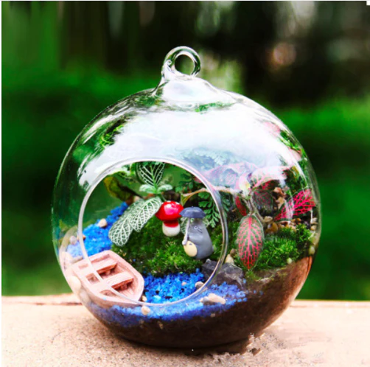

**How to create GUI?**

* **Drag-and-drop interface builders**: This method is intuitive and requires minimal coding.
* **Languages**: Many programming languages have GUI frameworks and libraries that provide pre-built GUI components. These frameworks and libraries simplify the process of building a GUI and offer customization options.
* **Integrated Development Environments (IDEs):** IDEs like Visual Studio and Eclipse offer integrated tools and visual designers for building GUIs. These tools provide drag-and-drop components, as well as code editors and debuggers.
* **Markup languages**: Markup languages like HTML, CSS, and XML are used to create the structure, layout, and appearance of GUI components. These languages offer a high level of flexibility and can be used with frameworks and libraries to create more complex GUIs.
* **Design tools to create GUI**: Tools like Sketch, Adobe XD, etc are designers to create mockups and wireframes of GUIs.

**FEATURES OF GUI**

* **Navigation**

The GUI provides an easy-to-use navigation system that enables customers to explore the website, find products, and move from one page to another.

* **Product pages**

In GUI it displays the products in an easy-to-read and visually appealing manner. This includes product images, descriptions, reviews, and pricing information, so the customers can satisfy their wants by searching the information related to their wants.

* **Shopping cart**

In GUI, the shopping cart displays all the items that a customer has added to their cart. Customers can easily modify the quantity or remove items from the cart. GUI elements such as buttons and forms allow customers to proceed to checkout or continue shopping.

* **Checkout**

In GUI the checkout process enables customers to enter their billing and shipping information, select payment options, and review their order before submitting it. GUI elements such as forms, buttons, and error messages help customers complete the checkout process smoothly.

**CHARACTERISTICS OF SOUL GARDEN**

* **Design**

When arranging plants, variation in size, color and texture is desirable. Use rocks, sand, wood and other natural materials to create cliffs, rock ledges, dry streambeds or lush tropical forests. Undulations representing hills and valleys will make the scene more interesting than a flat surface. Sketching a design of the terrarium before actually assembling it can be helpful.

* **Prepare the container**

Before planting, clean and disinfect the inside of the container by washing it with hot, soapy water and rinsing thoroughly. Make sure the inside of the container is dry before planting. These can be added easily with a spoon, funnel or other convenient tool.

* **Growing medium**

Next, add the growing medium. It should be slightly moist so that it doesn’t stir up dust but not so moist that it is muddy and sticks to the sides. For most containers, a minimum depth of 1½ inches is necessary to provide sufficient volume.

* **Adding plants**

Select only healthy, disease-free plants because closed terrariums represent an ideal environment for plant diseases to flourish. If there are disease concerns, enclose plants in a plastic bag and place in bright light for about two weeks before planting in the terrarium.

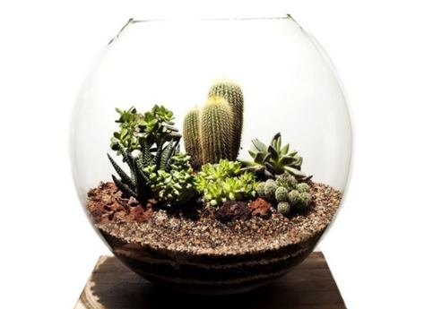 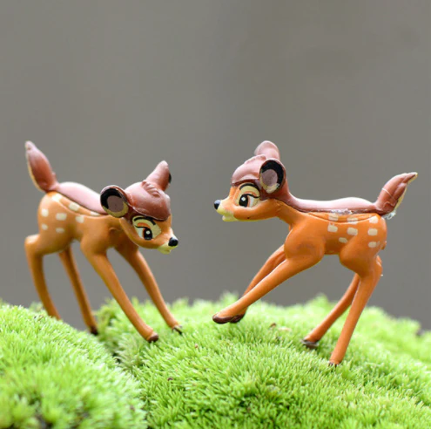

**RESULTS**

From the product point of view, As a result of all the studies that have been conducted, it has been found out that the most important materials used during constructing a terrarium are glass containers, draining stones, natural ornamental stones and miniature accessories. It has been determined that mostly succulent and cactus is used as plants and that there are many plants (for example Acorus Gramineus, Adiantum raddianum, Calathea rufibarba, Cryptanthus bivittatus Dracaena sanderiana , Ficus pumila , Fittonia verschaffeltii, Hedera helix, Hypoestes...etc) these are very suitable plants in India.

**COMMERCIALIZATION**

Before going to its distribution we shall know what benefit from the business point of view:

Market Analysis:

Identify target industries and customers.

Analyze competitors and define unique selling points.

Legal and Ethical Considerations:

Comply with data protection and privacy regulations.

Implement user consent and data anonymization.

User Interface and Experience:

Design an intuitive and user-friendly interface.

Conduct usability testing and provide user support.

Security and Authentication:

Ensure robust security measures and access control.

Regularly update and monitor security protocols.

Scalability and Performance:

Optimize for quick and accurate facial recognition.

Use cloud-based infrastructure for scalability.

**CONCLUSION**

In conclusion, facial recognition technology has the potential to offer a range of positive benefits and contribute to a more secure and efficient society. It can be used for a variety of purposes, such as enhancing public safety, improving border control, and streamlining the authentication and identification process. Additionally, facial recognition technology can enable innovative solutions in areas such as healthcare, retail, and finance, leading to increased convenience and better service for customers.

With responsible use and proper regulation, facial recognition technology has the potential to create a safer and more efficient world. It can help law enforcement agencies to quickly identify suspects and solve crimes, facilitate border crossings for travelers, and simplify the authentication and identification process for various industries. Moreover, facial recognition technology can improve security for sensitive facilities such as banks, hospitals, and government buildings, thus making them safer for employees and customers.

As with any emerging technology, facial recognition does come with challenges that must be addressed. It's important to recognize and mitigate the risks associated with privacy, accuracy, bias, and social acceptance. Companies that are involved in the development and use of facial recognition technology must take these challenges seriously and develop responsible practices that prioritize the safety and privacy of individuals.

Overall, facial recognition technology can offer significant benefits and help create a safer and more efficient society if implemented in a responsible and ethical way. With continued development and careful management, facial recognition technology can be an important tool for improving security and enhancing the way we live, work, and interact with one another.