# Lab: DOM and Events

## Sum Numbers

Write a JS function that **reads** two numbers from input fields in a **web page** and puts their **sum in another field** when the user **clicks** on a button.

### Input/Output

There will be no input/output, your program should instead **modify** the given HTML file.

|  |
| --- |
| **Sample HTML** |
| <input type="text" id="num1" /> +  <input type="text" id="num2" /> =  <input type="text" id="sum" readonly="readonly" />  <input type="button" value="Calc" onclick="calc()" />  <script>  function calc() {  // TODO: sum = num1 + num2  }  </script> |

### Examples

### 

## Show More

Write a JS function that **expands** a hidden section of text when a link is **clicked**. The link should **disappear** as the rest of the text shows up.

### Input/Output

There will be no input/output, your program should instead **modify** the given HTML file.

|  |
| --- |
| **Sample HTML** |
| Welcome to the "Show More Text Example".  <a href="#" id="more" onclick= "showText()">Read more …</a>  <span id="text" style= "display:none">Welcome to JavaScript and DOM.</span>  <script>  function showText() {  // TODO  }  </script> |

### Examples

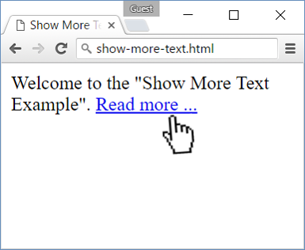 🡪 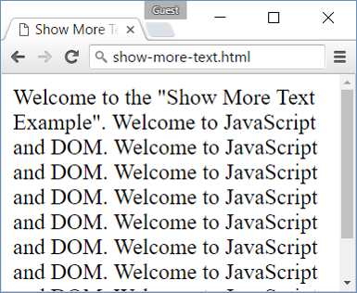

## Collect List Items

Write a JS function that scans a given **HTML list** and **appends** all collected list items’ text to a **text area** on the same page when the user **clicks** on a button.

### Input/Output

There will be no input/output, your program should instead **modify** the given HTML file.

|  |
| --- |
| **Sample HTML** |
| <ul id="items">  <li>first item</li>  <li>second item</li>  <li>third item</li>  </ul>  <textarea id="result"></textarea>  <br>  <button onclick="extractText()">Extract Text</button>  <script>  function extractText() {  // TODO  }  </script> |

### Examples

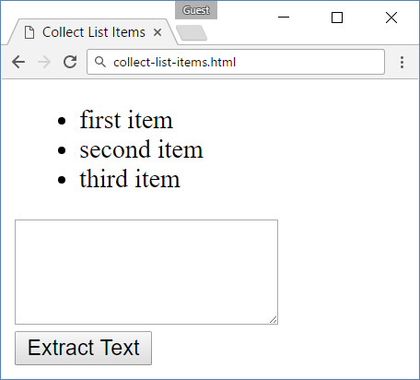 🡪 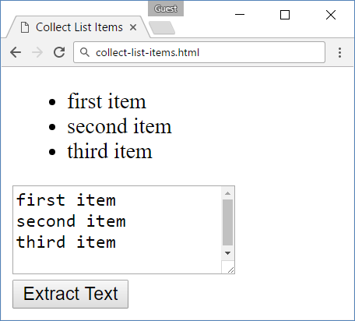

## Add and Delete

Extend the previous problem to display a **[Delete] link** after each list item. **Clicking** it, should **delete** the item with no confirmation.

### Input/Output

There will be no input/output, your program should instead **modify** the given HTML file.

|  |
| --- |
| **Sample HTML** |
| <h1>List of Items</h1>  <ul id="items"></ul>  <input type="text" id="newText" />  <input type="button" value="Add"  onclick="addItem()">  <script>  function addItem() { ...  function deleteItem() { ... }  }  </script> |

### Examples

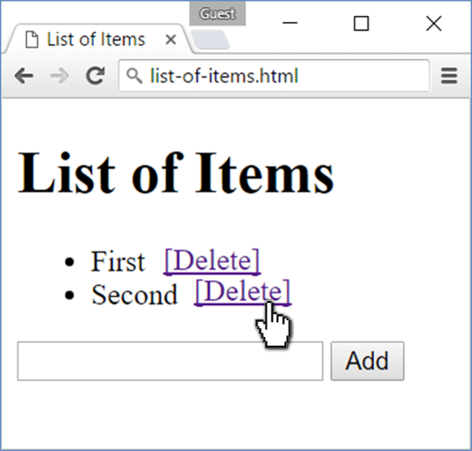🡪 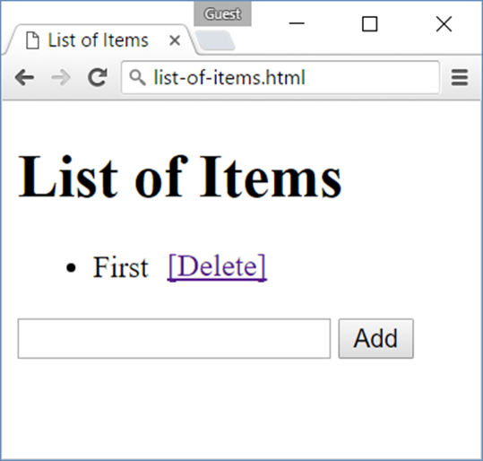

## Delete from Table

## Stopwatch

Write a JS program that **implements** a web timer that supports **minutes** and **seconds**. The user should be able to control it with **buttons**. Clicking **[Start]** **resets** the timer back to zero. Only one of the buttons should be enabled at a time (you cannot stop the timer if it’s not running).

### Input/Output

There will be no input/output, your program should instead **modify** the given HTML file.

|  |
| --- |
| **Sample HTML** |
| <div id="time" style="border:3px solid blue; text-align:center; font-size:2em; margin-bottom:10px">00:00</div>  <button id="startBtn">Start</button>  <button id="stopBtn" disabled="true">Stop</button>  <script>window.onload = function() { stopwatch(); }</script> |

### Examples

