Important Considerations for setting up an Oracle Cloud Instance

By Rajib Ghosh, Senior Solutions Architect, Oracle for Research

Understanding the basics of setting up an Oracle Cloud tenancy and instance can help researchers and the technology specialists get running quickly. However, taking a moment to understand some additional details can help optimize your use of Oracle Cloud. We encourage you to consider the following points when setting up an Oracle cloud instance

A compute instance can be virtual machine (VM) or a physical bare metal machine (BM). Here, we explain the key considerations for setting up a compute instance.

* Compute images
* Instance shapes
* Network tiers and security lists
* Usage control, automation and credits

**Compute images**

A compute image is a template of a virtual hard drive that determines the operating system and other software for an instance. Oracle cloud provides the following types of images -

1. Platform images – These are pre-built Linux or Windows operating system images ready to be deployed in the Oracle cloud. Platform images are tested by Oracle against various hardware shapes and are optimized to perform on Oracle cloud. Each image comes with multiple release builds to choose from. This is available as advanced option for compute instance creation. Platform image for [ARM based devices](https://archlinuxarm.org/#:~:text=Our%20collaboration%20with%20Arch%20Linux,and%20responsibility%20over%20the%20system.) is available through Oracle Linux 8 image.

9d0ace8d437771d0ab7defbb12129a9d Choose pre-built platform images while starting your project. If you software configurations are not closely tied to a Linux distribution like Centos or Ubuntu, we recommend using Oracle Linux. This has certain maintenance, security and compatibility advantages such as automated patching over other releases on Oracle cloud. You can convert your current Linux distributions to Oracle Linux quickly with [this link](https://linux.oracle.com/switch/centos/). Also, note that windows images cannot be exported out of the Oracle cloud tenancy because of Microsoft licensing considerations and you may need to take a backup of your installed software and data and export them out.

1. Oracle images – These are pre-built images created by Oracle with software tools pre-installed in them. They are tested for software version compatibilities against the OS version and are installed with latest patches. They are also tested against relevant sample data. They are designed to jump-start research projects and deliver a common image framework for researchers within and across universities. Some of the popular HPC (High performance computing) and Data science images are listed below:
   1. [AI (All-in-One) GPU Image for Data Science](https://console.us-ashburn-1.oraclecloud.com/marketplace/application/78643201/usageInformation)
   2. [Genome analysis toolkit](https://console.us-ashburn-1.oraclecloud.com/marketplace/application/81390072/usageInformation)
   3. [Julia AI/HPC GPU Image](https://console.us-ashburn-1.oraclecloud.com/marketplace/application/79537675/usageInformation)
   4. [NVIDIA images and NVIDIA GPU image](https://console.us-ashburn-1.oraclecloud.com/marketplace/application/54854361/usageInformation)

9d0ace8d437771d0ab7defbb12129a9d You may use the following steps to determine whether you need to use an Oracle provided image or build your own from scratch.

1. Compare the toolset and the version provided by Oracle image with the toolsets and version you require. Oracle images usually provides latest compatible working software versions with patches applied. Also, Oracle images are tested and benchmarked against relevant shapes with representative sample data. Check to see if this is advantageous and works for your scenario.
2. If the tools and versions required are very specific and have a much lesser footprint than the Oracle image, it is better to start from the closest operating system image.
3. Consult with Oracle for Research or Oracle cloud technical team for a solution that works best for your scenario.
4. Cloud marketplace images - These are [Oracle cloud partner images](https://cloudmarketplace.oracle.com/marketplace/en_US/productHomePage) developed by various third party vendors. These images can be directly provisioned to your Oracle cloud tenancy from the marketplace without any download. Some marketplace images of interest to researchers are included below –
   1. [Oracle HPC Cluster](https://cloudmarketplace.oracle.com/marketplace/en_US/listing/67628143) and [Oracle HPC File system](https://cloudmarketplace.oracle.com/marketplace/en_US/listing/75560175)
   2. [NVIDIA GPU Cloud machine image](https://cloudmarketplace.oracle.com/marketplace/en_US/listing/54854361)
   3. [Oracle Linux 7 Cluster Networking Image](https://cloudmarketplace.oracle.com/marketplace/en_US/listing/63394796)
   4. Molecular dynamics images ( [NAMD runbook](https://github.com/oci-hpc/oci-hpc-runbook-namd) and [GROMACS runbooks](https://github.com/oci-hpc/oci-hpc-runbook-gromacs))
   5. [Oracle marketplace slurm image (HPC + Slurm combo)](https://cloudmarketplace.oracle.com/marketplace/en_US/listing/67628143)
   6. [Oracle cloud slurm image](https://github.com/oracle-quickstart/oci-slurm)
   7. [BeeGFS on demand](https://cloudmarketplace.oracle.com/marketplace/en_US/listing/81525078)

C:\9d0ace8d437771d0ab7defbb12129a9d Consider testing with these images if you are looking to build [cluster networking infrastructure](https://cloudmarketplace.oracle.com/marketplace/en_US/listing/73328167) using Lustre or BeeGFS

1. Github Images – Images with associated code and documentation are also provided in [OCI-HPC Github](https://github.com/oci-hpc). OCI images are also available as containers and can be found in [opencontainers Github](https://github.com/opencontainers/image-spec) repository. The github repositories can be cloned or forked by you for additional customization and provides a more collaborative and community development approach.
2. Custom images – These are images you create from on-campus or from a different cloud. They contain with your custom tools and versions, configurations and data. Once uploaded they can be shared within Oracle cloud across tenancies and exported out for external usage as well. You can also build them from a running Oracle cloud instance as well. Custom images provide a point-in-time snapshot of an instance and can be versioned.

9d0ace8d437771d0ab7defbb12129a9d Use custom images to build the same instance in another availability domain. Export the image to object store and download it to move it out of Oracle cloud. You can also [move attached block volumes](https://blog.hussaindba.com/export-import-custom-image-copying-backup-of-block-volumes-between-the-regions-in-oci/) as well using between OCI tenancies and regions

1. Boot volumes – are a persistent way to keep your software installs and configurations in a volume to use in another instance later. Boot volumes cannot be shared by multiple instances concurrently and can be used within the same availability domain in your tenancy. However, they can be cloned to replicate and build another instance. Boot volumes can be extended as well.
2. Image OCIDs – are the unique identity tags allocated to an image in Oracle cloud. It is possible to have multiple OCID for an image based on various regions i,e Ashburn, Frankfurt. You may also share OCID for custom images you built with other researchers as well. For more information, you may refer to [Oracle cloud provided images](https://docs.cloud.oracle.com/en-us/iaas/images/) or [Oracle custom images](https://docs.cloud.oracle.com/en-us/iaas/Content/Compute/Tasks/managingcustomimages.htm)

9d0ace8d437771d0ab7defbb12129a9dUse Image OCID feature to manage and share resources in an environment with large number of cloud images with many researchers working simultaneously.

**Instance shapes**

Instance shapes are hardware specifications (i,e CPU, memory or storage) that can be used to spin up a hardware instance of a specific image. Instance shapes are broadly categorized as virtual (VM) or physical bare metal (BM) and are available from multiple vendors. Instance shapes provides you with the flexibility to scale your application across low cost to high performance hardware available in the cloud. Oracle cloud provides both flexible (AMD Rome) and fixed shapes (Intel Skylake).

The following table describes the available shapes, specification and their usage.

|  |  |  |  |  |
| --- | --- | --- | --- | --- |
| **Instance type** | **Shape Series** | **Shape** | **Specification** | 9d0ace8d437771d0ab7defbb12129a9d**Features, Tips and Additional links** |
| Virtual | AMD Rome | Flexible oCPU  VM.StandardE3.Flex | oCPU 0~64  Memory 0~1TB  Block storage only  *(Memory and network bandwidth scales linearly with oCPU)* | Better price- performance.  *Start with smaller and scale your workload with to a larger oCPU shape to benchmark on price-performance.* [*Oracle blog on AMD ROME shapes*](https://blogs.oracle.com/cloud-infrastructure/announcing-the-launch-of-e3-standard-instance-on-amd-rome-architecture) |
|  | Intel Skylake | Fixed oCPU   |  | | --- | | VM.Standard2.1 | | VM.Standard2.2 | | VM.Standard2.4 | | VM.Standard2.8 | | VM.Standard2.16 | | VM.Standard2.24 | | oCPU : 1~24  Memory : 15~320GB  Network : 1~24Gbps  Block storage only  *(Memory and network band width scales linearly with oCPU)* | *Mostly for general purpose workloads i.e running an application. Better price performance for continuously running VMs. Can be shut down and brought back up as standard shapes are not billed in stopped state.* |
|  | Legacy and Specialty shapes | Always free shape  VM.StandardE2.1Micro | 1 oCPU+1GB RAM  Block storage (1 x 46GB)  *Can run continuously with no billing. Only 2 per tenancy is allowed.* | *Use for Oracle cloud automation and scheduling scripts. You may also use this as a secure gateway VM to your compute VMs and clusters in a private subnet.* |
|  | Legacy and Specialty shapes | Standard AMD shapes   |  | | --- | | VM.StandardE2.1 | | VM.StandardE2.2 | | VM.StandardE2.4 | | VM.StandardE2.8 | | oCPU :1~8  Memory : 1~64 GB  Network : 0.48~5.6Gbps  Block storage only  *(High performant AMD EPYC shapes with linear scaling of memory and network capacity with oCPU)* | *Better price-performance than VM standard shapes*. *Good for general and low CPU test workloads in a virtual environment.* |
|  | Legacy and Specialty shapes | DenseIO shapes   |  | | --- | | VM.DenseIO2.8 | | VM.DenseIO2.16 | | VM.DenseIO2.24 | | oCPU : 8~24  Memory : 120~320GB  Storage : 6.4~25.6 NVMe SSD storage with 1~4drives  *(Memory and storage scales linearly with oCPU)* | *Faster IO performance. Recommended for testing IO intensive workloads on a VM based NVME environment before scaling up to corresponding BM shapes* |
|  | Legacy and Specialty shapes | GPU shapes  VM.GPU2.1 | oCPU : 12  Memory : 72 GB  Block storage only | *Only available VM GPU shape. Test your AI/ML GPU workload in a VM based GPU environment before scaling to BM GPU shape* |
| Bare metal | Physical server | Standard shapes   |  | | --- | | BM.StandardE2.52 | | oCPU : 52 Memory : 768GB  Network : 2NIC x 25 Gbps  Block storage only | *Price-performant bare metal shape. Test your workloads before moving to the BM2.52 DenseIO shape* |
|  |  | DenseIO shapes   |  | | --- | | BM.DenseIOE2.52 | | oCPU : 52 Memory : 768GB  Network : 2NIC x 25Gbps  51.2 TB local NVME SSD | *Highest IO intensive performance. Additional block storages (up to 1PB / instance) can be attached as well. Scaling flexibility by clustering as well as attached block volumes* |
|  |  | Standard shapes   |  | | --- | | BM.StandardE2.64 | |  | | oCPU : 64 Memory 512  Network : 2NIC x 25Gbps  Block storage only | *Price-performant for high CPU / lower memory and IO workloads than BM2.52 shapes. A good start to test your workload on BM shapes* |
|  |  | Standard shapes   |  | | --- | | BM.StandardE3.128 | |  | | oCPU : 128 Memory 2048  Network : 2NIC x 50Gbps  Block storage only | *Highest oCPU, memory and bandwidth for large IO throughputs over block storage. Test your workload for comparable price performance against BM.DenseIO 2.52 shapes* |
|  |  | GPU shapes   |  | | --- | | BM.GPU2.2  BM GPU3.4  BM.GPU3.8 | | oCPU 28 Memory 256 GB  oCPU 52 Memory 768 GB  Network 2NIC x 25Gbps  Block storage only | *Bare metal 3.x GPU shapes are based on nVIDIA V100 as opposed to older P100 architecture. Suited for Deep learning (DL) GPU applications. DL applications with large matrix manipulations can take advantage of BM 3.x (higher tensor core) shapes* |
|  |  | HPC shapes   |  | | --- | | BM.HPC2.36 | | oCPU 36 Memory 384  6.7 local NVME (8 drives)  Network 2NIC x 25Gbps + 100Gbps RDMA | *Recommended for parallel workloads where inter-process communication is predominant So scaling requires a RDMA cluster networking to facilitate inter-node communication* |
|  |  | Old standard shapes  BM.Standard1.36  BM.StandardB.144 | oCPU 36 memory 256GB  oCPU 44 memory 512GB  Network 1NIC x 25Gbps  Block storage only | *This may be used for workloads with lower CPU or memory requirements and lower throughput requirements or when the high end shapes are not available* |

**Network tier and security lists**

Network components like subnets and security lists provide the required isolation to your VM/BM instances from direct external access. Oracle cloud network is restrictive by default and only allows SSH (port 22) access to allow external logins to the VMs. This is sufficient for most researcher use-cases if you perform your work logging into the VMs. However, if you wish to stand up an application and have specific port requirements, you need to open them by adding a ingress security list entry for the VMs subnet.

The diagram below shows addition of port 3389 to enable RDP access for any Windows VMs in the subnet. Note that the source is set to a CIDR value 0.0.0.0/0 meaning that is open to anyone trying to RDP to Oracle cloud on that port. However, you may consult your on-campus network administrator to set this your on-campus network CIDR values to restrict access to your cloud VM to university network only.

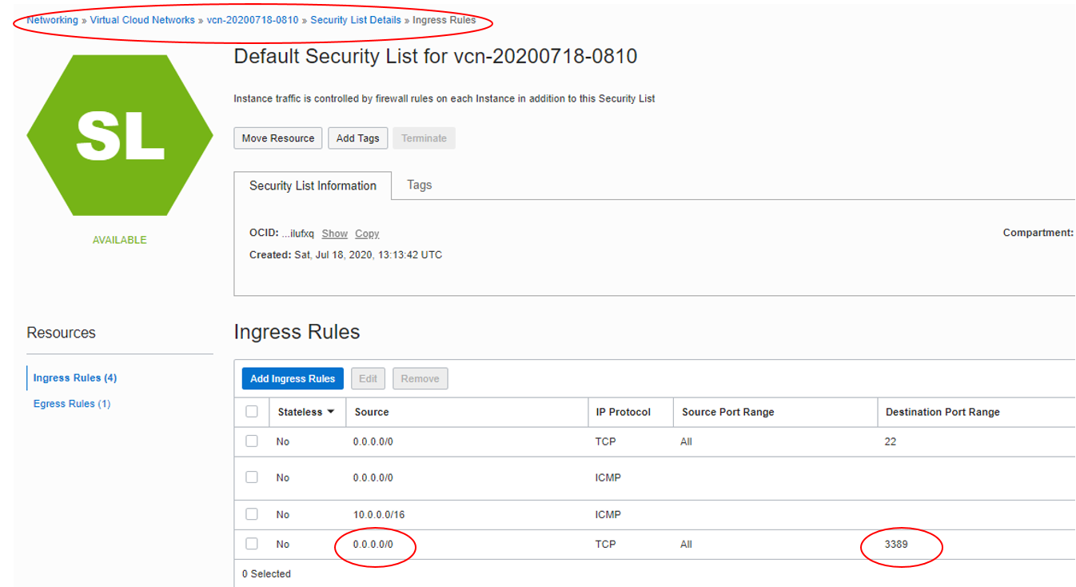

However, you may also secure your VM in a self-service manner without the help of your network administrator. However, it is a bit involved and a recommended practice is to create all your computational VM/BM in a private subnet and access them from a free tier windows or Linux machine in a public facing subnet in Oracle cloud. This lets you SSH connect to your Always free VM in public subnet and use it as a gateway to connect to your compute instances in the private subnet. You may refer to [OCI VCN Introductory page](https://www.oracle.com/a/ocom/docs/cloud/virtual-cloud-network-100.pdf) or consult OFR technical team for details. A schematic diagram of the architecture and a screenshot showing the updated security list rule are shown below. This security rule will only allow RDP (remote desktop) access from the Oracle cloud free tier VM as opposed to anywhere in the internet

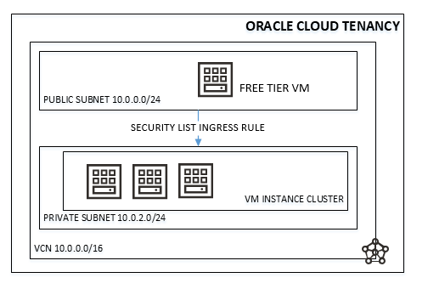



1. Managing usage and costs -

**Usage control, automation and credits**

To get more out of Oracle cloud tenancy credits, it is imperative that compute resources be fully utilized. With most of HPC and AI/ML computations being batch oriented, it is extremely important that instances be used at full or near full capacity and terminated when not in use. Credit control can be effectively performed in two ways – 1) Using high-end shapes only for computational cycles 2) Using automation to start / terminate instances when not in use. You may refer to [Resource billing for stopped instances](https://docs.cloud.oracle.com/en-us/iaas/Content/Compute/Tasks/restartinginstance.htm#resource-billing) for more details as well.

9d0ace8d437771d0ab7defbb12129a9dSome of the important tips are described below:

* 1. Start with low-cost and scale to high-end shapes – Standard and AMD VM shapes provides lower per hour cost and is recommended to use during the software installation, image building and testing phases for your project. Standard shapes can be stopped without billing but high end shapes like DenseIO, GPU or HPC shapes must be terminated to stop billing. It is recommended to get a benchmark of your workload by starting with a VM and slowly moving to expensive BM shapes.
  2. Start with low data volume and scale up– Start with a lower data volume to get a sense of CPU and memory utilization and scale the data to find the optimal threshold of CPU and RAM for that shape. You may do the same for IO intensive loads to check out various storage types (local SSD, block volume or a combination) to see how they perform while scaling with data. Testing workloads in this way can give you a sense of performance gains that can be achieved as you scale up your workloads and shape.
  3. Utilizing GPU/HPC shapes – GPU and HPC shapes are expensive and should only be used during computational cycles only. The BM GPU and HPC shapes are billed by the hour and hence need previous workload cycle estimation for effective usage. Measuring CPU and memory utilization at the operating system level and CPU/GPU level and benchmarking them against your data can help. Several tools like (free,vmstat or iostat), [fio](https://fio.readthedocs.io/en/latest/fio_doc.html), [mdtest](https://wiki.lustre.org/MDTest), IO500 or [nvidia-smi](https://developer.nvidia.com/nvidia-system-management-interface) can be used for this purpose.
  4. Instance creation and termination automation – The rule of thumb is to create an instance just before your computation and terminate them after your run. You may also do this manually from OCI console but it is easier said than done and hence automation is a better choice. Oracle recommends OCI command line interface (CLI) or Terraform scripts in conjunction with Linux shell or Windows powershell for automation and control. Though OCI provides an application API interface, OCI CLI provides a quicker and efficient way to develop and manage automation. The following links can help you on your journey to automation:
  5. [OCI CLI Getting started](https://oracle.github.io/learning-library/oci-library/DevOps/OCI_CLI/OCI_CLI_HOL.html#practice-5-use-query-to-find-oracle-linux-image-id,-then-launch-a-compute-instance) and [documentation](https://docs.cloud.oracle.com/en-us/iaas/Content/API/Concepts/cliconcepts.htm)
  6. [OCI CLI github site](https://github.com/oracle/oci-cli)
  7. [OCI CLI command reference](https://docs.cloud.oracle.com/en-us/iaas/tools/oci-cli/2.12.11/oci_cli_docs/)
  8. [OCI terraform provider examples](https://github.com/terraform-providers/terraform-provider-oci/tree/master/examples)
  9. [Cluster in the cloud](https://cluster-in-the-cloud.readthedocs.io/en/latest/)
  10. Estimating cluster size and instance scaling – Estimate the number of nodes for a specific shape is necessary for optimal use of the Oracle cloud shapes and clusters. Though the estimation process can vary depending on project needs, a general practice is to estimate the total CPU/GPU hours, IO throughput and network bandwidth for the project, benchmark it against the Oracle cloud shapes to estimate the number of nodes required for your workload. Once done, you may be able to use the OCI [Instance pooling](https://docs.cloud.oracle.com/en-us/iaas/Content/Compute/Tasks/creatinginstancepool.htm) feature to [auto-scale](https://docs.cloud.oracle.com/en-us/iaas/Content/Compute/Tasks/autoscalinginstancepools.htm) nodes based on your workload.
  11. Credit control with cost analysis, budgeting and alerts – [Cost analysis](https://docs.cloud.oracle.com/en-us/iaas/Content/Billing/Concepts/costanalysisoverview.htm) provides you with a summarized and a drill down view of resource usage and costs for your tenancy with a variety of visualization charts. You can also customize them by adding different filters that may be of importance to you. Oracle cloud automatically generates detail summarized reports and you may be able to integrate them with your on-campus cost reporting system as well. Furthermore, it is possible to set soft limits on your tenancy spend ([budgets](https://docs.cloud.oracle.com/en-us/iaas/Content/Billing/Concepts/budgetsoverview.htm)) and [set alerts](https://docs.cloud.oracle.com/en-us/iaas/Content/Billing/Tasks/managingalertrules.htm) to know when you are exceeding your budgets.