--< NUMBER 1 >--

--< Counts # of past and current employees in department >--

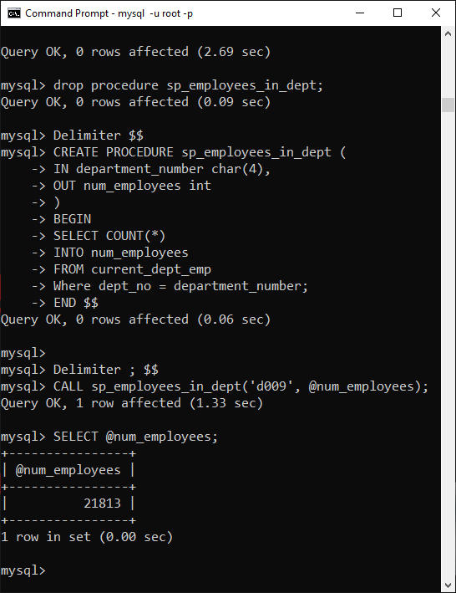

--< NUMBER 3 >--

--< Calls the stored procedures in #1 & #2 to display past and current employees >--

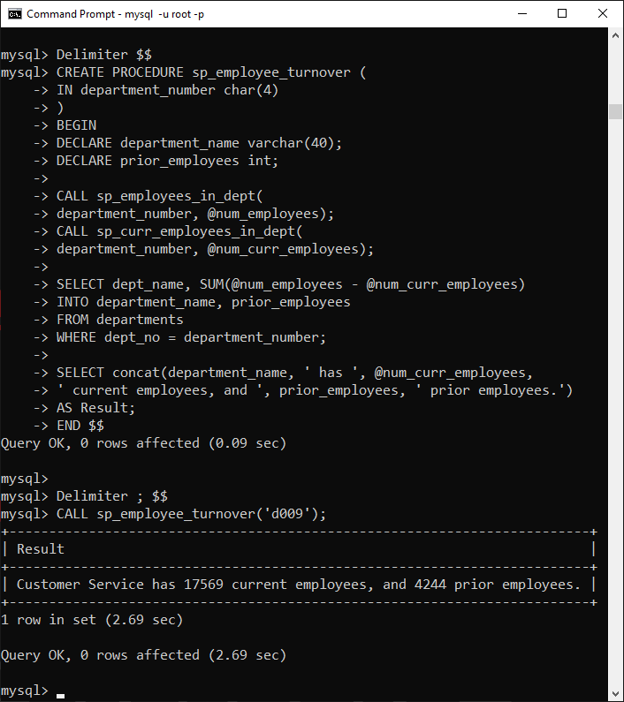

--< NUMBER 2 >--

--< Counts # of current employees in department >--

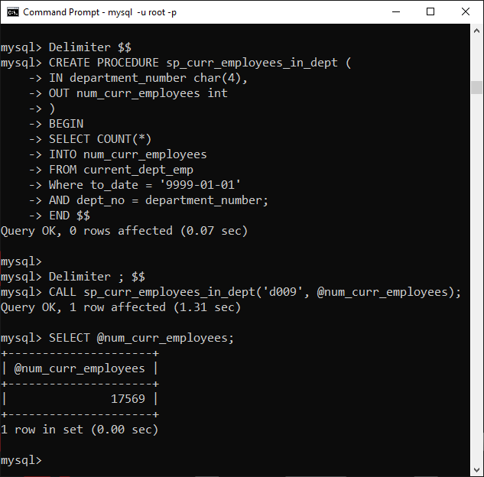

--< NUMBER 4 >--

--< Calls a previous procedure and checks dept size >--

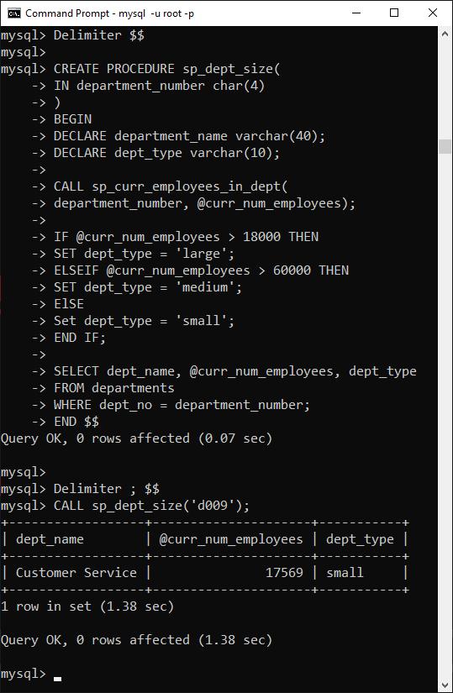

--< NUMBER 5 >--

--< Gets average salaray per title per department >--

--< No input perameter, just used to save retyping many lines of code >--

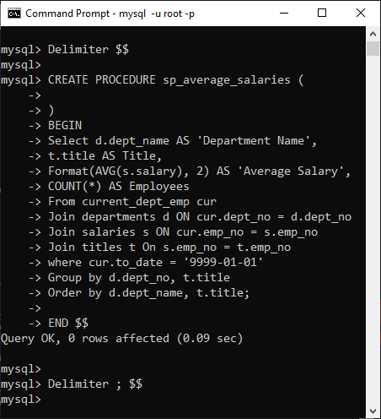

**URL to GitHub Repository:**

https://github.com/rgim/MySQL-Week4.git

