Relational Databases with MySQL Week 6 Coding Assignment

Coding Steps:

This week you will be working together as a team to create a full CRUD application.

Your console CRUD application will need to use a database to store all the application data.

As a team, decide what you want your project to do. Get instructor approval early in the week before beginning development.

You need to have at least 3 entities.

Users should be able to interact via the console (i.e. Scanner(System.in)))

Use git to collaborate.

Everyone will be graded on their individual contributions.

**URL to GitHub Repository**:

https://github.com/rgim/MySQL-final.git

**Screenshots of Code**:

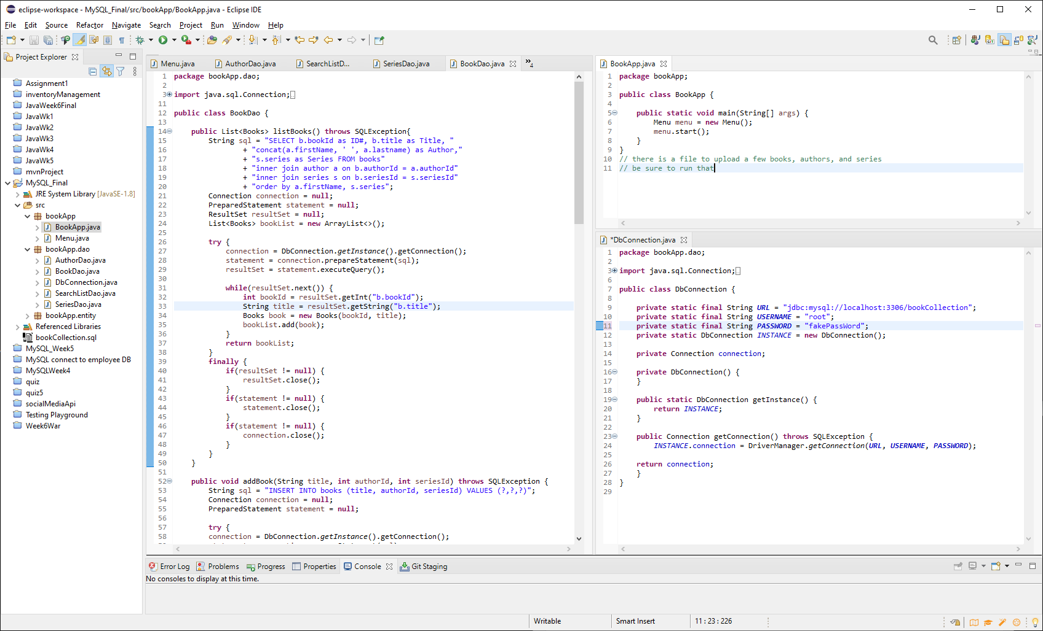

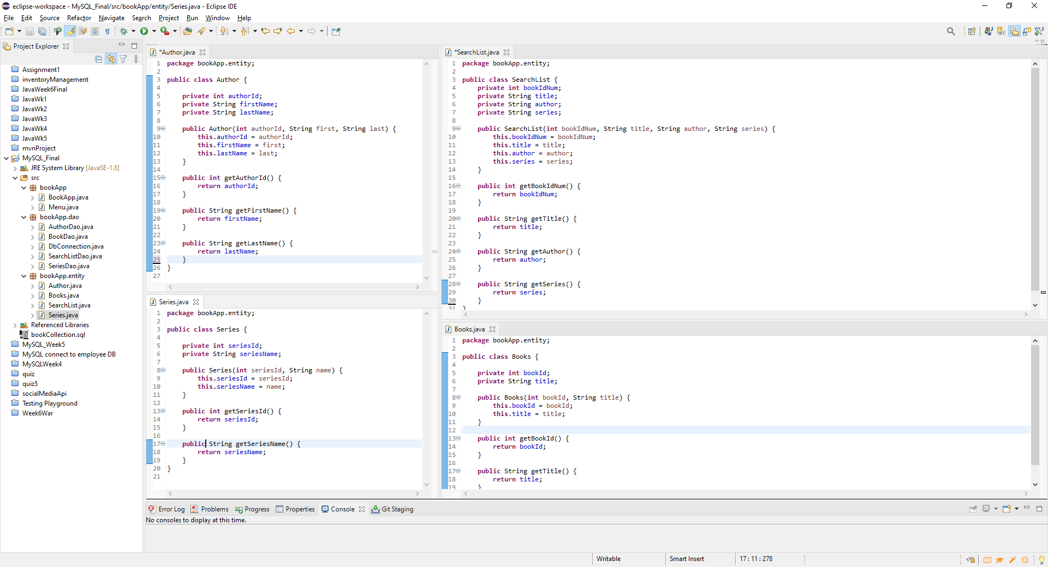

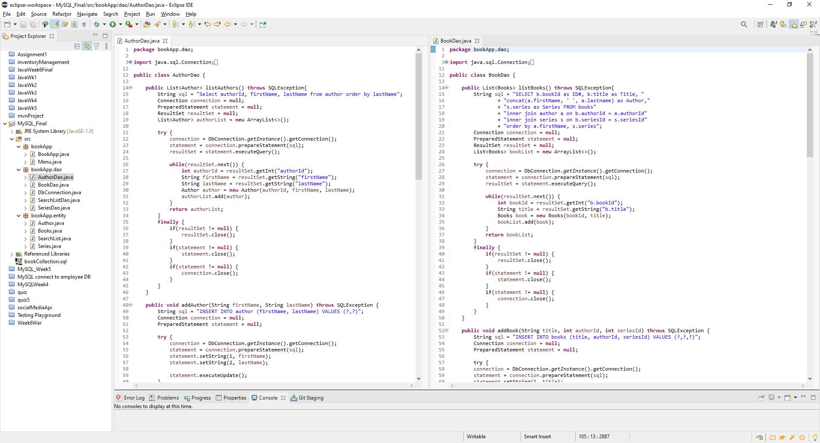

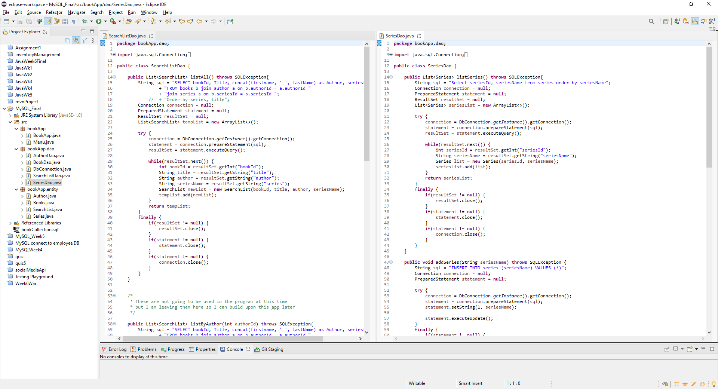

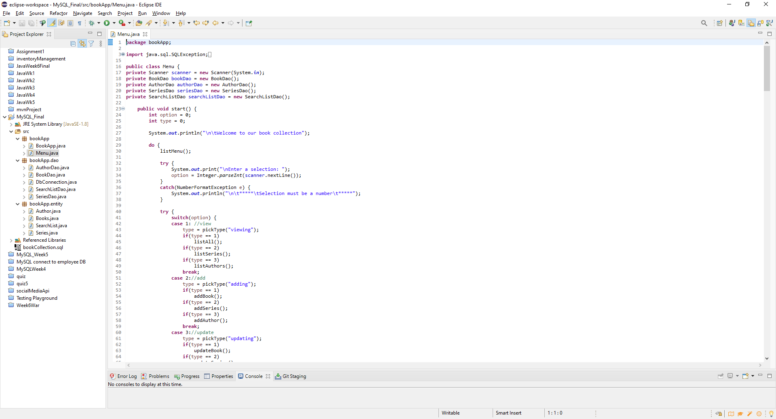

**Screenshots of Running Application**:

Welcome to our book collection

Menu

------------------------------------------

1- VIEW a list of books, series, or authors

2- ADD a book, series, or author

3- UPDATE a book, series, or author

4- DELETE a book, series, or author

5- EXIT PROGRAM

Enter a selection: 1

What are you viewing?

1- Book

2- Series

3- Author

1

Id# Title Author Series

1 The Red Pyramid Rick Rioridan The Kane Chronicles

2 The Throne of Fire Rick Rioridan The Kane Chronicles

3 The Serpent's Shadow Rick Rioridan The Kane Chronicles

4 The Lost Hero Rick Rioridan The Heroes of Olympus

5 The Son of Neptune Rick Rioridan The Heroes of Olympus

6 The Mark of Athena Rick Rioridan The Heroes of Olympus

7 The House of Hades Rick Rioridan The Heroes of Olympus

8 The Blood of Olympus Rick Rioridan The Heroes of Olympus

19 The Lightning Thief Rick Rioridan Percy Jackson and the Olympians

20 The Sea of Monsters Rick Rioridan Percy Jackson and the Olympians

21 The Titan's Curse Rick Rioridan Percy Jackson and the Olympians

22 The Battle of the Labyrinth Rick Rioridan Percy Jackson and the Olympians

23 The Last Olympian Rick Rioridan Percy Jackson and the Olympians

9 The False Prince Jennifer A. Nielsen Ascendance

10 The Runaway King Jennifer A. Nielsen Ascendance

11 The Shadow Throne Jennifer A. Nielsen Ascendance

12 The Captive Kingdom Jennifer A. Nielsen Ascendance

13 The Traitor's Game Jennifer A. Nielsen Traitor's Game

14 The Deceiver's Heart Jennifer A. Nielsen Traitor's Game

15 The Warrior's Curse Jennifer A. Nielsen Traitor's Game

16 Mark of the Thief Jennifer A. Nielsen Mark of the Theif

17 Rise of the Wolf Jennifer A. Nielsen Mark of the Theif

18 Wrath of the Storm Jennifer A. Nielsen Mark of the Theif

Menu

------------------------------------------

1- VIEW a list of books, series, or authors

2- ADD a book, series, or author

3- UPDATE a book, series, or author

4- DELETE a book, series, or author

5- EXIT PROGRAM

Enter a selection: 1

What are you viewing?

1- Book

2- Series

3- Author

2

ID# Series

--------------------

3 Ascendance

5 Mark of the Theif

6 Percy Jackson and the Olympians

2 The Heroes of Olympus

1 The Kane Chronicles

4 Traitor's Game

Menu

------------------------------------------

1- VIEW a list of books, series, or authors

2- ADD a book, series, or author

3- UPDATE a book, series, or author

4- DELETE a book, series, or author

5- EXIT PROGRAM

Enter a selection: 1

What are you viewing?

1- Book

2- Series

3- Author

3

ID# Author

--------------------

2 Jennifer A. Nielsen

1 Rick Rioridan

Menu

------------------------------------------

1- VIEW a list of books, series, or authors

2- ADD a book, series, or author

3- UPDATE a book, series, or author

4- DELETE a book, series, or author

5- EXIT PROGRAM

Enter a selection: 2

What are you adding?

1- Book

2- Series

3- Author

1

*** Before adding a book, both the author and series must be in the program ***

*** We will check for both of those now ***

ID# Author

--------------------

2 Jennifer A. Nielsen

1 Rick Rioridan

Enter the number 0 if the author is NOT on the list.

Enter the author's ID# : 0

*** Returning you to the main menu to add the author ***

Menu

------------------------------------------

1- VIEW a list of books, series, or authors

2- ADD a book, series, or author

3- UPDATE a book, series, or author

4- DELETE a book, series, or author

5- EXIT PROGRAM

Enter a selection: 2

What are you adding?

1- Book

2- Series

3- Author

3

ID# Author

--------------------

2 Jennifer A. Nielsen

1 Rick Rioridan

*** Please double check the Author is not already on the list ***

*** Continue only if the Authoris not already on the list ***

0- EXIT the add/update menu

1- CONTINUE and add/update a(n) Author

1

Enter the author's first name: Becky

Enter the author's last name: Gimbella

*** Add successful ***

Menu

------------------------------------------

1- VIEW a list of books, series, or authors

2- ADD a book, series, or author

3- UPDATE a book, series, or author

4- DELETE a book, series, or author

5- EXIT PROGRAM

Enter a selection: 2

What are you adding?

1- Book

2- Series

3- Author

1

*** Before adding a book, both the author and series must be in the program ***

*** We will check for both of those now ***

ID# Author

--------------------

3 Becky Gimbella

2 Jennifer A. Nielsen

1 Rick Rioridan

Enter the number 0 if the author is NOT on the list.

Enter the author's ID# : 3

ID# Series

--------------------

3 Ascendance

5 Mark of the Theif

6 Percy Jackson and the Olympians

2 The Heroes of Olympus

1 The Kane Chronicles

4 Traitor's Game

Enter the number 0 if the series is NOT on the list.

Enter the series's ID# : 0

*** Returning you to the main menu to add the series ***

Menu

------------------------------------------

1- VIEW a list of books, series, or authors

2- ADD a book, series, or author

3- UPDATE a book, series, or author

4- DELETE a book, series, or author

5- EXIT PROGRAM

Enter a selection: 2

What are you adding?

1- Book

2- Series

3- Author

2

ID# Series

--------------------

3 Ascendance

5 Mark of the Theif

6 Percy Jackson and the Olympians

2 The Heroes of Olympus

1 The Kane Chronicles

4 Traitor's Game

*** Please double check the Series is not already on the list ***

*** Continue only if the Seriesis not already on the list ***

0- EXIT the add/update menu

1- CONTINUE and add/update a(n) Series

1

Enter the series name: My Favorite Things

*** Add successful ***

Menu

------------------------------------------

1- VIEW a list of books, series, or authors

2- ADD a book, series, or author

3- UPDATE a book, series, or author

4- DELETE a book, series, or author

5- EXIT PROGRAM

Enter a selection: 2

What are you adding?

1- Book

2- Series

3- Author

1

*** Before adding a book, both the author and series must be in the program ***

*** We will check for both of those now ***

ID# Author

--------------------

3 Becky Gimbella

2 Jennifer A. Nielsen

1 Rick Rioridan

Enter the number 0 if the author is NOT on the list.

Enter the author's ID# : 2

ID# Series

--------------------

3 Ascendance

5 Mark of the Theif

7 My Favorite Things

6 Percy Jackson and the Olympians

2 The Heroes of Olympus

1 The Kane Chronicles

4 Traitor's Game

Enter the number 0 if the series is NOT on the list.

Enter the series's ID# : 6

Enter the book title: z vacations are fun

*** Add successful ***

Menu

------------------------------------------

1- VIEW a list of books, series, or authors

2- ADD a book, series, or author

3- UPDATE a book, series, or author

4- DELETE a book, series, or author

5- EXIT PROGRAM

Enter a selection: 1

What are you viewing?

1- Book

2- Series

3- Author

1

Id# Title Author Series

1 The Red Pyramid Rick Rioridan The Kane Chronicles

2 The Throne of Fire Rick Rioridan The Kane Chronicles

3 The Serpent's Shadow Rick Rioridan The Kane Chronicles

4 The Lost Hero Rick Rioridan The Heroes of Olympus

5 The Son of Neptune Rick Rioridan The Heroes of Olympus

6 The Mark of Athena Rick Rioridan The Heroes of Olympus

7 The House of Hades Rick Rioridan The Heroes of Olympus

8 The Blood of Olympus Rick Rioridan The Heroes of Olympus

19 The Lightning Thief Rick Rioridan Percy Jackson and the Olympians

20 The Sea of Monsters Rick Rioridan Percy Jackson and the Olympians

21 The Titan's Curse Rick Rioridan Percy Jackson and the Olympians

22 The Battle of the Labyrinth Rick Rioridan Percy Jackson and the Olympians

23 The Last Olympian Rick Rioridan Percy Jackson and the Olympians

9 The False Prince Jennifer A. Nielsen Ascendance

10 The Runaway King Jennifer A. Nielsen Ascendance

11 The Shadow Throne Jennifer A. Nielsen Ascendance

12 The Captive Kingdom Jennifer A. Nielsen Ascendance

13 The Traitor's Game Jennifer A. Nielsen Traitor's Game

14 The Deceiver's Heart Jennifer A. Nielsen Traitor's Game

15 The Warrior's Curse Jennifer A. Nielsen Traitor's Game

16 Mark of the Thief Jennifer A. Nielsen Mark of the Theif

17 Rise of the Wolf Jennifer A. Nielsen Mark of the Theif

18 Wrath of the Storm Jennifer A. Nielsen Mark of the Theif

24 z vacations are fun Jennifer A. Nielsen Percy Jackson and the Olympians

Menu

------------------------------------------

1- VIEW a list of books, series, or authors

2- ADD a book, series, or author

3- UPDATE a book, series, or author

4- DELETE a book, series, or author

5- EXIT PROGRAM

Enter a selection: 3

What are you updating?

1- Book

2- Series

3- Author

1

Id# Title Author Series

1 The Red Pyramid Rick Rioridan The Kane Chronicles

2 The Throne of Fire Rick Rioridan The Kane Chronicles

3 The Serpent's Shadow Rick Rioridan The Kane Chronicles

4 The Lost Hero Rick Rioridan The Heroes of Olympus

5 The Son of Neptune Rick Rioridan The Heroes of Olympus

6 The Mark of Athena Rick Rioridan The Heroes of Olympus

7 The House of Hades Rick Rioridan The Heroes of Olympus

8 The Blood of Olympus Rick Rioridan The Heroes of Olympus

19 The Lightning Thief Rick Rioridan Percy Jackson and the Olympians

20 The Sea of Monsters Rick Rioridan Percy Jackson and the Olympians

21 The Titan's Curse Rick Rioridan Percy Jackson and the Olympians

22 The Battle of the Labyrinth Rick Rioridan Percy Jackson and the Olympians

23 The Last Olympian Rick Rioridan Percy Jackson and the Olympians

9 The False Prince Jennifer A. Nielsen Ascendance

10 The Runaway King Jennifer A. Nielsen Ascendance

11 The Shadow Throne Jennifer A. Nielsen Ascendance

12 The Captive Kingdom Jennifer A. Nielsen Ascendance

13 The Traitor's Game Jennifer A. Nielsen Traitor's Game

14 The Deceiver's Heart Jennifer A. Nielsen Traitor's Game

15 The Warrior's Curse Jennifer A. Nielsen Traitor's Game

16 Mark of the Thief Jennifer A. Nielsen Mark of the Theif

17 Rise of the Wolf Jennifer A. Nielsen Mark of the Theif

18 Wrath of the Storm Jennifer A. Nielsen Mark of the Theif

24 z vacations are fun Jennifer A. Nielsen Percy Jackson and the Olympians

Enter the number 0 if the book is NOT on the list.

Enter the book's ID# : 24

What are you correcting?

1- Book title

2- Book author

3- Book series

Enter 1, 2, or 3: 1

Enter the correct title for this book:Vacations are Fun

*** Update successful ***

Menu

------------------------------------------

1- VIEW a list of books, series, or authors

2- ADD a book, series, or author

3- UPDATE a book, series, or author

4- DELETE a book, series, or author

5- EXIT PROGRAM

Enter a selection: 3

What are you updating?

1- Book

2- Series

3- Author

1

Id# Title Author Series

1 The Red Pyramid Rick Rioridan The Kane Chronicles

2 The Throne of Fire Rick Rioridan The Kane Chronicles

3 The Serpent's Shadow Rick Rioridan The Kane Chronicles

4 The Lost Hero Rick Rioridan The Heroes of Olympus

5 The Son of Neptune Rick Rioridan The Heroes of Olympus

6 The Mark of Athena Rick Rioridan The Heroes of Olympus

7 The House of Hades Rick Rioridan The Heroes of Olympus

8 The Blood of Olympus Rick Rioridan The Heroes of Olympus

19 The Lightning Thief Rick Rioridan Percy Jackson and the Olympians

20 The Sea of Monsters Rick Rioridan Percy Jackson and the Olympians

21 The Titan's Curse Rick Rioridan Percy Jackson and the Olympians

22 The Battle of the Labyrinth Rick Rioridan Percy Jackson and the Olympians

23 The Last Olympian Rick Rioridan Percy Jackson and the Olympians

9 The False Prince Jennifer A. Nielsen Ascendance

10 The Runaway King Jennifer A. Nielsen Ascendance

11 The Shadow Throne Jennifer A. Nielsen Ascendance

12 The Captive Kingdom Jennifer A. Nielsen Ascendance

13 The Traitor's Game Jennifer A. Nielsen Traitor's Game

14 The Deceiver's Heart Jennifer A. Nielsen Traitor's Game

15 The Warrior's Curse Jennifer A. Nielsen Traitor's Game

16 Mark of the Thief Jennifer A. Nielsen Mark of the Theif

17 Rise of the Wolf Jennifer A. Nielsen Mark of the Theif

18 Wrath of the Storm Jennifer A. Nielsen Mark of the Theif

24 Vacations are Fun Jennifer A. Nielsen Percy Jackson and the Olympians

Enter the number 0 if the book is NOT on the list.

Enter the book's ID# : 24

What are you correcting?

1- Book title

2- Book author

3- Book series

Enter 1, 2, or 3: 2

ID# Author

--------------------

3 Becky Gimbella

2 Jennifer A. Nielsen

1 Rick Rioridan

Enter the number 0 if the author is NOT on the list.

Enter the author's ID# : 3

*** Update successful ***

Menu

------------------------------------------

1- VIEW a list of books, series, or authors

2- ADD a book, series, or author

3- UPDATE a book, series, or author

4- DELETE a book, series, or author

5- EXIT PROGRAM

Enter a selection: 3

What are you updating?

1- Book

2- Series

3- Author

1

Id# Title Author Series

1 The Red Pyramid Rick Rioridan The Kane Chronicles

2 The Throne of Fire Rick Rioridan The Kane Chronicles

3 The Serpent's Shadow Rick Rioridan The Kane Chronicles

4 The Lost Hero Rick Rioridan The Heroes of Olympus

5 The Son of Neptune Rick Rioridan The Heroes of Olympus

6 The Mark of Athena Rick Rioridan The Heroes of Olympus

7 The House of Hades Rick Rioridan The Heroes of Olympus

8 The Blood of Olympus Rick Rioridan The Heroes of Olympus

19 The Lightning Thief Rick Rioridan Percy Jackson and the Olympians

20 The Sea of Monsters Rick Rioridan Percy Jackson and the Olympians

21 The Titan's Curse Rick Rioridan Percy Jackson and the Olympians

22 The Battle of the Labyrinth Rick Rioridan Percy Jackson and the Olympians

23 The Last Olympian Rick Rioridan Percy Jackson and the Olympians

9 The False Prince Jennifer A. Nielsen Ascendance

10 The Runaway King Jennifer A. Nielsen Ascendance

11 The Shadow Throne Jennifer A. Nielsen Ascendance

12 The Captive Kingdom Jennifer A. Nielsen Ascendance

13 The Traitor's Game Jennifer A. Nielsen Traitor's Game

14 The Deceiver's Heart Jennifer A. Nielsen Traitor's Game

15 The Warrior's Curse Jennifer A. Nielsen Traitor's Game

16 Mark of the Thief Jennifer A. Nielsen Mark of the Theif

17 Rise of the Wolf Jennifer A. Nielsen Mark of the Theif

18 Wrath of the Storm Jennifer A. Nielsen Mark of the Theif

24 Vacations are Fun Becky Gimbella Percy Jackson and the Olympians

Enter the number 0 if the book is NOT on the list.

Enter the book's ID# : 24

What are you correcting?

1- Book title

2- Book author

3- Book series

Enter 1, 2, or 3: 3

ID# Series

--------------------

3 Ascendance

5 Mark of the Theif

7 My Favorite Things

6 Percy Jackson and the Olympians

2 The Heroes of Olympus

1 The Kane Chronicles

4 Traitor's Game

Enter the number 0 if the series is NOT on the list.

Enter the series's ID# : 7

*** Update successful ***

Menu

------------------------------------------

1- VIEW a list of books, series, or authors

2- ADD a book, series, or author

3- UPDATE a book, series, or author

4- DELETE a book, series, or author

5- EXIT PROGRAM

Enter a selection: 1

What are you viewing?

1- Book

2- Series

3- Author

1

Id# Title Author Series

1 The Red Pyramid Rick Rioridan The Kane Chronicles

2 The Throne of Fire Rick Rioridan The Kane Chronicles

3 The Serpent's Shadow Rick Rioridan The Kane Chronicles

4 The Lost Hero Rick Rioridan The Heroes of Olympus

5 The Son of Neptune Rick Rioridan The Heroes of Olympus

6 The Mark of Athena Rick Rioridan The Heroes of Olympus

7 The House of Hades Rick Rioridan The Heroes of Olympus

8 The Blood of Olympus Rick Rioridan The Heroes of Olympus

19 The Lightning Thief Rick Rioridan Percy Jackson and the Olympians

20 The Sea of Monsters Rick Rioridan Percy Jackson and the Olympians

21 The Titan's Curse Rick Rioridan Percy Jackson and the Olympians

22 The Battle of the Labyrinth Rick Rioridan Percy Jackson and the Olympians

23 The Last Olympian Rick Rioridan Percy Jackson and the Olympians

9 The False Prince Jennifer A. Nielsen Ascendance

10 The Runaway King Jennifer A. Nielsen Ascendance

11 The Shadow Throne Jennifer A. Nielsen Ascendance

12 The Captive Kingdom Jennifer A. Nielsen Ascendance

13 The Traitor's Game Jennifer A. Nielsen Traitor's Game

14 The Deceiver's Heart Jennifer A. Nielsen Traitor's Game

15 The Warrior's Curse Jennifer A. Nielsen Traitor's Game

16 Mark of the Thief Jennifer A. Nielsen Mark of the Theif

17 Rise of the Wolf Jennifer A. Nielsen Mark of the Theif

18 Wrath of the Storm Jennifer A. Nielsen Mark of the Theif

24 Vacations are Fun Becky Gimbella My Favorite Things

Menu

------------------------------------------

1- VIEW a list of books, series, or authors

2- ADD a book, series, or author

3- UPDATE a book, series, or author

4- DELETE a book, series, or author

5- EXIT PROGRAM

Enter a selection: 3

What are you updating?

1- Book

2- Series

3- Author

3

ID# Author

--------------------

3 Becky Gimbella

2 Jennifer A. Nielsen

1 Rick Rioridan

Enter the number 0 if the author is NOT on the list.

Enter the author's ID# : 3

What are you correcting?

1- First name

2- Last name

Enter 1 or 2: 1

Enter the correct first name for this author:Rebecca

*** Update successful ***

Menu

------------------------------------------

1- VIEW a list of books, series, or authors

2- ADD a book, series, or author

3- UPDATE a book, series, or author

4- DELETE a book, series, or author

5- EXIT PROGRAM

Enter a selection: 3

What are you updating?

1- Book

2- Series

3- Author

3

ID# Author

--------------------

3 Rebecca Gimbella

2 Jennifer A. Nielsen

1 Rick Rioridan

Enter the number 0 if the author is NOT on the list.

Enter the author's ID# : 3

What are you correcting?

1- First name

2- Last name

Enter 1 or 2: 2

Enter the correct last name for this author:Gimbel

*** Update successful ***

Menu

------------------------------------------

1- VIEW a list of books, series, or authors

2- ADD a book, series, or author

3- UPDATE a book, series, or author

4- DELETE a book, series, or author

5- EXIT PROGRAM

Enter a selection: 3

What are you updating?

1- Book

2- Series

3- Author

2

ID# Series

--------------------

3 Ascendance

5 Mark of the Theif

7 My Favorite Things

6 Percy Jackson and the Olympians

2 The Heroes of Olympus

1 The Kane Chronicles

4 Traitor's Game

Enter the number 0 if the Series is NOT on the list.

Enter the Series's ID# : 7

Enter the correct name for this series:Favorite Things of Mine

*** Update successful ***

Menu

------------------------------------------

1- VIEW a list of books, series, or authors

2- ADD a book, series, or author

3- UPDATE a book, series, or author

4- DELETE a book, series, or author

5- EXIT PROGRAM

Enter a selection: 1

What are you viewing?

1- Book

2- Series

3- Author

1

Id# Title Author Series

1 The Red Pyramid Rick Rioridan The Kane Chronicles

2 The Throne of Fire Rick Rioridan The Kane Chronicles

3 The Serpent's Shadow Rick Rioridan The Kane Chronicles

4 The Lost Hero Rick Rioridan The Heroes of Olympus

5 The Son of Neptune Rick Rioridan The Heroes of Olympus

6 The Mark of Athena Rick Rioridan The Heroes of Olympus

7 The House of Hades Rick Rioridan The Heroes of Olympus

8 The Blood of Olympus Rick Rioridan The Heroes of Olympus

19 The Lightning Thief Rick Rioridan Percy Jackson and the Olympians

20 The Sea of Monsters Rick Rioridan Percy Jackson and the Olympians

21 The Titan's Curse Rick Rioridan Percy Jackson and the Olympians

22 The Battle of the Labyrinth Rick Rioridan Percy Jackson and the Olympians

23 The Last Olympian Rick Rioridan Percy Jackson and the Olympians

9 The False Prince Jennifer A. Nielsen Ascendance

10 The Runaway King Jennifer A. Nielsen Ascendance

11 The Shadow Throne Jennifer A. Nielsen Ascendance

12 The Captive Kingdom Jennifer A. Nielsen Ascendance

13 The Traitor's Game Jennifer A. Nielsen Traitor's Game

14 The Deceiver's Heart Jennifer A. Nielsen Traitor's Game

15 The Warrior's Curse Jennifer A. Nielsen Traitor's Game

16 Mark of the Thief Jennifer A. Nielsen Mark of the Theif

17 Rise of the Wolf Jennifer A. Nielsen Mark of the Theif

18 Wrath of the Storm Jennifer A. Nielsen Mark of the Theif

24 Vacations are Fun Rebecca Gimbel Favorite Things of Mine

Menu

------------------------------------------

1- VIEW a list of books, series, or authors

2- ADD a book, series, or author

3- UPDATE a book, series, or author

4- DELETE a book, series, or author

5- EXIT PROGRAM

Enter a selection: 4

What are you deleting?

1- Book

2- Series

3- Author

2

ID# Series

--------------------

3 Ascendance

7 Favorite Things of Mine

5 Mark of the Theif

6 Percy Jackson and the Olympians

2 The Heroes of Olympus

1 The Kane Chronicles

4 Traitor's Game

Enter the number 0 if the series is NOT on the list.

Enter the series's ID# : 7

*** You cannot delete this series, since it has books assigned to it ***

Menu

------------------------------------------

1- VIEW a list of books, series, or authors

2- ADD a book, series, or author

3- UPDATE a book, series, or author

4- DELETE a book, series, or author

5- EXIT PROGRAM

Enter a selection: 4

What are you deleting?

1- Book

2- Series

3- Author

3

ID# Author

--------------------

3 Rebecca Gimbel

2 Jennifer A. Nielsen

1 Rick Rioridan

Enter the number 0 if the author is NOT on the list.

Enter the author's ID# : 3

*** You cannot delete this author, since they have books assigned to them ***

Menu

------------------------------------------

1- VIEW a list of books, series, or authors

2- ADD a book, series, or author

3- UPDATE a book, series, or author

4- DELETE a book, series, or author

5- EXIT PROGRAM

Enter a selection: 4

What are you deleting?

1- Book

2- Series

3- Author

1

Id# Title Author Series

1 The Red Pyramid Rick Rioridan The Kane Chronicles

2 The Throne of Fire Rick Rioridan The Kane Chronicles

3 The Serpent's Shadow Rick Rioridan The Kane Chronicles

4 The Lost Hero Rick Rioridan The Heroes of Olympus

5 The Son of Neptune Rick Rioridan The Heroes of Olympus

6 The Mark of Athena Rick Rioridan The Heroes of Olympus

7 The House of Hades Rick Rioridan The Heroes of Olympus

8 The Blood of Olympus Rick Rioridan The Heroes of Olympus

9 The False Prince Jennifer A. Nielsen Ascendance

10 The Runaway King Jennifer A. Nielsen Ascendance

11 The Shadow Throne Jennifer A. Nielsen Ascendance

12 The Captive Kingdom Jennifer A. Nielsen Ascendance

13 The Traitor's Game Jennifer A. Nielsen Traitor's Game

14 The Deceiver's Heart Jennifer A. Nielsen Traitor's Game

15 The Warrior's Curse Jennifer A. Nielsen Traitor's Game

16 Mark of the Thief Jennifer A. Nielsen Mark of the Theif

17 Rise of the Wolf Jennifer A. Nielsen Mark of the Theif

18 Wrath of the Storm Jennifer A. Nielsen Mark of the Theif

19 The Lightning Thief Rick Rioridan Percy Jackson and the Olympians

20 The Sea of Monsters Rick Rioridan Percy Jackson and the Olympians

21 The Titan's Curse Rick Rioridan Percy Jackson and the Olympians

22 The Battle of the Labyrinth Rick Rioridan Percy Jackson and the Olympians

23 The Last Olympian Rick Rioridan Percy Jackson and the Olympians

24 Vacations are Fun Rebecca Gimbel Favorite Things of Mine

Enter the number 0 if the book is NOT on the list.

Enter the book's ID# : 24

*** Delete successful ***

Menu

------------------------------------------

1- VIEW a list of books, series, or authors

2- ADD a book, series, or author

3- UPDATE a book, series, or author

4- DELETE a book, series, or author

5- EXIT PROGRAM

Enter a selection: 4

What are you deleting?

1- Book

2- Series

3- Author

2

ID# Series

--------------------

3 Ascendance

7 Favorite Things of Mine

5 Mark of the Theif

6 Percy Jackson and the Olympians

2 The Heroes of Olympus

1 The Kane Chronicles

4 Traitor's Game

Enter the number 0 if the series is NOT on the list.

Enter the series's ID# : 7

*** Delete successful ***

Menu

------------------------------------------

1- VIEW a list of books, series, or authors

2- ADD a book, series, or author

3- UPDATE a book, series, or author

4- DELETE a book, series, or author

5- EXIT PROGRAM

Enter a selection: 4

What are you deleting?

1- Book

2- Series

3- Author

3

ID# Author

--------------------

3 Rebecca Gimbel

2 Jennifer A. Nielsen

1 Rick Rioridan

Enter the number 0 if the author is NOT on the list.

Enter the author's ID# : 3

*** Delete successful ***

Menu

------------------------------------------

1- VIEW a list of books, series, or authors

2- ADD a book, series, or author

3- UPDATE a book, series, or author

4- DELETE a book, series, or author

5- EXIT PROGRAM

Enter a selection: 1

What are you viewing?

1- Book

2- Series

3- Author

1

Id# Title Author Series

1 The Red Pyramid Rick Rioridan The Kane Chronicles

2 The Throne of Fire Rick Rioridan The Kane Chronicles

3 The Serpent's Shadow Rick Rioridan The Kane Chronicles

4 The Lost Hero Rick Rioridan The Heroes of Olympus

5 The Son of Neptune Rick Rioridan The Heroes of Olympus

6 The Mark of Athena Rick Rioridan The Heroes of Olympus

7 The House of Hades Rick Rioridan The Heroes of Olympus

8 The Blood of Olympus Rick Rioridan The Heroes of Olympus

19 The Lightning Thief Rick Rioridan Percy Jackson and the Olympians

20 The Sea of Monsters Rick Rioridan Percy Jackson and the Olympians

21 The Titan's Curse Rick Rioridan Percy Jackson and the Olympians

22 The Battle of the Labyrinth Rick Rioridan Percy Jackson and the Olympians

23 The Last Olympian Rick Rioridan Percy Jackson and the Olympians

9 The False Prince Jennifer A. Nielsen Ascendance

10 The Runaway King Jennifer A. Nielsen Ascendance

11 The Shadow Throne Jennifer A. Nielsen Ascendance

12 The Captive Kingdom Jennifer A. Nielsen Ascendance

13 The Traitor's Game Jennifer A. Nielsen Traitor's Game

14 The Deceiver's Heart Jennifer A. Nielsen Traitor's Game

15 The Warrior's Curse Jennifer A. Nielsen Traitor's Game

16 Mark of the Thief Jennifer A. Nielsen Mark of the Theif

17 Rise of the Wolf Jennifer A. Nielsen Mark of the Theif

18 Wrath of the Storm Jennifer A. Nielsen Mark of the Theif

Menu

------------------------------------------

1- VIEW a list of books, series, or authors

2- ADD a book, series, or author

3- UPDATE a book, series, or author

4- DELETE a book, series, or author

5- EXIT PROGRAM

Enter a selection: 1

What are you viewing?

1- Book

2- Series

3- Author

2

ID# Series

--------------------

3 Ascendance

5 Mark of the Theif

6 Percy Jackson and the Olympians

2 The Heroes of Olympus

1 The Kane Chronicles

4 Traitor's Game

Menu

------------------------------------------

1- VIEW a list of books, series, or authors

2- ADD a book, series, or author

3- UPDATE a book, series, or author

4- DELETE a book, series, or author

5- EXIT PROGRAM

Enter a selection: 1

What are you viewing?

1- Book

2- Series

3- Author

3

ID# Author

--------------------

2 Jennifer A. Nielsen

1 Rick Rioridan

Menu

------------------------------------------

1- VIEW a list of books, series, or authors

2- ADD a book, series, or author

3- UPDATE a book, series, or author

4- DELETE a book, series, or author

5- EXIT PROGRAM

Enter a selection: 5

Have a nice day

Press any key to exit

**URL to GitHub Repository**:

https://github.com/rgim/MySQL-final.git