ASTRONOMY 205: HOMEWWORK 2

1. Full Sky Catalogue
   1. 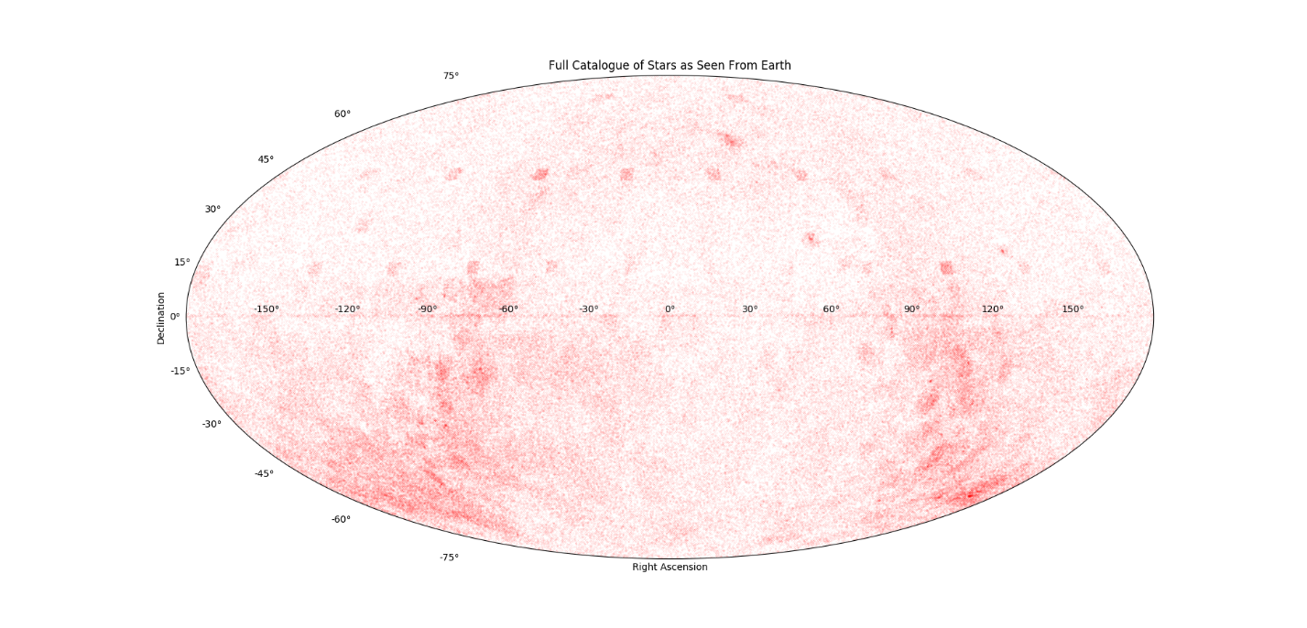Plot right ascension versus declination

The data gives the right ascension in hours, minutes, seconds and the declination in degrees, arcminutes, arcseconds. This needed to be changed to one number that could be plotted. In order to plot this data, we used a Mollweide projection. Python’s Mollweide projects takes latitude and longitude coordinates in radians and plots them on a standard projection. The conversion from hours, minutes, seconds and degrees, arcminutes, arcseconds to radians is straight forward. We multiply each of the hours, minutes, and seconds by 15, 15/60, and 15/3600, respectively, then add them together. This puts the right ascension in degrees. We then multiply by pi/180 to get it to radians. For declination, we multiply degrees, arcminutes, and arcseconds by 1, 1/60, and 1/3600, respectively, and add them together. Then we multiply by pi/180 to get declination in radians. The results are then plotted using matpotlib.

* 1. 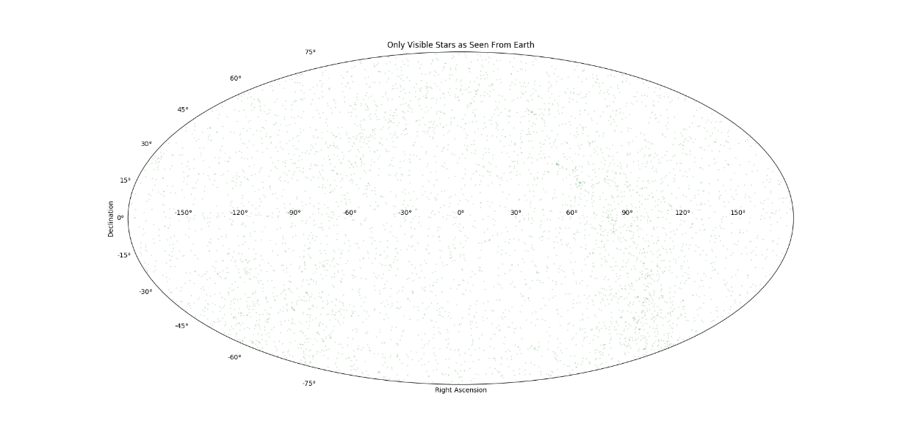Plot all stars visible to the unaided human eye

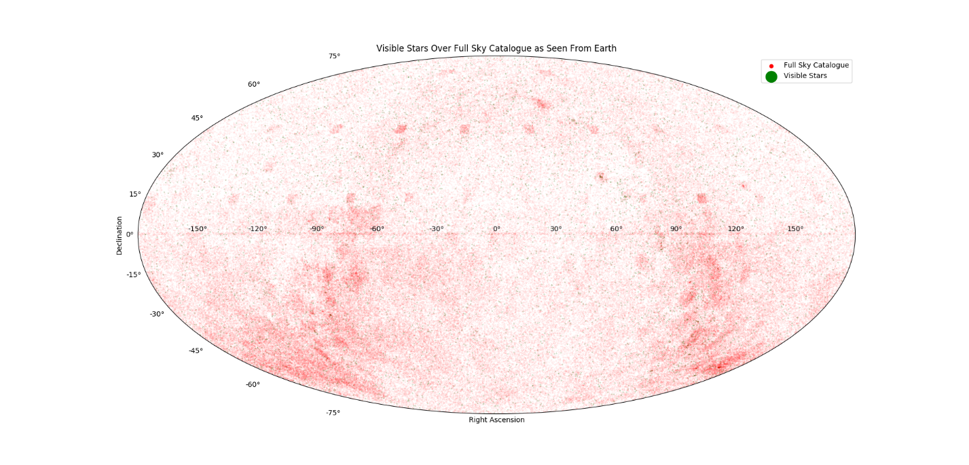The visible stars can be filtered out by looking at the data in the last column. The data shows the apparent magnitude of each star. Since the minimum apparent magnitude of stars visible to the unaided human eye is 6.0, we simply take all stars whose apparent magnitude is less than an apparent magnitude of 6.0. Then we plot using matplotlib. We found that there are 5074 visible stars.

* 1. 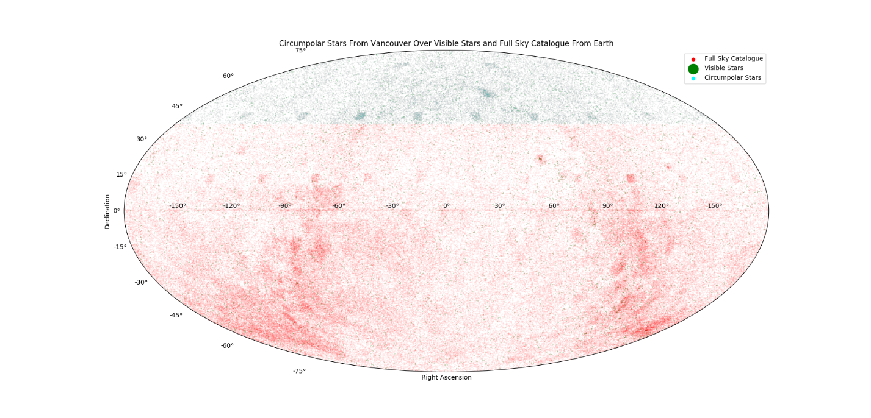Plot all stars that are circumpolar when viewed from Vancouver

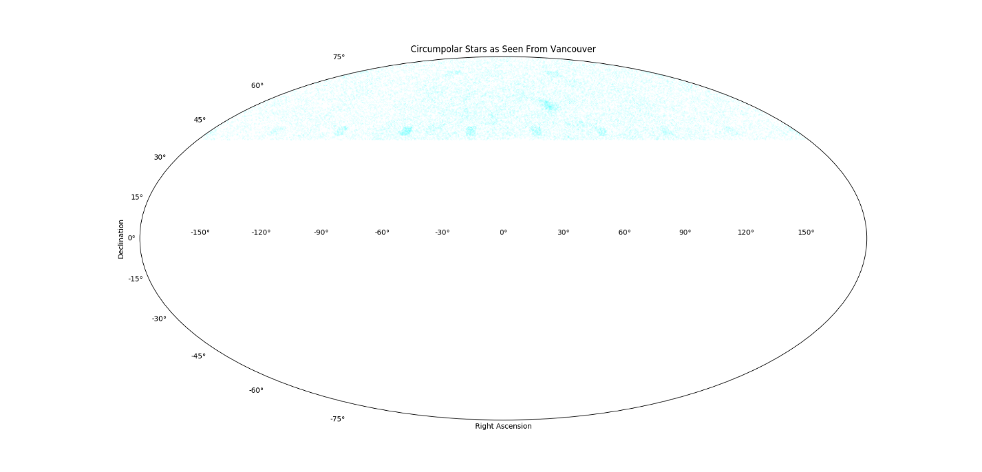The methodology for finding the circumpolar stars is very similar. Circumpolar stars are defined as those who never set. They have a declination of at least 90 degrees minus the latitude of the city. These stars can be taken out and mapped once again using matplotlib. Then by repeating this but taking out from the visible stars, we find that there are 860 circumpolar visible stars when viewed from Vancouver. In total, there are 24964 circumpolar stars at Vancouver’s latitude.

1. 47 Tucanae V-B
   1. 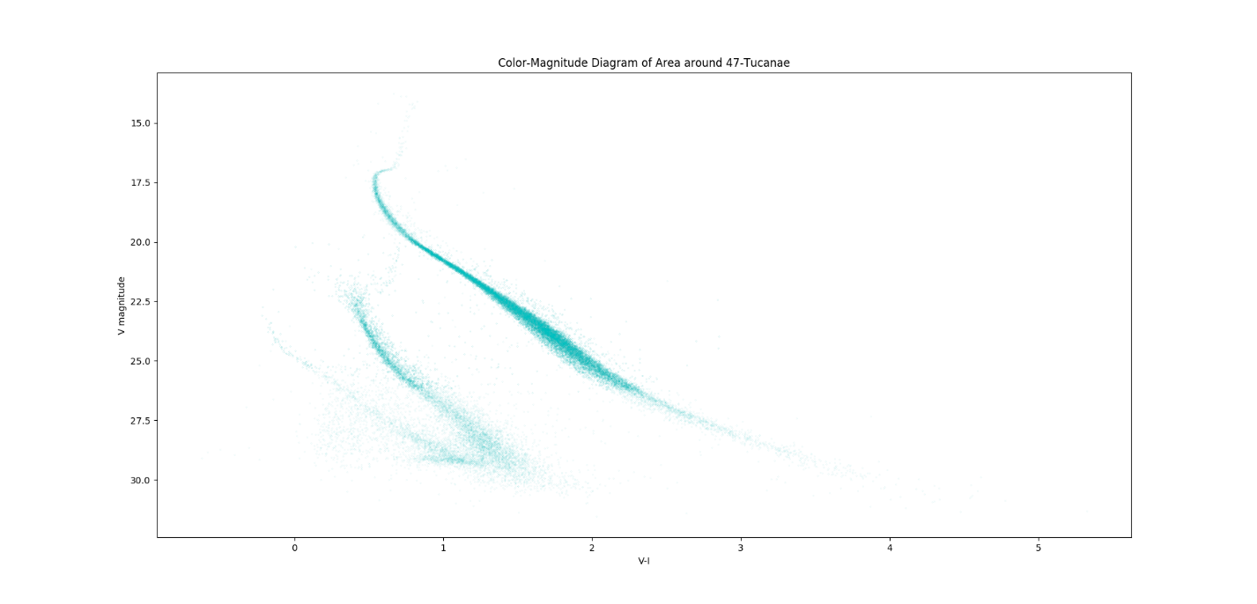Plot the Color-Magnitude Diagram of the data provided

The data provided had four columns, two showing the magnitude of the star in the two different ranges and two showing the proper motion of the star in two directions. The first half of this data was used to create a color-magnitude diagram. From the data, we can calculate V-I and plot it on the x-axis. The data is plotted to form a CMD by putting V inverted on the y-axis and V-I which we calculated on the x-axis.

Most notably on the CMD is two distinct groupings of stars. The first and largest goes down the middle a seems to resemble the main sequence portion of a H-R Diagram. Meanwhile, on the left side. There are two groups. The larger, denser section of stars appears to be a similar section of the main sequence portion of a H-R Diagram. The other section is in the proper position and slope of the white dwarfs on a HRD, when set in conjunction with the first larger portion of main sequence stars.

* 1. Plot the proper motion of the star as proper motion x versus proper motion y

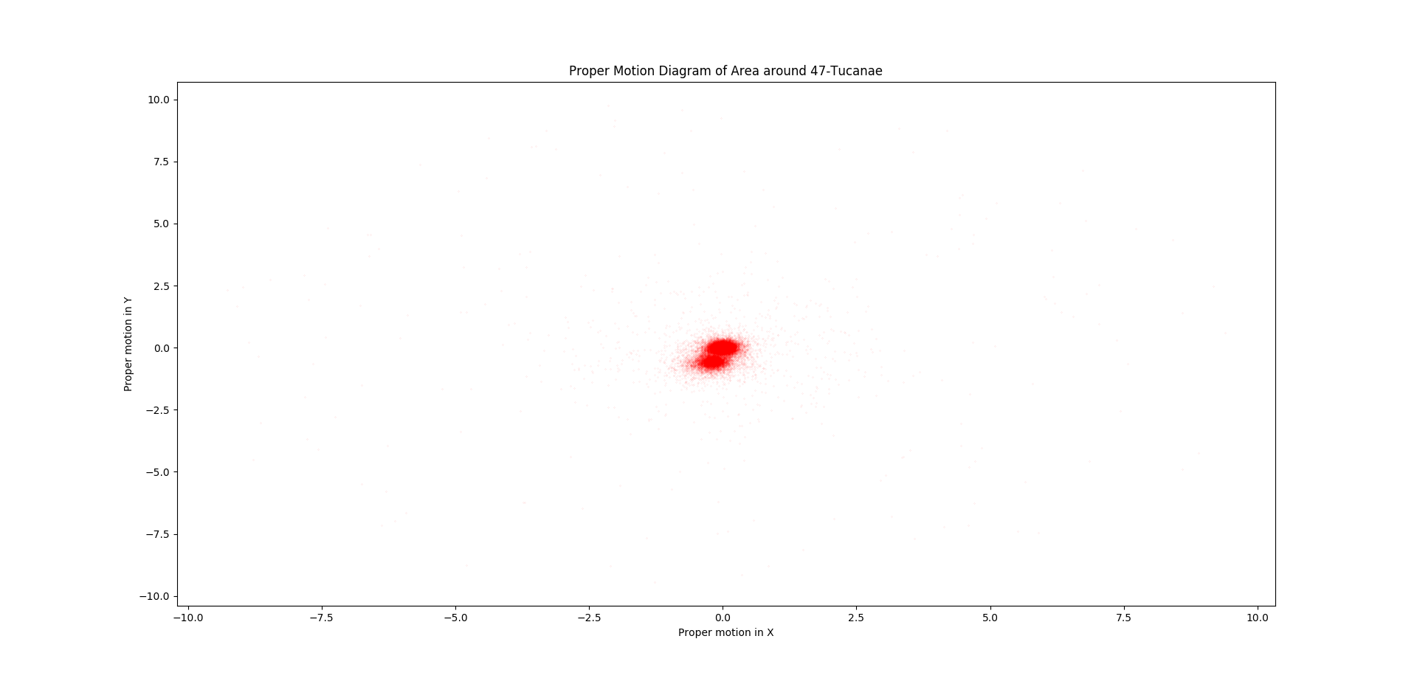The remaining columns are data can be used to plot the proper motion of each star. On the graph, we use matplotlib to plot the Y proper motion on the y-axis and the X proper motion on the x-axis. While not immediately obvious, as we zoom into the graph, we notice two distinct groups of stars. One is centered around the zero point while the second is centered somewhere close to (-0.2, -0.6). Since the Small Magellanic Cloud is behind 47-Tucanae, we can assume that one of these groups belongs to Small Magellanic Cloud and the other belongs to 47-Tucanae. If we suspect that we are aiming for 47-Tucanae, we should expect the 47-Tucanae cluster to have an average proper motion of approximately zero. Thus, we can conclude that the group centered around (0, 0) represents the 47-Tucanae and the group centered around (-0.2, -0.6) represents the Small Magellanic Cloud while any other stars are extraneous data points. We can then isolate the two groups and plot just the stars on the CMD that are contained within the 47-Tucanae group (a circle centered at (0,0) with radius of approximately 0.3).

* 1. Plot the Color-Magnitude Diagram of only the 47 Tucanae stars

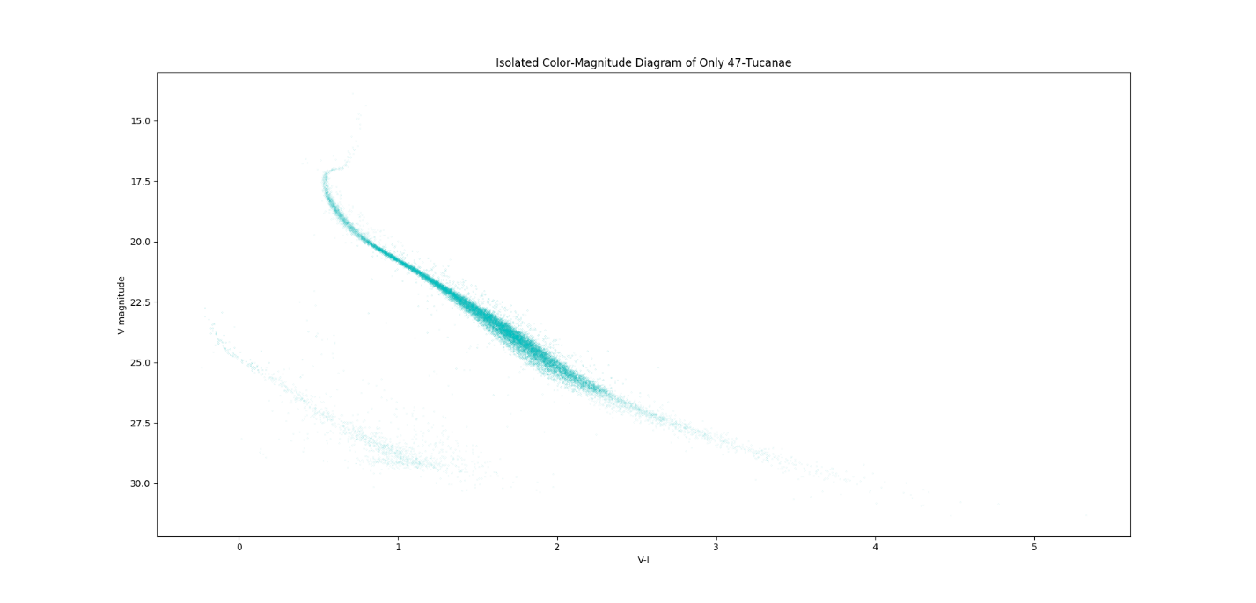We can do this using the same data selection method that we used in the first section of this homework. We can see now with the data of the CMD of only 47-Tucanae that this method was very effective. We have recreated a standard CMD with a large main sequence and a turn-off point for the red giants. In the bottom left we can still make out the few white dwarfs that are in the cluster. There doesn’t seem to be any extraneous data in the way.

* 1. Calculate the distance between Earth and the Small Magellanic Cloud

In order to calculate the distance to the Small Magellanic Cloud, we first must find a common point between the CMD for 47-Tucanae and the Small Magellanic Cloud. We can tell from the graphs that both data sets have a common main sequence segment that we can draw from.

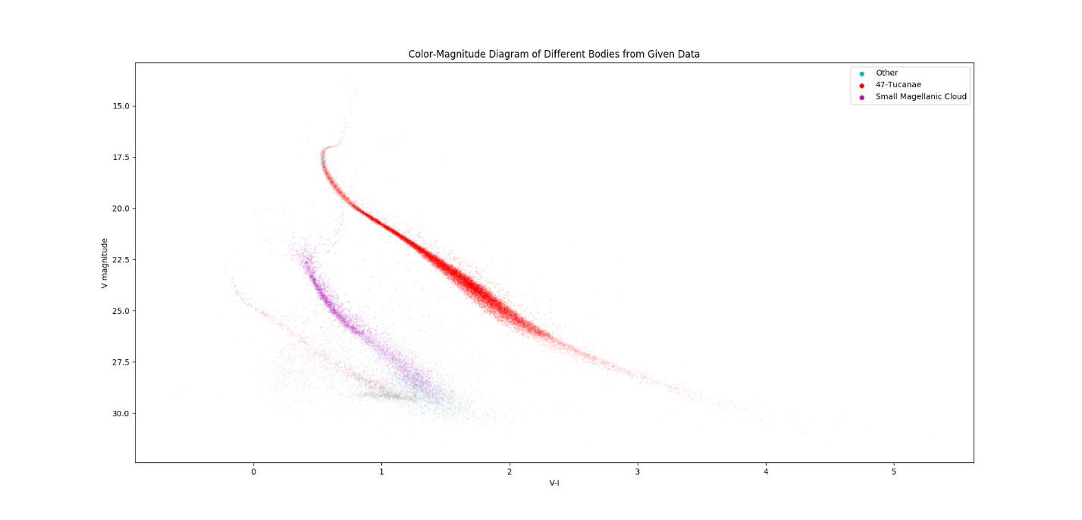

From this, since all main sequence stars have a very specific absolute luminosity, especially red giants as they move off the main sequence, we can find an equation that derives the distance between two objects as a function of the difference in the apparent magnitudes:

Then we find that the ratio in distances is equal to ten to the power of one fifth the difference in apparent magnitudes. We can attempt to move the data over each other to see if we can calculate an approximate difference in apparent magnitudes. Through some trial and error we end up shifting the Small Magellanic Cloud Data about 5.9 magnitudes towards the 47-Tucanae data, meaning that our difference in apparent magnitudes is approximately 5.9.

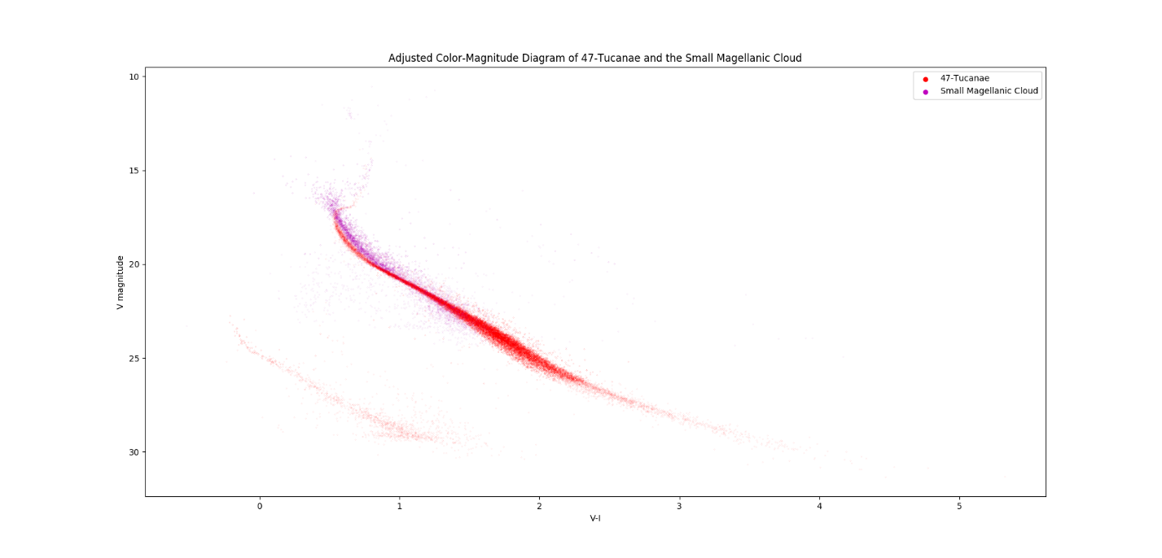 Finally, we can calculate the distance to the Small Magellanic Cloud:

And we find the distance to the Small Magellanic Cloud to be about 60.5 kiloparsecs away.

Question 1 Code:

**import numpy as np**

**import matplotlib.pyplot as plt**

**def giveRA(data):**

**RA = np.zeros(len(data[:, 0]))**

**for index in range(len(data[:, 0])):**

**RA[index] = 15*data[index, 0]+15/60*data[index, 1]**

**RA[index] += 15/3600*data[index, 2]**

**return RA*np.pi/180**

**def giveDec(data):**

**Dec = np.zeros(len(data[:, 3]))**

**for index in range(len(data[:, 3])):**

**Dec[index] = data[index, 3]+1/60*data[index, 4]+1/3600*data[index, 5]**

**return Dec*np.pi/180**

**filename = "C:/Users/ryank/Desktop/Work/Classes/Python/ASTR205/Data/"**

**filename += "FullSkyCatalogue.txt"**

**Data = np.loadtxt(filename)**

**combinedData = np.zeros((len(Data[:, 0]), 3))**

**combinedData[:, 0] = giveRA(Data)**

**combinedData[:, 1] = giveDec(Data)**

**combinedData[:, 2] = Data[:, 6]**

**combinedData[(np.where(combinedData[:, 0]>np.pi)), 0] -= 2*np.pi**

**visibleData = combinedData[(np.where(combinedData[:, 2]<=6)), :][0]**

**circumpolarData = combinedData[np.where(combinedData[:, 1]>=(90-49)*np.pi/180),**

**:][0]**

**circumpolarVisibleData = visibleData[np.where(visibleData[:, 1]>=(90-49)*np.pi/180)]**

**print(len(combinedData))**

**print(len(visibleData))**

**print(len(circumpolarData))**

**print(len(circumpolarVisibleData))**

**fig = plt.figure(num = 1, figsize=(10,5))**

**ax = fig.add_subplot(111, projection='mollweide')**

**ax.scatter(combinedData[:, 0], combinedData[:, 1], s=0.01, marker='.',**

**color='red')**

**plt.title('Full Catalogue of Stars as Seen From Earth')**

**plt.xlabel('Right Ascension')**

**plt.ylabel('Declination')**

**plt.show()**

**fig = plt.figure(num = 1, figsize=(10,5))**

**ax = fig.add_subplot(111, projection='mollweide')**

**ax.scatter(visibleData[:, 0], visibleData[:, 1], s=0.1, marker='.',**

**color='green')**

**plt.title('Only Visible Stars as Seen From Earth')**

**plt.xlabel('Right Ascension')**

**plt.ylabel('Declination')**

**plt.show()**

**fig = plt.figure(num = 1, figsize=(10,5))**

**ax = fig.add_subplot(111, projection='mollweide')**

**ax.scatter(combinedData[:, 0], combinedData[:, 1], s=0.01, marker='.',**

**color='red', label='Full Sky Catalogue')**

**ax.scatter(visibleData[:, 0], visibleData[:, 1], s=0.1, marker='.',**

**color='green', label='Visible Stars')**

**plt.title('Visible Stars Over Full Sky Catalogue as Seen From Earth')**

**plt.xlabel('Right Ascension')**

**plt.ylabel('Declination')**

**plt.legend(loc='best', markerscale=100)**

**plt.show()**

**fig = plt.figure(num = 1, figsize=(10,5))**

**ax = fig.add_subplot(111, projection='mollweide')**

**ax.scatter(circumpolarData[:, 0], circumpolarData[:, 1], s=0.01, marker='.',**

**color='cyan')**

**plt.title('Circumpolar Stars as Seen From Vancouver')**

**plt.xlabel('Right Ascension')**

**plt.ylabel('Declination')**

**plt.show()**

**fig = plt.figure(num = 1, figsize=(10,5))**

**ax = fig.add_subplot(111, projection='mollweide')**

**ax.scatter(combinedData[:, 0], combinedData[:, 1], s=0.01, marker='.',**

**color='red', label='Full Sky Catalogue')**

**ax.scatter(visibleData[:, 0], visibleData[:, 1], s=0.1, marker='.',**

**color='green', label='Visible Stars')**

**ax.scatter(circumpolarData[:, 0], circumpolarData[:, 1], s=0.01, marker='.',**

**color='cyan', label='Circumpolar Stars')**

**plt.title('Circumpolar Stars From Vancouver Over Visible Stars and Full Sky Catalogue From Earth')**

**plt.xlabel('Right Ascension')**

**plt.ylabel('Declination')**

**plt.legend(loc='best', markerscale=100)**

**plt.show()**

Question 2 Code:

**import numpy as np**

**import matplotlib.pyplot as plt**

**filename = "C:/Users/ryank/Desktop/Work/Classes/Python/ASTR205/Data/"**

**filename += "HST47TucPhotometrics.txt"**

**Data = np.loadtxt(filename)**

**V_BData = np.empty((len(Data[:, 0]), 2))**

**V_BData[:, 0] = Data[:, 0]**

**V_BData[:, 1] = Data[:, 0] - Data[:, 1]**

**plt.gca().invert_yaxis()**

**plt.title('Color-Magnitude Diagram of Area around 47-Tucanae')**

**plt.xlabel('V-I')**

**plt.ylabel('V magnitude')**

**plt.scatter(V_BData[:, 1], V_BData[:, 0], s=0.01, marker='.', color='c')**

**plt.show()**

**plt.title('Proper Motion Diagram of Area around 47-Tucanae')**

**plt.xlabel('Proper motion in X')**

**plt.ylabel('Proper motion in Y')**

**plt.scatter(Data[:, 3], Data[:, 2], s=0.01, marker='.', color='r')**

**plt.show()**

**V_BData47Tuc = V_BData[(np.where(Data[:, 2]**2+Data[:, 3]**2<=0.3**2)), :][0]**

**Tuc47Data = Data[(np.where(Data[:, 2]**2+Data[:, 3]**2<=0.3**2)), :][0]**

**SmallMagellanicData = Data[(np.where((Data[:, 2]+0.6)**2+(Data[:, 3]+0.2)**2<=0.25**2)), :][0]**

**V_BDataSmallMagellanic = V_BData[(np.where((Data[:, 2]+0.6)**2+(Data[:, 3]+0.2)**2<=0.25**2)), :][0]**

**OtherData = Data[np.where(np.logical_not(np.logical_or(((Data[:, 2]+0.6)**2+(Data[:, 3]+0.2)**2<=0.25**2), Data[:, 2]**2+Data[:, 3]**2<=0.1))), :][0]**

**V_BDataOther = V_BData[np.where(np.logical_not(np.logical_or(((Data[:, 2]+0.6)**2+(Data[:, 3]+0.2)**2<=0.25**2), Data[:, 2]**2+Data[:, 3]**2<=0.1))), :][0]**

**plt.gca().invert_yaxis()**

**plt.title('Isolated Color-Magnitude Diagram of Only 47-Tucanae')**

**plt.xlabel('V-I')**

**plt.ylabel('V magnitude')**

**plt.scatter(V_BData47Tuc[:, 1], V_BData47Tuc[:, 0], s=0.01, marker='.',**

**color='c')**

**plt.show()**

**plt.gca().invert_yaxis()**

**plt.title('Color-Magnitude Diagram of Different Bodies from Given Data')**

**plt.xlabel('V-I')**

**plt.ylabel('V magnitude')**

**plt.scatter(V_BDataOther[:, 1], V_BDataOther[:, 0], s=0.01, marker='.',**

**color='c', label='Other')**

**plt.scatter(V_BData47Tuc[:, 1], V_BData47Tuc[:, 0], s=0.01, marker='.',**

**color='r', label='47-Tucanae')**

**plt.scatter(V_BDataSmallMagellanic[:, 1], V_BDataSmallMagellanic[:, 0], s=0.01,**

**marker='.', color='m', label='Small Magellanic Cloud')**

**plt.legend(numpoints=1, markerscale=100, loc='best')**

**plt.show()**

**plt.title('Proper Motion Digram of Different Bodies from Given Data')**

**plt.xlabel('Proper motion in X')**

**plt.ylabel('Proper motion in Y')**

**plt.scatter(OtherData[:, 3], OtherData[:, 2], s=0.01, marker='.', color='c',**

**label='Other')**

**plt.scatter(Tuc47Data[:, 3], Tuc47Data[:, 2], s=0.01, marker='.', color='r',**

**label='47-Tucanae')**

**plt.scatter(SmallMagellanicData[:, 3], SmallMagellanicData[:, 2], s=0.01,**

**marker='.', color='m', label='Small Magellanic Cloud')**

**plt.legend(numpoints=1, markerscale=100, loc='best')**

**plt.show()**

**plt.gca().invert_yaxis()**

**plt.title('Adjusted Color-Magnitude Diagram of 47-Tucanae and the Small Magellanic Cloud')**

**plt.xlabel('V-I')**

**plt.ylabel('V magnitude')**

**plt.scatter(V_BData47Tuc[:, 1], V_BData47Tuc[:, 0], s=0.01, marker='.',**

**color='r', label='47-Tucanae')**

**plt.scatter(V_BDataSmallMagellanic[:, 1]+0.1, V_BDataSmallMagellanic[:, 0]-5.8, s=0.01,**

**marker='.', color='m', label='Small Magellanic Cloud')**

**plt.legend(numpoints=1, markerscale=100, loc='best')**

**plt.show()**