**Assignment 4  
Exploring the Properties of an Open Cluster**

1. 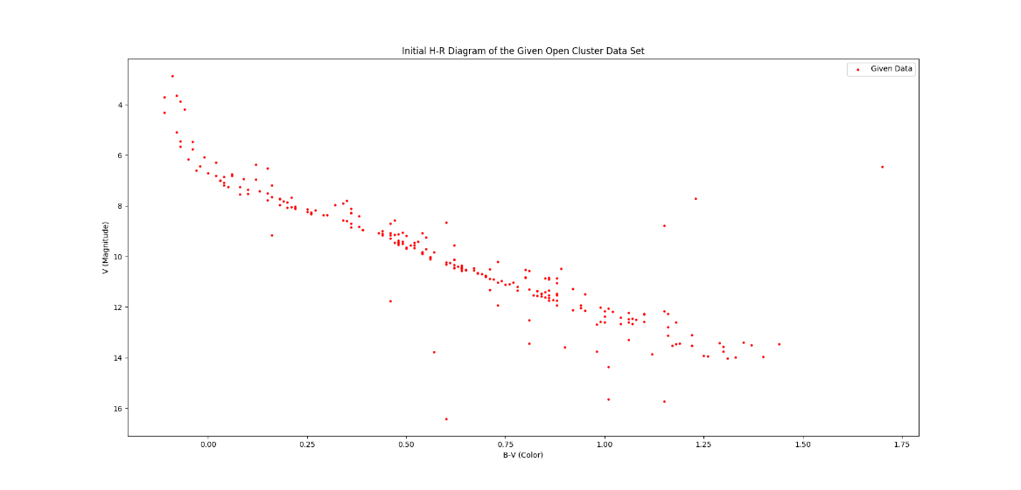We first plotted the given data from the cluster in a color-magnitude diagram. Getting the first look at the data gave us the following:

The data appears normal with a strong main sequence curve, a couple of binaries, and some background or foreground stars. We can count the binaries and compare it to the total number of stars in the linear section to calculate the binary frequency of the cluster. We counted a total of 33 stars that are off the linear parts of the main sequence. We then calculated a total of 105 other stars on the main sequence. Both numbers consider the presence of foreground and background stars. Thus, we calculate the binary frequency of the cluster to be approximately 0.239 or 23.9%.

1. 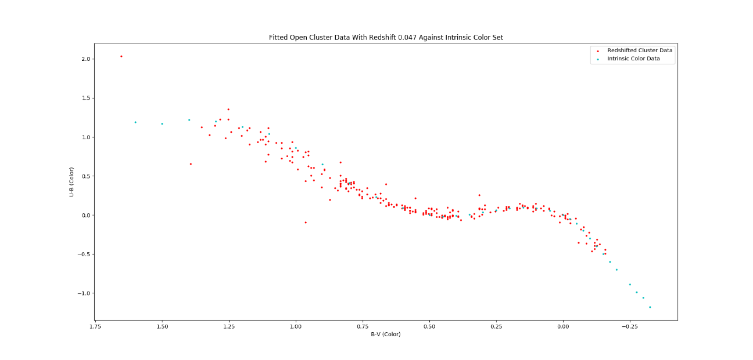After finding the binary frequency of the cluster, we can analyze it for the redshift and extinction of the cluster. We have a data set that describes the intrinsic color of main sequence stars. We can plot this against our given data set in a color-color diagram to find the redshift as the amount needed to shift the diagram to match the intrinsic color data. We get the following plot when we shift the data:

The above plot has a redshift of 0.047. This redshift matches up the intrinsic color data in the cyan with the cluster data in the red along the main sequence and not the binaries. Thus, we suppose the open cluster has a redshift of 0.047. Since extinction is three times the redshift, the cluster also has an extinction of 3*0.047 or 0.141

1. 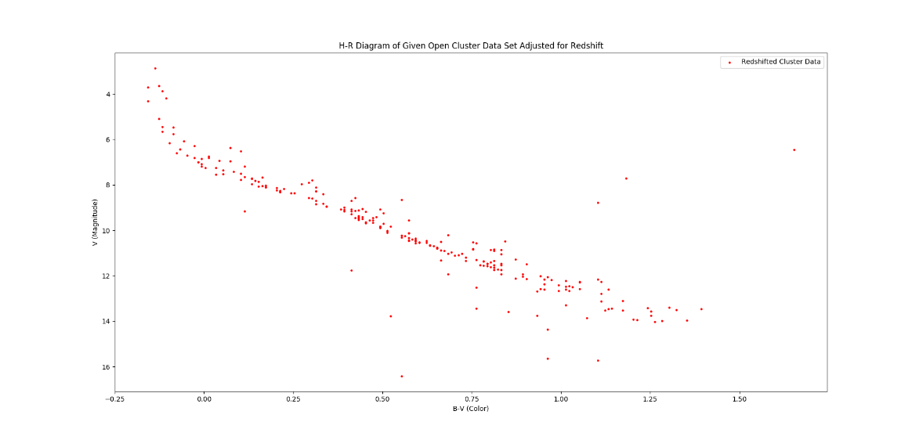The cluster is now replotted with the redshift and extinction correction. It’s H-R diagram now looks as follows.
2. We can calculate distance to the cluster by comparing the data to a data set of absolute magnitude of main sequence songs to our given data set. Repeating a similar process to above, we plot the given cluster data along with a data set of absolute magnitudes of stars at the turn off point. We then shift the absolute magnitude data along only its magnitude until it matches our given cluster data. Then shifted data appears as follows:

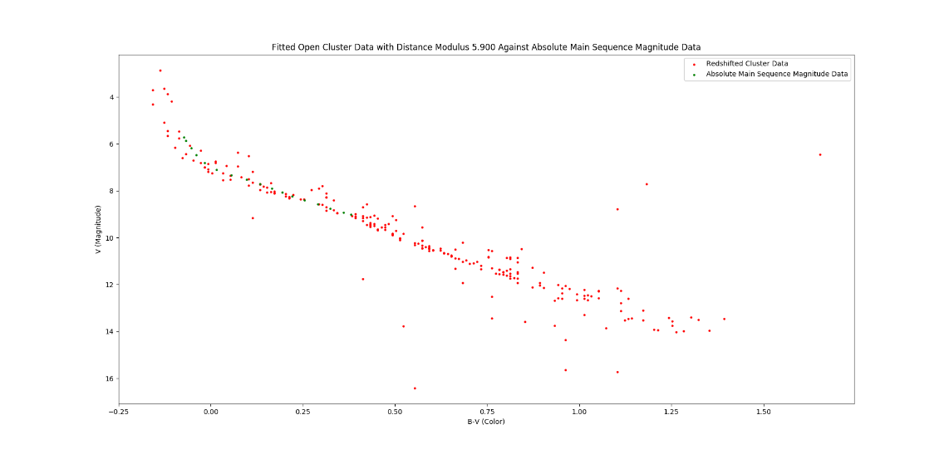

Again, we try to line up the absolute magnitude data with the non-binary data to get the most accurate numbers. We find that we get a distance modulus of 5.9 magnitudes, or rather we shift our data 5.9 magnitudes up. Using this, we can calculate the distance to the open cluster at 141.840 parsecs.

1. Finally, we can look how old the cluster is by comparing it to various isochrones. We are given three isochrone data sets: one at 3.16e7 years, 1.00e8 years, and 3.16e8 years. We can plot the shifted cluster data with the isochrones and calculate the isochrone that is nearest to the data set. This isochrone will tell us the age of the cluster. When plotted, we plot the given open cluster data using the redshift and distance modulus. We get the following:

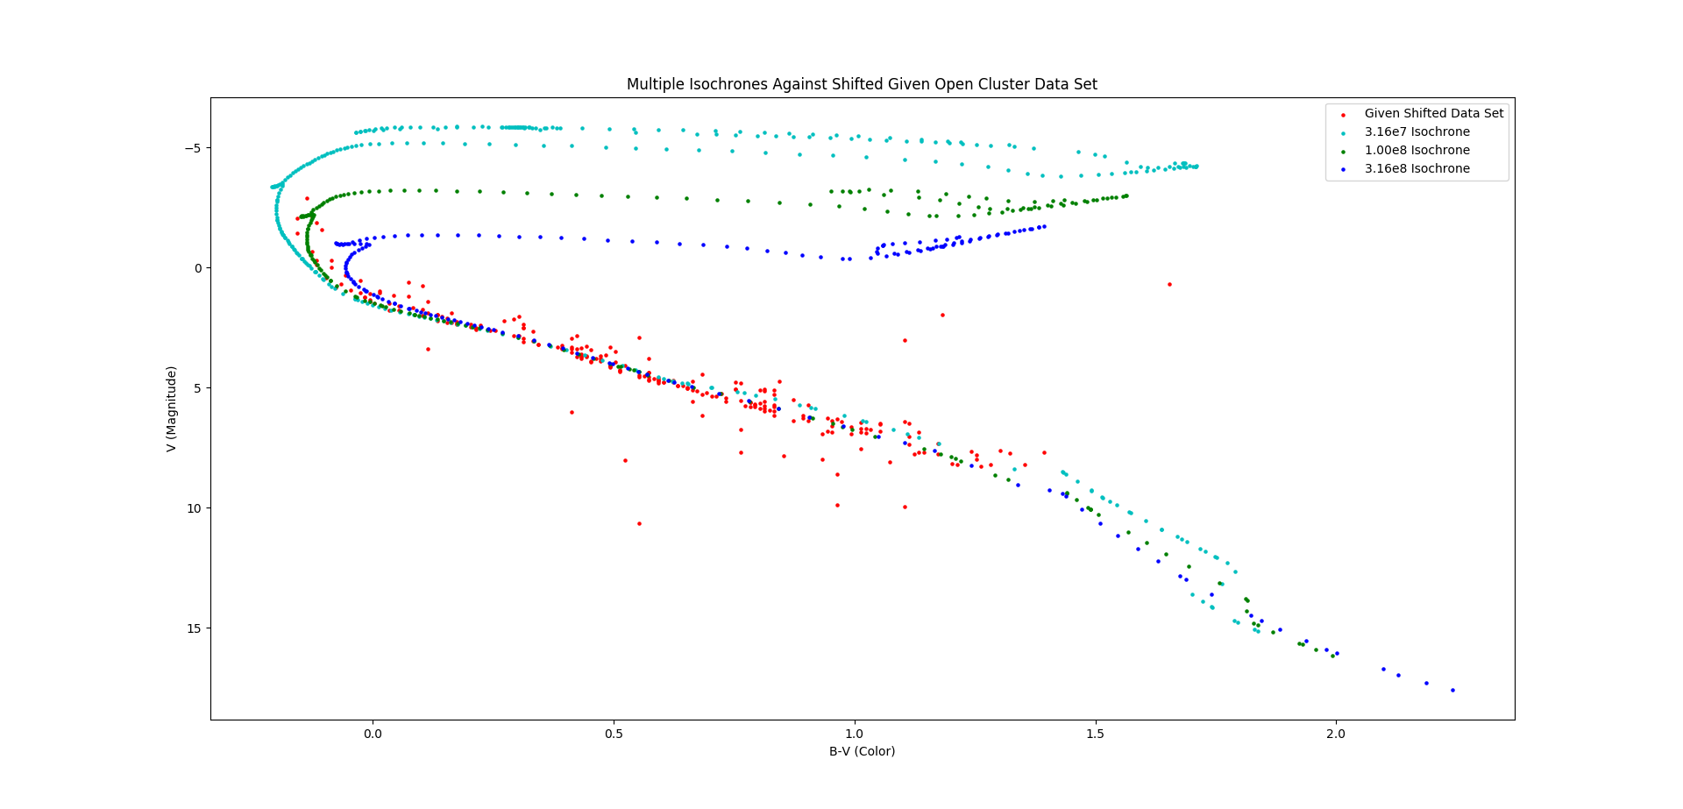The closest isochrone to our data set is the 1.00e8 isochrone in green. Therefore, we conclude that the open cluster is approximately 1.00e8 years old or 100 million years old.

1. The youngest isochrone is a bit higher in the magnitude of low main sequence stars (i.e. low mass stars) than the rest of the older isochrones. This can be explained by the Hayashi track. The Hayashi track is the path that lower mass stars take to become part of the main sequence. Stars of mass less than approximately 3 solar masses. In these models, the lower mass stars take longer to reach the main sequence than higher mass stars. This may be due to the amount of time needed for the star to contract and begin nuclear fusion. For some of the lowest mass stars, it takes approximately 100 million years until the stars can become apart of the main sequence.
2. The age of the stars suggests it formed in the Cretaceous period, or the last dinosaur age. The Cretaceous period began around 145 million years ago and ended around 72 million years ago. This places the open cluster well into halfway through the Cretaceous period. This period was the last of the dinosaur ages, predated by the Jurassic period. Thus, there were dinosaurs before and after the formation of the open cluster.
3. This exhausts all ideas I have for analyzing this open cluster. While I believe that there are more options out there, this is currently all I can think of.

**import numpy as np**

**import matplotlib.pyplot as plt**

**filename = "C:/Users/ryank/Desktop/Work/Classes/Python/ASTR205/Data/"**

**filename += "ClusterUBVData.txt"**

**Data = np.loadtxt(filename)**

**filename = "C:/Users/ryank/Desktop/Work/Classes/Python/ASTR205/Data/"**

**filename += "UB-BVIntrinsicColorBasis.txt"**

**IntrinsicColorData = np.loadtxt(filename)**

**filename = "C:/Users/ryank/Desktop/Work/Classes/Python/ASTR205/Data/"**

**filename += "UBVIntrinsicMS.txt"**

**IntrinsicMSData = np.loadtxt(filename)**

**filename = "C:/Users/ryank/Desktop/Work/Classes/Python/ASTR205/Data/"**

**filename += "IsochroneFor3.16e7Years.txt"**

**Isochrone316e7 = np.loadtxt(filename)**

**filename = "C:/Users/ryank/Desktop/Work/Classes/Python/ASTR205/Data/"**

**filename += "IsochroneFor1.00e8Years.txt"**

**Isochrone1e8 = np.loadtxt(filename)**

**filename = "C:/Users/ryank/Desktop/Work/Classes/Python/ASTR205/Data/"**

**filename += "IsochroneFor3.16e8Years.txt"**

**Isochrone316e8 = np.loadtxt(filename)**

**plt.gca().invert_yaxis()**

**plt.title("Initial H-R Diagram of the Given Open Cluster Data Set")**

**plt.xlabel("B-V (Color)")**

**plt.ylabel("V (Magnitude)")**

**plt.scatter(Data[:, 3], Data[:, 2], s=5, c='r', label='Given Data')**

**plt.legend(loc='best')**

**plt.show()**

**binaryFrequency = (33/(105+33))**

**BFText = "Approximately {:.3f} binary systems in the cluster data set."**

**print(BFText.format(binaryFrequency))**

**redshift=0.047**

**title = "Fitted Open Cluster Data With Redshift {:.3f} Against Intrinsic Color"**

**title += " Set"**

**plt.gca().invert_xaxis()**

**plt.title(title.format(redshift))**

**plt.xlabel("B-V (Color)")**

**plt.ylabel("U-B (Color)")**

**plt.scatter(Data[:, 3]-redshift, Data[:, 4]-0.72*redshift, s=5, c='r',**

**label='Redshifted Cluster Data')**

**plt.scatter(IntrinsicColorData[:, 0], IntrinsicColorData[:, 1], s=5, c='c',**

**label='Intrinsic Color Data')**

**plt.legend(loc='best')**

**plt.show()**

**extinction = 3*redshift**

**print("Extinction is {:.3f}.".format(extinction))**

**plt.gca().invert_yaxis()**

**plt.title("H-R Diagram of Given Open Cluster Data Set Adjusted for Redshift")**

**plt.xlabel("B-V (Color)")**

**plt.ylabel("V (Magnitude)")**

**plt.scatter(Data[:, 3]-redshift, Data[:, 2], s=5, c='r',**

**label='Redshifted Cluster Data')**

**plt.legend(loc='best')**

**plt.show()**

**distanceModulus = 5.9**

**title = "Fitted Open Cluster Data with Distance Modulus {:.3f} Against "**

**title += "Absolute Main Sequence Magnitude Data"**

**plt.gca().invert_yaxis()**

**plt.title(title.format(distanceModulus))**

**plt.xlabel("B-V (Color)")**

**plt.ylabel("V (Magnitude)")**

**plt.scatter(Data[:, 3]-redshift, Data[:, 2], s=5, c='r',**

**label='Redshifted Cluster Data')**

**plt.scatter(IntrinsicMSData[:, 1],**

**IntrinsicMSData[:, 0]+distanceModulus-extinction,**

**s=5, c='g', label='Absolute Main Sequence Magnitude Data')**

**plt.legend(loc='best')**

**plt.show()**

**print("Distance is {:.3f} pc.".format(10*(10**(1/5*(distanceModulus-extinction)))))**

**plt.gca().invert_yaxis()**

**plt.title('Multiple Isochrones Against Shifted Given Open Cluster Data Set')**

**plt.xlabel('B-V (Color)')**

**plt.ylabel('V (Magnitude)')**

**plt.scatter(Data[:, 3]-redshift, Data[:, 2]-distanceModulus+extinction,**

**s=5, c='r', label='Given Shifted Data Set')**

**plt.scatter(Isochrone316e7[:, 0]-Isochrone316e7[:, 1], Isochrone316e7[:, 1],**

**s=5, c='c', label='3.16e7 Isochrone')**

**plt.scatter(Isochrone1e8[:, 0]-Isochrone1e8[:, 1], Isochrone1e8[:, 1],**

**s=5, c='g', label='1.00e8 Isochrone')**

**plt.scatter(Isochrone316e8[:, 0]-Isochrone316e8[:, 1], Isochrone316e8[:, 1],**

**s=5, c='b', label='3.16e8 Isochrone')**

**plt.legend(loc='best')**

**plt.show()**

**print("Isochrone at 1.00e8 years is best fit for the given cluster data.")**

**dinosaurs = "1.00e8 years is definitely within the Cretaceous Period during"**

**dinosaurs += " the lifetime of the dinosaurs."**

**print(dinosaurs)**

**dinosaurs = "Dinosaurs would have lived before the formation of the cluster as"**

**dinosaurs += " well in the Jurassic Period."**

**print(dinosaurs)**