Astronomy 205: Assignment 5

- Assume the density in the Sun varies such that:

- Derive an expression for the mass of the Sun as m(r) in terms of ρ_{C}:

- Substitute R into the equation above to find the total mass in terms of ρ_{C}:

- Apply the expression from (2) into the hydrostatic equilibrium equation and derive an expression for the central pressure:

- Solve for the central density in terms of solar masses and solar radii using expression from (2):

- Apply the expression of central density to the central pressure equation and drive an expression of central pressure in terms of M and R:

- Using the equation for hydrostatic equilibrium and the expression for central pressure, derive an expression for P(r) in terms of M, R, and r:

- Use the ideal gas law to obtain an expression for T(r):

- Calculate the values of ρ_{C}, P_{C}, and T_{C} using the model and compare them with the Standard Solar Model:

When we plot the Standard Solar Model against our above equations for temperature, pressure, and mass, all normalized to either the central value or the total solar mass/radius:
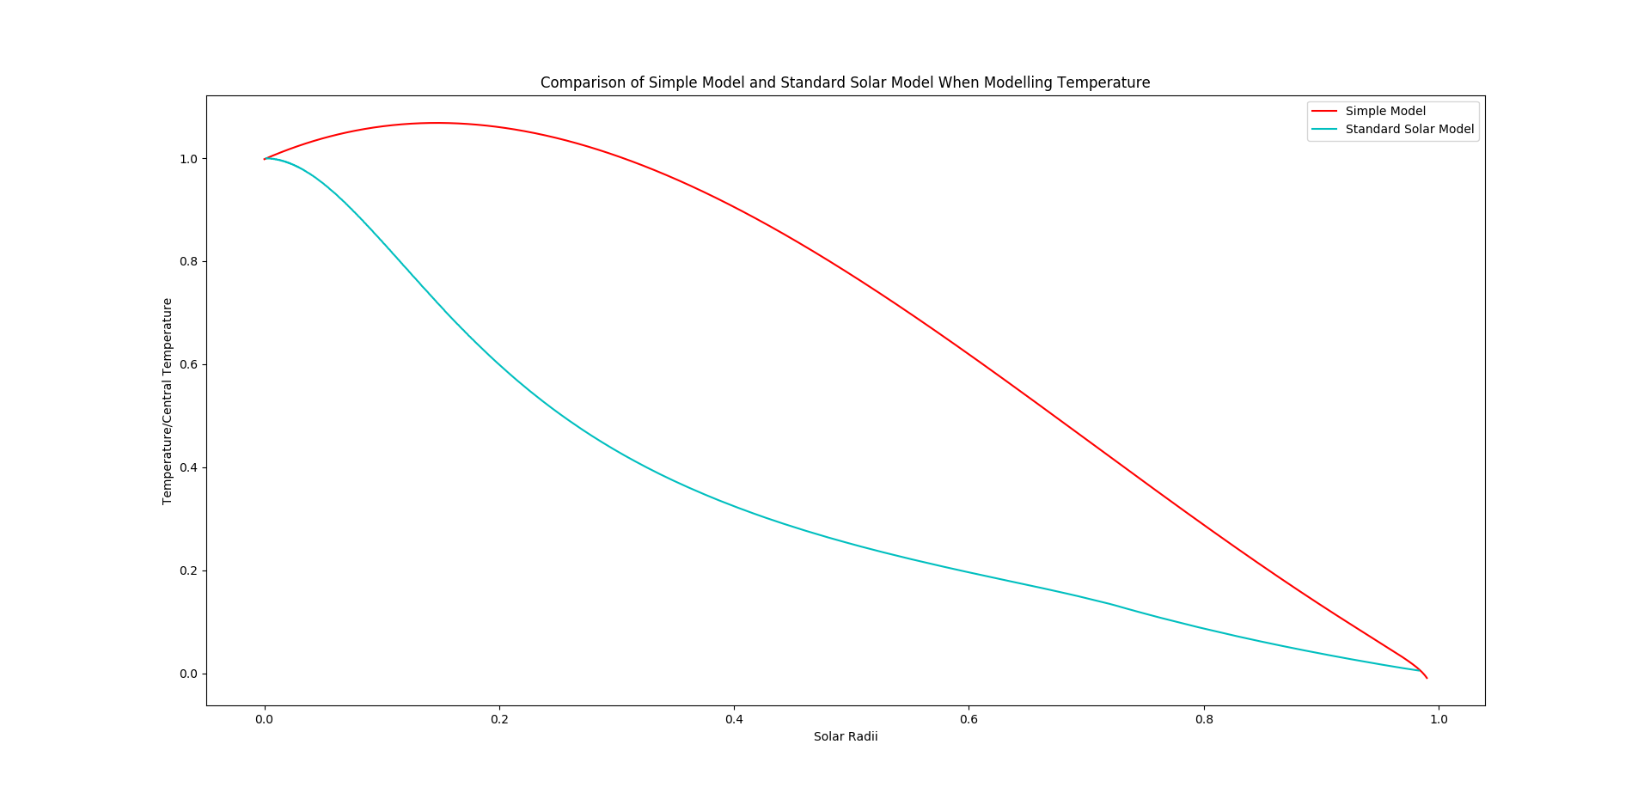
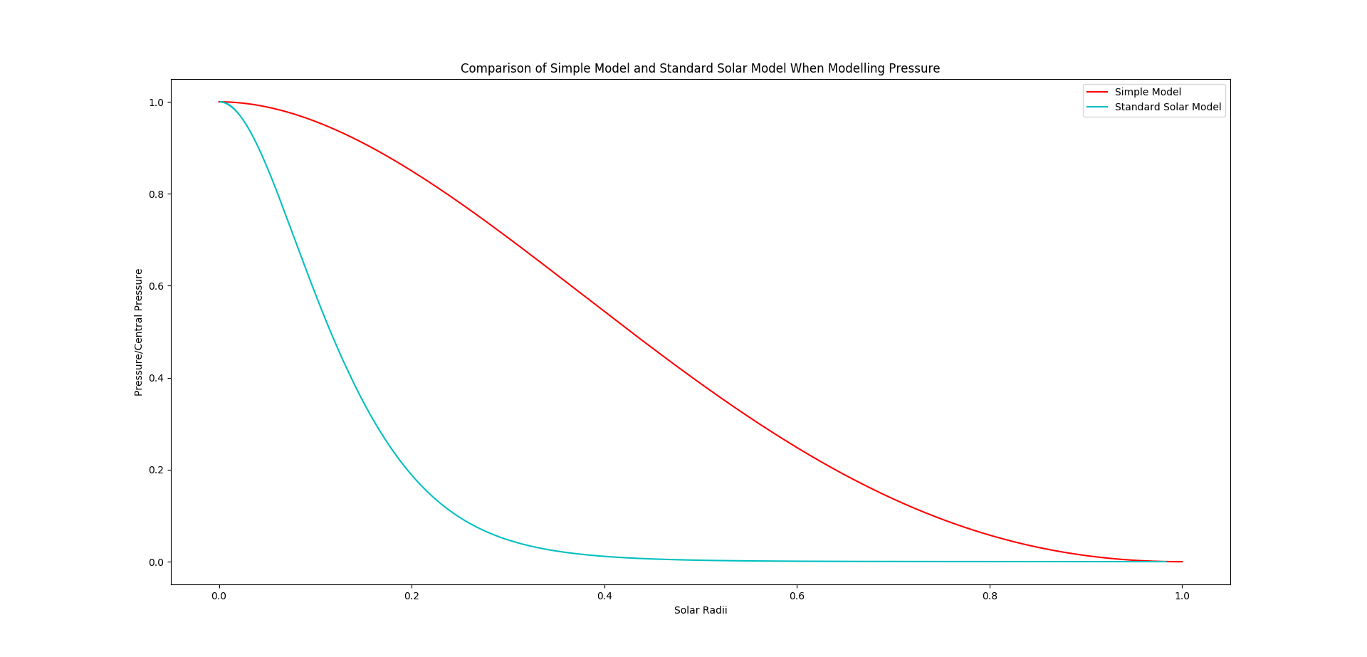
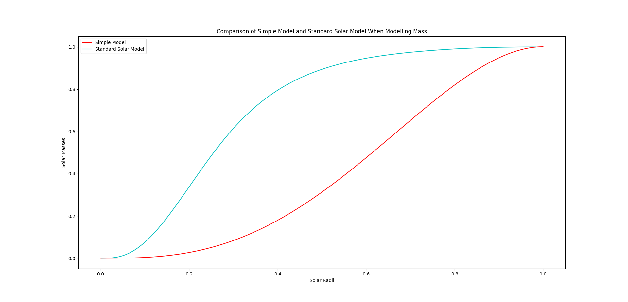
As we can see from the graphs above, the general shape of the graphs is maintained in the mass and pressure equations but not for the temperature equation. Both curves seem to resemble logistic functions moving in different directions (one increasing and the other decreasing). Furthermore, they seem only to differ in the steepness and the midpoint of the logistics curve. The temperature graph is much different. Our model says that the temperature inside of the sun will actually increase above the central temperature. In general the shape of the simple model, it bows out in a slightly parabolic (or possibly hyperbolic) curve rather then bending in like the Standard Solar Model. This gives the impression that this simple model is not the best for modeling temperature although it can do a passable job of modeling pressure and mass.

import numpy as np
import matplotlib.pyplot as plt

def rho(radius):
return rhoC*(1-radius/RS)

def mass(radius):
return 4*np.pi*rhoC*((radius**3)/3-(radius**4)/(4*RS))

def temperature(radius):
return (pressure(radius)*mH*mu)/(k*rho(radius))

def pressure(radius):
P = PC
P -= G*np.pi*(rhoC**2)*(2*(radius**2)/3-7*(radius**3)/(9*RS)+(radius**4)/(4*RS**2))
return P

filename = "C:/Users/ryank/Desktop/Work/Classes/Python/ASTR205/Data/"
filename += "StandardSolarModel.txt"
Data = np.loadtxt(filename)

rhoC = 5639.191
PC = 4.485e14
PCSSM = 2.338e16
TC = 5.772e6
TCSSM = 1.548e7
G = 6.674e-11
k = 1.3807e-23
mu = 1/1.67
mH = 1.67e-27
RS = 6.96e8
MS = 1.989e30

rtest = np.linspace(0, 1, 1000)
mtest = mass(rtest*RS)/MS
ttest = temperature(rtest[:-10]*RS)/TC
ptest = pressure(rtest*RS)/PC

plt.plot(rtest, mtest, c='r', label='Simple Model')
plt.plot(Data[:, 1], Data[:, 0], c='c', label='Standard Solar Model')
plt.legend(loc='best')
plt.title('Comparison of Simple Model and Standard Solar Model When Modelling Mass')
plt.xlabel("Solar Radii")
plt.ylabel("Solar Masses")
plt.show()

plt.plot(rtest[:-10], ttest, c='r', label='Simple Model')
plt.plot(Data[:, 1], Data[:, 2]/TCSSM, c='c', label='Standard Solar Model')
plt.legend(loc='best')
plt.title('Comparison of Simple Model and Standard Solar Model When Modelling Temperature')
plt.xlabel('Solar Radii')
plt.ylabel('Temperature/Central Temperature')
plt.show()

plt.plot(rtest, ptest, c='r', label='Simple Model')
plt.plot(Data[:, 1], (Data[:, 4]*0.1)/PCSSM, c='c', label='Standard Solar Model')
plt.legend(loc='best')
plt.title('Comparison of Simple Model and Standard Solar Model When Modelling Pressure')
plt.xlabel('Solar Radii')
plt.ylabel('Pressure/Central Pressure')
plt.show()

