
SALES PLAYBOOK
Scroll-controlled cinematic property websites
built from the photographs a property already has.
A living sales pitch for visually distinctive hospitality properties
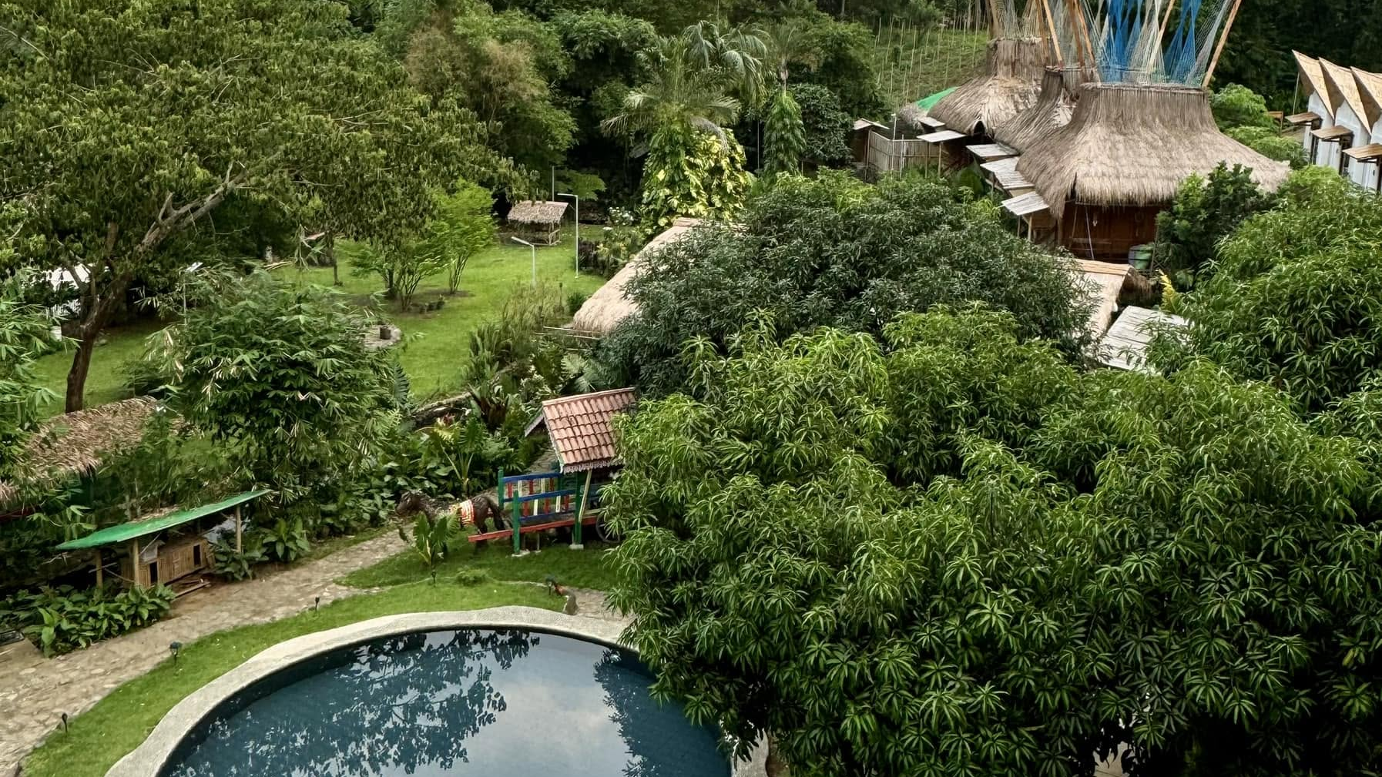
You provide the place. We create the website and the cinematic experience.
Working demonstration: Good Food Farm • Version 1.0 • 28 August 2026

01 THE CORE PITCH

Make the place felt before the guest arrives.
Cinematic Flight is a website design and build service for resorts, retreats, villas, farm stays, hospitality venues, and destination properties whose current website does not communicate the quality of the place.
You provide the place. We create the website and the cinematic experience.
PRIMARY MESSAGE

The 30-second pitch
Most property websites reduce a distinctive place to the same grid of rooms, rates, and thumbnails. Cinematic Flight takes the photographs a property already has and turns them into a responsive, scroll-controlled journey inside a complete property website. Instead of asking a visitor to imagine the place from a gallery, the website lets them move through it—then connects that experience to the property’s enquiry or booking route.

The one-line version
We design property websites you can enter, using real photographs of the real place.

The first next step
Start with a free reading of the property’s existing photographs. We assess whether the material can carry a convincing journey, name any missing views, and explain what the website could become—before anything is designed or agreed.
SALES DISCIPLINE
Do not lead with technology, AI, animation, or production method. Lead with the gap the owner recognises: the place is better than the website. Then let the working Good Food Farm demonstration make the difference visible.

02 THE SALES NARRATIVE

A conversation that moves from recognition to action.
- Name the gap — “Your place is better than your website.” Most property sites present a place like a catalogue. The photographs may be strong; the template flattens them.
- Make the consequence human — A person choosing where to stay is trying to feel the place before committing. A thumbnail gallery asks them to do the emotional work themselves.
- Show the same material two ways — Use the Good Food Farm demonstration: the same verified photographs appear first as a familiar gallery and then as an ordered cinematic journey. Nothing is presented as a fabricated competitor before-and-after.
- Explain the service — We select the real photographs that carry the character and flow of the property, create the cinematic view, and design the complete website around it. The result is responsive on desktop and mobile.
- Remove the first objection — New photography is not automatically required. Existing website, brochure, and archive images are reviewed first. If an essential view is missing, it is named clearly.
- Offer the low-friction next step — Invite the owner to a free reading of the photographs. The aim is not to force a project decision; it is to establish whether the material and property are a strong fit.

Three-part explanation of the offer
- Your property — we identify photographs that establish the place and its flow.
- The cinematic view — we connect those photographs into a guided, scroll-controlled journey.
- The complete website — we design the commercial experience around the journey and connect the enquiry or booking route.
DELIVERY CHOICE
The cinematic view may be added to a suitable current website, or it may become the signature experience inside a complete new property website. State this once, after the three-part explanation.

03 THE DISCOVERY CONVERSATION

Qualify the place before selling the build.

Opening questions
- What do guests understand immediately when they arrive at the property that your current website fails to communicate?
- Which views, spaces, or transitions make people say, “I didn’t realise it was like this”?
- Where do your strongest photographs live today—website, brochure, booking platforms, social media, or an archive?
- What action should a visitor take after they feel the place: enquire, check availability, book, request a package, or contact a host?
- Are you improving the current website or open to a complete rebuild?

Signals of a strong fit
Fit signal | What to listen for
Distinctive physical experience | The place has a strong arrival, landscape, sequence of spaces, or atmosphere that static thumbnails undersell.
Usable real photography | The owner already has several coherent views with enough quality and continuity to assess.
Visible website gap | The current site does not express the quality, character, or flow the owner knows guests experience in person.
Clear visitor action | The journey can lead naturally to an enquiry, booking route, availability check, or another approved conversion path.
Decision-maker access | The conversation includes the owner or stakeholder who can decide on brand, website, and commercial direction.

Suggested 20-minute demo flow
- 3 minutes — Ask what the current website fails to convey.
- 5 minutes — Show the immersive Good Food Farm opening without over-explaining it.
- 4 minutes — Show the same photographs as a gallery and as a flight.
- 4 minutes — Explain property → cinematic view → complete website.
- 4 minutes — Invite the free photographic reading and agree the next exchange.

04 OBJECTIONS AND RESPONSES

Answer plainly. Keep the experience premium and the claims grounded.
Sales moment | Language to use
“Do we need a new photo shoot?” | Not necessarily. We begin with the photographs you already have and assess their suitability before anything is built. If a key view is missing, we name it clearly.
“Is this only an animation?” | No. Cinematic Flight is a website design and build service. The cinematic property view is the signature experience inside the website, supported by the information and action a guest needs.
“Can it work with our current site?” | Possibly. The cinematic view can be considered for a suitable existing website, or it can anchor a complete rebuild. The right route depends on the current site and commercial goal.
“Will it work on phones?” | The working prototype uses separate desktop and phone-weight media and responsive layouts. Production scope still includes real-device verification for the final property experience.
“Will it improve bookings?” | The purpose is to communicate the place more powerfully and connect that experience to the property’s chosen action. We do not promise a booking uplift without measured client results.
“Is this AI-generated imagery?” | The experience is anchored in verified photographs of the real property. The site does not use synthetic imagery to represent the place.
“How much does it cost?” | Pricing is defined after the photographic reading and a clear scope: add to an existing site or build a complete new property website. Do not quote an unapproved range.

PROTOTYPE TRUTH
The Good Food Farm example is a working demonstration. The local enquiry form currently demonstrates validation and success states only; it is not connected to an external endpoint. Do not describe it as a live lead-capture system until that connection is approved and implemented.

05 APPROACHING A LEAD

Start with the place, not the sale.
The strongest opening shows that you noticed something specific about the property. The lead should feel selected because the place has character—not added to a generic web-design list.

The spoken spiel
Hi [NAME]. I came across [PROPERTY], and [SPECIFIC VIEW, ARRIVAL, LANDSCAPE, OR ATMOSPHERE] stood out. The place feels distinctive, but a normal gallery can only show it one frame at a time. I design scroll-controlled cinematic property websites using photographs you already have, so visitors can move through the place before arriving. I’d be happy to give you a free reading of the images already online and show what they might do. Would that be useful?
45-SECOND CONVERSATION OPENER

A simple five-part approach
- Notice — Choose one truthful, property-specific detail from the website or approved public material.
- Recognise — Name what makes the place feel distinctive without criticising the owner or insulting the current site.
- Explain — Say plainly that Cinematic Flight designs and builds property websites with a scroll-controlled cinematic experience made from existing photographs.
- Demonstrate — Offer the Good Food Farm example only after the lead understands the business offer.
- Invite — Ask permission to provide the free photographic reading. Use one small, clear next action.

Tone guardrails
- Personalise the first two sentences; never send an observation you cannot support.
- Say “the website may not communicate the full feeling of the place,” not “your website is bad.”
- Avoid AI, animation, drone, and production jargon in the opening message.
- Do not promise more bookings, a delivery date, or a price before the offer is defined.
- End with one question that is easy to answer.

06 LEAD MESSAGE LIBRARY

Messages you can copy, personalise, and send.
BEFORE SENDING
Replace every bracketed field, keep one specific observation, and choose only one call to action. If the message could be sent unchanged to another property, it is not ready.

Warm contact
Hi [NAME]—I’m building Cinematic Flight, a website design service for distinctive properties. It turns photographs a property already has into a scroll-controlled journey inside the website. I thought of [PROPERTY] because [SPECIFIC REASON]. Would you be open to a quick look at the working example?

Referral introduction
Hi [NAME], [REFERRER] suggested I contact you. I’ve been looking at [PROPERTY], especially [SPECIFIC DETAIL]. I create cinematic property websites from existing photographs, helping the website express more of what the place feels like in person. I can start with a free reading of the photographs already online. Would it be useful if I sent a short example?

Cold email
Subject: An idea for how [PROPERTY] could feel online
Hi [NAME], I came across [PROPERTY] and noticed [SPECIFIC, TRUTHFUL OBSERVATION]. The place appears to have a stronger sense of arrival and atmosphere than a conventional photo gallery can communicate. I design and build scroll-controlled cinematic property websites using photographs the property already has. I’d be happy to give you a free reading of the images already online and tell you whether they could carry this kind of experience. May I send you the working Good Food Farm example?

Instagram or Facebook message
Hi—[SPECIFIC DETAIL] at [PROPERTY] caught my attention. I build cinematic property websites that turn existing photographs into a guided, scroll-controlled journey. I think your material may be a strong fit. Would you like me to send a short working example and a free reading of the photographs already online?

LinkedIn message
Hi [NAME], I’m reaching out because [PROPERTY] has [SPECIFIC QUALITY], and the current online presentation may not communicate the full feeling of the place. Cinematic Flight designs property websites around a scroll-controlled journey made from existing photographs. If useful, I can send a concise example and assess whether the property’s current images could carry it.

06 MESSAGE LIBRARY CONTINUED

Keep the next step small and specific.

When the lead shows interest
Great—thank you. The next step is for me to read [PROPERTY]’s existing photographs, see whether they establish a convincing sequence, and identify any important missing view. Please send the website or approved photo link you would like me to review.

Invitation to a short demo
I can show you the Good Food Farm demonstration in 15–20 minutes: the experience, the same photographs as a gallery, and how the journey connects to a complete website. Would [OPTION A] or [OPTION B] suit you?

First follow-up
Hi [NAME], just bringing this back to the top of your messages. I’m offering a free reading of [PROPERTY]’s existing photographs—whether they could support a cinematic website experience and what may be missing. Would you like me to take a look?

Second follow-up with value
Hi [NAME], one reason [PROPERTY] could suit this approach is [OBSERVATION]. That [VIEW / TRANSITION / ATMOSPHERE] could become part of the website journey instead of remaining one gallery thumbnail. I’m happy to send the working example if useful.

After a demo
Thank you for exploring Cinematic Flight. The useful next step is a short reading of [PROPERTY]’s existing photographs. I’ll assess whether they can form a convincing journey and name any missing views before we discuss scope. There is no commitment attached.

Graceful close-out
Hi [NAME], I’ll close the loop here so I don’t keep filling your inbox. If communicating the feeling of [PROPERTY] becomes a priority later, I’d be glad to provide the photographic reading or working example. Wishing you and the team well.

Useful calls to action
- May I send the working example?
- Would you like a free reading of the photographs already online?
- Would a 15–20 minute walkthrough be useful?
- Which website or approved photo folder should I review?

07 LIVING OFFER WORKSHEET

Update these fields as the commercial offer becomes real.
The brass fields are intentionally editable. Keep the core positioning stable; update only when there is approved evidence, a defined delivery process, or a deliberate commercial decision.

Current offer
Primary market: [Define the first geographic or hospitality niche]
Named service: [Confirm Cinematic Property Website, Cinematic Flight, or package name]
Delivery options: [Define add-on criteria and complete-rebuild scope]
Pricing: [Add only after scope and commercial approval]
Lead time: [Add only after production capacity is validated]
Enquiry route: [Insert approved email, form endpoint, or booking link]

Proof ledger
Working demonstrations: [Good Food Farm; add only verified work]
Client outcomes: [Insert measured results with source and date]
Testimonials: [Insert approved quotation and permission status]
Device verification: [Record production browser and real-device checks]

Never drift from these truths
- Describe Cinematic Flight first as a website design and build service.
- Use real property photographs as the visible proof; do not introduce synthetic property imagery.
- Do not invent performance results, testimonials, client outcomes, pricing, availability, or production promises.
- Keep the free photographic reading as the low-friction first step until the offer changes deliberately.
- Mark prototype features as prototypes until the live service is implemented and verified.
REVISION RULE
When a claim changes, record the evidence, source, owner, and approval date beside it before using the claim in sales material.

