

**Semantic Web Project**

**Public Bicycle Sharing Stations Query System**

**-  
Reinforced by Semantic Web Technology**

**2019 - 2020**

**Team members: Supervisor:**

Jiawei XU Antoine ZIMMERMANN

Malshani RANCHA GODAGE

# **1 Introduction**

Semantic web technologies are becoming more famous and popular in the field of web development and IoT fields which provide concise solutions for existing problems of the internet and communication world. It enables computers and people to store and access the meaning full information linked together consortiums of standard organizations.

This report explains how we utilize semantic web technologies to solve a problem which copes with day to day lives of current society. This project is discussing transport domain which talks about bicycle sharing stations, some other public and private transport methods, tourism, prices of transport, weather and etc. In the beginning, we talk about bicycle sharing systems and furthermore other mentioned problems.

Bicycle sharing stations provide service to people who want to use bicycles and travel for a while and drop it in any station, but not to keep them. The system is fully automated and data is updated over the network, but there is no one portal to access all data and join this data with different data such as,

* Other transport data (trains, trams, buses and cars)
* Prices of transportation
* Weather condition

Open data of different scenarios are published in various public and private websites separately. They are not linked together. They may be linked as documents, but not as entities. Data on each website follow their own standards, own format and own vocabularies. To reduce the mentioned issue, in this project we are given a system to design and implement using semantic web technologies.

# **2 Technologies**

Basically this application uses Semantic Web technologies starting from extracting open data to displaying them on the website. We use Protege to build our OWL ontology for the domain of bicycle sharing system. Apache Jena is using to create and access RDF triples and RDF graphs.

Apache Jena Fueski is a server which uses SPARQL. We use Fueski server to persist the data set and SPARQL to query it. We use RDFa when preresenting data on the website. Since the system is web based we are using web development frameworks and technologies such as SpringBoot, HTML, Maven, AJAX, jQuery and BootStrap.

**3 Design**

Following figure illustrates the basic architecture of the project. Flow is depicted in arrows.

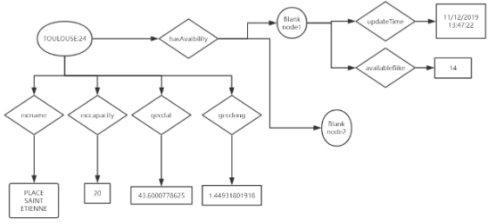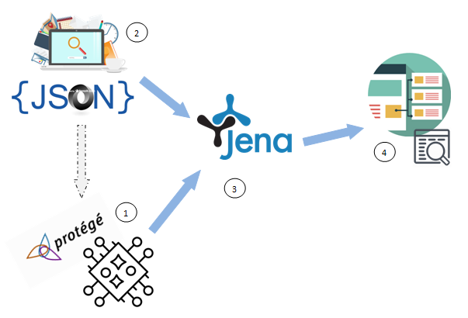

(1) represents-> existing ontologies and ontology we created in Protege by analyzing JSON data of website

(2) represents-> the JSON data of static and dynamic web pages

(3) represents-> the RDF model is saving in Fueski server which is generated using (1), (2) numbers

(4) represents-> the website visualizing the data from Fueski server

When we design the whole project, it consists of three major parts, which will be described in this section.

1. Design the Model Structure: One of the most important parts of this project is to model the scenario. We checked the format and content of data we are going to use such as real time and static data of bicycle sharing stations. We applied knowle
2. Extract data and generate the model: Then we decided how to extract static and dynamic data. After extracting static data, RDF triplets are generated according to model we designed.
3. Visualizing the data: We design this as Website and REST API by providing search options over the data set.

.

**4 Implementation**

Two java projects are developed as extractData and bicycleSharingStations (website)

## **4-1 Design the model structure**

After analyzing the data, we model our scenario. We identified what are the entities and properties of this specific domain. Since, we could not find a suitable domain ontology for the bicycle sharing stations, we proposed and developed and OWL ontology in Protege. Following figure depicts the ontology we created.

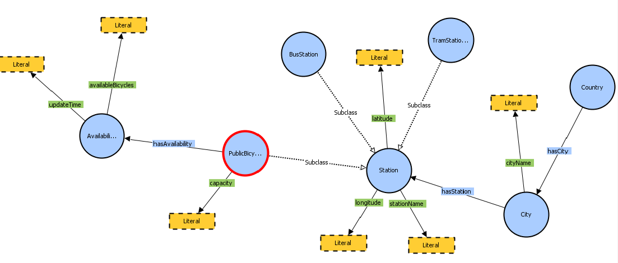

**4-2 Create the model**

We extracted open data published in websites given by service providers. All of them (for now three cities) are written in JSON. We developed a program to extract all the static data of selected cities, then create RDF triplets. All the triplets are linked to generate the RDF model according to the Ontology we created. Then save this model in Fueski server. Now we can add dynamic data of stations only running the according program specific to the city. Each time you run the program for a city, these dynamic data will be added to the model. Model has been expanded.

**3-2-1 Display on a web site**

To display the data on the web site, we created SpringBoot web application. it has a dropdown to select a city, then user press the search button, AJAX request is sent REST API, there we have a service when the city is given, choose the relevant information such as stationName, latitude, longitude, capacityOfBicycles, availableBicycles.

### 

**4 Planning of realization**

We have two iterations. By the first iteration we have extracted bicycle sharing stations data to generate the RDF triples. We have created the model and save in as a data set in the fueski server.

By the final submission, we are going to update the ontology. Because the ontology we created is basic. Even though the ontology is not validated by domain experts, we are going to use and develop the ontology for the better use of RDF graph we generated.

# **4 How to run the project**

Two projects have to compile and run. One project is to create a triple store and second one is for display the data. To create the Data store,

1. Run Fueski server
2. Add new data store, name: bicycle_stations
3. Open the project extractData and open the package complete(extractdata\src\main\java\complete)
4. Run ‘CreateModel.java’ program to extract static data of SAINT-ETIENNE, LYON and TOULOUSE cities, Wait until the process completes, it gives a messages.
5. Run DynamicSaintEtienne.java, DynamicLyon.java, DynamicToulouse.java programs to extract dynamic data. Wait until the process completes.

Now you have extracted necessary data and saved RDF triplet and Fueski triple store. If you see the <http://localhost:3030/bicycle_stations>, you can see the data. Web project should be working properly now. Web project is developed using Spring boot and maven. First enter command mvn clean install, then run the project with mvn spring-boot:run command. Now browse the <http://localhost:8080> to see the web site. Select a city in dropdown list, you can see the data.

# **Discussion**

When we add the language tag for literal, it gives us issues when querying the result, due to the limited time, we are not going to fix this issue. We use literals without language tag. We hope to fix this before final submission

In the Flueski data set, we have saved the availability history of stations.

Following table depicts how we divided the workload. We design the project as the agreement of both team members. We did pair programming but one of us is responsible for each task.

|  |  |
| --- | --- |
| Task | Responsible member |
| Design the model | Jiawei XU, Malshani R.G |
| Generate OWL ontology in Protege | Jiawei XU |
| Extract Static data, create the model and save it in the server | Jiawei XU |
| Extract Dynamic data, create statement and save it in the server as update the model | Malshani R. G |
| Setup website and REST API | Malshani R. G |
| Add RDFa in HTML | Malshani R. G |
| Testing | Jiawei XU, Malshani R.G |

# **6 References**

[1] <https://www.w3.org/TR/rdf-sparql-query/>

[2] <https://spring.io/guides/gs/spring-boot/>

[3] <https://jena.apache.org/tutorials/rdf_api.html>