Exploratory Data Analysis (EDA) Report
Since this is a Reinforcement Learning networking project, standard static datasets (like Kaggle CSVs) are not applicable. Instead, the 'Dataset' represents the massive state-space telemetry logs generated dynamically by our Gym environment.
We simulated 2000 timesteps of random exploration to capture network dynamics. Total recorded samples: 12000.

1. Channel Fading Characteristics
The channel gains update via a Gauss-Markov fading model, ensuring dynamic state changes.
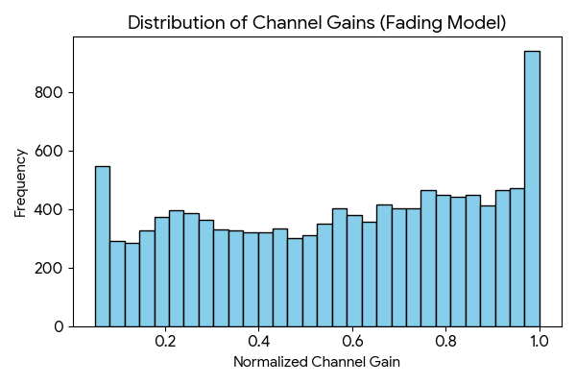

2. Battery Depletion Dynamics
The battery level distribution shows heavy depletion tails caused by users being forced into high-SIC clusters by blind schedulers.
