Ryan Goding

8/11/2020

IT FDN 110: Introduction to Programming (Python)

Assignment 05

# Introduction

Assignment 05 asks us to modify a provided script of CDInventory.py. The modifications include replacing the inner data structure by dictionaries, adding the functionality to load existing data from CDInventory.txt file and the functionality to delete an entry of the users choosing.

# Body

This assignment introduced me to dictionary objects and how to work with existing code written by someone other than yourself. Working with someone else’s code is almost harder than working from your own, as you don’t know any of the history or logic in some of the choices that were made. It required me to relearn the entire code and was surprising to me that it didn’t save too much time. Figure 1 shows the modified CDInventory_Starter code being worked in Spyder.

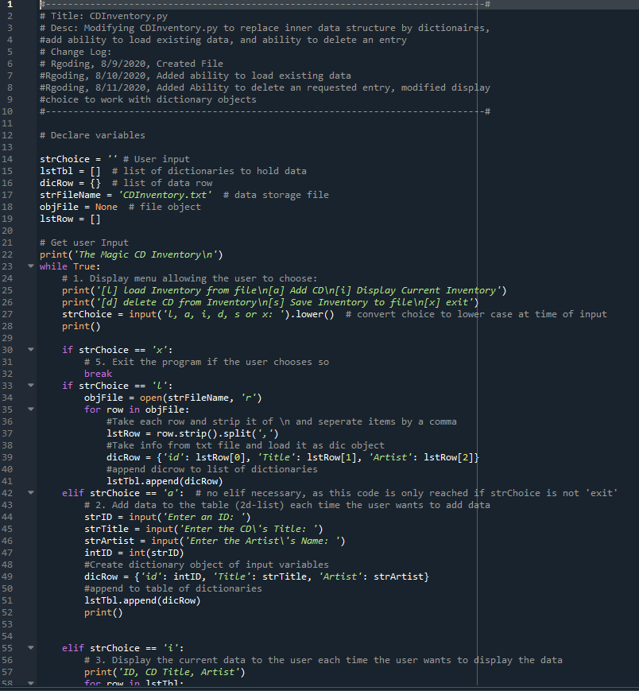

Figure 1: Developing CDInventory.py in Spyder IDE

I first started the assignment by creating the load function. This seemed the most straight forward, I created a for loop to look at the text file, strip and separate with a comma enter the values into a dictionary object, and then append that row to the list of dictionary objects (1). This process repeats for each row in the text file. To test this functionality three CD entries were created and then saved as shown in Figure 2 and Figure 3. Figure 4 then shows CDInventory.py loading CD entries that were previously saved to CDInventory.txt.

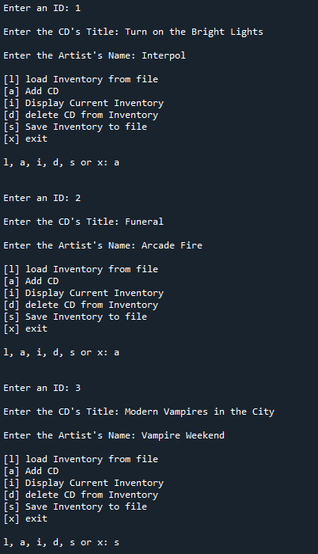

Figure 2: CDInventory.py Script Run in Spyder, Saving Three CDs

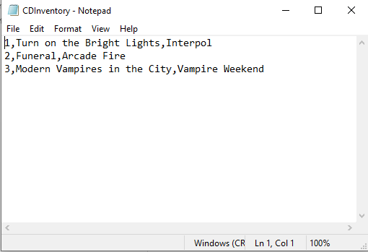

Figure 3: Three CDs Written to CDInvetory.txt

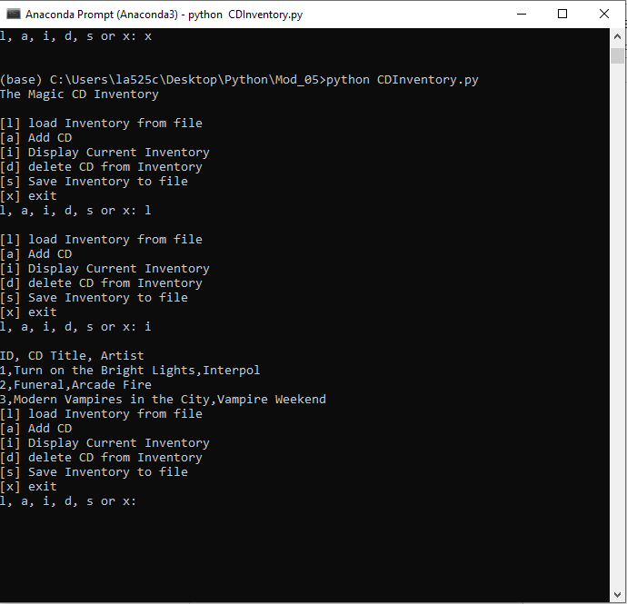

Figure 4: Running CDInventory.py on terminal, loading data from txt file, and displaying Inventory

The next functionality I worked was the option for the user to delete an entry that was added through CDInventory.py. I first asked the user for an input of the entry number to delete. This at first gave me problems because I did not convert that input to an int value. I then created a for loop to search through the list of dictionaries for that ID value, and then remove that row if found (2). Figure 5 shows the user deleting CD id 2 after it has been entered, and Figure 6 shows the txt file after it was been saved through CDInventory.py

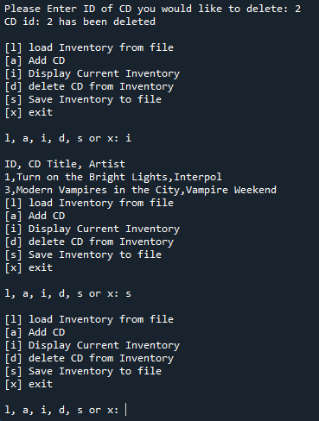

Figure : Deleting an Entry, and then Saving to txt file

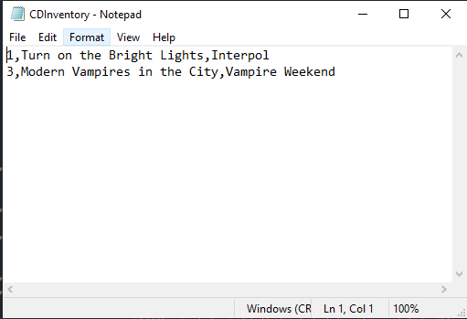

Figure : After Deleting Entry 2 and Saving to txt file

This assignment also asked us to create an Assignment_05 repository on Github to share our script and knowledge document. The link for my repository is <https://github.com/rgoding/Assignment_05>.

# Summary

I found this assignment challenging on multiple areas. Working with existing code proved to be a challenge, as well as modifying each function and new functions of the code to work with dictionary objects. It also showed me how large each functionality could get as more and more options are given to the user, creating more and more combinations of ways they can break the code.

# References

1. Dictionaries in Python, John Sturtz, <https://realpython.com/python-dicts/>
2. Python Dictionary, programiz.com, <https://www.programiz.com/python-programming/dictionary>

# Appendix

## Listing CDInventory.py

1. #-------------------------------------------------------------------------------#
2. # Title: CDInventory.py
3. # Desc: Modifying CDInventory.py to replace inner data structure by dictionaires,
4. #add ability to load existing data, and ability to delete an entry
5. # Change Log:
6. # Rgoding, 8/9/2020, Created File
7. #Rgoding, 8/10/2020, Added ability to load existing data
8. #Rgoding, 8/11/2020, Added Ability to delete an requested entry, modified display
9. #choice to work with dictionary objects
10. #-------------------------------------------------------------------------------#
12. # Declare variables
14. strChoice = '' # User input
15. lstTbl = []  # list of dictionaries to hold data
16. dicRow = {}  # list of data row
17. strFileName = 'CDInventory.txt'  # data storage file
18. objFile = None  # file object
19. lstRow = []

22. # Get user Input
23. **print**('The Magic CD Inventory\n')
24. **while** True:
25. # 1. Display menu allowing the user to choose:
26. **print**('[l] load Inventory from file\n[a] Add CD\n[i] Display Current Inventory')
27. **print**('[d] delete CD from Inventory\n[s] Save Inventory to file\n[x] exit')
28. strChoice = input('l, a, i, d, s or x: ').lower()  # convert choice to lower case at time of input
29. **print**()
31. **if** strChoice == 'x':
32. # 5. Exit the program if the user chooses so
33. **break**
34. **if** strChoice == 'l':
35. objFile = open(strFileName, 'r')
36. **for** row **in** objFile:
37. #Take each row and strip it of \n and seperate items by a comma
38. lstRow = row.strip().split(',')
39. #Take info from txt file and load it as dic object
40. dicRow = {'id': lstRow[0], 'Title': lstRow[1], 'Artist': lstRow[2]}
41. #append dicrow to list of dictionaries
42. lstTbl.append(dicRow)
43. **elif** strChoice == 'a':  # no elif necessary, as this code is only reached if strChoice is not 'exit'
44. # 2. Add data to the table (2d-list) each time the user wants to add data
45. strID = input('Enter an ID: ')
46. strTitle = input('Enter the CD\'s Title: ')
47. strArtist = input('Enter the Artist\'s Name: ')
48. intID = int(strID)
49. #Create dictionary object of input variables
50. dicRow = {'id': intID, 'Title': strTitle, 'Artist': strArtist}
51. #append to table of dictionaries
52. lstTbl.append(dicRow)
53. **print**()

56. **elif** strChoice == 'i':
57. # 3. Display the current data to the user each time the user wants to display the data
58. **print**('ID, CD Title, Artist')
59. **for** row **in** lstTbl:
60. **print**(*row.values(), sep = ',')
61. **elif** strChoice == 'd':
62. delEntry = int(input('Please Enter ID of CD you would like to delete: '))
63. #create for loop to cycle through lstTbl to find requested entry to delete
64. **for** row **in** lstTbl:
65. **if** delEntry **in** row.values():
66. lstTbl.remove(row)
67. **print**('CD id: ' + str(delEntry) + ' has been deleted')
68. **print**()
69. **elif** strChoice == 's':
70. # 4. Save the data to a text file CDInventory.txt if the user chooses so
71. objFile = open(strFileName, 'a')
72. **for** row **in** lstTbl:
73. strRow = ''
74. **for** item **in** row.values():
75. strRow += str(item) + ','
76. strRow = strRow[:-1] + '\n'
77. objFile.write(strRow)
78. objFile.close()
79. **else**:
80. **print**('Please choose either l, a, i, d, s or x!')