Week 5: Data Visualization Lab

Ralph Goguanco (PID A15937787

02/07/2022

# Week 5 Data visualization Lab  
  
# Install the package ggplot2  
# install.packages("ggplot2")  
  
# Any time I want to use this  
# Package I need to load it  
library(ggplot2)  
  
#View(cars)  
  
# A quick base R plot - this is not ggplot  
plot(cars)

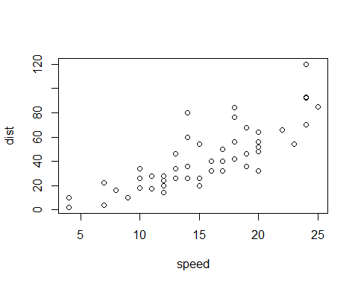

# Our first ggplot  
# We need data + aes + geoms  
ggplot(data=cars) +  
 aes(x=speed, y=dist) +  
 geom_point()

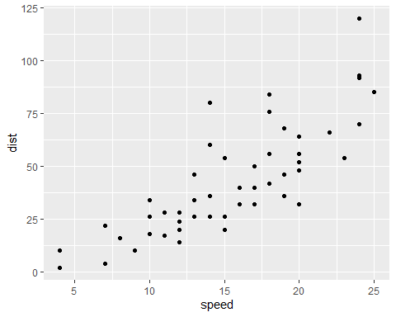

p <- ggplot(data=cars) +   
 aes(x=speed, y=dist) +  
 geom_point()  
  
# Add a line geom with geom_line()  
p + geom_line()

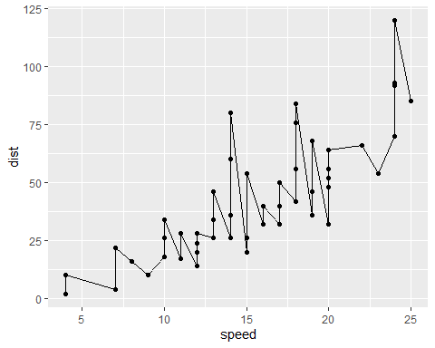

# Add a trend line close to the data  
p + geom_smooth()

## `geom_smooth()` using method = 'loess' and formula 'y ~ x'

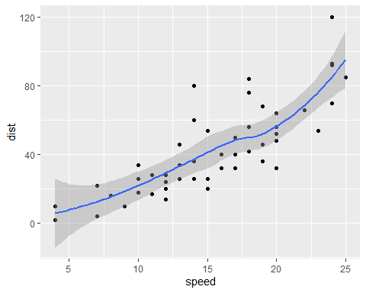

p + geom_smooth(method="lm")

## `geom_smooth()` using formula 'y ~ x'

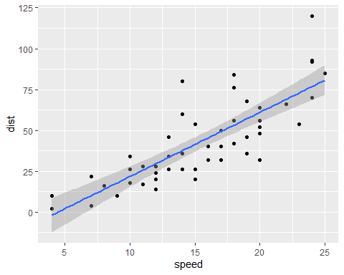

# Read in our drug expression data  
url <- "https://bioboot.github.io/bimm143_S20/class-material/up_down_expression.txt"  
genes <- read.delim(url)  
head(genes)

## Gene Condition1 Condition2 State  
## 1 A4GNT -3.6808610 -3.4401355 unchanging  
## 2 AAAS 4.5479580 4.3864126 unchanging  
## 3 AASDH 3.7190695 3.4787276 unchanging  
## 4 AATF 5.0784720 5.0151916 unchanging  
## 5 AATK 0.4711421 0.5598642 unchanging  
## 6 AB015752.4 -3.6808610 -3.5921390 unchanging

# Q. how many genes are in this dataset?  
nrow(genes)

## [1] 5196

# Q. how many "up" regulated genes  
table(genes$State)

##   
## down unchanging up   
## 72 4997 127

# Q. What fraction of total genes is up-regulated  
round( (table(genes$State) / nrow(genes)) * 100, 2)

##   
## down unchanging up   
## 1.39 96.17 2.44

# Let's make a first plot attempt  
g <- ggplot(data=genes) +  
 aes(x=Condition1, y=Condition2,  
 col=State) +  
 geom_point()  
  
g

# Add some color  
g + scale_color_manual( values=c("blue", "gray", "red")) +  
 labs(title="Gene expression changes",x="Control (no drug)")

theme_bw()

## List of 93  
## $ line :List of 6  
## ..$ colour : chr "black"  
## ..$ size : num 0.5  
## ..$ linetype : num 1  
## ..$ lineend : chr "butt"  
## ..$ arrow : logi FALSE  
## ..$ inherit.blank: logi TRUE  
## ..- attr(*, "class")= chr [1:2] "element_line" "element"  
## $ rect :List of 5  
## ..$ fill : chr "white"  
## ..$ colour : chr "black"  
## ..$ size : num 0.5  
## ..$ linetype : num 1  
## ..$ inherit.blank: logi TRUE  
## ..- attr(*, "class")= chr [1:2] "element_rect" "element"  
## $ text :List of 11  
## ..$ family : chr ""  
## ..$ face : chr "plain"  
## ..$ colour : chr "black"  
## ..$ size : num 11  
## ..$ hjust : num 0.5  
## ..$ vjust : num 0.5  
## ..$ angle : num 0  
## ..$ lineheight : num 0.9  
## ..$ margin : 'margin' num [1:4] 0points 0points 0points 0points  
## .. ..- attr(*, "unit")= int 8  
## ..$ debug : logi FALSE  
## ..$ inherit.blank: logi TRUE  
## ..- attr(*, "class")= chr [1:2] "element_text" "element"  
## $ title : NULL  
## $ aspect.ratio : NULL  
## $ axis.title : NULL  
## $ axis.title.x :List of 11  
## ..$ family : NULL  
## ..$ face : NULL  
## ..$ colour : NULL  
## ..$ size : NULL  
## ..$ hjust : NULL  
## ..$ vjust : num 1  
## ..$ angle : NULL  
## ..$ lineheight : NULL  
## ..$ margin : 'margin' num [1:4] 2.75points 0points 0points 0points  
## .. ..- attr(*, "unit")= int 8  
## ..$ debug : NULL  
## ..$ inherit.blank: logi TRUE  
## ..- attr(*, "class")= chr [1:2] "element_text" "element"  
## $ axis.title.x.top :List of 11  
## ..$ family : NULL  
## ..$ face : NULL  
## ..$ colour : NULL  
## ..$ size : NULL  
## ..$ hjust : NULL  
## ..$ vjust : num 0  
## ..$ angle : NULL  
## ..$ lineheight : NULL  
## ..$ margin : 'margin' num [1:4] 0points 0points 2.75points 0points  
## .. ..- attr(*, "unit")= int 8  
## ..$ debug : NULL  
## ..$ inherit.blank: logi TRUE  
## ..- attr(*, "class")= chr [1:2] "element_text" "element"  
## $ axis.title.x.bottom : NULL  
## $ axis.title.y :List of 11  
## ..$ family : NULL  
## ..$ face : NULL  
## ..$ colour : NULL  
## ..$ size : NULL  
## ..$ hjust : NULL  
## ..$ vjust : num 1  
## ..$ angle : num 90  
## ..$ lineheight : NULL  
## ..$ margin : 'margin' num [1:4] 0points 2.75points 0points 0points  
## .. ..- attr(*, "unit")= int 8  
## ..$ debug : NULL  
## ..$ inherit.blank: logi TRUE  
## ..- attr(*, "class")= chr [1:2] "element_text" "element"  
## $ axis.title.y.left : NULL  
## $ axis.title.y.right :List of 11  
## ..$ family : NULL  
## ..$ face : NULL  
## ..$ colour : NULL  
## ..$ size : NULL  
## ..$ hjust : NULL  
## ..$ vjust : num 0  
## ..$ angle : num -90  
## ..$ lineheight : NULL  
## ..$ margin : 'margin' num [1:4] 0points 0points 0points 2.75points  
## .. ..- attr(*, "unit")= int 8  
## ..$ debug : NULL  
## ..$ inherit.blank: logi TRUE  
## ..- attr(*, "class")= chr [1:2] "element_text" "element"  
## $ axis.text :List of 11  
## ..$ family : NULL  
## ..$ face : NULL  
## ..$ colour : chr "grey30"  
## ..$ size : 'rel' num 0.8  
## ..$ hjust : NULL  
## ..$ vjust : NULL  
## ..$ angle : NULL  
## ..$ lineheight : NULL  
## ..$ margin : NULL  
## ..$ debug : NULL  
## ..$ inherit.blank: logi TRUE  
## ..- attr(*, "class")= chr [1:2] "element_text" "element"  
## $ axis.text.x :List of 11  
## ..$ family : NULL  
## ..$ face : NULL  
## ..$ colour : NULL  
## ..$ size : NULL  
## ..$ hjust : NULL  
## ..$ vjust : num 1  
## ..$ angle : NULL  
## ..$ lineheight : NULL  
## ..$ margin : 'margin' num [1:4] 2.2points 0points 0points 0points  
## .. ..- attr(*, "unit")= int 8  
## ..$ debug : NULL  
## ..$ inherit.blank: logi TRUE  
## ..- attr(*, "class")= chr [1:2] "element_text" "element"  
## $ axis.text.x.top :List of 11  
## ..$ family : NULL  
## ..$ face : NULL  
## ..$ colour : NULL  
## ..$ size : NULL  
## ..$ hjust : NULL  
## ..$ vjust : num 0  
## ..$ angle : NULL  
## ..$ lineheight : NULL  
## ..$ margin : 'margin' num [1:4] 0points 0points 2.2points 0points  
## .. ..- attr(*, "unit")= int 8  
## ..$ debug : NULL  
## ..$ inherit.blank: logi TRUE  
## ..- attr(*, "class")= chr [1:2] "element_text" "element"  
## $ axis.text.x.bottom : NULL  
## $ axis.text.y :List of 11  
## ..$ family : NULL  
## ..$ face : NULL  
## ..$ colour : NULL  
## ..$ size : NULL  
## ..$ hjust : num 1  
## ..$ vjust : NULL  
## ..$ angle : NULL  
## ..$ lineheight : NULL  
## ..$ margin : 'margin' num [1:4] 0points 2.2points 0points 0points  
## .. ..- attr(*, "unit")= int 8  
## ..$ debug : NULL  
## ..$ inherit.blank: logi TRUE  
## ..- attr(*, "class")= chr [1:2] "element_text" "element"  
## $ axis.text.y.left : NULL  
## $ axis.text.y.right :List of 11  
## ..$ family : NULL  
## ..$ face : NULL  
## ..$ colour : NULL  
## ..$ size : NULL  
## ..$ hjust : num 0  
## ..$ vjust : NULL  
## ..$ angle : NULL  
## ..$ lineheight : NULL  
## ..$ margin : 'margin' num [1:4] 0points 0points 0points 2.2points  
## .. ..- attr(*, "unit")= int 8  
## ..$ debug : NULL  
## ..$ inherit.blank: logi TRUE  
## ..- attr(*, "class")= chr [1:2] "element_text" "element"  
## $ axis.ticks :List of 6  
## ..$ colour : chr "grey20"  
## ..$ size : NULL  
## ..$ linetype : NULL  
## ..$ lineend : NULL  
## ..$ arrow : logi FALSE  
## ..$ inherit.blank: logi TRUE  
## ..- attr(*, "class")= chr [1:2] "element_line" "element"  
## $ axis.ticks.x : NULL  
## $ axis.ticks.x.top : NULL  
## $ axis.ticks.x.bottom : NULL  
## $ axis.ticks.y : NULL  
## $ axis.ticks.y.left : NULL  
## $ axis.ticks.y.right : NULL  
## $ axis.ticks.length : 'simpleUnit' num 2.75points  
## ..- attr(*, "unit")= int 8  
## $ axis.ticks.length.x : NULL  
## $ axis.ticks.length.x.top : NULL  
## $ axis.ticks.length.x.bottom: NULL  
## $ axis.ticks.length.y : NULL  
## $ axis.ticks.length.y.left : NULL  
## $ axis.ticks.length.y.right : NULL  
## $ axis.line : list()  
## ..- attr(*, "class")= chr [1:2] "element_blank" "element"  
## $ axis.line.x : NULL  
## $ axis.line.x.top : NULL  
## $ axis.line.x.bottom : NULL  
## $ axis.line.y : NULL  
## $ axis.line.y.left : NULL  
## $ axis.line.y.right : NULL  
## $ legend.background :List of 5  
## ..$ fill : NULL  
## ..$ colour : logi NA  
## ..$ size : NULL  
## ..$ linetype : NULL  
## ..$ inherit.blank: logi TRUE  
## ..- attr(*, "class")= chr [1:2] "element_rect" "element"  
## $ legend.margin : 'margin' num [1:4] 5.5points 5.5points 5.5points 5.5points  
## ..- attr(*, "unit")= int 8  
## $ legend.spacing : 'simpleUnit' num 11points  
## ..- attr(*, "unit")= int 8  
## $ legend.spacing.x : NULL  
## $ legend.spacing.y : NULL  
## $ legend.key :List of 5  
## ..$ fill : chr "white"  
## ..$ colour : logi NA  
## ..$ size : NULL  
## ..$ linetype : NULL  
## ..$ inherit.blank: logi TRUE  
## ..- attr(*, "class")= chr [1:2] "element_rect" "element"  
## $ legend.key.size : 'simpleUnit' num 1.2lines  
## ..- attr(*, "unit")= int 3  
## $ legend.key.height : NULL  
## $ legend.key.width : NULL  
## $ legend.text :List of 11  
## ..$ family : NULL  
## ..$ face : NULL  
## ..$ colour : NULL  
## ..$ size : 'rel' num 0.8  
## ..$ hjust : NULL  
## ..$ vjust : NULL  
## ..$ angle : NULL  
## ..$ lineheight : NULL  
## ..$ margin : NULL  
## ..$ debug : NULL  
## ..$ inherit.blank: logi TRUE  
## ..- attr(*, "class")= chr [1:2] "element_text" "element"  
## $ legend.text.align : NULL  
## $ legend.title :List of 11  
## ..$ family : NULL  
## ..$ face : NULL  
## ..$ colour : NULL  
## ..$ size : NULL  
## ..$ hjust : num 0  
## ..$ vjust : NULL  
## ..$ angle : NULL  
## ..$ lineheight : NULL  
## ..$ margin : NULL  
## ..$ debug : NULL  
## ..$ inherit.blank: logi TRUE  
## ..- attr(*, "class")= chr [1:2] "element_text" "element"  
## $ legend.title.align : NULL  
## $ legend.position : chr "right"  
## $ legend.direction : NULL  
## $ legend.justification : chr "center"  
## $ legend.box : NULL  
## $ legend.box.just : NULL  
## $ legend.box.margin : 'margin' num [1:4] 0cm 0cm 0cm 0cm  
## ..- attr(*, "unit")= int 1  
## $ legend.box.background : list()  
## ..- attr(*, "class")= chr [1:2] "element_blank" "element"  
## $ legend.box.spacing : 'simpleUnit' num 11points  
## ..- attr(*, "unit")= int 8  
## $ panel.background :List of 5  
## ..$ fill : chr "white"  
## ..$ colour : logi NA  
## ..$ size : NULL  
## ..$ linetype : NULL  
## ..$ inherit.blank: logi TRUE  
## ..- attr(*, "class")= chr [1:2] "element_rect" "element"  
## $ panel.border :List of 5  
## ..$ fill : logi NA  
## ..$ colour : chr "grey20"  
## ..$ size : NULL  
## ..$ linetype : NULL  
## ..$ inherit.blank: logi TRUE  
## ..- attr(*, "class")= chr [1:2] "element_rect" "element"  
## $ panel.spacing : 'simpleUnit' num 5.5points  
## ..- attr(*, "unit")= int 8  
## $ panel.spacing.x : NULL  
## $ panel.spacing.y : NULL  
## $ panel.grid :List of 6  
## ..$ colour : chr "grey92"  
## ..$ size : NULL  
## ..$ linetype : NULL  
## ..$ lineend : NULL  
## ..$ arrow : logi FALSE  
## ..$ inherit.blank: logi TRUE  
## ..- attr(*, "class")= chr [1:2] "element_line" "element"  
## $ panel.grid.major : NULL  
## $ panel.grid.minor :List of 6  
## ..$ colour : NULL  
## ..$ size : 'rel' num 0.5  
## ..$ linetype : NULL  
## ..$ lineend : NULL  
## ..$ arrow : logi FALSE  
## ..$ inherit.blank: logi TRUE  
## ..- attr(*, "class")= chr [1:2] "element_line" "element"  
## $ panel.grid.major.x : NULL  
## $ panel.grid.major.y : NULL  
## $ panel.grid.minor.x : NULL  
## $ panel.grid.minor.y : NULL  
## $ panel.ontop : logi FALSE  
## $ plot.background :List of 5  
## ..$ fill : NULL  
## ..$ colour : chr "white"  
## ..$ size : NULL  
## ..$ linetype : NULL  
## ..$ inherit.blank: logi TRUE  
## ..- attr(*, "class")= chr [1:2] "element_rect" "element"  
## $ plot.title :List of 11  
## ..$ family : NULL  
## ..$ face : NULL  
## ..$ colour : NULL  
## ..$ size : 'rel' num 1.2  
## ..$ hjust : num 0  
## ..$ vjust : num 1  
## ..$ angle : NULL  
## ..$ lineheight : NULL  
## ..$ margin : 'margin' num [1:4] 0points 0points 5.5points 0points  
## .. ..- attr(*, "unit")= int 8  
## ..$ debug : NULL  
## ..$ inherit.blank: logi TRUE  
## ..- attr(*, "class")= chr [1:2] "element_text" "element"  
## $ plot.title.position : chr "panel"  
## $ plot.subtitle :List of 11  
## ..$ family : NULL  
## ..$ face : NULL  
## ..$ colour : NULL  
## ..$ size : NULL  
## ..$ hjust : num 0  
## ..$ vjust : num 1  
## ..$ angle : NULL  
## ..$ lineheight : NULL  
## ..$ margin : 'margin' num [1:4] 0points 0points 5.5points 0points  
## .. ..- attr(*, "unit")= int 8  
## ..$ debug : NULL  
## ..$ inherit.blank: logi TRUE  
## ..- attr(*, "class")= chr [1:2] "element_text" "element"  
## $ plot.caption :List of 11  
## ..$ family : NULL  
## ..$ face : NULL  
## ..$ colour : NULL  
## ..$ size : 'rel' num 0.8  
## ..$ hjust : num 1  
## ..$ vjust : num 1  
## ..$ angle : NULL  
## ..$ lineheight : NULL  
## ..$ margin : 'margin' num [1:4] 5.5points 0points 0points 0points  
## .. ..- attr(*, "unit")= int 8  
## ..$ debug : NULL  
## ..$ inherit.blank: logi TRUE  
## ..- attr(*, "class")= chr [1:2] "element_text" "element"  
## $ plot.caption.position : chr "panel"  
## $ plot.tag :List of 11  
## ..$ family : NULL  
## ..$ face : NULL  
## ..$ colour : NULL  
## ..$ size : 'rel' num 1.2  
## ..$ hjust : num 0.5  
## ..$ vjust : num 0.5  
## ..$ angle : NULL  
## ..$ lineheight : NULL  
## ..$ margin : NULL  
## ..$ debug : NULL  
## ..$ inherit.blank: logi TRUE  
## ..- attr(*, "class")= chr [1:2] "element_text" "element"  
## $ plot.tag.position : chr "topleft"  
## $ plot.margin : 'margin' num [1:4] 5.5points 5.5points 5.5points 5.5points  
## ..- attr(*, "unit")= int 8  
## $ strip.background :List of 5  
## ..$ fill : chr "grey85"  
## ..$ colour : chr "grey20"  
## ..$ size : NULL  
## ..$ linetype : NULL  
## ..$ inherit.blank: logi TRUE  
## ..- attr(*, "class")= chr [1:2] "element_rect" "element"  
## $ strip.background.x : NULL  
## $ strip.background.y : NULL  
## $ strip.placement : chr "inside"  
## $ strip.text :List of 11  
## ..$ family : NULL  
## ..$ face : NULL  
## ..$ colour : chr "grey10"  
## ..$ size : 'rel' num 0.8  
## ..$ hjust : NULL  
## ..$ vjust : NULL  
## ..$ angle : NULL  
## ..$ lineheight : NULL  
## ..$ margin : 'margin' num [1:4] 4.4points 4.4points 4.4points 4.4points  
## .. ..- attr(*, "unit")= int 8  
## ..$ debug : NULL  
## ..$ inherit.blank: logi TRUE  
## ..- attr(*, "class")= chr [1:2] "element_text" "element"  
## $ strip.text.x : NULL  
## $ strip.text.y :List of 11  
## ..$ family : NULL  
## ..$ face : NULL  
## ..$ colour : NULL  
## ..$ size : NULL  
## ..$ hjust : NULL  
## ..$ vjust : NULL  
## ..$ angle : num -90  
## ..$ lineheight : NULL  
## ..$ margin : NULL  
## ..$ debug : NULL  
## ..$ inherit.blank: logi TRUE  
## ..- attr(*, "class")= chr [1:2] "element_text" "element"  
## $ strip.switch.pad.grid : 'simpleUnit' num 2.75points  
## ..- attr(*, "unit")= int 8  
## $ strip.switch.pad.wrap : 'simpleUnit' num 2.75points  
## ..- attr(*, "unit")= int 8  
## $ strip.text.y.left :List of 11  
## ..$ family : NULL  
## ..$ face : NULL  
## ..$ colour : NULL  
## ..$ size : NULL  
## ..$ hjust : NULL  
## ..$ vjust : NULL  
## ..$ angle : num 90  
## ..$ lineheight : NULL  
## ..$ margin : NULL  
## ..$ debug : NULL  
## ..$ inherit.blank: logi TRUE  
## ..- attr(*, "class")= chr [1:2] "element_text" "element"  
## - attr(*, "class")= chr [1:2] "theme" "gg"  
## - attr(*, "complete")= logi TRUE  
## - attr(*, "validate")= logi TRUE