

AI-Powered Legal Document Generator
Phase 04: Project Planning
Internship Project Submission
AI-generated template, not legal advice; have a lawyer review.

LegalEase - AI-Powered Legal Document GeneratorPhase 04 - Planning

Table of Contents
1. Planning Approach2
2. Task Schedule2
3. Gantt Chart3
4. Timeline and Weekly Deliverables3
5. Risk Register3
6. Tools and Resources4

1. Planning Approach
The project was planned as four one-week iterations that follow the six milestones of the project brief: M1 model selection and environment, M2 core generation and export, M3 API, M4 user interface, M5 deployment scripts and M6 end-to-end testing. Must-have features were scheduled first so that a working product existed by the end of week 3. Dates below are the planned schedule; the Status column shows the state of each deliverable on 25 September 2026 (Done = present in the repository and verified by running it).
2. Task Schedule
Table 1: Task list with owner, planned dates, duration (working days) and status
ID | Task | Owner | Start | End | Days | Status
T01 | Brainstorming and idea selection | Intern | 31 Aug | 01 Sep | 2 | Done
T02 | Requirement analysis (FR, NFR, user stories) | Intern | 01 Sep | 03 Sep | 3 | Done
T03 | M1: Model selection and dev environment | Intern | 03 Sep | 04 Sep | 2 | Done
T04 | System design: architecture, DFD, prompts | Intern | 07 Sep | 08 Sep | 2 | Done
T05 | M2: Core generation (Gemini + offline templates) | Intern | 08 Sep | 10 Sep | 3 | Done
T06 | M2: Export utilities (TXT, DOCX, PDF) | Intern | 10 Sep | 11 Sep | 2 | Done
T07 | M3: FastAPI backend (/, /health, /generate) | Intern | 14 Sep | 15 Sep | 2 | Done
T08 | M4: Streamlit UI (form, preview, editor, downloads) | Intern | 15 Sep | 17 Sep | 3 | Done
T09 | Demo mode, AI fallback and error handling | Intern | 17 Sep | 18 Sep | 2 | Done
T10 | M6: Automated tests (pytest) and UI checks | Intern | 21 Sep | 22 Sep | 2 | Done
T11 | M5: Deployment scripts (run.sh, run.bat) | Intern | 22 Sep | 22 Sep | 1 | Done
T12 | Screenshots, demo and testing videos | Intern | 23 Sep | 23 Sep | 1 | Done
T13 | Documentation, final report and presentation | Intern | 23 Sep | 25 Sep | 3 | Done
T14 | Mentor review of report and slides | Mentor | 25 Sep | 25 Sep | 1 | Planned
T15 | Final demonstration and viva | Intern + Mentor | 28 Sep | 28 Sep | 1 | Planned

3. Gantt Chart

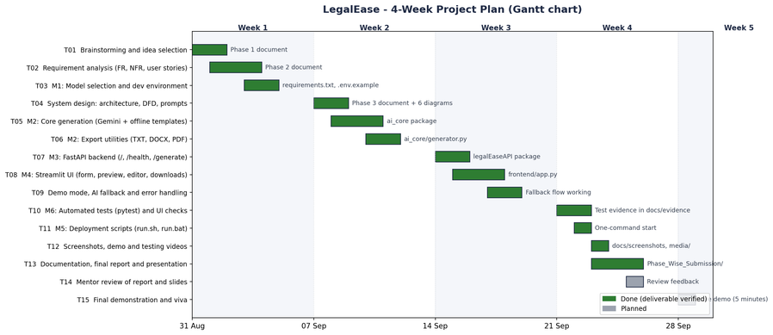

Figure 1: Gantt chart of the 4-week plan
Gantt_Chart.xlsx contains the same plan with a visual bar column, a day-by-day coloured grid, a native Excel stacked-bar chart, the weekly deliverables and the risk register.
4. Timeline and Weekly Deliverables
Table 2: Weekly deliverables
Week | Focus | Deliverables
Week 1 (31 Aug - 4 Sep) | Idea, requirements and setup | Problem statement, personas, idea comparison, FR/NFR list, user stories, Python environment and model choice.
Week 2 (7 - 11 Sep) | Design and core engine | Architecture, DFD, use case and flow diagrams; prompt design; ai_core generation and TXT/DOCX/PDF export.
Week 3 (14 - 18 Sep) | API and user interface | FastAPI routes with Pydantic validation; Streamlit form, preview, editor and downloads; Demo mode and fallback.
Week 4 (21 - 25 Sep) | Testing and documentation | pytest suite with coverage, UI edge-case checks, screenshots, videos, phase documents, report and slides.

5. Risk Register
Table 3: Risk register (L = likelihood, I = impact: H/M/L)
ID | Risk | L | I | Mitigation | Status
R1 | Gemini API key unavailable or free quota exhausted | H | H | Demo mode (offline templates) and automatic fallback with a clear message | Mitigated
R2 | Model retired or renamed (the spec used gemini-1.5-pro) | H | H | Model ID read from GEMINI_MODEL in .env; default gemini-3.8-flash | Mitigated
R3 | AI output inaccurate, incomplete or badly structured | M | H | Structured prompt, output validation, disclaimer, lawyer review | Mitigated
R4 | Prompt injection or HTML injection through user input | M | M | Inputs wrapped in <<< >>> delimiters; HTML escaped in the preview | Mitigated
R5 | Unicode (₹, curly quotes) breaks PDF export | M | M | fpdf2 with bundled DejaVu fonts; automated Unicode tests | Mitigated
R6 | Exports ignore the user's edits (bug in the spec code) | H | H | current_export_text() used for preview and all downloads; tested | Fixed
R7 | Backend not running during the demo | M | M | run.sh / run.bat start both servers; friendly UI error; demo checklist | Mitigated
R8 | Schedule slip in week 3 or 4 | M | M | Must-have features first; weekly deliverables; nice-to-have items can move | Closed

6. Tools and Resources
Table 4: Tools and resources
Tool | Used for
Python 3.13.14, VS Code, Git | Programming, editing and version control
FastAPI 0.141.1, Uvicorn 0.54.0, Pydantic 2.13.4 | Backend API and validation
Streamlit 1.64.0 | Frontend user interface
google-genai 2.25.0 | Google Gemini API access (model from GEMINI_MODEL)
python-docx 1.1.2, fpdf2 2.8.8, Pillow 12.3.0 | DOCX, PDF and image handling
pytest 9.0.3, pytest-cov 7.1.0, Playwright 1.63.0 | Automated tests, coverage, screenshots, UI checks and videos
LibreOffice, pdf2image, ffmpeg, Graphviz, matplotlib | Rendering exports, videos and diagrams
openpyxl 3.1.5, python-pptx 1.0.2 | Excel sheets and the presentation

Page 1 of 1

