

AI-Powered Legal Document Generator
Phase 06: Project Testing
Internship Project Submission
AI-generated template, not legal advice; have a lawyer review.

LegalEase - AI-Powered Legal Document GeneratorPhase 06 - Testing

Table of Contents
1. Test Strategy and Environment2
2. Automated Test Results2
3. UI Checks on the Running Application3
4. Requirement Traceability4
5. Bugs Found and Fixed4
6. Conclusion4

1. Test Strategy and Environment
Unit tests: parser, sanitiser, prompts, offline templates, exports, configuration.
API tests: FastAPI TestClient for every route, validation rule and AI-failure type (fake Gemini client).
Integration tests: real HTTP calls to uvicorn and Streamlit AppTest runs of frontend/app.py.
End-to-end UI checks: Playwright drives the running app in Chromium and saves a screenshot per check.
Environment: Debian 13, Python 3.13.14, 2 CPUs, 1.9 GB RAM, Chromium (Playwright 1.63.0).
2. Automated Test Results
Table 1: pytest results (97 passed in 12.14s)
Module | Area | Tests | Passed | Failed
tests/test_api.py | API routes, validation, fallback | 25 | 25 | 0
tests/test_config.py | Configuration and Demo mode | 14 | 14 | 0
tests/test_exports.py | TXT, DOCX and PDF exports | 9 | 9 | 0
tests/test_frontend.py | Frontend helpers, HTTP and AppTest UI | 13 | 13 | 0
tests/test_gemini_generator.py | Prompt, validation, error classes | 13 | 13 | 0
tests/test_offline_generator.py | Offline templates | 14 | 14 | 0
tests/test_parser_and_utils.py | Parser, sanitiser, preview | 9 | 9 | 0
Total |  | 97 | 97 | 0

Table 2: Coverage by package (pytest-cov)
Package | Line coverage
ai_core | 95% (747 of 786 statements, 6 files)
config.py | 95% (71 of 75 statements, 1 file)
frontend | 86% (205 of 239 statements, 4 files)
legalEaseAPI | 96% (108 of 113 statements, 3 files)
Total (statements) | 93% of 1,213 statements (82 missed)

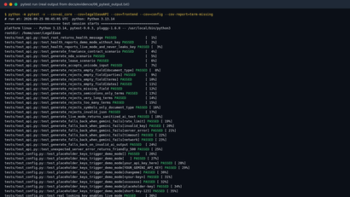 | 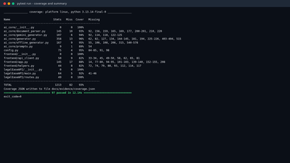
Figure 1: pytest run: tests passing | Figure 2: pytest run: coverage and summary

3. UI Checks on the Running Application
Table 3: UI checks: 17 of 17 passed
ID | Check | Actual result | Status | Screenshot
UI-01 | Home page loads with Demo mode badge and disclaimer | Badge and disclaimer found | Pass | 01_home_demo_mode.png
UI-02 | GET /health reports the resolved mode | mode = demo, model = gemini-3.8-flash | Pass | 02_api_health_endpoint.png
UI-03 | API docs list POST /generate | POST /generate listed | Pass | 03_api_swagger_docs.png
UI-04 | Scenario 1 freelance contract generated | Parties found=True, term rows=4 | Pass | 06_s1_freelance_terms_table.png
UI-05 | Scenario 2 NDA generated | Client = Disclosing Party, freelancer = Receiving Party | Pass | 08_s2_nda_generated.png
UI-06 | Scenario 3 lease generated | Address, ₹25,000 and ₹75,000 found | Pass | 11_s3_lease_rent_clauses.png
UI-07 | Edited text is saved and previewed | term rows=5 | Pass | 13_s4_edits_saved_preview.png
UI-08 | TXT download uses edited text | 5636 chars; edits found=True | Pass | 15_s4_txt_export_opened.png
UI-09 | DOCX download uses edited text and formatting | table rows=5, logos=1, pages=3 | Pass | 16_s4_docx_page1.png
UI-10 | PDF download uses edited text; header/footer on every page | pages=3, disclaimer on all=True | Pass | 18_s4_pdf_page1.png
UI-11 | Custom logo is used in the PDF export | header image size (720, 200) | Pass | 22_s5_employment_pdf_custom_logo.png
UI-12 | Empty form shows validation errors | Please fix the following before generating: | | Document type is requ | Pass | 23_edge_empty_fields.png
UI-13 | Very long terms are rejected | message shown for 5,477 characters | Pass | 24_edge_very_long_terms.png
UI-14 | Backend 422 validation message shown | Some inputs are invalid: 'document_type' must contain letters, not onl | Pass | 25_edge_invalid_input_backend_422.png
UI-15 | Backend down shows friendly error | Friendly error and offline badge shown | Pass | 27_edge_backend_down_error.png
UI-16 | AI failure falls back to offline template | Live AI generation failed: The Gemini API key was rejected (invalid ke | Pass | 29_edge_ai_failure_fallback.png
UI-17 | Mobile layout renders without horizontal scrolling | document width = 390px | Pass | 32_mobile_downloads.png

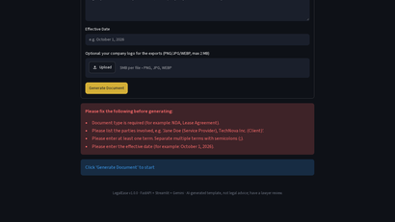 | 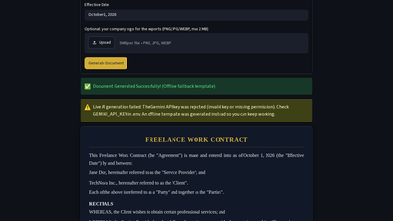
Figure 3: Empty fields: friendly validation | Figure 4: Real Gemini error: automatic fallback

4. Requirement Traceability
Table 4: Every functional requirement is covered by passing tests (details in Traceability_Matrix.xlsx)
Req. | Test cases (automated / UI) | Result
FR-01 | 7 automated / 1 UI | Covered, all passed
FR-02 | 14 automated / 3 UI | Covered, all passed
FR-03 | 13 automated / 3 UI | Covered, all passed
FR-04 | 8 automated / 1 UI | Covered, all passed
FR-05 | 23 automated / 1 UI | Covered, all passed
FR-06 | 16 automated / 1 UI | Covered, all passed
FR-07 | 3 automated / 4 UI | Covered, all passed
FR-08 | 3 automated / 1 UI | Covered, all passed
FR-09 | 8 automated / 3 UI | Covered, all passed
FR-10 | 4 automated / 2 UI | Covered, all passed
FR-11 | 4 automated / 4 UI | Covered, all passed
FR-12 | 3 automated / 2 UI | Covered, all passed
FR-13 | 3 automated / 1 UI | Covered, all passed
FR-14 | 2 automated / 1 UI | Covered, all passed
FR-15 | 4 automated / 1 UI | Covered, all passed

5. Bugs Found and Fixed
Table 5: Bug table
ID | Bug | Found by | Fix
BUG-01 | Lease template repeated the words 'Security deposit: Security deposit of ...' | Scenario 3 export review | Reworded the deposit and rent clauses; re-checked in the lease screenshots.
BUG-02 | DOCX terms table had two equal-width columns (clause number column too wide) | LibreOffice render of the DOCX | Disabled table autofit and set column widths (2.2 cm and 14 cm).
BUG-03 | DOCX footer page numbers were larger than the surrounding text | LibreOffice render of the DOCX | Each Word field part now uses its own run with the footer font size.
BUG-04 | A term row of the DOCX table could split across two pages | Long-terms export test | Added the Word 'cantSplit' property to every table row.
BUG-05 | Unit test passed raw Markdown to the output validator (test bug, not app bug) | pytest run | The test now sanitises the text first, exactly like the live code path.
BUG-06 | Result card in the testing video showed a Streamlit 'Connection error' dialog | Video frame review | The recorder now navigates to about:blank before the servers stop.

6. Conclusion
All 97 automated test cases and all 17 UI checks passed, with 93% line coverage. In total 114 test cases are listed in Test_Cases.xlsx. One path could not be verified: a successful live Gemini generation, because no real API key was available. Live-mode logic was tested with a fake client, and a real Google API error (invalid key, HTTP 400) was used to verify the fallback.

Page 1 of 1

