

AI-Powered Legal Document Generator
Final Project Report
Internship Project
AI-generated template, not legal advice; have a lawyer review.

LegalEase - AI-Powered Legal Document GeneratorFinal Project Report

Certificate
This is to certify that the project report titled "LegalEase - AI-Powered Legal Document Generator" is a record of the work carried out by [YOUR NAME] during the internship, under the guidance of [MENTOR NAME].
Placeholder: Certificate placeholder. Replace this page with the official certificate issued by your institution or organisation.

Page 1 of 1

LegalEase - AI-Powered Legal Document GeneratorFinal Project Report

Abstract
LegalEase is a web application that drafts structured legal documents such as freelance contracts, non-disclosure agreements, rental agreements and employment contracts from four inputs: the document type, the parties, the key terms separated by semicolons and the effective date. A FastAPI backend validates the request with Pydantic and builds a structured prompt for Google Gemini through the current google-genai SDK; the model ID is read from the environment (default gemini-3.8-flash). A Streamlit frontend with a dark theme shows a styled preview, lets the user edit the draft, and exports the edited text as TXT, DOCX (python-docx) and PDF (fpdf2 with Unicode fonts), each with a logo, numbered clauses, a terms table or bullets, page numbers and the disclaimer "AI-generated template, not legal advice; have a lawyer review."
Two reliability features were added to the original brief: a Demo mode that uses deterministic offline templates when no API key is configured, and an automatic fallback that returns the same templates with a clear message when the Gemini call fails because of a rate limit, an invalid key, a timeout or a network error. A bug in the brief, where downloads ignored the user's edits, was also fixed.
The system was verified with 97 automated pytest test cases (63 test functions, all passing, 93% line coverage) and 17 end-to-end UI checks on the running app, documented with 34 screenshots, a 3:35 demo video and a 2:41 testing video. A successful live Gemini generation was not demonstrated because no real API key was available; the live path was tested with a fake client and a real Google error response.
Keywords: generative AI, Google Gemini, legal document drafting, FastAPI, Streamlit, python-docx, fpdf2, prompt engineering, software testing.
Page 1 of 1

LegalEase - AI-Powered Legal Document GeneratorFinal Project Report

Table of Contents
Chapter 1: Introduction8
1.1 Background8
1.2 Motivation8
1.3 Objectives8
1.4 Scope8
1.5 Organisation of the Report8
Chapter 2: Literature Review9
2.1 Drafting by a Lawyer9
2.2 Static Templates9
2.3 Document Assembly Tools9
2.4 Large Language Models for Drafting9
2.5 Summary and Gap9
Chapter 3: Problem Statement and Objectives9
3.1 Problem Statement9
3.2 Proposed Solution10
3.3 Success Criteria and Results10
Chapter 4: System Analysis10
4.1 Existing and Proposed System10
4.2 Functional Requirements10
4.3 Non-Functional Requirements11
4.4 Feasibility Study11
Chapter 5: System Design12
5.1 System Architecture12
5.2 Data Flow13
5.3 Use Cases13
5.4 AI Generation and Fallback Flows14
5.5 Data Model and API14
5.6 Prompt Design14
5.7 User Interface Design15
Chapter 6: Implementation15
6.1 Technology Stack15
6.2 Backend and AI Module15
6.3 Export Module15
6.4 Frontend15
6.5 Scenario Walkthrough16
6.6 Challenges and Solutions17
Chapter 7: Testing and Results18
7.1 Test Strategy18
7.2 Automated Test Results18
7.3 UI Checks and Edge Cases18
7.4 Performance19
7.5 Videos19
Chapter 8: Limitations20
Chapter 9: Future Enhancements20
Chapter 10: Conclusion20
References20
Appendix A: Setup and Run Guide21
Appendix B: API Documentation21

Page 1 of 1

LegalEase - AI-Powered Legal Document GeneratorFinal Project Report

List of Figures
Figure 1: System architecture of LegalEase12
Figure 2: Data flow diagram, level 0 and level 113
Figure 3: Use case diagram13
Figure 4: AI generation flow14
Figure 5: Demo mode and fallback flow14
Figure 6: Annotated layout of the input screen15
Figure 7: Scenario 1 inputs (Jane Doe and TechNova Inc.)16
Figure 8: Scenario 1 terms as clauses 3.1 to 3.416
Figure 9: Scenario 2: NDA with Disclosing and Receiving Party16
Figure 10: Scenario 3: lease rent and deposit clauses (₹)16
Figure 11: Scenario 4: editing the document16
Figure 12: Scenario 4: saved edits in the preview16
Figure 13: Downloaded DOCX, page 117
Figure 14: Downloaded PDF, page 117
Figure 15: PDF with an uploaded company logo17
Figure 16: Mobile: home17
Figure 17: Mobile: preview17
Figure 18: Mobile: downloads17
Figure 19: End of the real pytest run: coverage table and summary18
Figure 20: Very long terms rejected19
Figure 21: Invalid input rejected by the API (422)19
Figure 22: Backend down: friendly message19
Figure 23: Gemini error: automatic fallback19

Page 1 of 1

LegalEase - AI-Powered Legal Document GeneratorFinal Project Report

Chapter 1: Introduction
1.1 Background
Contracts and agreements are part of everyday work for freelancers, landlords and small companies. Most of these documents follow a familiar structure: a title, the parties, recitals, numbered clauses and a signature block. Writing them from scratch is slow, and copying an old document often leaves wrong names, dates or amounts. Generative AI models such as Google Gemini can now write long, formal text that follows detailed formatting instructions, which makes them a good fit for producing first drafts.
1.2 Motivation
The goal of this internship project was to build a small but complete product around this idea: a tool that non-lawyers can use to get a clean, editable first draft in seconds, with professional exports and clear reminders that a lawyer must review the result. The project also aimed to show good engineering practice: modular code, validation, error handling, configuration without hard-coded secrets and automated tests.
1.3 Objectives
Generate a formally structured legal document (title, parties, recitals, numbered sections, signatures) from four inputs in a few seconds.
Use the current Google Gemini API through the google-genai SDK, with the model ID configured in .env.
Keep the app usable without an API key (Demo mode) and when the AI service fails (automatic fallback).
Let users edit the draft and download exactly the edited text as TXT, DOCX and PDF.
Validate every input on both the frontend and the backend and show plain-English error messages.
Prove the behaviour with automated tests, UI checks, screenshots and videos from real runs.
1.4 Scope
Version 1.0 covers contracts, NDAs, leases, employment contracts and general agreements; live Gemini, Demo mode and fallback; preview, editing and TXT/DOCX/PDF export; logo upload; and local deployment. Legal advice, e-signatures, user accounts and cloud hosting are out of scope.
1.5 Organisation of the Report
Chapter 2 reviews existing approaches. Chapter 3 states the problem and objectives. Chapter 4 analyses the requirements and feasibility. Chapter 5 presents the design and Chapter 6 the implementation. Chapter 7 reports the tests and results. Chapters 8 to 10 cover limitations, future work and the conclusion. The appendices contain the setup guide and the API documentation.
Chapter 2: Literature Review
2.1 Drafting by a Lawyer
A lawyer produces the most reliable documents because they understand the law, the jurisdiction and the client's situation. The drawbacks for small users are cost and turnaround time, especially for low-value, repetitive documents such as simple NDAs or freelance contracts.
2.2 Static Templates
Word-processor templates and template websites are cheap and fast, but they are generic. The user must find every placeholder, add their own terms in the right place and keep the numbering consistent. Formatting often breaks when text is added, and important clauses may be missing for the user's case.
2.3 Document Assembly Tools
Document assembly systems ask a questionnaire and fill a pre-written template. They produce consistent results but each template must be written and maintained by experts, and the questionnaire limits what users can express. Free-form terms such as "payment within 30 days of invoice" are hard to insert naturally.
2.4 Large Language Models for Drafting
Large language models (LLMs) can turn free-form terms into well-worded clauses and adapt the structure to the document type. Their known risks are invented facts (hallucination), inconsistent structure, sensitivity to prompt injection and dependence on an external service that can fail or change. Current provider documentation also shows that models are retired regularly, for example Gemini 1.5 models used in the original brief are no longer available, so applications should not hard-code model IDs.
2.5 Summary and Gap
Table 1: Comparison of drafting approaches
Approach | Cost | Speed | Custom terms | Editable export | Risk
Lawyer drafting | High | Days | Excellent | Yes | Low
Static templates | Free / low | Minutes | Manual | Partly | Missing clauses
Document assembly | Medium | Minutes | Limited | Yes | Low, rigid
Plain LLM chat | Low | Seconds | Good | Copy-paste only | Unstructured, no fallback
LegalEase | Low / free (Demo) | Seconds | Good (each term a clause) | TXT, DOCX, PDF | Template + disclaimer + fallback

LegalEase combines the flexibility of an LLM with the structure of a template: the prompt forces a fixed format, every user term becomes its own clause, the output is validated, and offline templates keep the app usable when the AI is not available.
Chapter 3: Problem Statement and Objectives
3.1 Problem Statement
Freelancers, small businesses and students often need simple legal documents such as freelance contracts, non-disclosure agreements (NDAs) and rental agreements. Hiring a lawyer for a first draft is slow and expensive, while free online templates are generic, hard to edit and often badly formatted. People end up copying documents from the internet and changing names by hand, which leads to missing clauses, wrong dates and unprofessional files.
3.2 Proposed Solution
LegalEase is a web application that drafts a structured legal document from four simple inputs: document type, parties, terms (separated by semicolons) and effective date. A FastAPI backend builds a careful prompt and asks Google Gemini to write the draft. The Streamlit frontend shows a styled preview, lets the user edit the text, and exports the edited version as TXT, DOCX or PDF with a logo, numbered clauses, a terms table and a disclaimer footer. Without an API key the app runs in Demo mode using deterministic offline templates, and if Gemini fails it falls back to the same templates with a clear message.
3.3 Success Criteria and Results
Table 2: Success criteria
Criterion | Target | Result (measured)
Structured document from 4 inputs | Title, parties, numbered clauses, signatures | Achieved for all 4 sample scenarios (UI-04 to UI-06, UI-11)
Response time in Demo mode | Under 1 second | 9 ms slowest of 4 API calls (median 5 ms)
Exports keep user edits | TXT, DOCX and PDF | Verified in downloaded files (UI-08 to UI-10)
Never crash on AI failure | Fallback with message | Real Google 400 error handled (UI-16); 6 failure types tested
Automated tests | At least 15, all passing | 97 of 97 passed, 93% coverage

Chapter 4: System Analysis
4.1 Existing and Proposed System
In the existing process a user copies an old document or a web template, replaces names and dates by hand and formats the file in a word processor. In the proposed system the user fills four fields, gets a structured draft, edits it in the browser and downloads a formatted file. Validation catches empty or oversized inputs before any processing, and the disclaimer reminds the user to get a legal review.
4.2 Functional Requirements
Table 3: Functional requirements
ID | Requirement | Priority
FR-01 | Accept document type, parties, terms (semicolon-separated) and effective date as inputs. | Must
FR-02 | Validate inputs on the frontend and backend (required, length limits, max 25 terms, letters required) and show friendly messages. | Must
FR-03 | Generate a structured legal document (title, parties, recitals, numbered sections and clauses, signatures) through POST /generate. | Must
FR-04 | Use Google Gemini through the google-genai SDK when a usable API key is configured; read the model ID from the environment. | Must
FR-05 | Provide Demo mode with deterministic offline templates when no usable key is set, with a visible badge. | Must
FR-06 | Fall back to the offline template with a clear message when Gemini fails (rate limit, invalid key, timeout, network, server error, invalid output). | Must
FR-07 | Show a styled, scrollable HTML preview of the generated document. | Must
FR-08 | Let the user edit the document in a text area, save the changes or reset to the original draft. | Must
FR-09 | Export the latest saved (edited) text as TXT, DOCX and PDF. | Must
FR-10 | Format exports: logo, Times New Roman in DOCX, terms as a table (DOCX) or bullets (PDF), header and footer with page numbers. | Must
FR-11 | Show the disclaimer in the UI and in the footer of every export. | Must
FR-12 | Provide GET / and GET /health reporting status, mode and model without exposing the key. | Should
FR-13 | Show a friendly error when the backend is unreachable or returns an error. | Must
FR-14 | Allow an optional company logo upload (PNG/JPG/WEBP, max 2 MB) used in the exports. | Should
FR-15 | Offer Quick-fill sample scenarios for common documents. | Could

4.3 Non-Functional Requirements
Table 4: Non-functional requirements
ID | Category | Requirement
NFR-01 | Performance | Demo-mode generation responds in under 1 second; exports are built in under 3 seconds on a 2-CPU machine.
NFR-02 | Reliability | The app never crashes because of the AI provider; every Gemini error returns a fallback document (HTTP 200) with a notice.
NFR-03 | Usability | Single page, plain-English labels and errors, works at 1366x768 and on a 390 px wide phone screen.
NFR-04 | Security | No secrets in code; .env is git-ignored; the API key is never returned by the API; user text is HTML-escaped in the preview.
NFR-05 | Maintainability | Modular packages (ai_core, legalEaseAPI, frontend), type hints, one config file, automated tests with coverage above 85%.
NFR-06 | Portability | Runs on Windows, macOS and Linux with Python 3.10 or newer; start scripts for both shells.
NFR-07 | Compatibility | DOCX opens in Microsoft Word and LibreOffice; PDF shows Unicode such as the rupee sign through embedded DejaVu fonts.
NFR-08 | Configurability | Model ID, timeouts, temperature and backend URL are set in .env without code changes.

4.4 Feasibility Study
Technical: all components are mature open-source Python libraries; Gemini is reached through the official google-genai SDK. The whole system ran on a 2-CPU, 1.9 GB RAM machine during development.
Economic: the software is free; Gemini offers a free tier, and Demo mode needs no key at all.
Operational: a single page with four fields and plain-English messages; one command (run.sh or run.bat) starts the system.
Legal and ethical: output is labelled as a template, not legal advice; no user data is stored.
Chapter 5: System Design
5.1 System Architecture

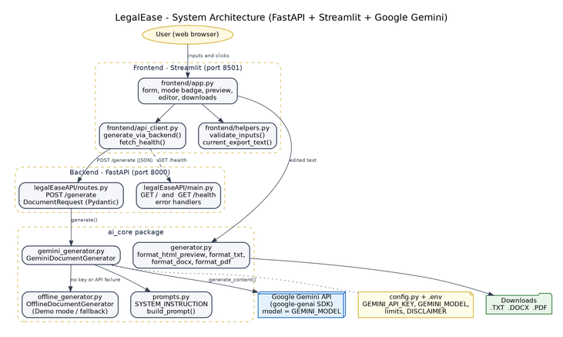

Figure 1: System architecture of LegalEase
The Streamlit frontend (port 8501) talks to the FastAPI backend (port 8000) over HTTP. The backend validates input with the DocumentRequest model and delegates to GeminiDocumentGenerator, which calls Gemini in live mode or OfflineDocumentGenerator in Demo and fallback mode. The frontend builds the exports from the latest edited text with ai_core/generator.py.
5.2 Data Flow

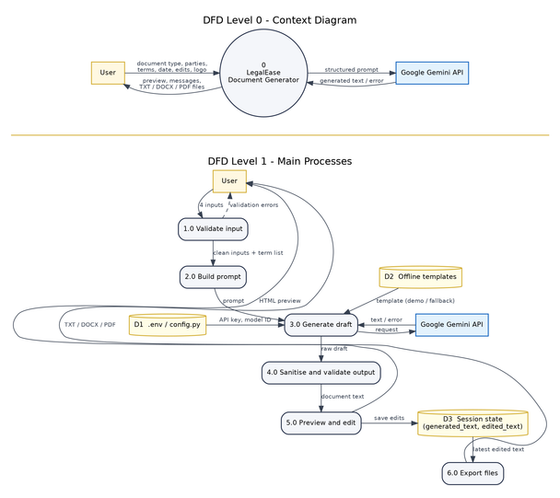

Figure 2: Data flow diagram, level 0 and level 1
5.3 Use Cases

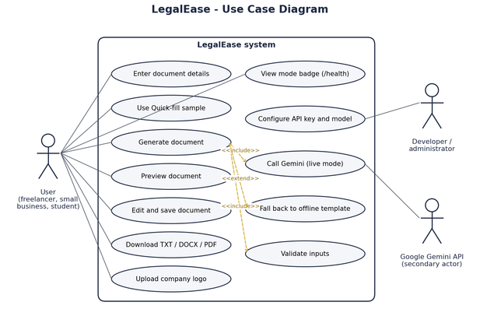

Figure 3: Use case diagram
5.4 AI Generation and Fallback Flows
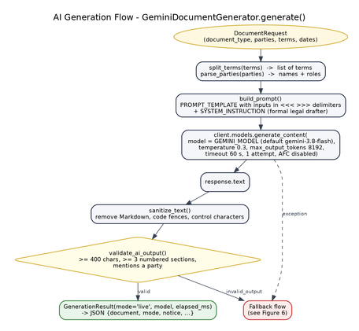 | 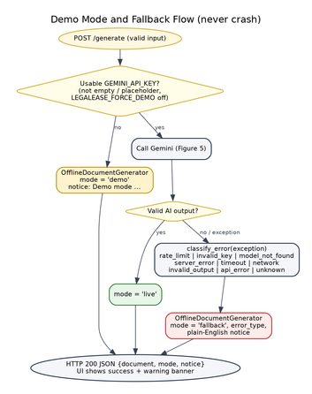
Figure 4: AI generation flow | Figure 5: Demo mode and fallback flow

The AI output is accepted only if it has at least 400 characters, at least three numbered sections and mentions at least one party. Errors are classified as rate_limit, invalid_key, model_not_found, server_error, timeout, network, invalid_output, api_error or unknown, and each type has its own plain-English notice.
5.5 Data Model and API
Table 5: API routes and data
Route | Method | Input | Output
/ | GET | none | message, app, version, mode
/health | GET | none | status, mode, model, api_key_configured, sdk, disclaimer
/generate | POST | document_type, parties, terms, dates (JSON) | document, mode, model, notice, error_type, elapsed_ms, terms, disclaimer

5.6 Prompt Design
The system instruction gives Gemini the role of a formal legal drafter, forbids invented facts (missing details become placeholders such as [Governing State]) and forbids Markdown. The user prompt wraps every input in <<< >>> delimiters, asks for a title in capitals, a preamble, numbered sections with sub-clauses, a section named exactly "Specific Terms" that restates each user term, the standard sections for the document type and a signature block. The exact text is in the Phase 3 document.
5.7 User Interface Design

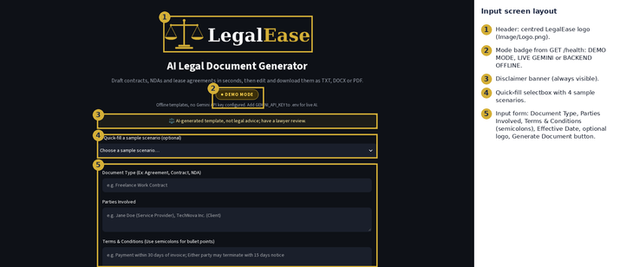

Figure 6: Annotated layout of the input screen
Chapter 6: Implementation
6.1 Technology Stack
Table 6: Technology stack
Layer | Technology (version) | Role
Frontend | Streamlit 1.64.0 | Form, badge, preview, editor, downloads
Backend | FastAPI 0.141.1, Uvicorn 0.54.0, Pydantic 2.13.4 | REST API and validation
AI | google-genai 2.25.0 (Gemini, model from GEMINI_MODEL) | Document drafting
Exports | python-docx 1.1.2, fpdf2 2.8.8, Pillow 12.3.0 | DOCX, PDF, logos
Config | python-dotenv 1.2.3 | .env settings
Testing | pytest 9.0.3, pytest-cov 7.1.0, Playwright 1.63.0 | Tests, coverage, UI checks, screenshots

6.2 Backend and AI Module
legalEaseAPI/main.py creates the FastAPI app, logs every request with its duration and converts validation errors into short sentences such as "'dates' must not be empty." routes.py defines DocumentRequest (whitespace stripped, length limits, at most 25 terms, letters required) and POST /generate, which receives the generator through a FastAPI dependency so tests can replace it. ai_core/gemini_generator.py creates the google-genai client with a timeout and a single attempt, sends the prompt with temperature 0.3, sanitises and validates the reply and handles every error.
6.3 Export Module
ai_core/generator.py parses the plain text into blocks (title, headings, clauses, bullets and the terms block). The DOCX uses A4 pages, Times New Roman 12 pt, the logo on the first page only, the Specific Terms as a two-column table and a footer with the disclaimer and "Page X of Y" fields. The PDF uses fpdf2 with DejaVu fonts, the logo and a gold rule in the header of every page, bold headings, bullet-style terms and the same footer. The TXT ends with the disclaimer line.
6.4 Frontend
frontend/app.py shows the logo, the mode badge from GET /health, the disclaimer, a Quick-fill selectbox and the input form. After generation it shows a success banner, the preview, the editor with Save Changes and Reset buttons, and the three download buttons, which always use the latest saved text.
6.5 Scenario Walkthrough
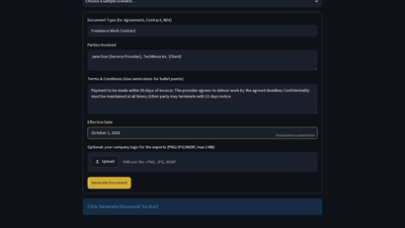 | 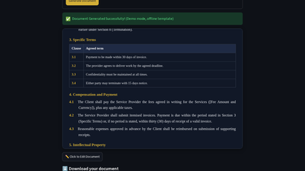
Figure 7: Scenario 1 inputs (Jane Doe and TechNova Inc.) | Figure 8: Scenario 1 terms as clauses 3.1 to 3.4

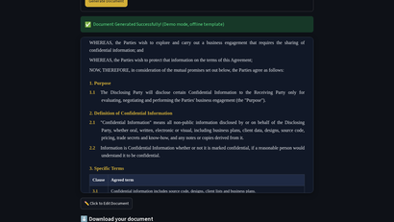 | 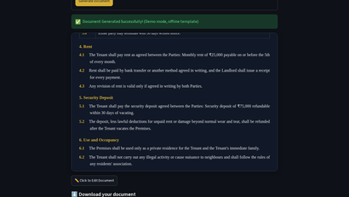
Figure 9: Scenario 2: NDA with Disclosing and Receiving Party | Figure 10: Scenario 3: lease rent and deposit clauses (₹)

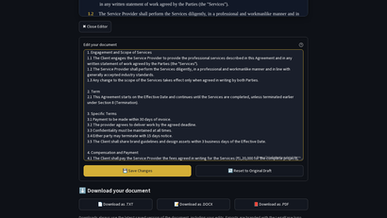 | 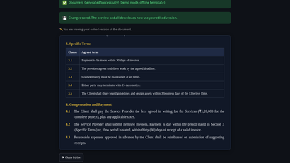
Figure 11: Scenario 4: editing the document | Figure 12: Scenario 4: saved edits in the preview

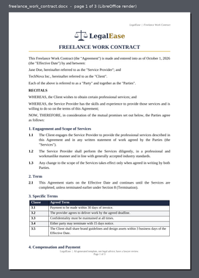 | 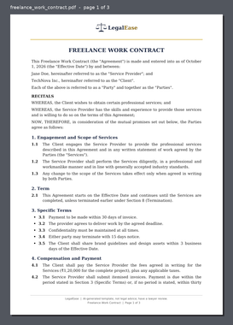 | 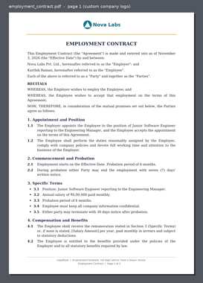
Figure 13: Downloaded DOCX, page 1 | Figure 14: Downloaded PDF, page 1 | Figure 15: PDF with an uploaded company logo

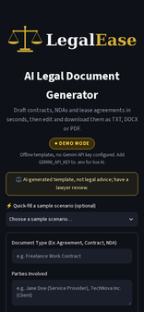 | 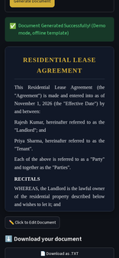 | 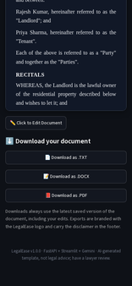
Figure 16: Mobile: home | Figure 17: Mobile: preview | Figure 18: Mobile: downloads

6.6 Challenges and Solutions
Table 7: Challenges and solutions
Challenge | Solution
The spec used the old google-generativeai SDK (genai.configure) | Rewrote the integration with the current google-genai SDK (genai.Client, models.generate_content, HttpOptions for timeout and retries).
The spec hard-coded gemini-1.5-pro | The model ID is read from GEMINI_MODEL in .env (default gemini-3.8-flash), so it can change without code edits.
Downloads in the spec used generated_text | Added current_export_text(): the preview and all three downloads use the latest saved edit; covered by tests and UI checks.
No real API key was available during development | Built Demo mode and a fallback path; tested live-mode logic with a fake Gemini client and exercised a real Google error with a deliberately invalid key.
Unicode in PDF export | Switched to fpdf2 with bundled DejaVu Serif/Sans fonts; missing glyphs (e.g. Tamil) log a warning instead of crashing.
User text containing { } broke template filling | Replaced str.format() with a small regex-based _fill() that only replaces known placeholders.
Automating Streamlit for screenshots | Wrote Playwright helpers that scroll the element first, retry the selection and offset the fixed header.

Chapter 7: Testing and Results
7.1 Test Strategy
Testing used four levels: unit tests for the parser, sanitiser, prompts, templates and exports; API tests with FastAPI's TestClient, including a fake Gemini client that raises each error type; integration tests with a real uvicorn server and Streamlit's AppTest; and end-to-end UI checks where Playwright drives the running application in Chromium and saves a screenshot for each check.
7.2 Automated Test Results
Table 8: pytest results: 97 passed in 12.14s
Test module | Test cases | Passed
tests/test_api.py | 25 | 25
tests/test_config.py | 14 | 14
tests/test_exports.py | 9 | 9
tests/test_frontend.py | 13 | 13
tests/test_gemini_generator.py | 13 | 13
tests/test_offline_generator.py | 14 | 14
tests/test_parser_and_utils.py | 9 | 9
Total | 97 | 97

Line coverage measured with pytest-cov is 93% (1,131 of 1,213 statements). The raw output is saved in docs/evidence/06_pytest_output.txt, together with the JUnit XML and coverage JSON files.

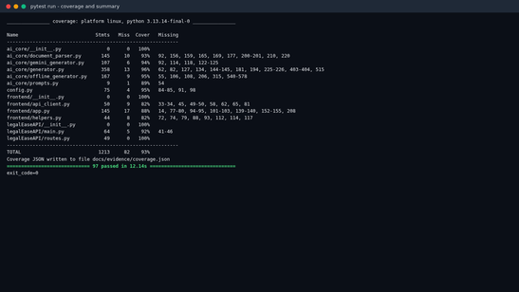

Figure 19: End of the real pytest run: coverage table and summary
7.3 UI Checks and Edge Cases
Table 9: End-to-end UI checks (17 of 17 passed)
ID | Check | Status
UI-01 | Home page loads with Demo mode badge and disclaimer | Pass
UI-02 | GET /health reports the resolved mode | Pass
UI-03 | API docs list POST /generate | Pass
UI-04 | Scenario 1 freelance contract generated | Pass
UI-05 | Scenario 2 NDA generated | Pass
UI-06 | Scenario 3 lease generated | Pass
UI-07 | Edited text is saved and previewed | Pass
UI-08 | TXT download uses edited text | Pass
UI-09 | DOCX download uses edited text and formatting | Pass
UI-10 | PDF download uses edited text; header/footer on every page | Pass
UI-11 | Custom logo is used in the PDF export | Pass
UI-12 | Empty form shows validation errors | Pass
UI-13 | Very long terms are rejected | Pass
UI-14 | Backend 422 validation message shown | Pass
UI-15 | Backend down shows friendly error | Pass
UI-16 | AI failure falls back to offline template | Pass
UI-17 | Mobile layout renders without horizontal scrolling | Pass

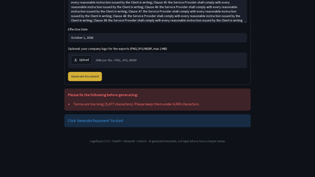 | 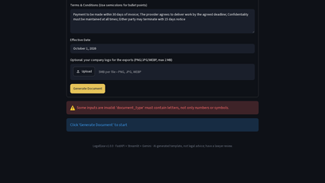
Figure 20: Very long terms rejected | Figure 21: Invalid input rejected by the API (422)

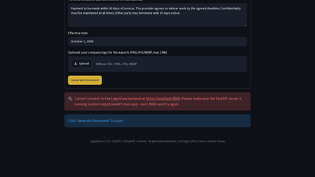 | 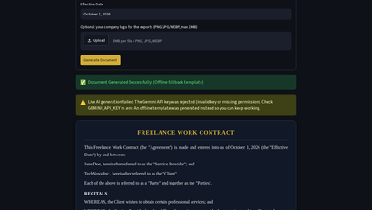
Figure 22: Backend down: friendly message | Figure 23: Gemini error: automatic fallback

7.4 Performance
Table 10: Performance measured on the development machine (2 CPUs)
Measurement (4 sample scenarios, this build) | Result
POST /generate in Demo mode (TestClient) | median 5 ms, max 9 ms
Building TXT + DOCX + PDF | median 326 ms, max 470 ms
Document length | 4,239 to 5,425 characters
Export sizes (TXT / DOCX / PDF) | about 5 KB / 75 KB / 79 KB
Full pytest suite | 12.1 s for 97 test cases

Live Gemini response times were not measured because no real API key was available; the configured timeout is 60 seconds and the frontend waits up to 120 seconds.
7.5 Videos
Demo video: media/Demo_Video.mp4 (3:35), walking through all scenarios.
Testing video: media/Testing_Video.mp4 (2:41), a live pytest run and the UI edge cases.
Chapter 8: Limitations
The live Gemini success path was not demonstrated in this submission because no real API key was available; live mode was tested with a fake client and a real invalid-key error from Google.
Documents are templates, not legal advice, and are not tailored to the law of a specific state or country.
There is no database: documents are not saved between sessions (privacy benefit, but no history).
PDF fonts cover Latin, Greek, Cyrillic and symbols such as the rupee sign, but not Tamil, Hindi or Chinese.
Demo-mode templates cover NDA, lease, employment, service and a general agreement; other types use the general template.
The app runs locally; it has no user login, HTTPS or rate limiting for public deployment yet.
Chapter 9: Future Enhancements
User accounts with saved document history (database)
Clause library and optional clauses selected with checkboxes
Indian regional languages (Tamil, Hindi) with suitable PDF fonts
E-signature integration and version comparison (track changes)
Jurisdiction-specific templates reviewed by practising lawyers
Deployment to a cloud host (Render, Railway or Google Cloud Run) with HTTPS
Chapter 10: Conclusion
LegalEase meets its objectives: it turns four simple inputs into a structured legal draft, lets the user edit it and exports exactly the edited version as TXT, DOCX and PDF with professional formatting and a disclaimer. The move to the current google-genai SDK and an environment-configured model keeps the project working as Gemini models change, while Demo mode and the fallback make the app usable without a key and robust to API failures. 97 automated tests and 17 UI checks passed with 93% coverage. The main open item is a verified live Gemini run with a real API key. The project gave practical experience in prompt design, API development, UI building, document generation and testing, and shows how AI can speed up routine drafting while keeping a human and a lawyer in the loop.
References
Google AI for Developers, 'Gemini API models', https://ai.google.dev/gemini-api/docs/models (accessed 25 Sep 2026).
Google, 'Google Gen AI Python SDK (google-genai)', https://googleapis.github.io/python-genai/ (accessed 25 Sep 2026).
FastAPI documentation, https://fastapi.tiangolo.com/ (accessed 25 Sep 2026).
Streamlit documentation, https://docs.streamlit.io/ (accessed 25 Sep 2026).
Pydantic documentation, https://docs.pydantic.dev/ (accessed 25 Sep 2026).
python-docx documentation, https://python-docx.readthedocs.io/ (accessed 25 Sep 2026).
fpdf2 documentation, https://py-pdf.github.io/fpdf2/ (accessed 25 Sep 2026).
pytest documentation, https://docs.pytest.org/ (accessed 25 Sep 2026).
Playwright for Python documentation, https://playwright.dev/python/ (accessed 25 Sep 2026).
Project specification 'LegalEase - AI-Powered Legal Document Generator' (internship brief, 25 pages).
Appendix A: Setup and Run Guide
# 1. Get the code and create a virtual environmentcd LegalEasepython -m venv venvsource venv/bin/activate # Windows: venv\Scripts\activatepip install -r requirements.txt# 2. Configure (an empty key runs Demo mode)cp .env.example .env # Windows: copy .env.example .env# GEMINI_API_KEY=your-key-from-aistudio.google.com (optional)# GEMINI_MODEL=gemini-3.8-flash# 3. Start both servers./run.sh # Windows: run.bat# backend -> http://localhost:8000 (docs at /docs)# frontend -> http://localhost:8501# 4. Run the testspython -m pytest -v

Appendix B: API Documentation
GET /health returns the resolved mode. Real response from this build:
{ "status": "ok", "app": "LegalEase", "version": "1.0.0", "mode": "demo", "mode_description": "Demo mode - offline deterministic templates (no usable GEMINI_API_KEY)", "model": "gemini-3.8-flash", "api_key_configured": false, "force_demo": false, "sdk": "google-genai", "disclaimer": "AI-generated template, not legal advice; have a lawyer review."}

POST /generate accepts document_type, parties, terms and dates (all required strings). It returns 200 with the document in every mode, or 422 when validation fails. Real 422 response for an empty date:
{ "error": "validation_error", "message": "'dates' must not be empty.", "errors": [ "'dates' must not be empty." ], "detail": [ { "loc": [ "body", "dates" ], "msg": "String should have at least 1 character", "type": "string_too_short" } ]}

curl -X POST http://localhost:8000/generate -H "Content-Type: application/json" -d '{ "document_type": "Freelance Work Contract", "parties": "Jane Doe (Service Provider), TechNova Inc. (Client)", "terms": "Payment within 30 days of invoice; Either party may terminate with 15 days notice", "dates": "October 1, 2026"}'

Page 1 of 1

