Sequential Binary Multiplier

第18組 A1053308 蘇詠盛、A1055547 王公志

# Abstract

使用Verilog做出Sequential Binary Multiplier，將教材ppt乘法器的DATAPATH以及CONTROL獨立為兩個MODULE。

# Content

VHDL程式碼

* **Sequential Binary Multiplier：**

module Sequential_Binary_Multiplier(Product, Ready, Multiplicand, Multiplier, Start, clock, reset_b);

parameter dp_width = 5;

output [2*dp_width - 1: 0] Product;

output Ready;

input [dp_width - 1: 0] Multiplicand, Multiplier;

input Start, clock, reset_b;

wire Load_regs, Decr_P, Add_regs, Shift_regs;

control (Ready, Load_regs, Add_regs, Shift_regs, Decr_P, Zero, Q0, clock, reset_b, Start);

datapath (Product, Q0, Zero, Multiplicand, Multiplier, Load_regs, Add_regs, Shift_regs, Decr_P, clock);

endmodule

* **Control Unit：**

module control(Ready, Load_regs,Add_regs, Shift_regs, Decr_P, Zero , Q0, clock, reset_b, Start);

output Ready;

input clock, Q0, Zero, reset_b, Start;

output Load_regs, Decr_P, Add_regs, Shift_regs;

reg Load_regs, Decr_P, Add_regs, Shift_regs;

reg [2:0] state, next_state;

parameter S_idle = 3'b001,

S_add = 3'b010,

S_shift = 3'b100;

wire Ready = (state == S_idle);

always@(posedge clock, negedge reset_b)begin

if(~reset_b)

state <= S_idle;

else

state <= next_state;

end

always@(state, Start, Q0, Zero)begin

next_state <= S_idle;

Load_regs <= 0;

Decr_P <= 0;

Add_regs <= 0;

Shift_regs <= 0;

case(state)

S_idle: begin if (Start) next_state <= S_add;

Load_regs <= 1;

end

S_add: begin next_state <= S_shift;

Decr_P <= 1;

if(Q0) Add_regs <= 1;

end

S_shift: begin Shift_regs <= 1;

if(Zero) next_state <= S_idle;

else next_state <= S_add;

end

endcase

end

endmodule

* **Datapath Unit：**

module datapath (Product, Q0,Zero, Multiplicand, Multiplier, Load_regs, Add_regs, Shift_regs, Decr_P, clock);

output Zero, Q0;

output [2 * dp_width - 1:0] Product;

input [dp_width-1:0] Multiplicand,Multiplier;

input clock, Load_regs, Add_regs, Shift_regs, Decr_P;

parameter BC_size = 3;

parameter dp_width = 5;

assign Product = {A, Q};

reg [dp_width - 1: 0] A, B, Q;

reg C;

reg [BC_size - 1:0] P;

wire Q0 = Q[0];

wire Zero = (P == 0);

always@(posedge clock) begin

if(Load_regs) begin

P <= dp_width;

A <= 0;

C <= 0;

B <= Multiplicand;

Q <= Multiplier;

end

if(Add_regs){C, A} <= A + B;

if(Shift_regs){C ,A, Q} <= {C, A, Q} >> 1;

if(Decr_P)P <= P-1;

end

endmodule

**模擬結果：**

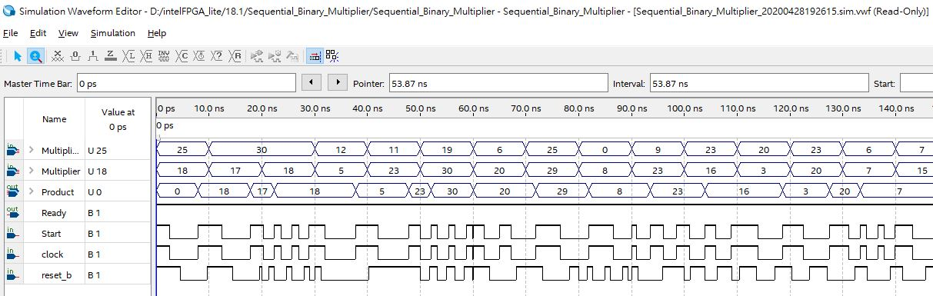

# Discussions

本次作業基本可以由各堂的PPT上得到作法，其餘部分則必須注意到reg和wire等等資料型態的差別，根據不同用途在不同module中來宣告。

**參考資料：課堂上課PPT講義**