**Component Design:**

Main

main (int argc, const char *argv[])

Create a scanner

Create a token

Have scanner start reading the file

Check for <identifiers>

Return 0

Print

Print (char source_name[], char date[])

Set the filename to source_name

get current time

set the page number to zero

printLine (char line[])

increment the line count

if line_count> page height Print header

print the string argument

PrintPageHeader ()

Print header (page number, source file name , current date)

PrintToken (Token *token)

Increment the line count

Default -> print token

printTreeRecursive (Identifier *identifier)

set LineNumberList

get TokenString

send identifier to binary tree

printTree (Identifier *identifier)

set proper labels and spaces

print identifier tree

Scanner

Scanner (FILE *source_file, char source_name[], char date[], Print printer)

Src_file= source_file

Copy (src_name, source name)

Copy (todays_date, date)

Initialize char table to identify what type of char we are looking at

Initialize Line numer=0

Source line [0] = ‘\0’

getSourceLine(char source_buffer)

create source buffer

create false Boolean

get a line from the filestream

if line received then true

return Boolean

getToken()

initialize a character code variable

skip past all the blanks

examine ch for LETTER, DIGIT, QUOTE, EOF, or SPECIAL

call appropriate function depending on ch

return new_token

getChar(char souce_buffer[])

set a temp char to EOF

if at the end of line ->return null character

else return the char at the index

skipBanks (char source_buffer[])

skip past the blanks

return pointer to the first non blank character

skipComments (char source_buffer[])

skip past the comments

return pointer to the first non blank character

watch for the EOF character

getWord (char *str, char *token_ptr. Token *tok)

Extract the word

Downshift the word, to make it lower case

Check if the word is a reserved word

If is not a reserved word its an identifier

Set token to identifier

getNumber (char *str, char *token_ptr, Token *tok)

extract number and convert it to a literal number

check if real or float

temp string number

set the token type to NUMBER

getString (char *str, char *token_ptr, Token *tok)

Initialize a temporary string

Whie char ch is not a ‘\’’

Read more characters

Append characters to temp string

Set the setType to STRING_LIT

Set the setCode to STRING

getSpecial (char *str, char *token_ptr, Token *tok)

initialize the temp string

check for character operators (:,<,>,.,|)

read next character

if (= or .) -> append both to temp string

else -> append first character to the temp string

downshiftWord (char word[])

make all characters in the incoming word lower case

isReservedWord (char *str, Token *tok)

Scan the token table for reserved words

If it is a reserved word -> set the token code member ->return True

Else -> return False

getLineNumer ()

return line_number

Token

Token ()

Initialize variables for binary search tree (lines, left, righ)

setCode (TokenCode newCode)

set newCode

getCode ()

Return token code member

setTokenString (string s)

setTokenString = s

getTokenString (string s)

return Token code member

LineNumberList

LineNumberList ()

Set val to 0

Set next to NULL

setLineNumberList (int num)

Set lineNumber =num

getLineNumberList ()

return LineNumber

setNextLineNumberList (LineNumberList *next)

Set nextLineNumber =next

getNextLineNumberList ()

return nextLineNumber

Identifier

Identifier (string val)

Set list = NULL

Set literal equal to val

tokenString is equal to val

setLeftChild (Identifier *tok)

set leftChild = tok

getLeftChild()

return leftChild

setRightChild (Identifier *tok)

set RightChild = tok

getRightChild()

return rightChild

getTokenString()

return literal

addToLineNumberList (LineNumberList *listItem)

if tmp is NULL list is listItem

else tmp= next line numner

setNextLineNumber to tmp

getLineNumberList()

return list

IdentifierBinaryTree

IdentifierBinaryTree()

Set value of treeRoot = NULL

depthFirstDeleteTree(Identifier *tok)

if tok->getLeftChild not NULL

getLeftChild

if tok->getRightChild not NULL

getRighChild

delete tok

setTreeRoot(Identifier *root)

Set value of treeRoot = root

getTreeRoot()

return treeRoot

addIdentifier2(Identifier* &head, Identifier* tok, int lineNum)

set false boolean called success

if head= NULL

head= tok

add head ToLineNumberList

set success to true

getTokenString and set leftChild, rightChild or head appropriately

Integer

Integer()

Set value to “INTEGER”

Return int

Real

Real()

Set value to “REAL”

Return double

string

setString(string value)

Set value to “String”

Return value

**UML DIAGRAM**

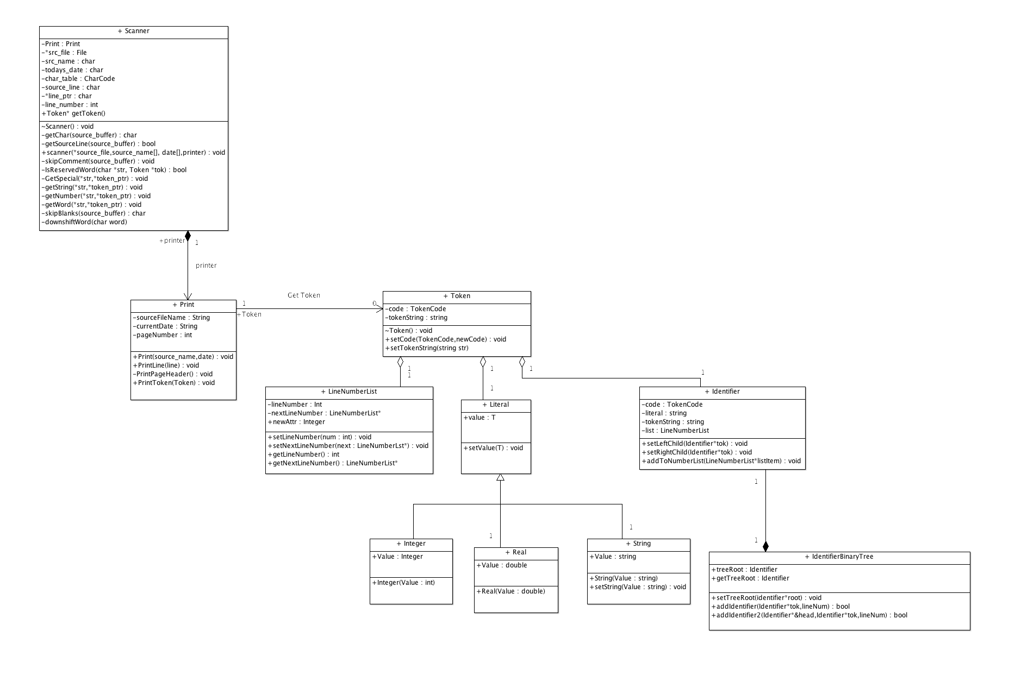

**Team Contribution Table**

|  |  |  |
| --- | --- | --- |
| Name | Login | Score (0= No contribution 2= good contribution) |
| Peter Johnson | ptjohns2 | 2 |
| Roberto Gonzalez | rgonza26 | 2 |
|  |  |  |
| URL to Repository: |  | https://github.com/rgonza26/Lab5 |

**Testing**

|  |  |  |  |  |
| --- | --- | --- | --- | --- |
| Function | Parameter (V->Valid, I ->Invalid) | Expected Result | Acutal Result | |
| main | argv |  |  |  |
| Test 1 | V | Program Produces Expected Results | Expected result | |
| Test 2 | I | Application Crashes | Expected result | |
|  |  |  |  |  |
|  |  |  |  |  |
| Function | Parameter (V->Valid, I ->Invalid) | Expected Result | Acutal Result | |
| print | sourceFileName |  |  |  |
| Test 3 | V | File Name matches valid flie name | Expected result | |
| Test 4 | I | File Name does not match valid file name | Expected result | |
| printLine | line |  |  |  |
| Test 5 | V | prints line | Expected result | |
| Test 6 | I | prints nothing | Expected result | |
| printPageHeader |  |  |  |  |
| Test 7 |  | prints header | Expected result | |
| printToken | Token |  |  |  |
| Test 8 | V (4) | Prints the integer literal | Expected result | |
| Test 9 | V (3.1) | Prints the Float literal | Expected result | |
| Test 10 | V ("test") | Prints the STRING literal | Expected result | |
| Test 11 | V ("PROGRAM") | Prints the Token | Expected result | |
| Test 12 | I | Nothing Prints NO_Token type | Expected result | |
| printTreeRecursive | Identifier |  |  |  |
| Test | V | Identifier gets added to leftChild, RightChild | Expected Result | |
| Test | I | tree error |  |  |
|  |  |  |  |  |
|  |  |  |  |  |
|  |  |  |  |  |
| Function | Parameter (V->Valid, I ->Invalid) | Expected Result | Acutal Result | |
| Scanner | Tested during Main |  |  |  |
|  |  |  |  | |
| getSourceLine | Tested during Main |  |  | |
|  |  |  |  |  |
| getToken | Tested during Main |  |  | |
|  |  |  |  | |
| getChar | source_buffer |  |  |  |
| Test 13 | V ("test) | returns 't' | Expected result | |
| Test 14 | I "" | returns" | Expected result | |
| skipBlanks | source_buffer |  |  | |
| Test 15 | V ( two spaces) | returns 2 | Expected result | |
| Test 16 | I (spaces here" | returns 1 | Expected result | |
| skipComment | source_buffer |  |  | |
| Test 17 | V "this is a {comment}" | Removes Comment from source line | Expected result | |
| Test 18 | I "this is a comment" | Prints the line | Expected result | |
| getWord | ch |  |  | |
| Test 19 | V 'a' | Tested during print | Expected result | |
| Test 20 | I '{' | Empty token string | Expected result | |
| getNumber | ch |  |  | |
| Test 21 | V '5' | Tested during print | Expected result | |
| Test 22 | I '{' | Empty token string | Expected result | |
| getString | ch |  |  | |
| Test 23 | V | Tested during print | Expected result | |
| Test 24 | I '{' | Empty token string | Expected result | |
| getSpecial | str |  |  | |
| Test 25 | V "program" | returns 1 | Expected result | |
| Test 26 | I 'nothing" | returns false | Expected result | |
| downshitfWord | char |  |  | |
| Test 27 | V 'OK' | ok | Expected result | |
| Test 28 | I '{' | Empty token string | Expected result | |
| isREservedWord | ch |  |  | |
| Test 29 | V"DO" | Tested during print | Expected result | |
| Test 30 | I '{' | Empty token string | Expected result | |
|  |  |  |  |  |
|  |  |  |  |  |
| Function | Parameter (V->Valid, I ->Invalid) | Expected Result | Acutal Result | |
| Token | Tested during Main |  |  |  |
|  |  |  |  | |
| setCode | Tested during Main |  |  | |
| getcode | TokenCode |  |  |  |
| Test 31 | V | new code is set | Expected result | |
| Test 32 | I | error no code set | Expected result | |
| setTokenString | Tested during Main |  |  | |
| getTokenString | String |  |  |  |
| Test 33 | V | val is set to token string | Expected result | |
| Test 34 | I | Val is not set error | Expected result | |
|  |  |  |  |  |
|  |  |  |  |  |
|  |  |  |  |  |
| Function | Parameter (V->Valid, I ->Invalid) | Expected Result | Acutal Result | |
| LineNumberList |  |  |  |  |
|  |  |  |  | |
| setLineNumber | int |  |  | |
| Test 35 | V | lineNumber = num | Expected result | |
| Test 36 | I | invalid | Expected result | |
| setNextLineNumber | LineNumberList |  |  |  |
| Test 37 | V | nextLineNumber = next | Expected result | |
| Test 38 | I | Invalid | Expected result | |
|  |  |  |  |  |
|  |  |  |  |  |
| Function | Parameter (V->Valid, I ->Invalid) | Expected Result | Acutal Result | |
| Identifier |  |  |  |  |
|  |  |  |  | |
| setLeftChild | Identifier |  |  | |
| Test 39 | V | this leftChild | Expected result | |
| Test 40 | I | Error | Expected result | |
| setRightChild | Identifier |  |  | |
| Test 41 | V | set RightChild | Expected result | |
| Test 42 | I | Error | Expected result | |
| addToLineNumberList | LineNumberList |  |  | |
| Test 43 | V | get NextLineNumber | Expected result | |
| Test 44 | I | Error | Expected result | |
|  |  |  |  | |
|  |  |  |  | |
|  |  |  |  |  |
|  |  |  |  |  |
| Function | Parameter (V->Valid, I ->Invalid) | Expected Result | Acutal Result | |
| IdentifierBinaryTree |  |  |  |  |
|  |  |  |  | |
| depthFirstDeleteTree | identifier |  |  | |
| Test 45 | V | getLeftChild or getRightChild | Expected result | |
| Test 46 | I | invalid | Expected result | |
| setTreeRoot | Identifier |  |  |  |
| Test 47 | V | treeRoot=root | Expected result | |
| Test 48 | I | Invalid | Expected result | |
|  |  |  |  |  |
|  |  |  |  |  |
| Function | Parameter (V->Valid, I ->Invalid) | Expected Result | Acutal Result | |
| Integer | int |  |  |  |
|  |  |  |  | |
| Real | double |  |  | |
|  |  |  |  | |
|  |  |  |  | |
| String | String |  |  |  |
|  |  |  |  | |
|  |  |  |  | |