**Assignment 4: Implementing Control Structures**

**Rinku Gopali**

**University of the Cumberlands**

**Advanced Programming Languages (MSCS-632-M50)**

**Dr. Vanessa Cooper**

**03/02/2025**

**Output of The Python Code:**

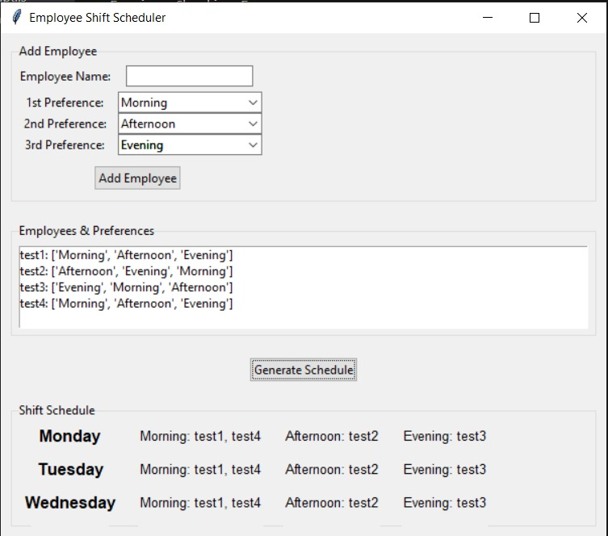

**Output of The JavaScript Code:**

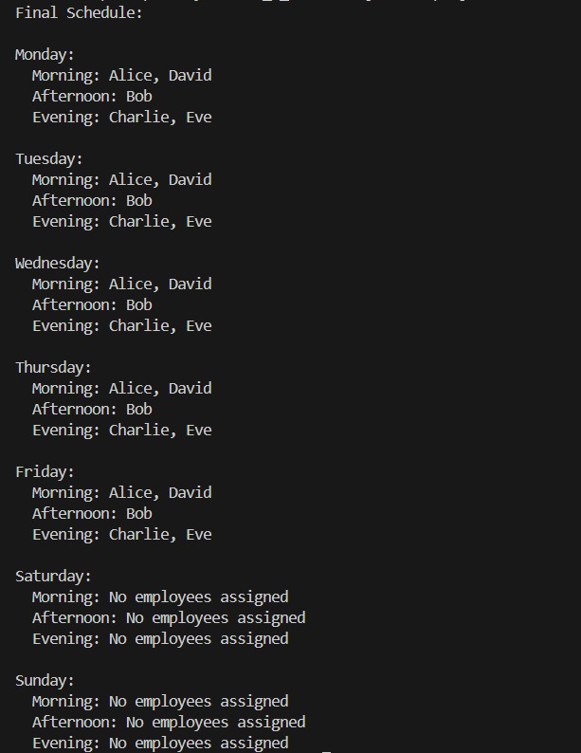

**Github Link:** [**https://github.com/rgopali25573/Assignment-4-Implementing-Control-Structures**](https://github.com/rgopali25573/Assignment-4-Implementing-Control-Structures)