Group Project

Forecasting International Tourist Visits in the United States

Andrew Tang
Isaac Park
Rachael Gottbetter
Suwat Chritamara

Whiting School of Engineering, Johns Hopkins University
EN.625.695.83 : Time Series Analysis
Instructor: Moustapha Pemy
November 14, 2023

Abstract
Today, tourism is one of the world’s largest and fastest-growing service industries. In the US, according to WTTC’s Travel & Tourism Economic Impact 2023 Global Trends Report, the GDP contribution of the U.S. travel and tourism sector grew by 16.9% in 2022 to reach $2 trillion. Additionally, the sector also created 2.7 million more jobs compared to 2021. The sector’s GDP contribution is forecast to reach $2.2 trillion, and job numbers will total 17.4 million in 2023.

Given how important tourism is for the United States economy, having the ability to forecast inbound tourism in the USA can be very powerful in helping with decision-making as well as infrastructure and policy planning. In this project, the objective is to find a suitable model that fits the data and then use that model to make a forecast. The best-fitting SARIMA model is constructed based on the AIC criteria. The fitted SARIMA (3,2,4) x (3,2,2)12 is able to forecast international tourist visits in the United States.

Background
There are various time series models that can be used for forecasting inbound tourism. Some of the time series models that can be used for this include: an autoregressive moving average model (ARMA), an autoregressive integrated moving average (ARIMA), and a seasonal autoregressive integrated moving average (SARIMA). These approaches have different features which make certain models more appropriate than other depending on the data phenomenon it is trying to capture. Thus, a strong model fit is important, and the forecasting performances of the models were evaluated based on root mean square error (RMSE) and mean absolute percentage error (MAPE).

Various studies have used a time series model to predict customer behavior. This includes Borhan and Arsad's (2014) study of “Forecasting International Tourism Demand from the US, Japan, and South Korea to Malaysia using a SARIMA Approach. Choden and Suntaree Unhapipat (2018) forecasted international tourist visits in Bumthang, Bhutan, using SARIMA. The study found that the best-fitted model is seasonal SARIMA (0, 0, 0) × (1, 1, 0). The SARIMA model is able to forecast international tourist visits for the period January 2017–June 2017 with 91% accuracy.

Lim and McAleer (2002) used the Box-Jenkins method to forecast international travel demand for Australia by using the autoregressive integrated moving average (ARIMA) model. The study tested various alternative models from the dataset of the period 1975–1989 based on three major tourist markets, namely Malaysia, Singapore, and Hong Kong. The study shows how the best-fit model is selected and its application in the field of forecasting. Other studies include Zahedjahromi, M. (2018), which studied forecasting tourists' arrivals to the USA with the SARIMA model. Rangika I. P. H. (2016) studies forecasting the tourist arrivals to Sri Lanka using the SARIMA model with the total number of tourist arrivals for the period of 1995 January to July 2016.

The Data

For this study, secondary data was used, which was collected from CEIC (original source: National Travel and Tourism Office). The data consists of monthly inbound tourists to the USA from 1996 to 2023. We decided to have a training and test set where the training set is used to find the model parameters while the test set is used to evaluate its out-of-sample performance.

The dataset is provided in Excel format at “US tourist arrival dataset” files as the following table:

Date  (Month/Year) | Number of Visitor Arrivals  (monthly)
04/1996 | 3,107,737
05/1996 | 3,243,037
06/1996 | 3,147,353
07/1996 | 4,278,520
08/1996 | 4,255,329
. | .
. | .
. | .
. | .
. | .
6/2023 | 4,996,037
7/2023 | 6,465,828
Table 1: Monthly international tourist visits in the USA from January 1996 to July 2023
(The full dataset is provided in Excel File name: “US tourist arrival dataset”)

ARMA, ARIMA and SARIMA models

In this project study, we will evaluate three different models: ARMA, ARIMA, and SARIMA, for time series forecasting. Generally, the functionalities of these models can be summarized as follows:
- ARMA: Autoregressive + Moving Average
- ARIMA: Autoregressive + Moving Average + Trend Differencing
- SARIMA: Autoregressive + Moving Average + Trend Differencing + Seasonal Differencing
The process $X_{t}$is ARMA (p,q) if:
- ${(X_{t})}_{t }is stationary$
- ARMA (p,q) model can be expressed as:
$X_{t}-∅_{1}X_{t-1}-...{-∅}_{p}X_{t-p}= Z_{t}+ θ_{1}Z_{t-1}+...+θ_{q}Z_{t-q}$ where $Z_{t}\sim WN \left(0, σ^{2}\right) and$the backward shift operator can be written as:
$∅\left(B\right)X_{t}= θ\left(B\right)Z_{t}$ where $∅\left(B\right)$ and $θ\left(B\right)$are polynomials of $B$ used for model coefficients, $X_{t}$ is the monthly tourist arrival series and $Z_{t}$ is an error term.

For $ARIMA \left(p,d, q\right)$ model with parameter $p,d,q$ if the process ${\left(1-B\right)}^{d}X_{t}$ $is causal$ $ARMA \left(p,q\right)$ process. $ARIMA(p,d, q)$ process can be written in terms of the Backward Shift Operator: $∅\left(B\right) {\left(1-B\right)}^{d} X_{t}= θ\left(B\right) Z_{t}$ , with;
$$∅\left(z\right)=1- ∅_{1}z-∅_{2}z^{2}- …-∅_{p}z^{p} and θ\left(z\right)=1+θ_{1}z-θ_{2}z^{2}- …-θ_{q}z^{q}$$
Lastly, the $SARIMA\left(p,d,q\right)x\left(P,D,Q\right)s$ model, where: p represents the nonseasonal AR order, q represents the nonseasonal MA order, d represents the nonseasonal differencing order, P represents the seasonal AR order, D represents the seasonal differencing order, Q represents the seasonal MA order, and s represents the time-span of repeating the seasonal pattern, or, in other terms, the seasonal period.

The $x_{t} is SARIMA$ $\left(p,d,q\right)x \left(P, D,Q\right)s with$ period s if the differenced series $Y_{t}= {(1-B)}^{d}{{(1-B^{s})}^{D}X}_{t}$ is causal ARMA with the general model is:
$∅\left(B\right) Φ \left(B^{s}\right)Y_{t}= θ\left(B\right) Θ \left(B^{s}\right)Z_{t} ,{ Z}_{t}\sim WN \left(0, σ^{2}\right)$ where,
$$∅ \left(z\right)=1- ∅_{1}z-… ∅_{p}z^{p}, Φ\left(z\right)=1-Φ_{1}z-…-Φ_{P}z^{P}, θ \left(z\right)=1+ θ_{z}+…+ θ^{q}z^{q},$$
$$Θ \left(z\right)=1+ Θ_{1}z+...+Θ_{Q}z^{Q}$$

Methodology

The data analysis will be done primarily using the Python statistical package. First, we attempt to do some data exploration to understand the data. Time series plots are used to visualize the patterns of inbound tourism over the study period. We also examine the autocorrelation function (ACF) and partial autocorrelation function (PACF) on the data to understand more about the features of the data. Then, we attempt to fit each of the time series models and find the parameters using the training set. The Akaike Information Criteria (AIC) and the Bayesian Information Criteria were used to determine which models to move forward with. Next, we evaluate the performance of the models that came out of the training set in the test set using root mean squared error (RMSE) and mean absolute percentage error (MAPE). Lastly, the selected model is used for a simple forecasting exercise.

Results
- Plots and Data Exploration
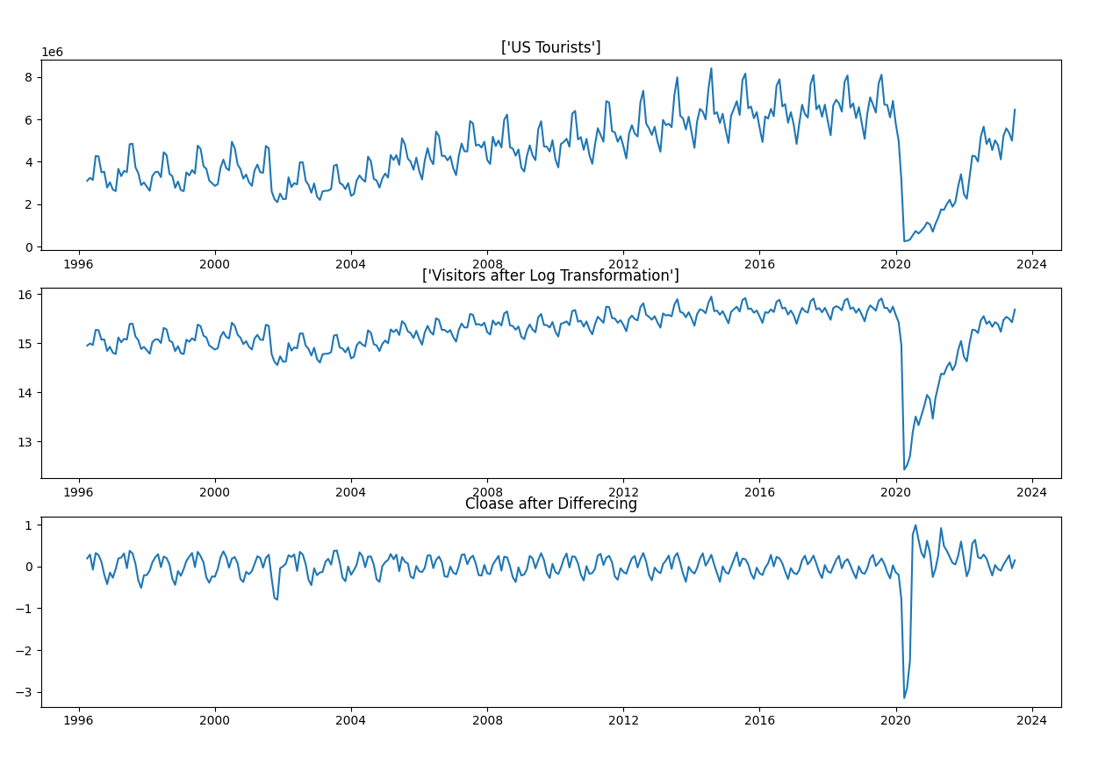
Figure 1: Time Series charts of the USA inbound tourism dataset, as well a log transformation and differencing transformation

Figure 1 plots the data of inbound tourist to USA as well as some transformations to see if it would help make the data stationary. Transformation may remove some trend but does not remove seasonality. One can see that the data exhibits both trend and seasonality. For example, we see a seasonal peak in the plot that normally occurs during the summer. We also see an upward trend that is persistent in the plot, except during the COVID-19 pandemic which was an exogenous shock. The presence of a trend and seasonality indicate some non-stationarity of the series.

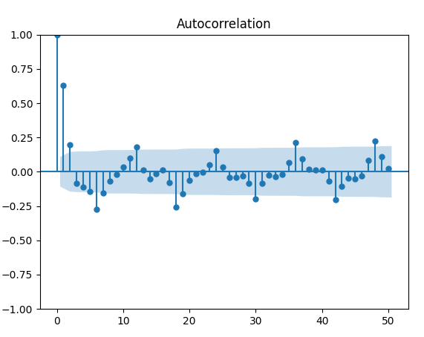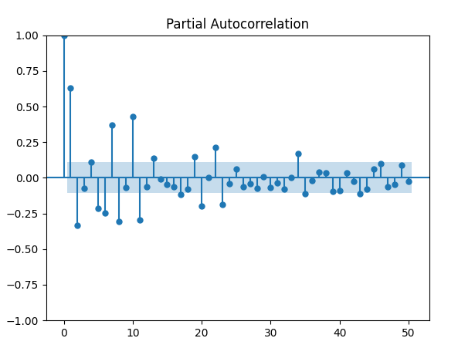
Figure 2: Autocorrelation and Partial Autocorrelation

The ACF and PACF plots are used to identify the order of the proposed model. The ACF and PACF plots suggested that the strongest number lags seem to be of low order. In addition, the autocorrelation charts also suggest again there is seasonality in the data.

- In-sample parameter selection
We then performed a grid search based off the data to find the optimal parameters for each of the time series models based off the AIC and BIC criterion.
Model | AIC | BIC
ARMA(3,4) | 9659.69 | 9693.83
ARIMA(3,2,4) | 9625.54 | 9637.63
SARIMA(3,2,4)x(3,2,2)12 | 8935.77 | 8984.01
Table 2: Training Set Optimal Parameters with AIC and BIC stats
- Out-of-sample Model Validation
Several measures can be used in judging the forecasting accuracy of fitted models. For our project, we decided to stick with RMSE and MAPE. Table 3 below summarizes the evaluation of the models on the testing set. We see that the SARIMA has the lowest RMSE
Model | RMSE | MAPE
ARMA(3,4) | 697798.39 | 33.7%
ARIMA(3,2,4) | 697894.61 | 26.5%
SARIMA(3,2,4)x(3,2,2)12 | 660958.26 | 34.7%
Table 3: Testing Set Model Evaluation based on RMSE and MAPE

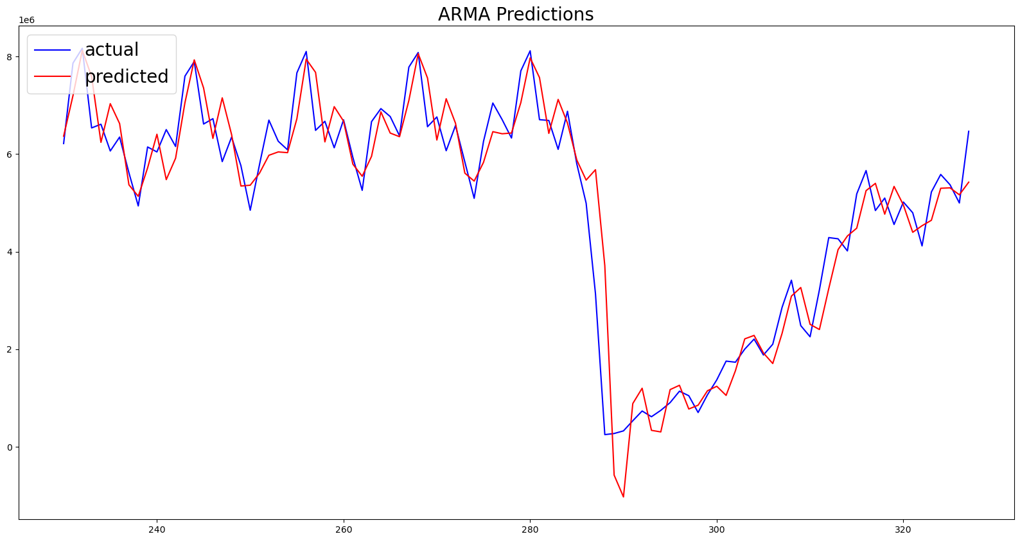

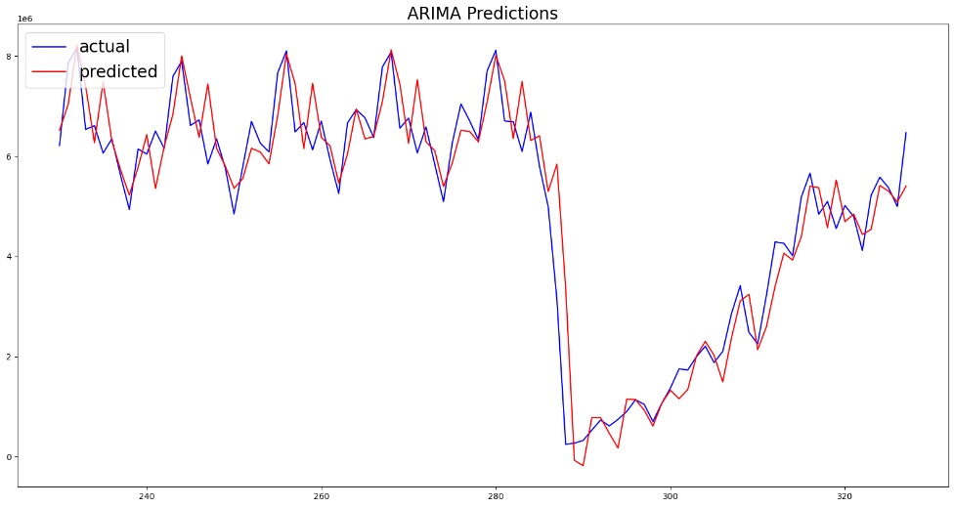
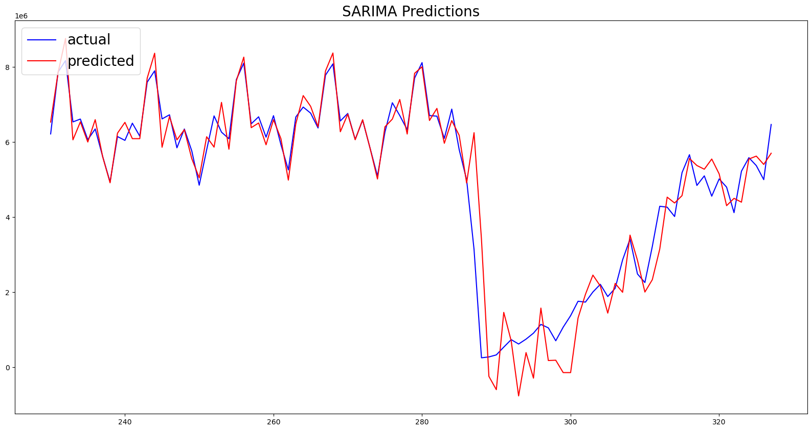

Figure 3: Plotting the Predicted Values and the Actual Data Values over the Testing Set

The figures above show the predicted values from each model within the testing set versus the actual data. Based off the RMSE and the charts above, we decided to move forward with the SARIMA(3,2,4)x(3,2,2)12 model for our simple forecasting exercise.

- Model Forecasting
Forecasting using the SARIMA(3,2,4)x(3,2,2)12 model for monthly inbound tourists to the USA is shown in below Table 4. We see that the forecasted values all look to slightly differ from the actual values in the forecast.

Date | Tourist Visit | Forecast Value | Error
10/2022 | 5,096,878 | 5,273,801 | 176,923
11/2022 | 4,555,544 | 5,545,150 | 989,606
12/2022 | 5,015,338 | 5,148,535 | 133,197
01/2023 | 4,795,951 | 4,302,907 | -493,044
02/2023 | 4,116,450 | 4,497,661 | 381,211
03/2023 | 5,221,211 | 4,395,950 | -825,261
04/2023 | 5,580,778 | 5,545,025 | -35,753
05/2023 | 5,369,628 | 5,623,005 | 253,377
06/2023 | 4,996,037 | 5,401,535 | 405,498
07/2023 | 6,465,828 | 5,699,342 | -766,486
Table 4: Plotting the Predicted Values and the Actual Data Values over the Testing Set

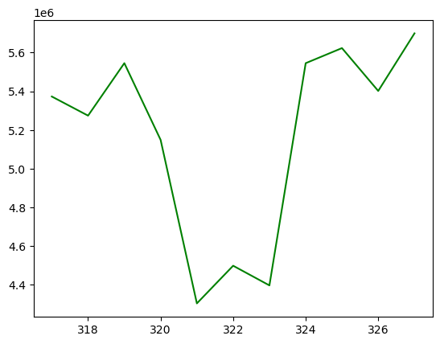
Figure 4: Plotting the SARIMA forecasted values
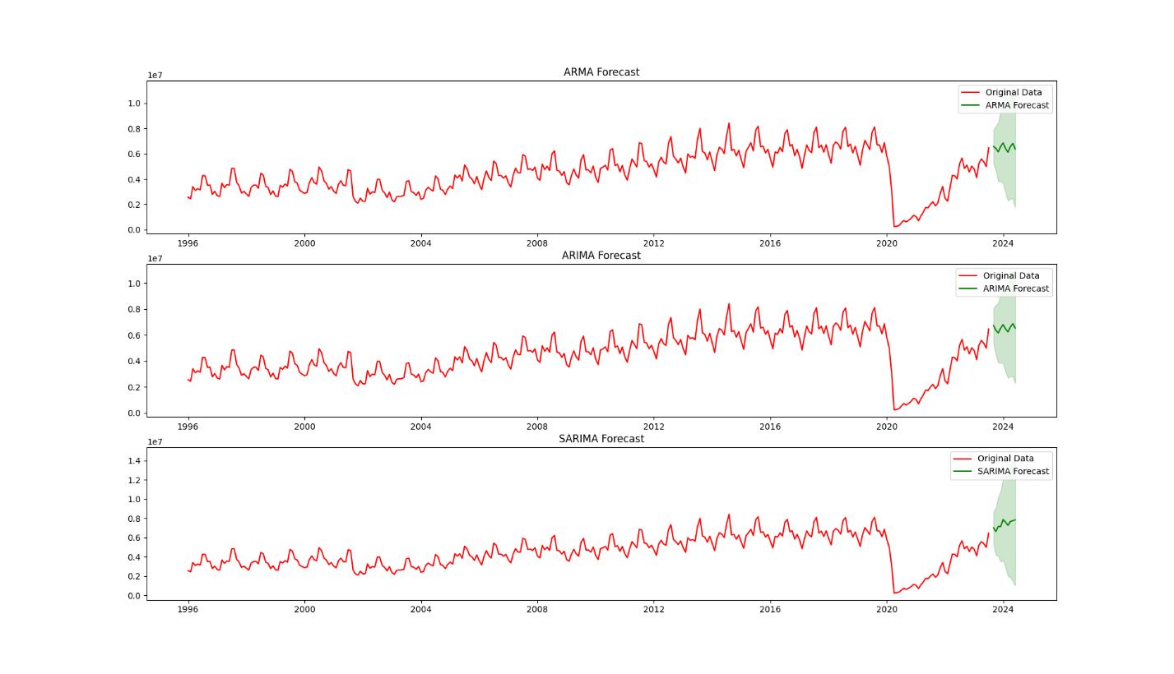

Figure 5: Plotting the ARMA, ARIMA, and SARIMA forecasted values (10 steps) with confidence interval at alpha = 0.2

Conclusion

Our analysis and results showed that the SARIMA model looked to have the best fit with the tourism data, which we believe is intuitive given that tourism has trends and seasonality in the data. The SARIMA model looked to be the best in terms of the in-sample fit as well as when we validated the models on the testing set. When we used it for the forecasting exercise, though, it looked like it slightly differed from the actual inbound tourist visits.

Reference
Borhan, N., & Arsad, Z. (2014). Forecasting international tourism demand from the US, Japan and South Korea to Malaysia: A SARIMA approach. 955–960. https://doi.org/10.1063/1.4887719

Choden and Suntaree Unhapipat (2018) ARIMA model to forecast international tourist visiting Bumthang, Bhutan, Journal of Physics: Conference Series 1039 012023

Lim C, McAleer M (2002) Time series forecasts of international travel demand for Australia. Tourism Management, 23, page 389-396

Rangika I. P, H., (2016). A seasonal ARIMA Model of tourism forecasting: The case of Sri
Lanka, Journal of Tourism, Hospitality and Sports.

Zahedjahromi, M. (2018). Forecasting Tourist Arrivals to the USA With SARIMA Models. University of Northern Colorado.

