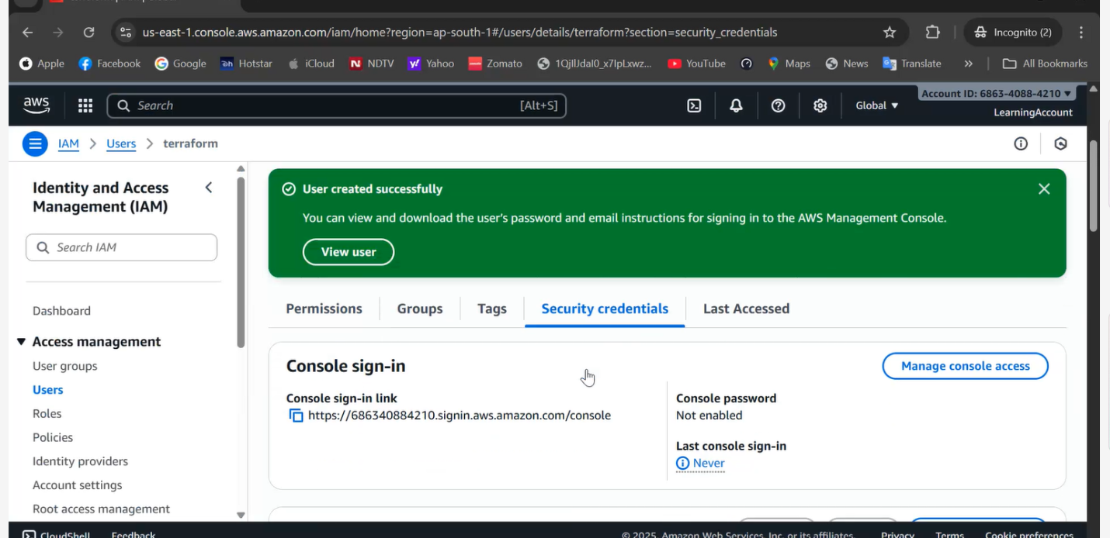Created new IAM account….{Always creating new IAM account….for security reasons and charges concern}…Terraform Local….Block is the next topic….

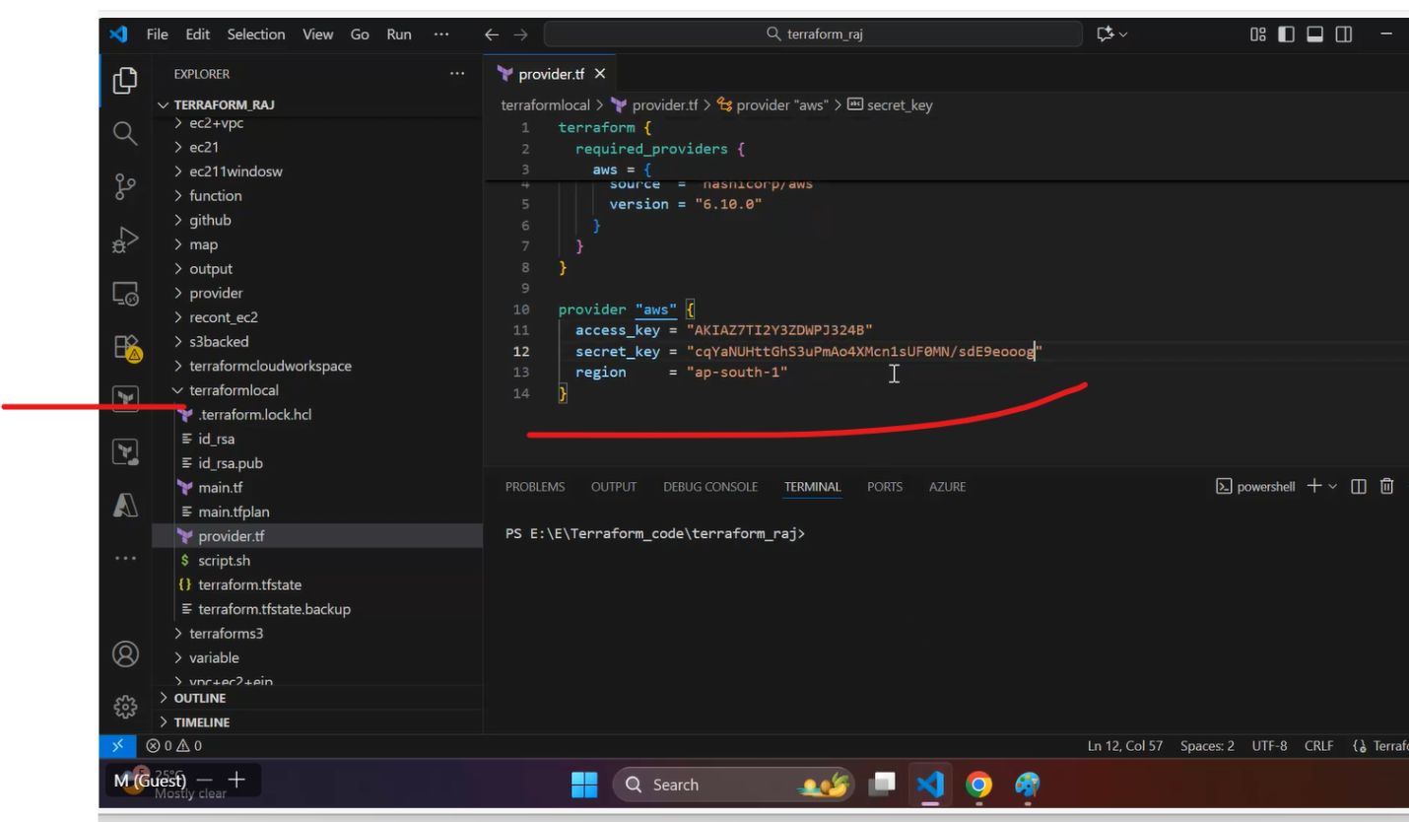

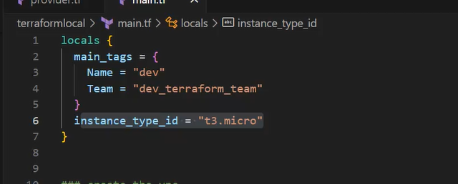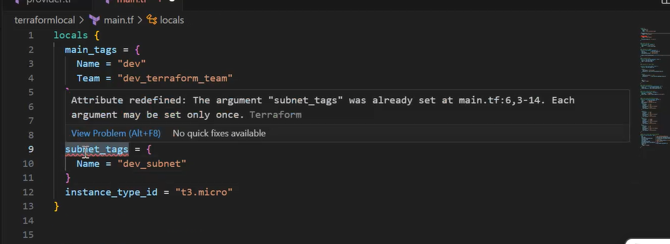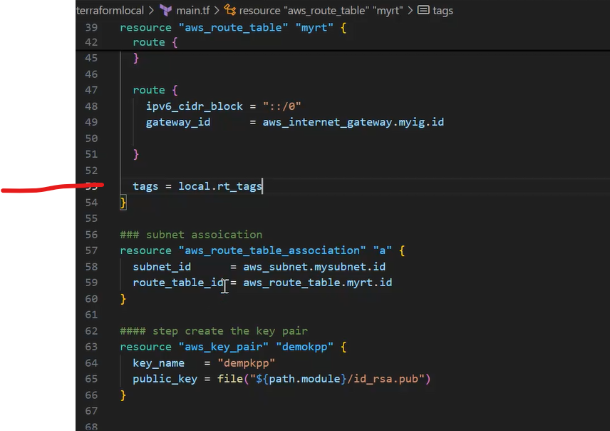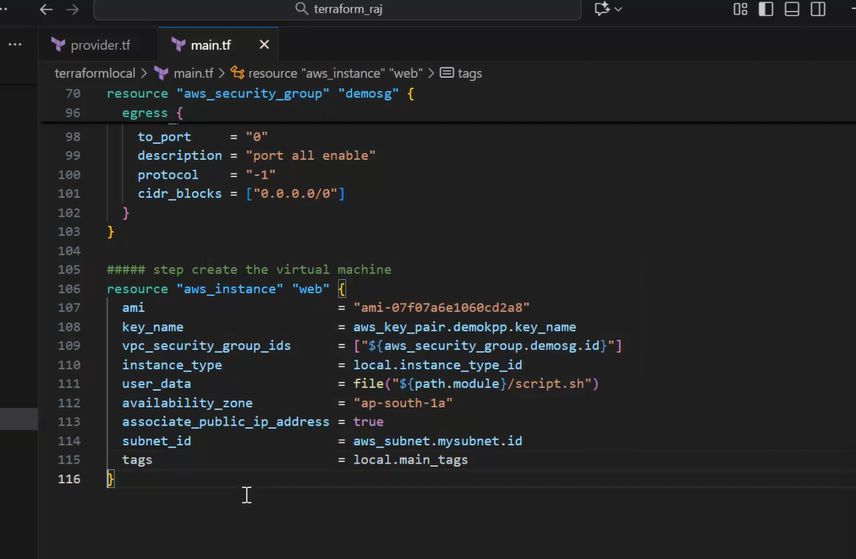locals {

  main_tags = {

    Name = "dev"

    Team = "dev_terraform_team"

  }

  subnet_tags = {

    Name = "dev_subnet"

  }

  rt_tags = {

    Name = "dev_rt"

  }

  instance_type_id   = "t3.micro"

  security_group_tag = "dempsgname"

}

### create the vpc

resource "aws_vpc" "myvpc" {

  cidr_block = "10.0.0.0/16"

  tags       = local.main_tags

}

### creation of subnet

resource "aws_subnet" "mysubnet" {

  vpc_id            = aws_vpc.myvpc.id

  cidr_block        = "10.0.0.0/24"

  availability_zone = "ap-south-1a"

  tags = local.subnet_tags

}

#### creation of ig

resource "aws_internet_gateway" "myig" {

  vpc_id = aws_vpc.myvpc.id

  tags   = local.main_tags

}

### creation of route table

resource "aws_route_table" "myrt" {

  vpc_id = aws_vpc.myvpc.id

  route {

    cidr_block = "0.0.0.0/0"

    gateway_id = aws_internet_gateway.myig.id

  }

  route {

    ipv6_cidr_block = "::/0"

    gateway_id      = aws_internet_gateway.myig.id

  }

  tags = local.rt_tags

}

### subnet assoication

resource "aws_route_table_association" "a" {

  subnet_id      = aws_subnet.mysubnet.id

  route_table_id = aws_route_table.myrt.id

}

#### step create the key pair

resource "aws_key_pair" "demokpp" {

  key_name   = "dempkpp"

  public_key = file("${path.module}/id_rsa.pub")

}

#### step create the security group

resource "aws_security_group" "demosg" {

  vpc_id      = aws_vpc.myvpc.id

  name        = local.security_group_tag

  description = "provide the sg"

  ingress {

    from_port   = "22"

    to_port     = "22"

    description = "port 22 enable"

    protocol    = "tcp"

    cidr_blocks = ["0.0.0.0/0"]

  }

  ingress {

    from_port   = "80"

    to_port     = "80"

    description = "port 22 enable"

    protocol    = "tcp"

    cidr_blocks = ["0.0.0.0/0"]

  }

  ingress {

    from_port   = "3389"

    to_port     = "3389"

    description = "port 22 enable"

    protocol    = "tcp"

    cidr_blocks = ["0.0.0.0/0"]

  }

  egress {

    from_port   = "0"

    to_port     = "0"

    description = "port all enable"

    protocol    = "-1"

    cidr_blocks = ["0.0.0.0/0"]

  }

}

##### step create the virtual machine

resource "aws_instance" "web" {

  ami                         = "ami-07f07a6e1060cd2a8"

  key_name                    = aws_key_pair.demokpp.key_name

  vpc_security_group_ids      = ["${aws_security_group.demosg.id}"]

  instance_type               = local.instance_type_id

  user_data                   = file("${path.module}/script.sh")

  availability_zone           = "ap-south-1a"

  associate_public_ip_address = true

  subnet_id                   = aws_subnet.mysubnet.id

  tags                        = local.main_tags

}

**Sudo apt update**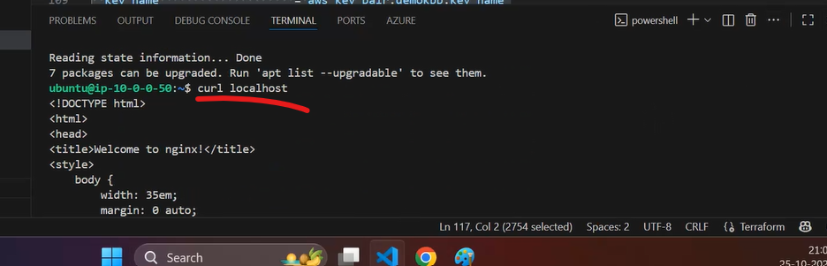

**Access the public IP and noticed nginx is loaded…..**

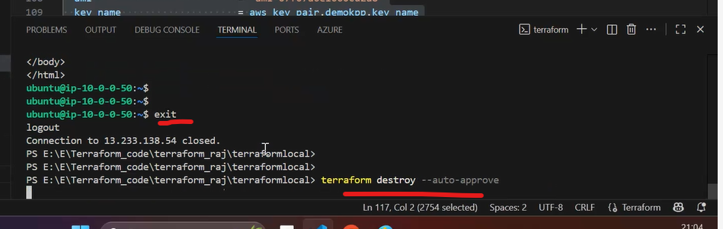**\**

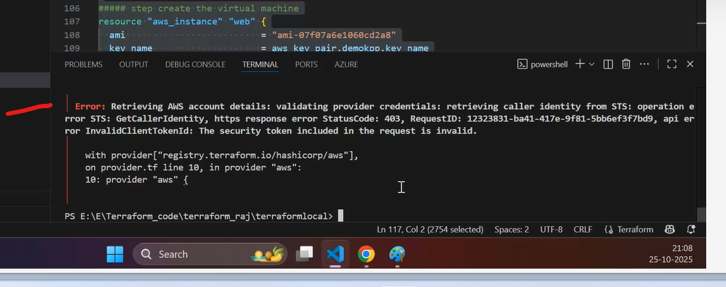

**He removed IAM account….Terraform init and then Terraform validate….he got the above error….**

**Next topic…he distributed the files using variables.tf and tfvars file…**

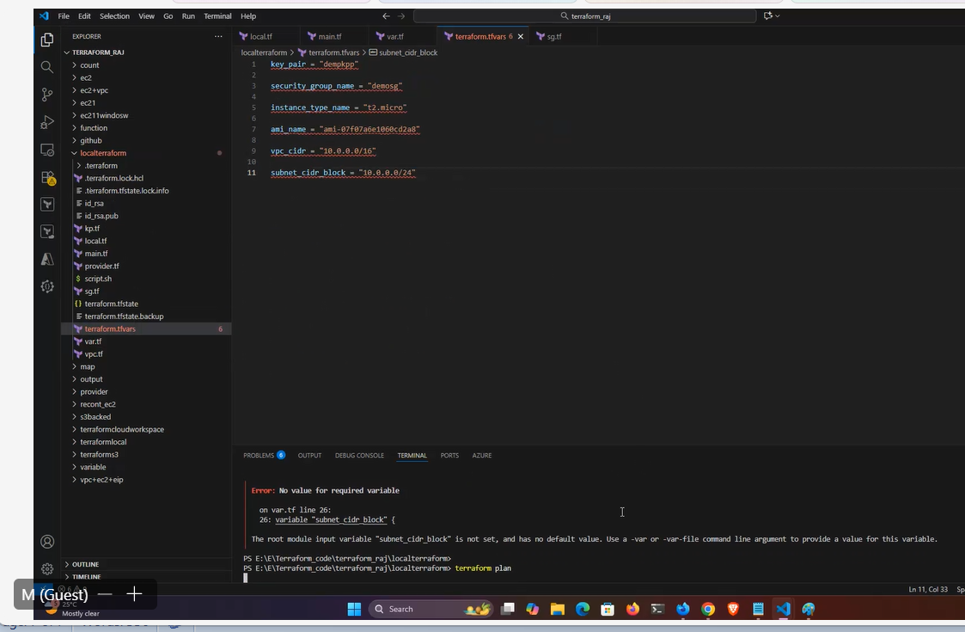

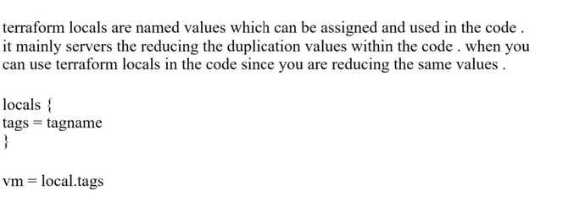**\*\*\*\*\*\*\*\*\*\*\*\*\*\*\*\*\*\*\*\*\*\*\***

locals {

  main_tags = {

    Name = "dev"

    Team = "dev_terraform_team"

  }

  subnet_tags = {

    Name = "dev_subnet"

  }

  rt_tags = {

    Name = "dev_rt"

  }

  instance_type_id   = "t3.micro"

  security_group_tag = "dempsgname"

}

### create the vpc

resource "aws_vpc" "myvpc" {

  cidr_block = "10.0.0.0/16"

  tags       = local.main_tags

}

### creation of subnet

resource "aws_subnet" "mysubnet" {

  vpc_id            = aws_vpc.myvpc.id

  cidr_block        = "10.0.0.0/24"

  availability_zone = "ap-south-1a"

  tags = local.subnet_tags

}

#### creation of ig

resource "aws_internet_gateway" "myig" {

  vpc_id = aws_vpc.myvpc.id

  tags   = local.main_tags

}

### creation of route table

resource "aws_route_table" "myrt" {

  vpc_id = aws_vpc.myvpc.id

  route {

    cidr_block = "0.0.0.0/0"

    gateway_id = aws_internet_gateway.myig.id

  }

  route {

    ipv6_cidr_block = "::/0"

    gateway_id      = aws_internet_gateway.myig.id

  }

  tags = local.rt_tags

}

### subnet assoication

resource "aws_route_table_association" "a" {

  subnet_id      = aws_subnet.mysubnet.id

  route_table_id = aws_route_table.myrt.id

}

#### step create the key pair

resource "aws_key_pair" "demokpp" {

  key_name   = "dempkpp"

  public_key = file("${path.module}/id_rsa.pub")

}

#### step create the security group

resource "aws_security_group" "demosg" {

  vpc_id      = aws_vpc.myvpc.id

  name        = local.security_group_tag

  description = "provide the sg"

  ingress {

    from_port   = "22"

    to_port     = "22"

    description = "port 22 enable"

    protocol    = "tcp"

    cidr_blocks = ["0.0.0.0/0"]

  }

  ingress {

    from_port   = "80"

    to_port     = "80"

    description = "port 22 enable"

    protocol    = "tcp"

    cidr_blocks = ["0.0.0.0/0"]

  }

  ingress {

    from_port   = "3389"

    to_port     = "3389"

    description = "port 22 enable"

    protocol    = "tcp"

    cidr_blocks = ["0.0.0.0/0"]

  }

  egress {

    from_port   = "0"

    to_port     = "0"

    description = "port all enable"

    protocol    = "-1"

    cidr_blocks = ["0.0.0.0/0"]

  }

}

##### step create the virtual machine

resource "aws_instance" "web" {

  ami                         = "ami-07f07a6e1060cd2a8"

  key_name                    = aws_key_pair.demokpp.key_name

  vpc_security_group_ids      = ["${aws_security_group.demosg.id}"]

  instance_type               = local.instance_type_id

  user_data                   = file("${path.module}/script.sh")

  availability_zone           = "ap-south-1a"

  associate_public_ip_address = true

  subnet_id                   = aws_subnet.mysubnet.id

  tags                        = local.main_tags

}

#### step create the key pair

resource "aws_key_pair" "demokpp" {

  key_name   = local.key_pair_name

  public_key = file("${path.module}/id_rsa.pub")

}

locals {

  main_tags = {

    Name = "dev"

    Team = "dev_terraform_team"

  }

  subnet_tags = {

    Name = "dev_subnet"

  }

  rt_tags = {

    Name = "dev_rt"

  }

  key_pair_name          = var.key_pair

  security_group_name_id = var.security_group_name

  instance_type_name_id  = var.instance_type_name

  ami_name_id            = var.ami_name

  vpc_id                 = var.vpc_cidr

  subnet_id              = var.subnet_cidr_block

  ##  instance_type_id   = "t3.micro"

  ###  security_group_tag = "dempsgname"

}

##### step create the virtual machine

resource "aws_instance" "web" {

  ami                         = local.ami_name_id

  key_name                    = aws_key_pair.demokpp.key_name

  vpc_security_group_ids      = ["${aws_security_group.demosg.id}"]

  instance_type               = local.instance_type_name_id

  user_data                   = file("${path.module}/script.sh")

  availability_zone           = "ap-south-1a"

  associate_public_ip_address = true

  subnet_id                   = aws_subnet.mysubnet.id

  tags                        = local.main_tags

}

#### step create the security group

resource "aws_security_group" "demosg" {

  vpc_id      = aws_vpc.myvpc.id

  name        = local.security_group_name_id

  description = "provide the sg"

  ingress {

    from_port   = "22"

    to_port     = "22"

    description = "port 22 enable"

    protocol    = "tcp"

    cidr_blocks = ["0.0.0.0/0"]

  }

  ingress {

    from_port   = "80"

    to_port     = "80"

    description = "port 22 enable"

    protocol    = "tcp"

    cidr_blocks = ["0.0.0.0/0"]

  }

  ingress {

    from_port   = "3389"

    to_port     = "3389"

    description = "port 22 enable"

    protocol    = "tcp"

    cidr_blocks = ["0.0.0.0/0"]

  }

  egress {

    from_port   = "0"

    to_port     = "0"

    description = "port all enable"

    protocol    = "-1"

    cidr_blocks = ["0.0.0.0/0"]

  }

}

key_pair = "dempkpp"

security_group_name = "demosg"

instance_type_name = "t2.micro"

ami_name = "ami-07f07a6e1060cd2a8"

vpc_cidr = "10.0.0.0/16"

subnet_cidr_block = "10.0.0.0/24"

variable "key_pair" {

  type        = string

  description = "provide the key pair"

}

variable "security_group_name" {

  type        = string

  description = "provide the sg name "

}

variable "instance_type_name" {

  type        = string

  description = "provide the instance type "

}

variable "ami_name" {

  type        = string

  description = "provide the ami details"

}

variable "vpc_cidr" {

  type        = string

  description = "provide the vidr of vpc"

}

variable "subnet_cidr_block" {

  type        = string

  description = "provde the subnet"

}

### create the vpc

resource "aws_vpc" "myvpc" {

  cidr_block = local.vpc_id

  tags       = local.main_tags

}

### creation of subnet

resource "aws_subnet" "mysubnet" {

  vpc_id            = aws_vpc.myvpc.id

  cidr_block        = local.subnet_id

  availability_zone = "ap-south-1a"

  tags = local.subnet_tags

}

#### creation of ig

resource "aws_internet_gateway" "myig" {

  vpc_id = aws_vpc.myvpc.id

  tags   = local.main_tags

}

### creation of route table

resource "aws_route_table" "myrt" {

  vpc_id = aws_vpc.myvpc.id

  route {

    cidr_block = "0.0.0.0/0"

    gateway_id = aws_internet_gateway.myig.id

  }

  route {

    ipv6_cidr_block = "::/0"

    gateway_id      = aws_internet_gateway.myig.id

  }

  tags = local.rt_tags

}

### subnet assoication

resource "aws_route_table_association" "a" {

  subnet_id      = aws_subnet.mysubnet.id

  route_table_id = aws_route_table.myrt.id

}

Summary:

In Part3:

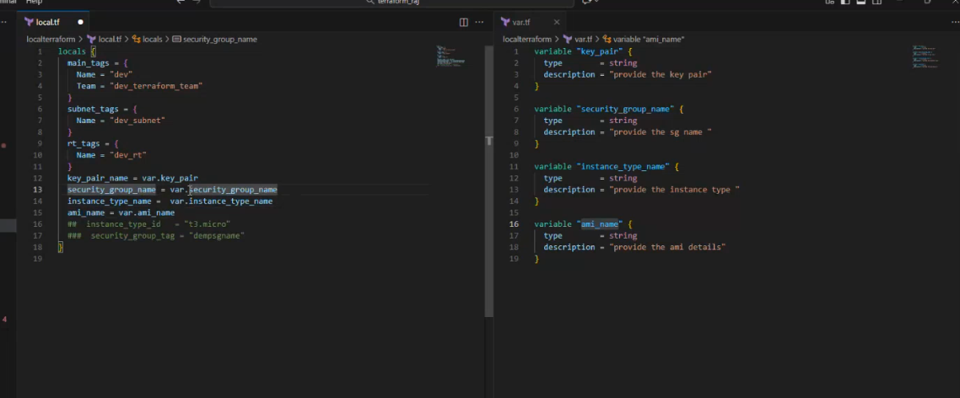

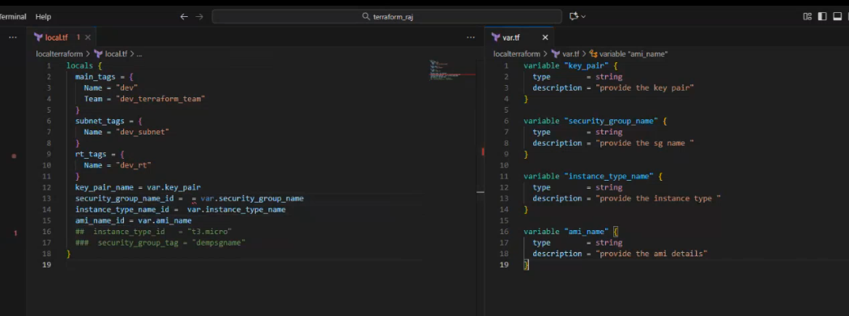

He added 4 variables to local.tf and then used in other tf files as local.[] instead of var.[]

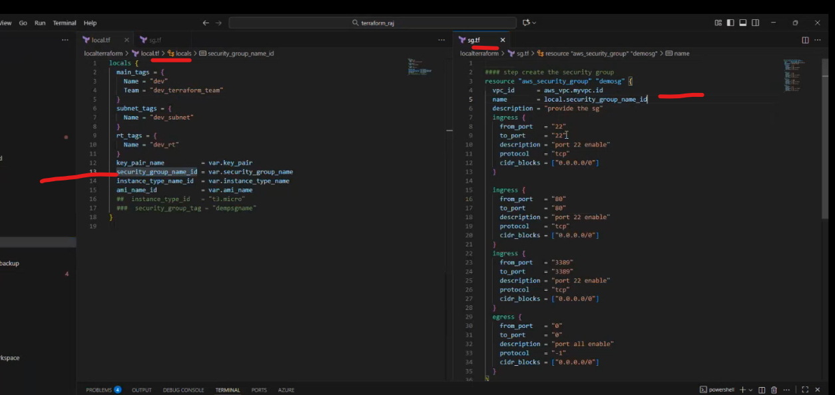

He created 2 new variables for VPC block, Subnet block

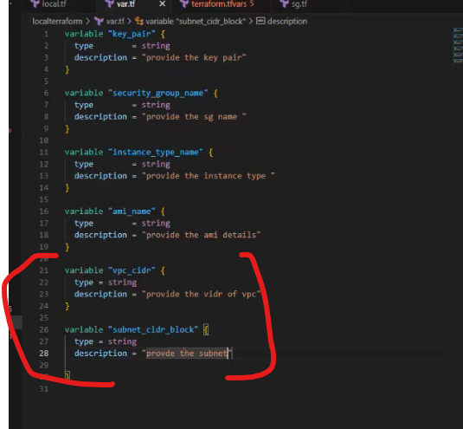

He added these 2 to local block…..local block has 6 values now…..

