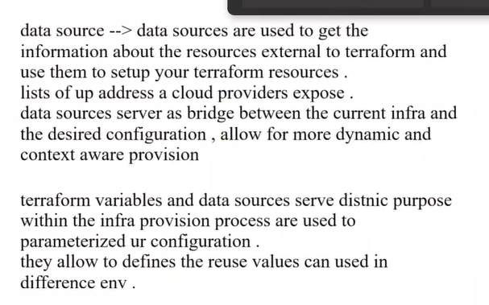

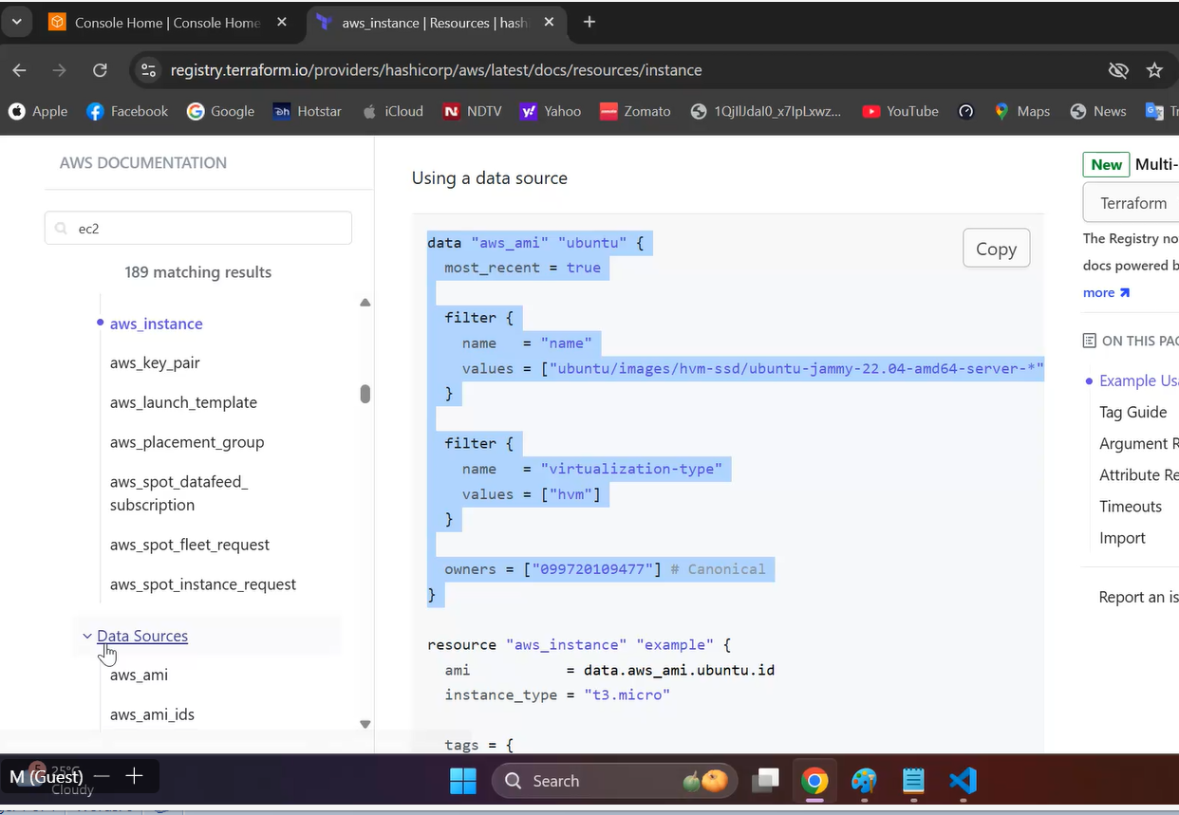

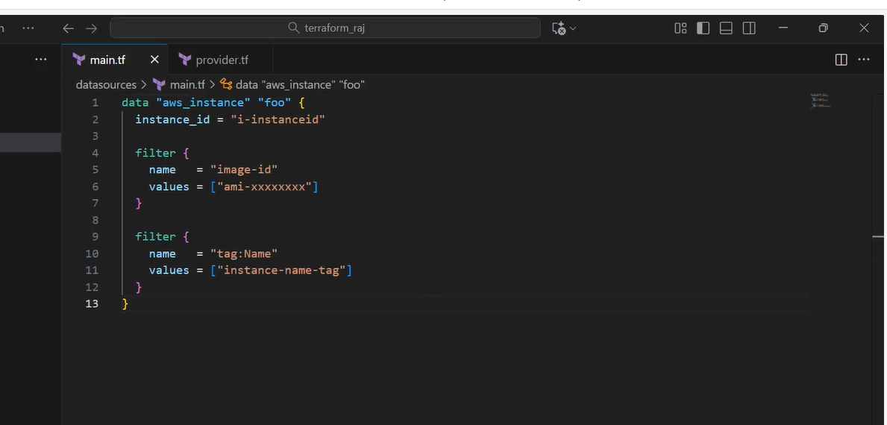

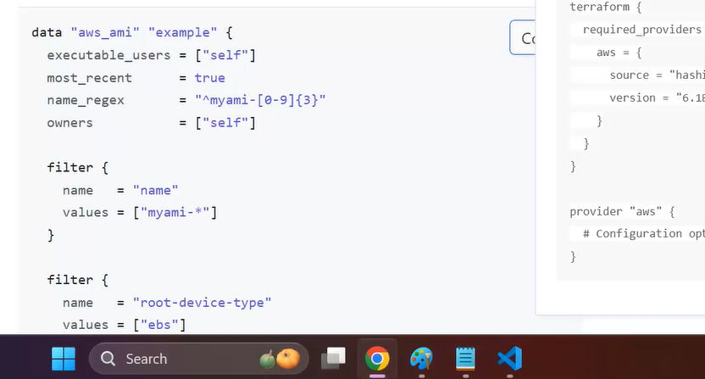

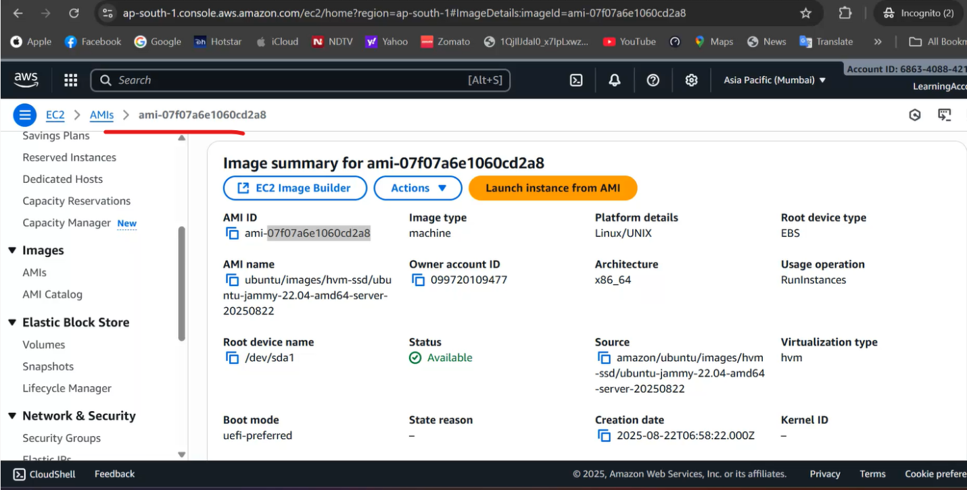

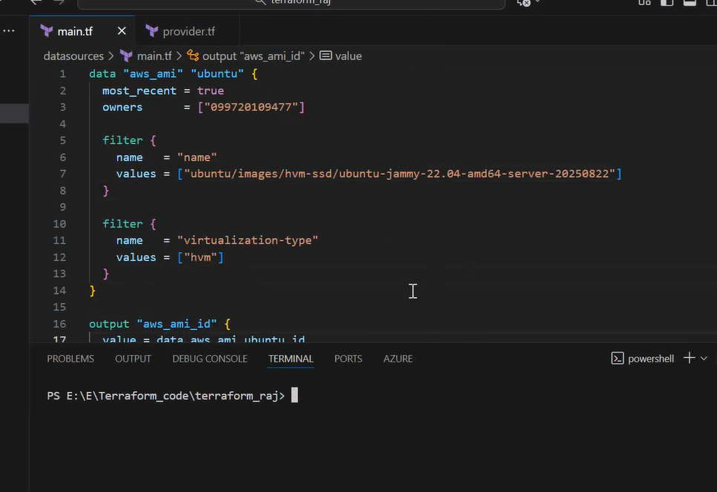

He did terraform init and terraform apply….which gives output

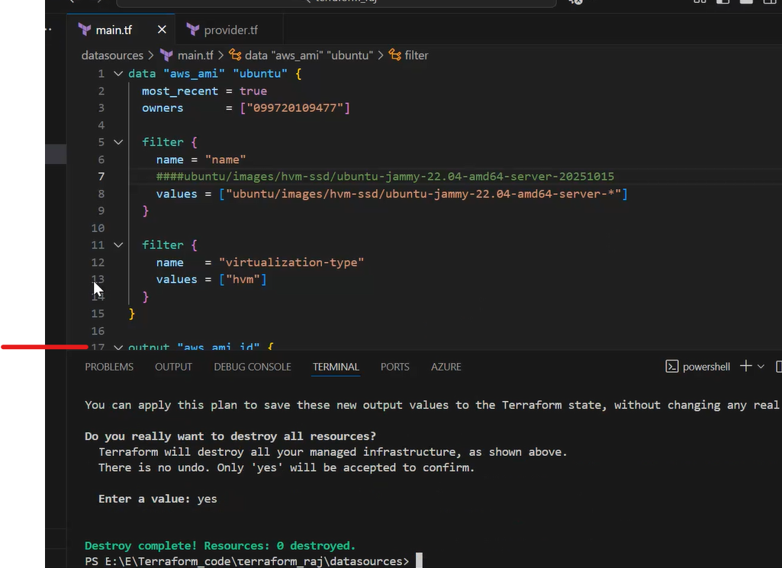

data "aws_ami" "ubuntu" {

  most_recent = true

  owners      = ["099720109477"]

  filter {

    name = "name"

    ####ubuntu/images/hvm-ssd/ubuntu-jammy-22.04-amd64-server-20251015

    values = ["ubuntu/images/hvm-ssd/ubuntu-jammy-22.04-amd64-server-*"]

  }

  filter {

    name   = "virtualization-type"

    values = ["hvm"]

  }

}

output "aws_ami_id" {

  value = data.aws_ami.ubuntu.id

}

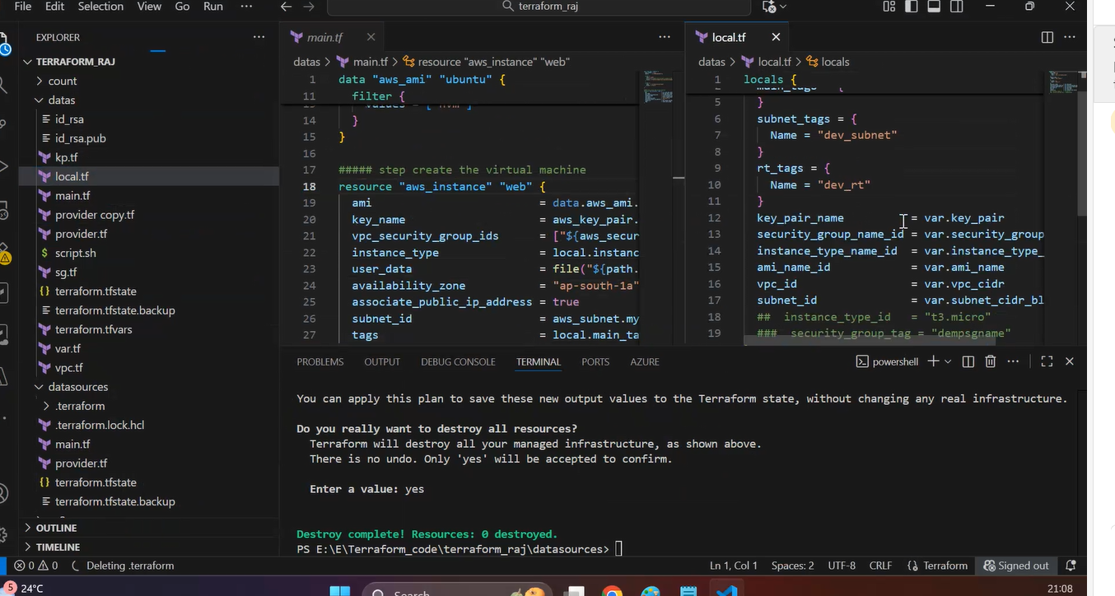

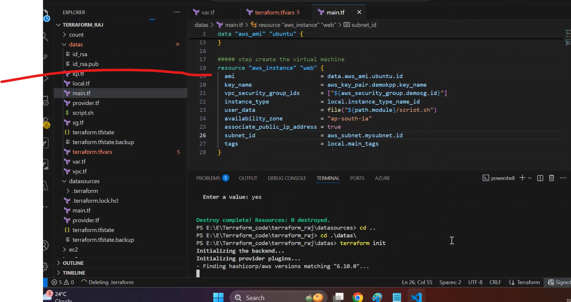

He used previous class code….then used data resource to fetch ami info and adjusted variables.tf, vm.tf, tfvars files and did the deployment

He regenerated id_rsa files…initial deployment public key not deployed….

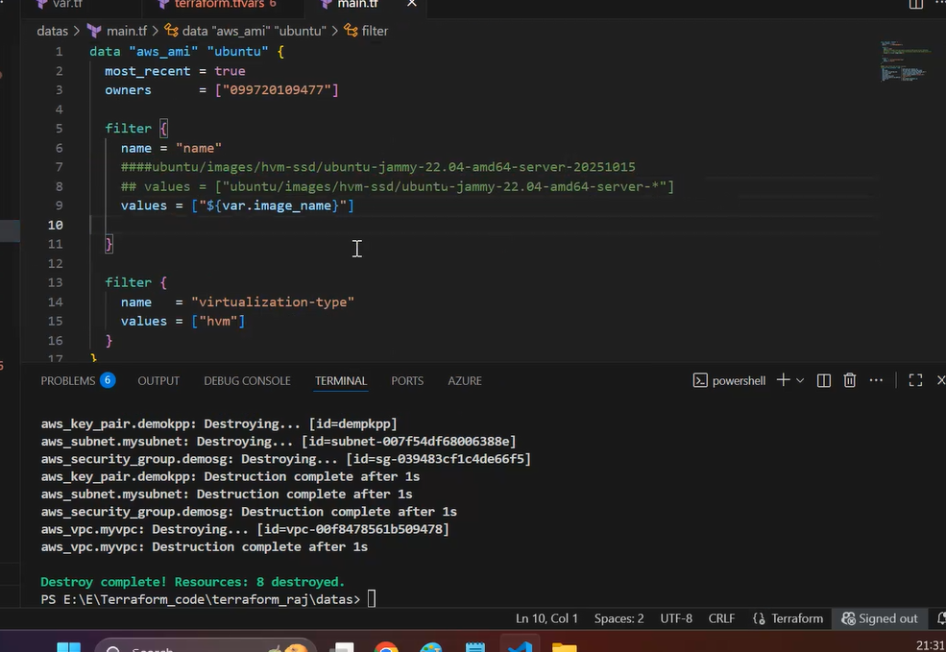

He manually created Windows EC2 and then attached EBs volume….