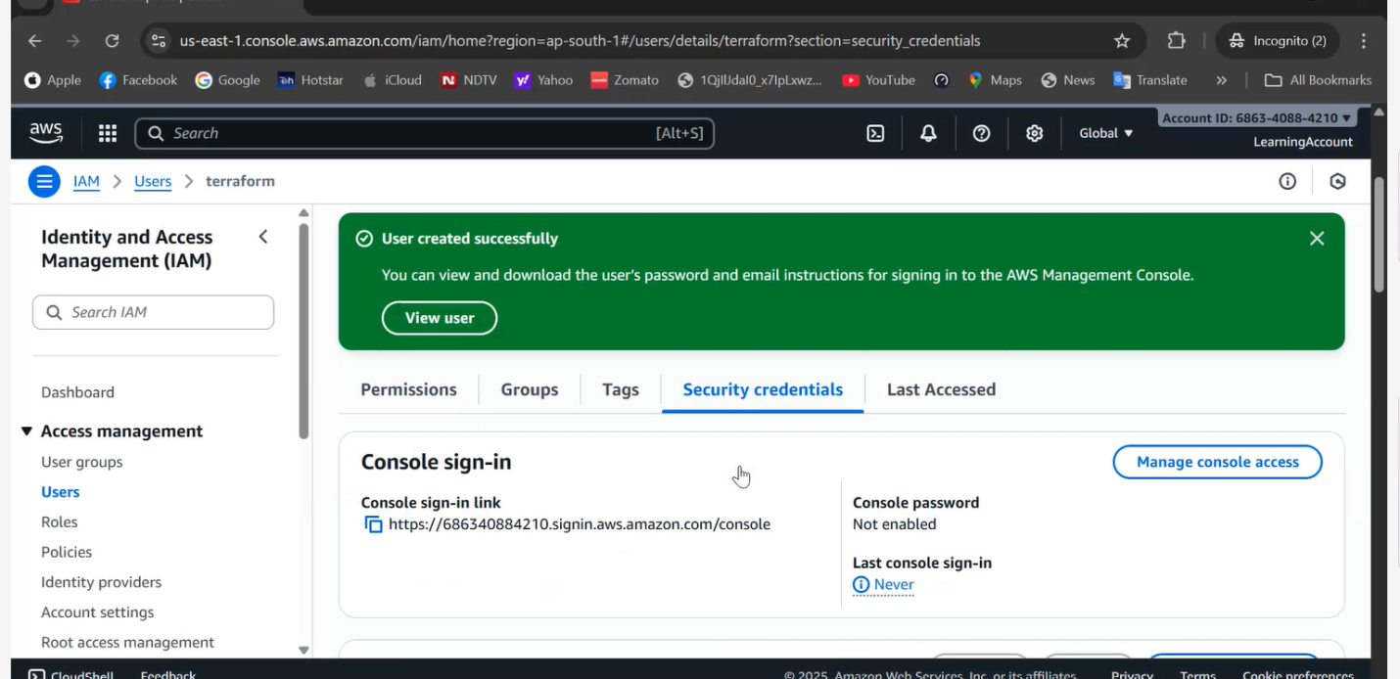Created new IAM account….{Always creating new IAM account….for security reasons and charges concern}…Terraform Local….Block is the next topic….
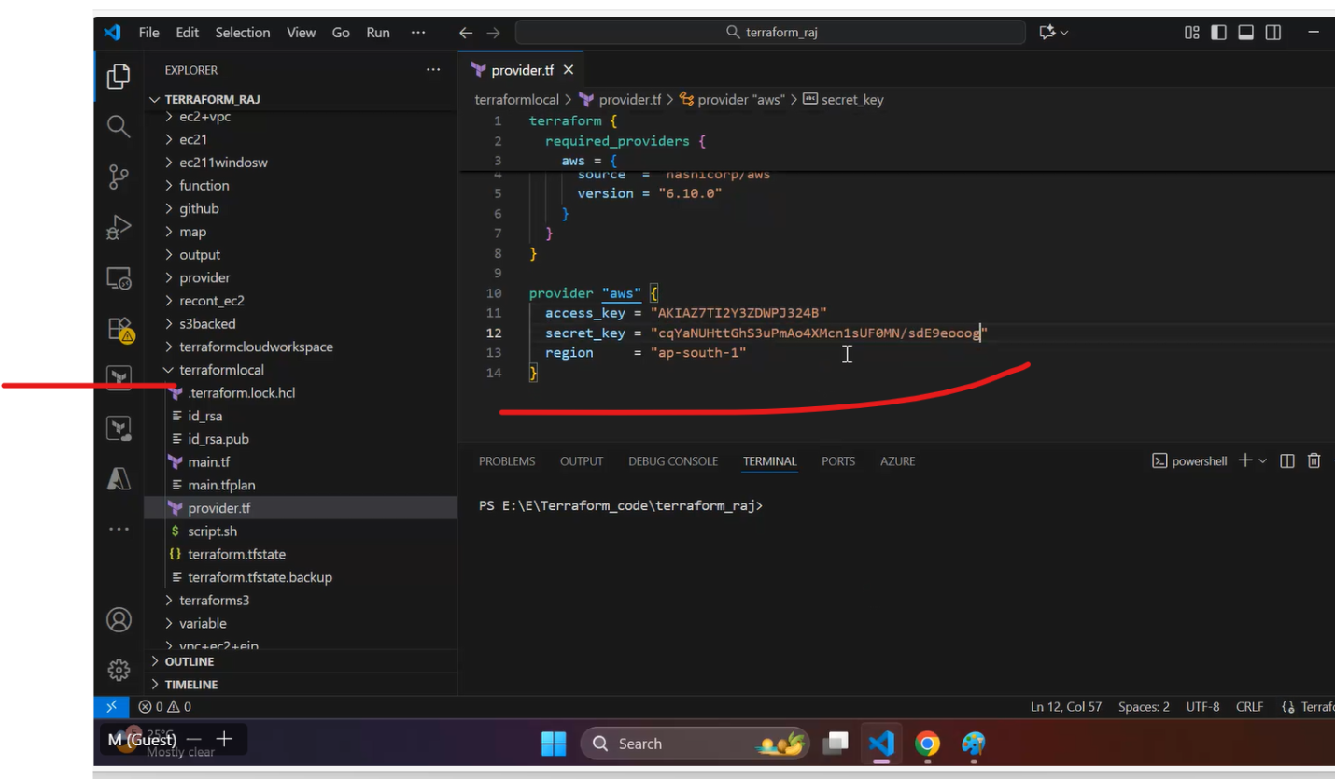
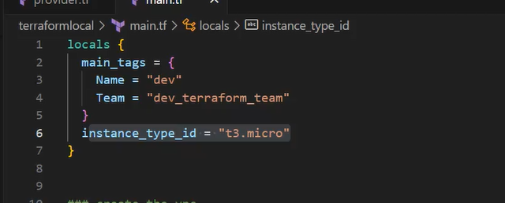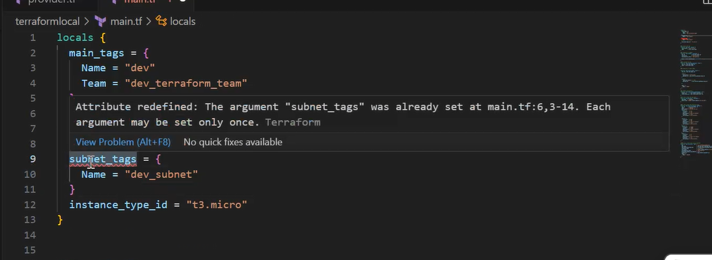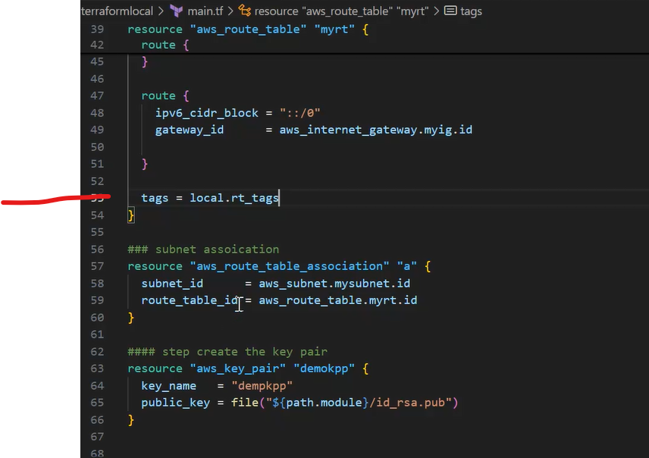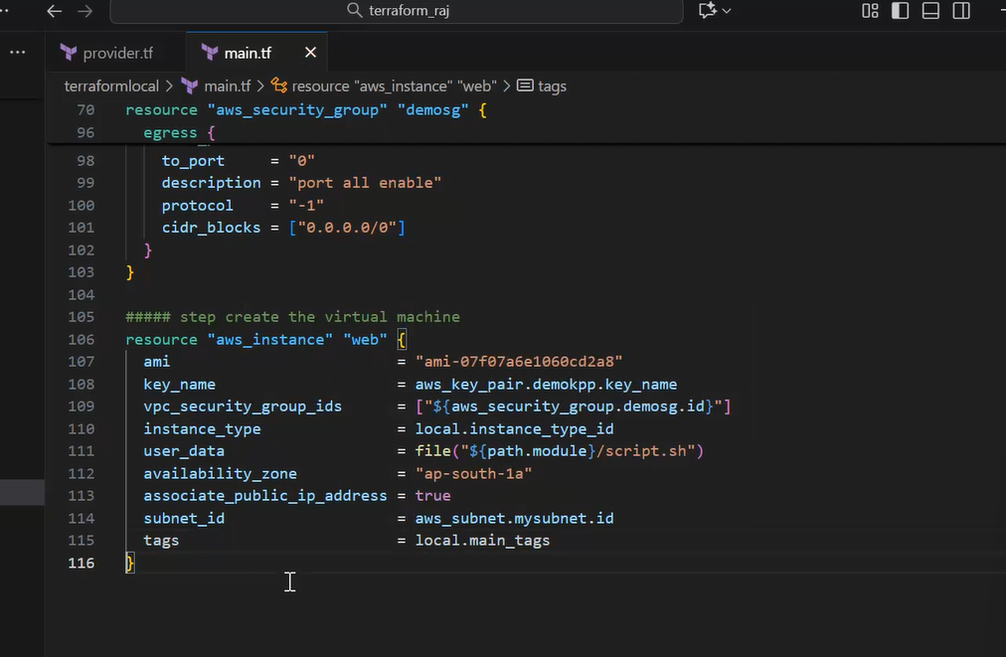locals {
main_tags = {
Name = "dev"
Team = "dev_terraform_team"
}
subnet_tags = {
Name = "dev_subnet"
}
rt_tags = {
Name = "dev_rt"
}
instance_type_id = "t3.micro"
security_group_tag = "dempsgname"
}

### create the vpc
resource "aws_vpc" "myvpc" {
cidr_block = "10.0.0.0/16"
tags = local.main_tags
}

### creation of subnet
resource "aws_subnet" "mysubnet" {
vpc_id = aws_vpc.myvpc.id
cidr_block = "10.0.0.0/24"
availability_zone = "ap-south-1a"

tags = local.subnet_tags
}

#### creation of ig
resource "aws_internet_gateway" "myig" {
vpc_id = aws_vpc.myvpc.id
tags = local.main_tags
}

### creation of route table

resource "aws_route_table" "myrt" {
vpc_id = aws_vpc.myvpc.id

route {
cidr_block = "0.0.0.0/0"
gateway_id = aws_internet_gateway.myig.id
}

route {
ipv6_cidr_block = "::/0"
gateway_id = aws_internet_gateway.myig.id

}

tags = local.rt_tags
}

### subnet assoication
resource "aws_route_table_association" "a" {
subnet_id = aws_subnet.mysubnet.id
route_table_id = aws_route_table.myrt.id
}

#### step create the key pair
resource "aws_key_pair" "demokpp" {
key_name = "dempkpp"
public_key = file("${path.module}/id_rsa.pub")
}

#### step create the security group
resource "aws_security_group" "demosg" {
vpc_id = aws_vpc.myvpc.id
name = local.security_group_tag
description = "provide the sg"
ingress {
from_port = "22"
to_port = "22"
description = "port 22 enable"
protocol = "tcp"
cidr_blocks = ["0.0.0.0/0"]
}

ingress {
from_port = "80"
to_port = "80"
description = "port 22 enable"
protocol = "tcp"
cidr_blocks = ["0.0.0.0/0"]
}
ingress {
from_port = "3389"
to_port = "3389"
description = "port 22 enable"
protocol = "tcp"
cidr_blocks = ["0.0.0.0/0"]
}
egress {
from_port = "0"
to_port = "0"
description = "port all enable"
protocol = "-1"
cidr_blocks = ["0.0.0.0/0"]
}
}

##### step create the virtual machine
resource "aws_instance" "web" {
ami = "ami-07f07a6e1060cd2a8"
key_name = aws_key_pair.demokpp.key_name
vpc_security_group_ids = ["${aws_security_group.demosg.id}"]
instance_type = local.instance_type_id
user_data = file("${path.module}/script.sh")
availability_zone = "ap-south-1a"
associate_public_ip_address = true
subnet_id = aws_subnet.mysubnet.id
tags = local.main_tags
}
Sudo apt update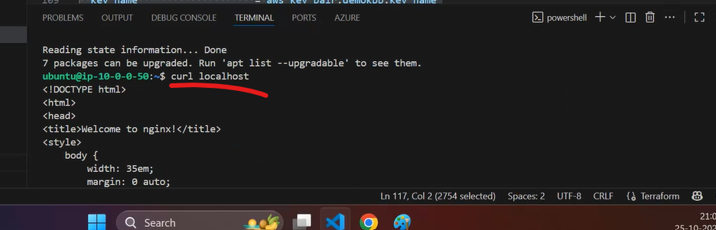
Access the public IP and noticed nginx is loaded…..
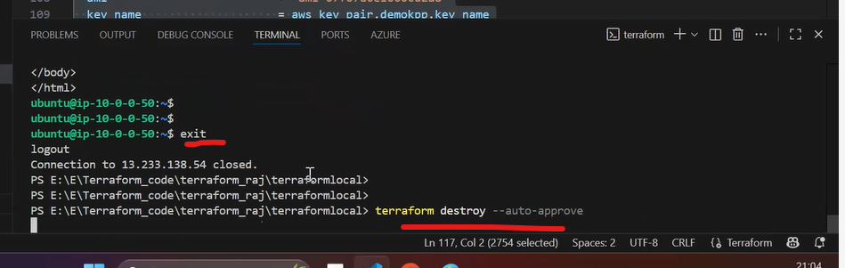\
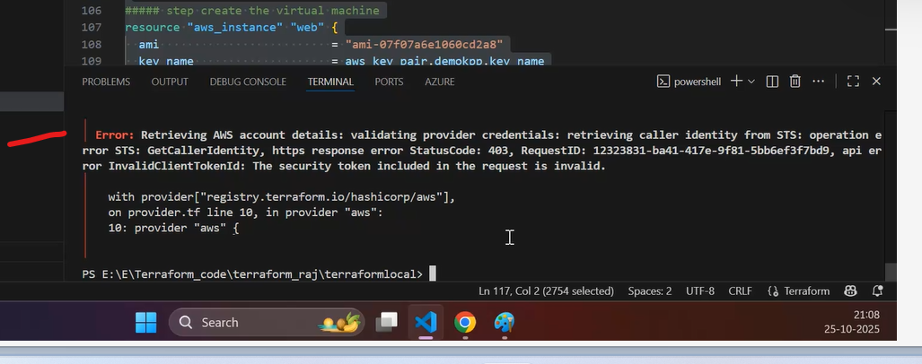
He removed IAM account….Terraform init and then Terraform validate….he got the above error….
Next topic…he distributed the files using variables.tf and tfvars file…
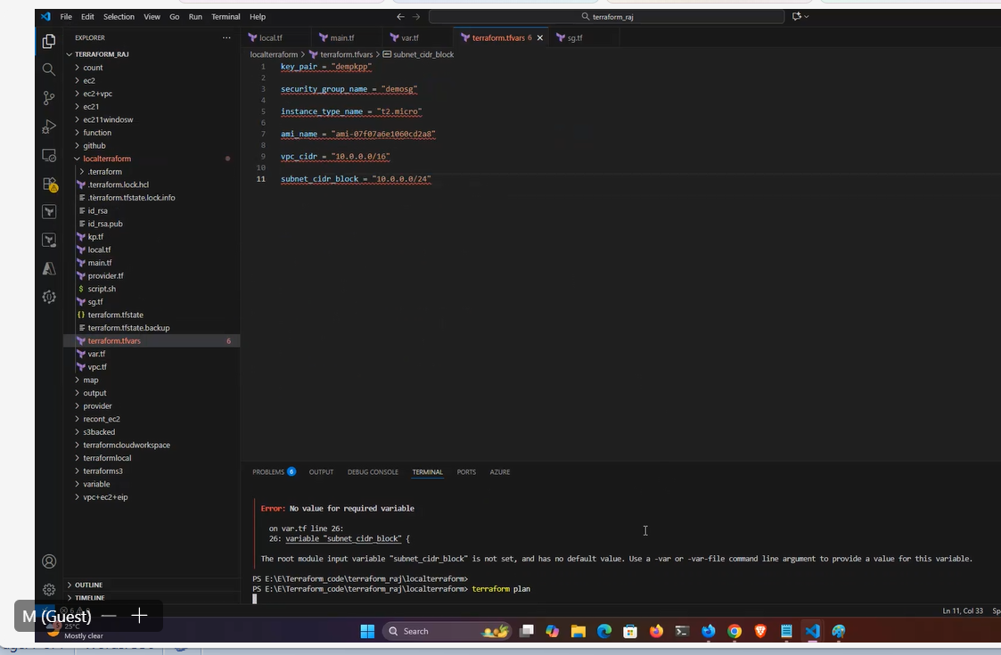
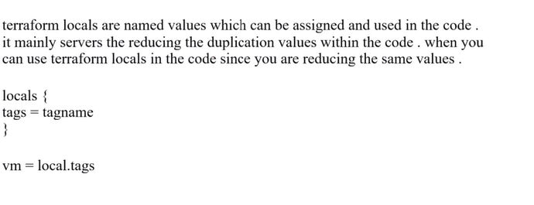***********************
locals {
main_tags = {
Name = "dev"
Team = "dev_terraform_team"
}
subnet_tags = {
Name = "dev_subnet"
}
rt_tags = {
Name = "dev_rt"
}
instance_type_id = "t3.micro"
security_group_tag = "dempsgname"
}

### create the vpc
resource "aws_vpc" "myvpc" {
cidr_block = "10.0.0.0/16"
tags = local.main_tags
}

### creation of subnet
resource "aws_subnet" "mysubnet" {
vpc_id = aws_vpc.myvpc.id
cidr_block = "10.0.0.0/24"
availability_zone = "ap-south-1a"

tags = local.subnet_tags
}

#### creation of ig
resource "aws_internet_gateway" "myig" {
vpc_id = aws_vpc.myvpc.id
tags = local.main_tags
}

### creation of route table

resource "aws_route_table" "myrt" {
vpc_id = aws_vpc.myvpc.id

route {
cidr_block = "0.0.0.0/0"
gateway_id = aws_internet_gateway.myig.id
}

route {
ipv6_cidr_block = "::/0"
gateway_id = aws_internet_gateway.myig.id

}

tags = local.rt_tags
}

### subnet assoication
resource "aws_route_table_association" "a" {
subnet_id = aws_subnet.mysubnet.id
route_table_id = aws_route_table.myrt.id
}

#### step create the key pair
resource "aws_key_pair" "demokpp" {
key_name = "dempkpp"
public_key = file("${path.module}/id_rsa.pub")
}

#### step create the security group
resource "aws_security_group" "demosg" {
vpc_id = aws_vpc.myvpc.id
name = local.security_group_tag
description = "provide the sg"
ingress {
from_port = "22"
to_port = "22"
description = "port 22 enable"
protocol = "tcp"
cidr_blocks = ["0.0.0.0/0"]
}

ingress {
from_port = "80"
to_port = "80"
description = "port 22 enable"
protocol = "tcp"
cidr_blocks = ["0.0.0.0/0"]
}
ingress {
from_port = "3389"
to_port = "3389"
description = "port 22 enable"
protocol = "tcp"
cidr_blocks = ["0.0.0.0/0"]
}
egress {
from_port = "0"
to_port = "0"
description = "port all enable"
protocol = "-1"
cidr_blocks = ["0.0.0.0/0"]
}
}

##### step create the virtual machine
resource "aws_instance" "web" {
ami = "ami-07f07a6e1060cd2a8"
key_name = aws_key_pair.demokpp.key_name
vpc_security_group_ids = ["${aws_security_group.demosg.id}"]
instance_type = local.instance_type_id
user_data = file("${path.module}/script.sh")
availability_zone = "ap-south-1a"
associate_public_ip_address = true
subnet_id = aws_subnet.mysubnet.id
tags = local.main_tags
}

#### step create the key pair
resource "aws_key_pair" "demokpp" {
key_name = local.key_pair_name
public_key = file("${path.module}/id_rsa.pub")
}

locals {
main_tags = {
Name = "dev"
Team = "dev_terraform_team"
}
subnet_tags = {
Name = "dev_subnet"
}
rt_tags = {
Name = "dev_rt"
}
key_pair_name = var.key_pair
security_group_name_id = var.security_group_name
instance_type_name_id = var.instance_type_name
ami_name_id = var.ami_name
vpc_id = var.vpc_cidr
subnet_id = var.subnet_cidr_block
## instance_type_id = "t3.micro"
### security_group_tag = "dempsgname"
}

##### step create the virtual machine
resource "aws_instance" "web" {
ami = local.ami_name_id
key_name = aws_key_pair.demokpp.key_name
vpc_security_group_ids = ["${aws_security_group.demosg.id}"]
instance_type = local.instance_type_name_id
user_data = file("${path.module}/script.sh")
availability_zone = "ap-south-1a"
associate_public_ip_address = true
subnet_id = aws_subnet.mysubnet.id
tags = local.main_tags
}

#### step create the security group
resource "aws_security_group" "demosg" {
vpc_id = aws_vpc.myvpc.id
name = local.security_group_name_id
description = "provide the sg"
ingress {
from_port = "22"
to_port = "22"
description = "port 22 enable"
protocol = "tcp"
cidr_blocks = ["0.0.0.0/0"]
}

ingress {
from_port = "80"
to_port = "80"
description = "port 22 enable"
protocol = "tcp"
cidr_blocks = ["0.0.0.0/0"]
}
ingress {
from_port = "3389"
to_port = "3389"
description = "port 22 enable"
protocol = "tcp"
cidr_blocks = ["0.0.0.0/0"]
}
egress {
from_port = "0"
to_port = "0"
description = "port all enable"
protocol = "-1"
cidr_blocks = ["0.0.0.0/0"]
}
}

key_pair = "dempkpp"

security_group_name = "demosg"

instance_type_name = "t2.micro"

ami_name = "ami-07f07a6e1060cd2a8"

vpc_cidr = "10.0.0.0/16"

subnet_cidr_block = "10.0.0.0/24"

variable "key_pair" {
type = string
description = "provide the key pair"
}

variable "security_group_name" {
type = string
description = "provide the sg name "
}

variable "instance_type_name" {
type = string
description = "provide the instance type "
}

variable "ami_name" {
type = string
description = "provide the ami details"
}

variable "vpc_cidr" {
type = string
description = "provide the vidr of vpc"
}

variable "subnet_cidr_block" {
type = string
description = "provde the subnet"

}

### create the vpc
resource "aws_vpc" "myvpc" {
cidr_block = local.vpc_id
tags = local.main_tags
}

### creation of subnet
resource "aws_subnet" "mysubnet" {
vpc_id = aws_vpc.myvpc.id
cidr_block = local.subnet_id
availability_zone = "ap-south-1a"

tags = local.subnet_tags
}

#### creation of ig
resource "aws_internet_gateway" "myig" {
vpc_id = aws_vpc.myvpc.id
tags = local.main_tags
}

### creation of route table

resource "aws_route_table" "myrt" {
vpc_id = aws_vpc.myvpc.id

route {
cidr_block = "0.0.0.0/0"
gateway_id = aws_internet_gateway.myig.id
}

route {
ipv6_cidr_block = "::/0"
gateway_id = aws_internet_gateway.myig.id

}

tags = local.rt_tags
}

### subnet assoication
resource "aws_route_table_association" "a" {
subnet_id = aws_subnet.mysubnet.id
route_table_id = aws_route_table.myrt.id
}

Summary:
In Part3:
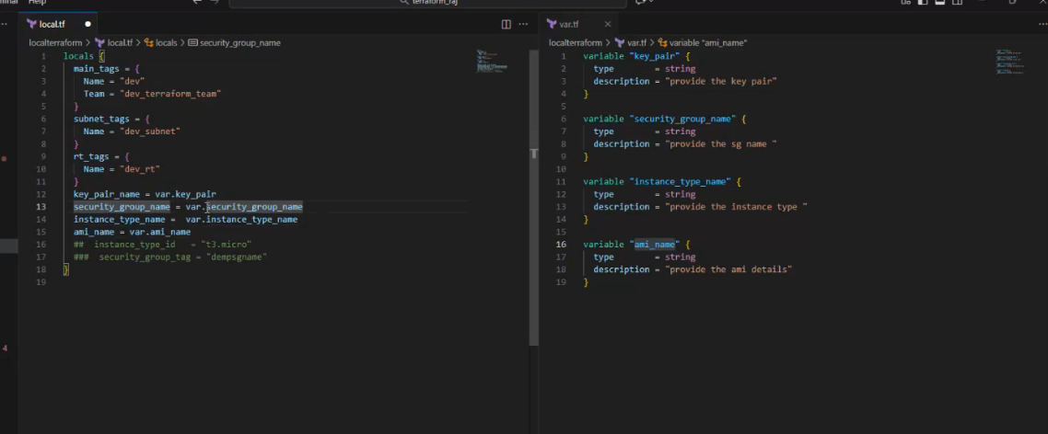
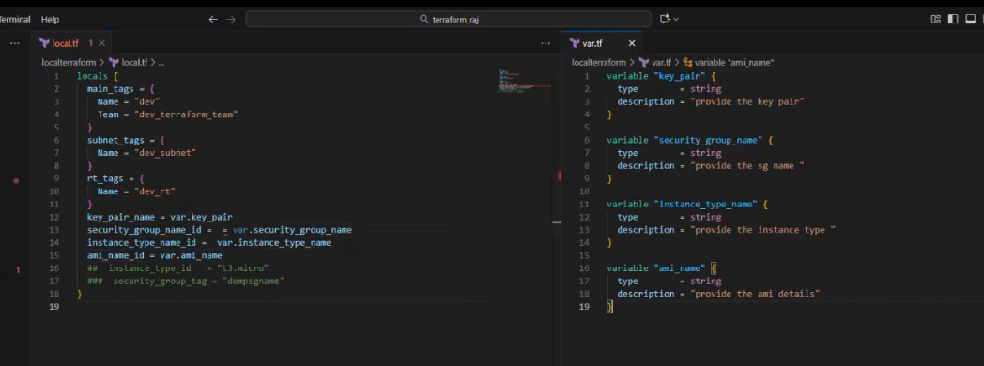
He added 4 variables to local.tf and then used in other tf files as local.[] instead of var.[]
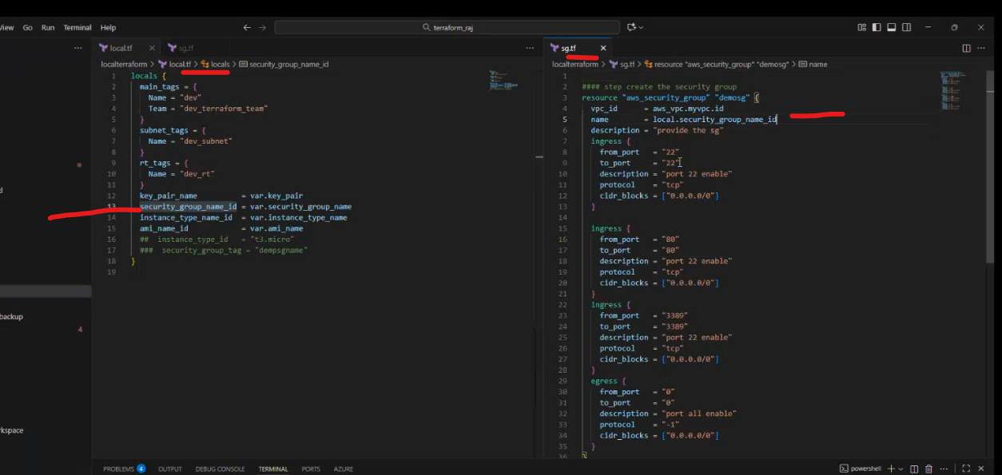
He created 2 new variables for VPC block, Subnet block
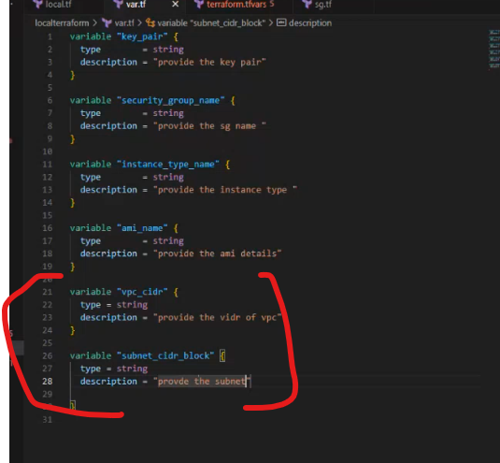
He added these 2 to local block…..local block has 6 values now…..

