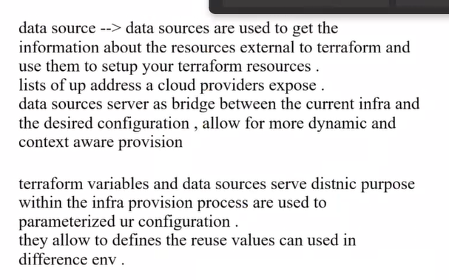
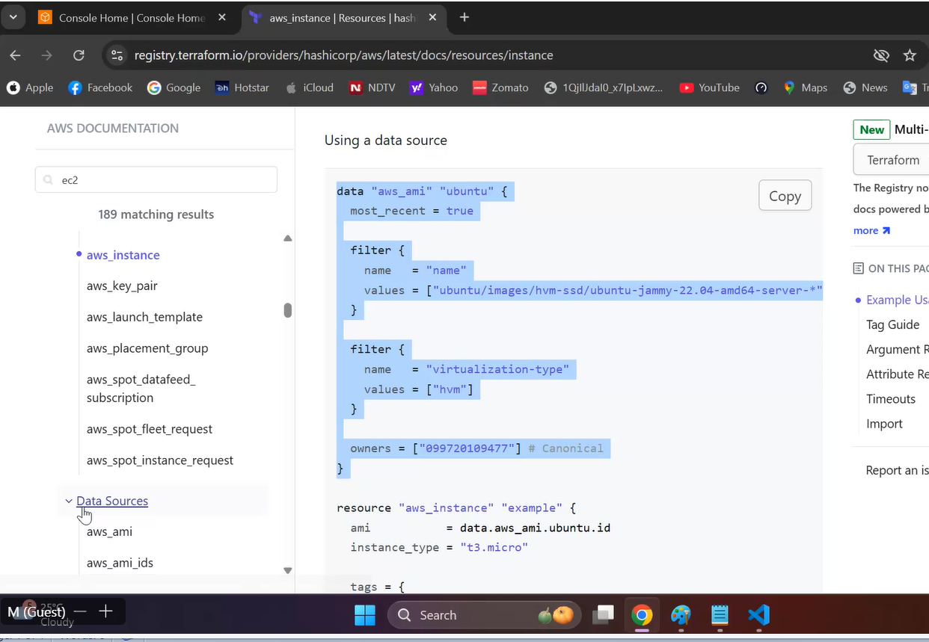

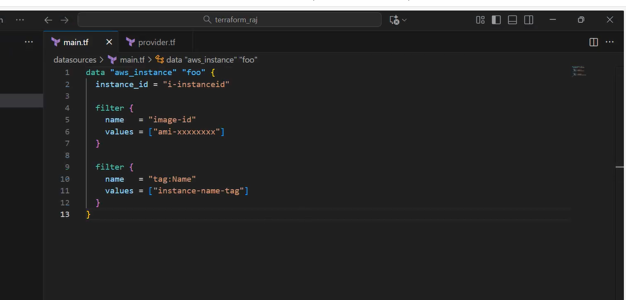
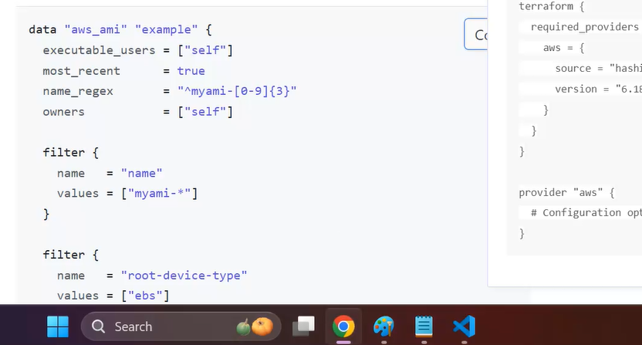
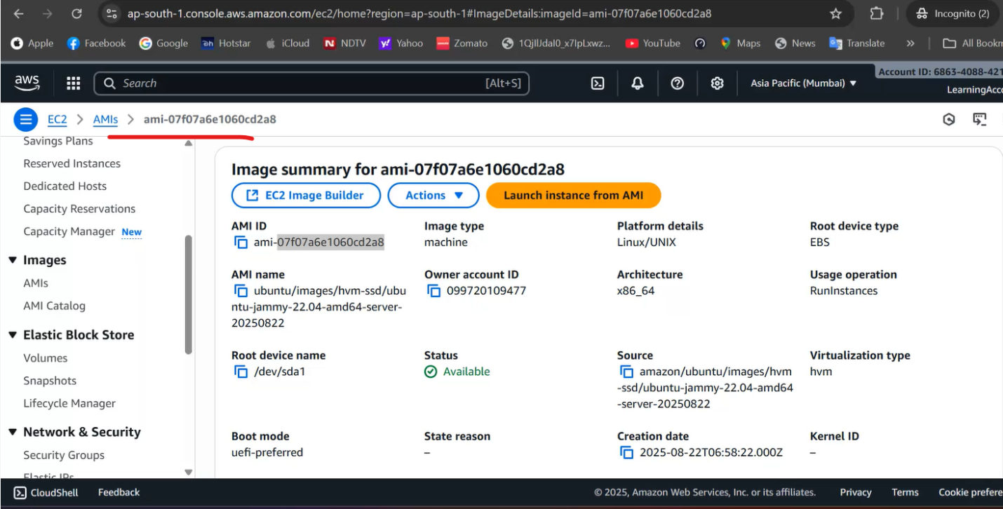
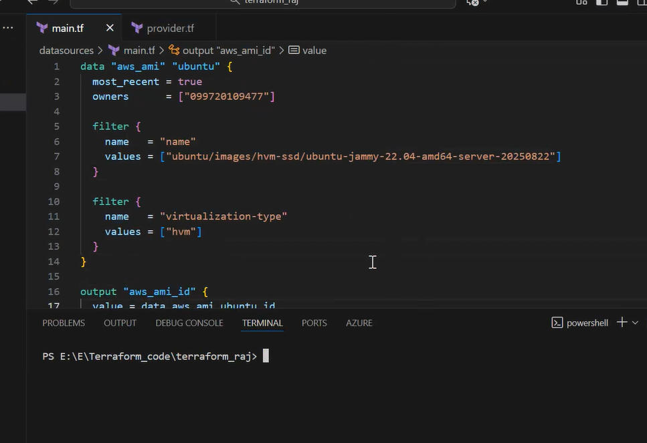
He did terraform init and terraform apply….which gives output
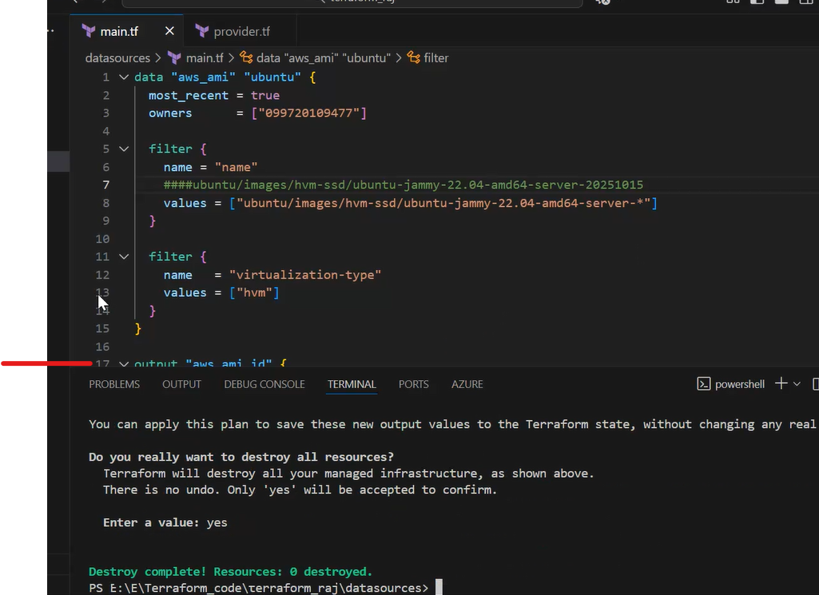
data "aws_ami" "ubuntu" {
most_recent = true
owners = ["099720109477"]

filter {
name = "name"
####ubuntu/images/hvm-ssd/ubuntu-jammy-22.04-amd64-server-20251015
values = ["ubuntu/images/hvm-ssd/ubuntu-jammy-22.04-amd64-server-*"]
}

filter {
name = "virtualization-type"
values = ["hvm"]
}
}

output "aws_ami_id" {
value = data.aws_ami.ubuntu.id
}

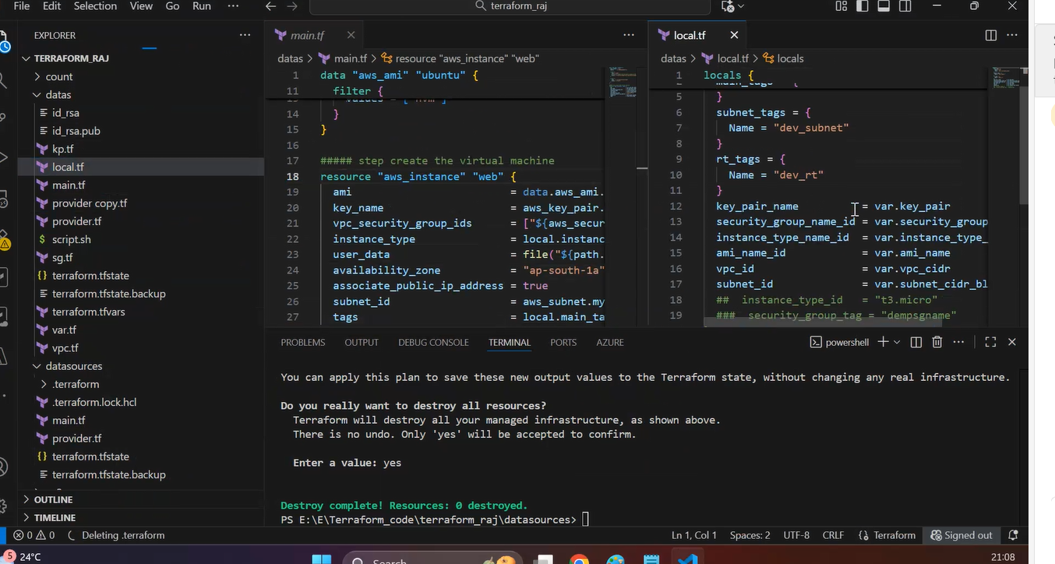
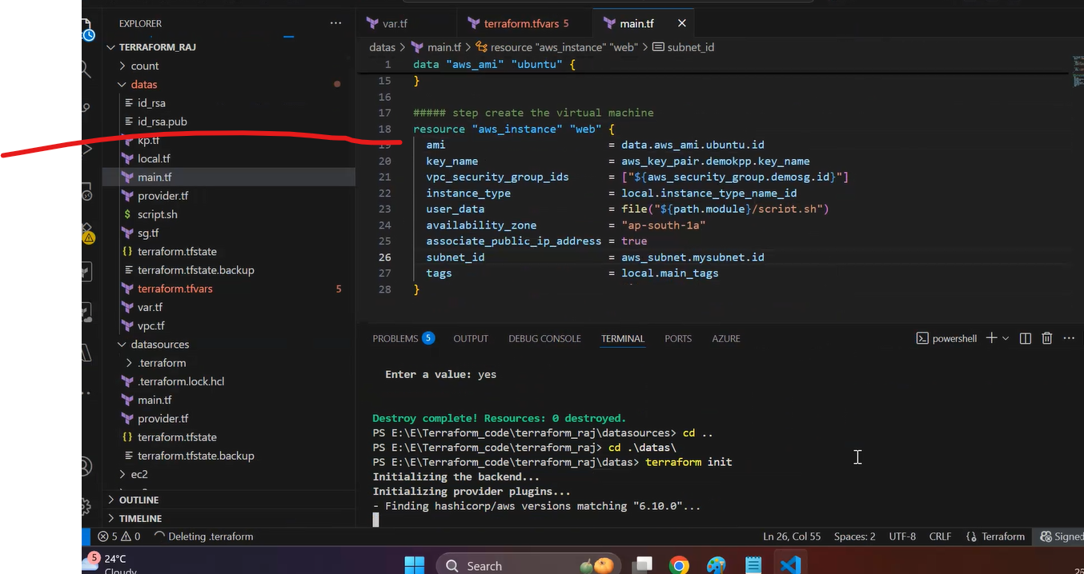
He used previous class code….then used data resource to fetch ami info and adjusted variables.tf, vm.tf, tfvars files and did the deployment
He regenerated id_rsa files…initial deployment public key not deployed….

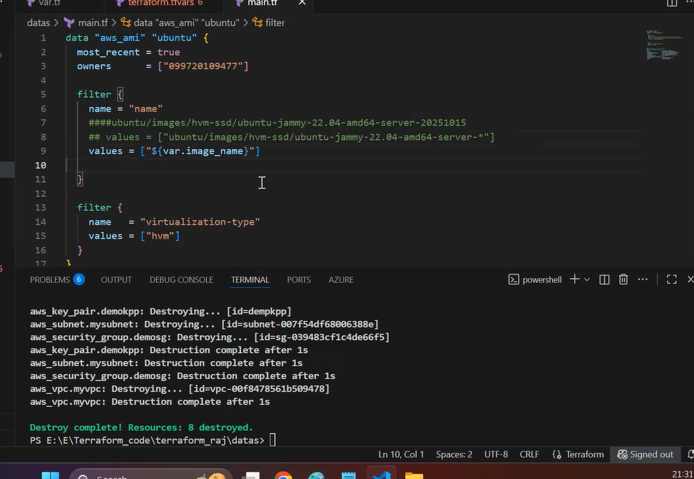

He manually created Windows EC2 and then attached EBs volume….

