Hora: A Program For Computer-Aided Choreography

Rebecca Graber
Advisor: Scott D. Anderson

Submitted in Partial Fulfillment of the Prerequisite for
Honors in Computer Science

April 2011

© 2011 Rebecca Graber

Table of Contents

Abstract…………………………………………………………………………………………....1

I. Introduction……………………………………………………………………………………. 1

II. Computers and Choreography………………………………………………………………… 2

III. Design………………………………………………………………………………………... 3
A. User interface…………………………………………………………………………. 3
B. Typical use case………………………………………………………………………. 6

IV. Implementation………………………………………………………………………………. 8
A. Blender Game Engine………………………………………………………………… 8
B. Creating the user interface…………………………………………………………… 10
C. Creating the dance…………………………………………………………………… 10
D. Animating Laddie…………………………………………………………………… 11
E. Multiple dancers……………………………………………………………………... 12
F. Playback……………………………………………………………………………… 13
G. Circular motion and limitations of the playback algorithm……..……..……………. 15

V. User Testing…………………………………………………………………………………. 19

VI. Future Work………………………………………………………………………………… 20

VII. Conclusion…………………………………………………………………………………. 20

VIII. Bibliography………………………………………………………………………………. 21

Abstract

This thesis introduces Hora, a new tool for computer-aided choreography of Israeli folkdances. Hora is aimed at the amateur choreographer. While there are other tools for computer-aided choreography, few speak the language of the amateur choreographer. Some programs, like DanceForms, require the user to use keyframe animation to produce their choreography, and are thus more suited to computer graphics specialists than dancers or choreographers. Others, like LabanWriter and LabanDancer, assume knowledge of dance notation, which is a difficult and highly specialized art. None take advantage of the modularity of dances, which can in some ways be viewed as permutations of a set of basic steps or actions. This modularity is particularly present in Israeli folk dances, which generally draw from a reasonably finite set of basic actions. Hora uses this modularity in combination with the techniques of 3D animation and user interface design to create an effective tool for choreography. Hora was built using the Blender Game Engine, a feature of the open-source 3D animation program Blender.

I. Introduction

Dancing is one of the oldest human pastimes. It provides a remarkable outlet for physical and emotional expression. Choreographing dances can also be an excellent creative exercise for anyone interested in dancing. However, choreography is often perceived as being the sole domain of professionals or at least well-experienced dancers. While professional choreography is indeed an art form requiring years of study, amateurs can still make valuable contributions to the art as a whole.
A lack of accessible tools can make choreography difficult. Choreographing a dance usually requires using another human being to observe the planned steps in motion. Moreover, once a dance has been choreographed, it is incredibly difficult to record the choreography in such a way that it can be transmitted to another person and easily followed. Dance notation systems like Labanotation and Benesh are highly specialized, complicated forms of notation that generally require experts to both read and write (Figure A).

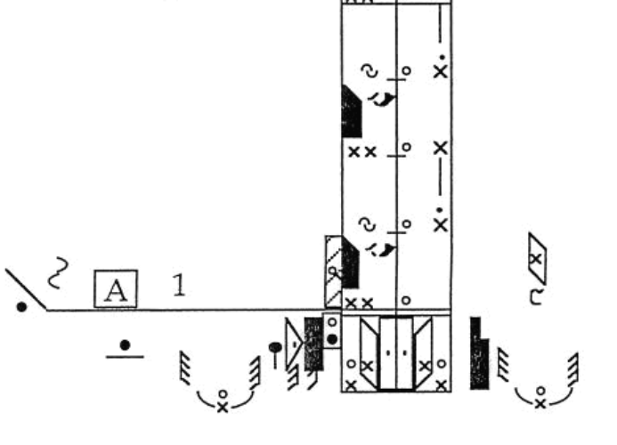

Figure A: A single measure of the Israeli dance Debka Kafrit in Labanotation [2]

These difficulties are particularly daunting to the amateur choreographer, who may not have access to actual dancers to help choreograph nor the ability to record his or her ideas using notation.
Computers, meanwhile, are wonderful equalizing forces. They can reduce the level of expertise needed to perform nearly any task. Applying computers to dance in such a way that allows amateur choreographers to produce their own dances will increase participation in dance and enrich the art form considerably. For the users themselves, it will provide a new form of accessible emotional expression and the chance to see their ideas fully realized and recorded for entry into the world of dance.
An easy-to-use piece of software would encourage these prospective choreographers to experiment and create new dances that they could then share with others. Thus, the goal of this project is to produce such a piece of software to aid choreography, specifically that of Israeli folk dances. This project focuses on Israeli dancing specifically because Israeli folk dances can generally be decomposed into several basic primitives and common combinations, as will be explained further in the implementation section.

II. Computers and Choreography

Most of the current work relating computers to dance has focused on the computerized creation and interpretation of dance scores (a written representation of an entire dance is called a dance score, similar to a music score). LabanWriter and LabanDancer are two of the best known examples of such software. LabanWriter, produced by the Ohio State University Department of Dance, allows users to create, edit, save, and print formatted Labanotation scores. LabanWriter is essentially a 2D graphics editor, where users simply drag and drop Labanotation symbols from a menu onto the staff [6]. At no point does the user actually get to see the sequence of movement described by the score. Recognizing this limitation, collaborators from Credo Interactive, Simon Fraser University, University of Waterloo, and the Dance Notation Bureau created LabanDancer, which takes a Labanotation score as input and produces a 3D animation of the choreography written therein [7]. While this was a significant advancement in the field of computer-aided choreography, it still requires an initial Labanotation score. Amateur choreographers cannot be expected to know Labanotation, so LabanDancer is unsuitable for amateurs, who are the target users of Hora.
The piece of software most similar to the one I propose is DanceForms (an offshoot of the character-animation software LifeForms), produced by Credo Interactive, in that the user can actually see their choreography as they are producing it. Using the DanceForms interface requires manipulating a 3D model of a dancer (or multiple dancers) into various poses and using keyframe animation to create a coherent piece [6]. In keyframe animation, the user establishes endpoints (keyframes) for a desired sequence and the computer creates a smooth transition between the endpoints using simple interpolation. Thus, if a user wants to animate a figure walking, they must figure out the poses a human being makes while walking and create each pose independently. The typical algorithm for creating a single step forward involves at least four keyframes, each of which involves careful adjustment of the feet, arms, hips, and spine [1]. It is doubtful that an amateur choreographer would have the animation knowledge necessary to create a realistic walking action using keyframes. There are a few DanceForm libraries of pre-animated sequences (generally individual steps, like a pirouette or chasse) available for choreographers, most notably Rhonda Ryman’s Ballet Moves II and Modern Dance Moves [6]. However, DanceForms still requires considerable expertise to use effectively, especially for those without access to these libraries. Moreover, DanceForms is proprietary software and thus neither fully accessible nor suited to modification for better use.
A particularly interesting example of linking computers and choreography comes from Elizabeth Bradley and Joshua Stuart’s work on chaotic mappings of choreographed sequences. Bradley and Stuart took ballet sequences and broke them up into a series of body positions (essentially keyframes). Using their program Chaographer, they mapped these positions onto states of a chaotic system. In a chaotic system, an algorithm produces a sequence of states. The algorithm is created such that by altering the initial value even slightly, the sequence is changed dramatically. Thus, by mapping the positions onto a chaotic system and altering the initial conditions of the mapping (that is, changing the first pose), Bradley and Stuart were able to generate an entirely new sequence.
Using another program, MotionMind, they were able interpolate between the poses in a manner both physically and stylistically consistent with balletic movement. To do this, MotionMind uses machine learning and a large corpus of motion sequences to determine common movements of each of the 23 main joints in the body (each pose is represented as a list of quaternions representing each joint, its angle of rotation, and the axis of rotation). It represents its findings as a weighted graph, which it traverses to create smooth transitions (called “tweens”) between the poses generated by chaotic variation. In this way, the computer is actually the choreographer of new dance sequences, albeit new sequences that are actually variations of human-choreographed dances. Bradley and Stuart used LifeForms to display the dances created.
None of the projects discussed above address the needs of the amateur choreographer. LabanWriter and LabanDancer require knowledge of an intricate system of notation unknown even to many professional choreographers. DanceForms assumes a knowledge of the process of keyframe animation and is thus geared towards computer animation experts rather than dancers. Chaographer and MotionMind allow the computer to actually create choreography, rather than having it assist the user in creating his or her own. Thus, by focusing on assisting amateur choreographers, Hora provides a novel contribution to the field of computers and choreography.

III. Design

The overall concept of Hora is fairly straightforward: users select dance steps from a menu and place them on a timeline (similar to movie editing in iMovie or FinalCutPro). They can then view the dance they have created being performed by an animated figure on the screen (nicknamed Laddie). For some steps, the user can also select the direction of movement (counterclockwise, clockwise, into the center, or outward) via an animated menu, which allows the user to view the step before adding it to the timeline.

A. User Interface

What follows is a more detailed description of Hora’s user interface, shown in Figure B.

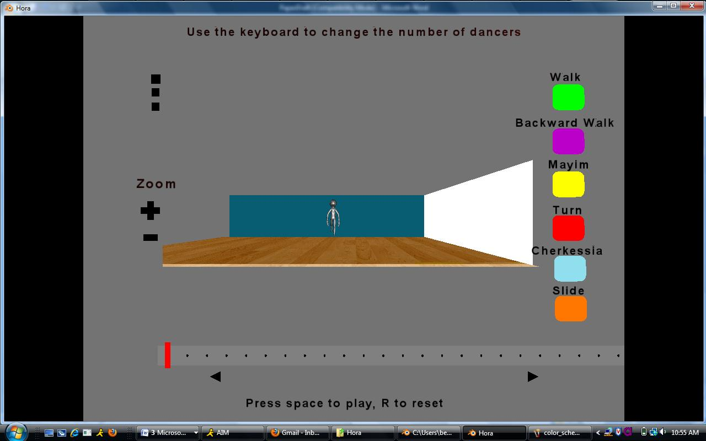
1
2
3
5
6
4
Figure B: Hora at the opening of the program, with numeric labels for the different parts of the interface explained in this section.

1. Playback Area
This area is where the actual dance is displayed. It is meant to resemble the inside of a simple dance studio, with a wooden floor and the back and left side walls visible to indicate the boundaries of the space. When the user selects different camera angles or zooms in, this is the only part of the screen that changes. The numeric keys at the top of the keyboard change the number of dancers on the floor, up to 4.

2. Steps Menu
This area is where the user selects the next step they would like to add. The steps are color-coded to make it easier to read the timeline. When a user adds a step to the timeline, the area indicating the duration of the step will turn the same base color as the menu option, with different shades indicating different parameterizations. At the moment, Hora only incorporates six steps:
1. Walks (1 beat; clockwise, counterclockwise, into the circle, or out of the circle; represented by green squares)
2. Backward Walks (1 beat; same options as regular walks; represented by purple squares)
3. Mayims (4 beats; left or right; represented by yellow squares)
4. Four-Step Turns (4 beats; left or right; represented by red squares)
5. Cherkessias (4 beats; facing clockwise, counterclockwise, center, or out; represented by blue squares)
6. Slides (2 beats; left or right). These steps were chosen both to represent different types of motions with different parameterizations and because they are enough to implement a very basic Israeli dance (the dance ‘Od Lo Ahavti Dai’ uses only these steps).

3. Camera Buttons
These three buttons allow the user to change the camera angle of the playback. They were chosen based on common camera angles in live Israeli dance videos and to provide flexibility in focusing on different aspects of the dance.
The opening (default) camera is the “balcony” view, as if the user is on a balcony at one end of the dance floor, several feet above the floor itself (as seen in Figure B). This allows the user to view an even combination of the individual steps and the overall pattern. This view was the most common in online videos of Israeli dances, so it was included as the default option in Hora.
The middle camera button switches the camera to the top view, as if the user is suspended above the dance floor (Figure C). This is the best angle for viewing the pattern of the dance and how it moves around the circle.

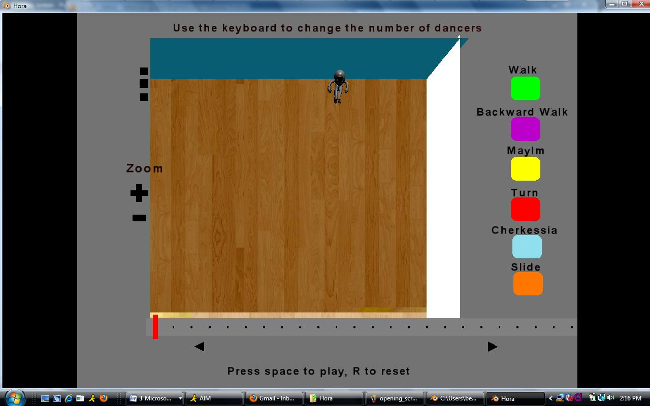
Figure C: Hora with the top (overhead) camera view selected

The final camera angle is the front view (Figure D), as if the user is standing at the opposite end of the dance floor. In reality, the camera is not directly in front of the scene, but placed slightly above the center to show the shape of the floor. This is the best view for viewing the individual steps. The top button places the camera for this view.

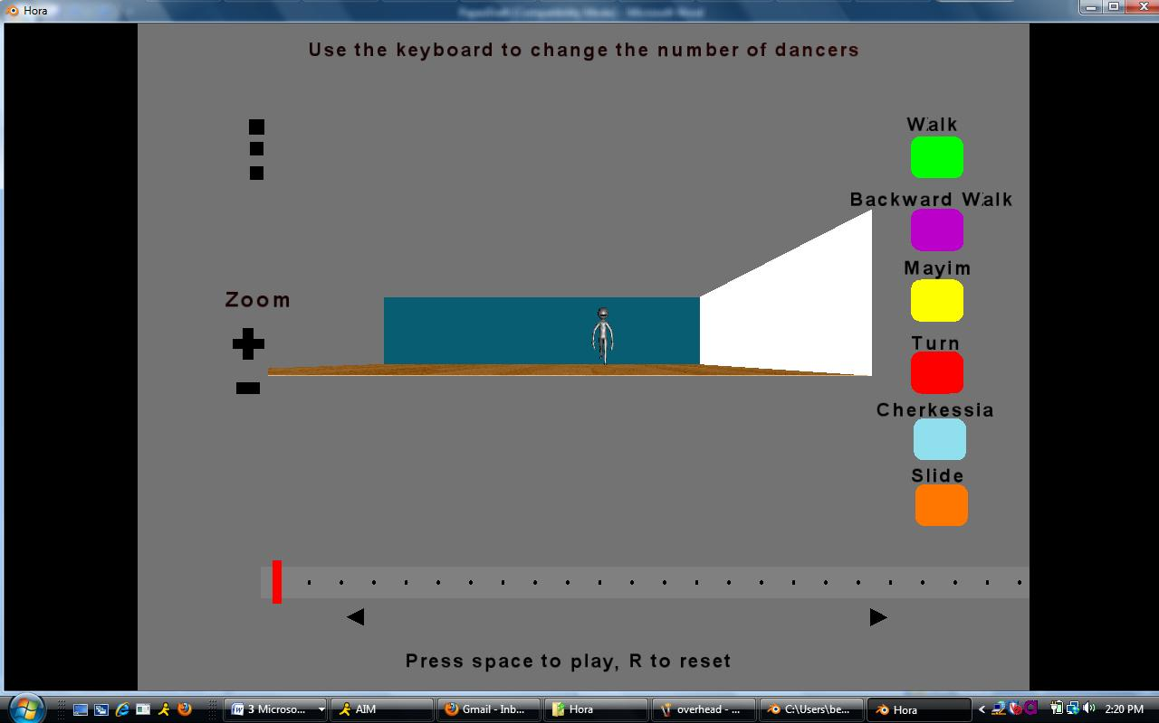
Figure D: Hora with the front camera view selected
4. Zooming buttons
The zoom buttons allow the user to zoom in (+) and out (-) of the scene. Zooming works the same as it does on physical cameras, adjusting the size of the camera lens but retaining the angle and location of the camera, so the focal point remains the same. This means that sometimes Laddie may go out of view. In earlier iterations of the project, the camera followed Laddie around the floor and thus ensured that he was always visible. However, Laddie’s overall armature moves in discrete jumps rather than continuously (for reasons explained later in the implementation section), so this made the view very choppy. Moreover, since the user may display multiple dancers, it did not make sense to force them to follow a single dancer.

5. Timeline
This area is where the user creates the dance. The timeline is actually 64 separate cubes, each representing one beat. In the current iteration of Hora, the program is hard-wired to only allow 64 beats of choreography. Ideally, future iterations will be able to dynamically determine the number of beats in a given song. Once the user has selected a step, she can drag the mouse along the timeline to indicate the duration of the step (in beats). A single click on an area of the timeline will place the selected step beginning on that beat and extending for whatever the default duration of the step is (1 beat for walks, 4 for cherkessias, etc.). In order for the playback to work properly, the user must select an area of the timeline that is a multiple of the default number of beats for the step. As the user drags the mouse along the timeline, the indicated cubes will change color to indicate a step has been placed. When the user hovers the mouse above a section of the timeline, a tooltip-type textbox will appear indicating the step at that beat. To reset the timeline, the user can hit ‘R’ on the keyboard.

6. Timeline navigation
These buttons allow the user to view different parts of the timeline, since it is too long to fit nicely on the screen.

B. Typical use case
To fully understand the functionality of Hora, it is helpful to view a typical sequence of interactions between the user and the program. The appearance of the program when the user first opens Hora is repeated here as Figure E.

Figure E: Hora at the opening of the program
The user then selects a step from the menu on the right. In Figure F, the user has selected a forward walk. When a step is selected, a menu appears (the four miniature scenes with accompanying white text) showing the possible directions the step may travel. The user selects the desired direction from this menu. In Figure F, the user has selected counterclockwise. The user then adds the steps by clicking and dragging along the timeline.

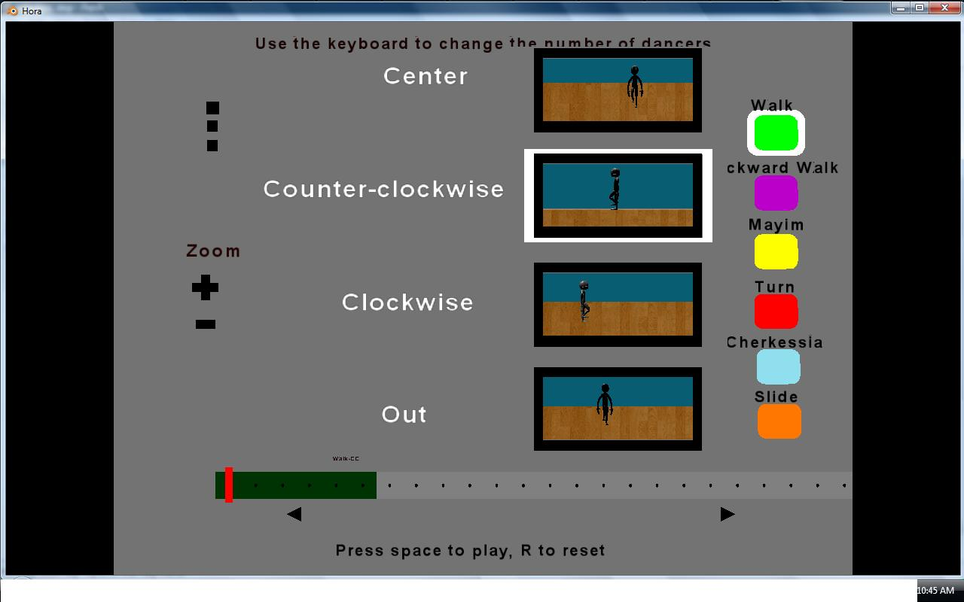
Figure F: Hora after the user has selected ‘Walk’ from the Steps Menu and set the direction to counter-clockwise using the Parameterization Menu.

When the user presses the space key, the menu disappears and the dance begins to play. The seekbar indicates the section of the timeline currently playing; the user may drag it to another spot on the timeline to begin playback from there.

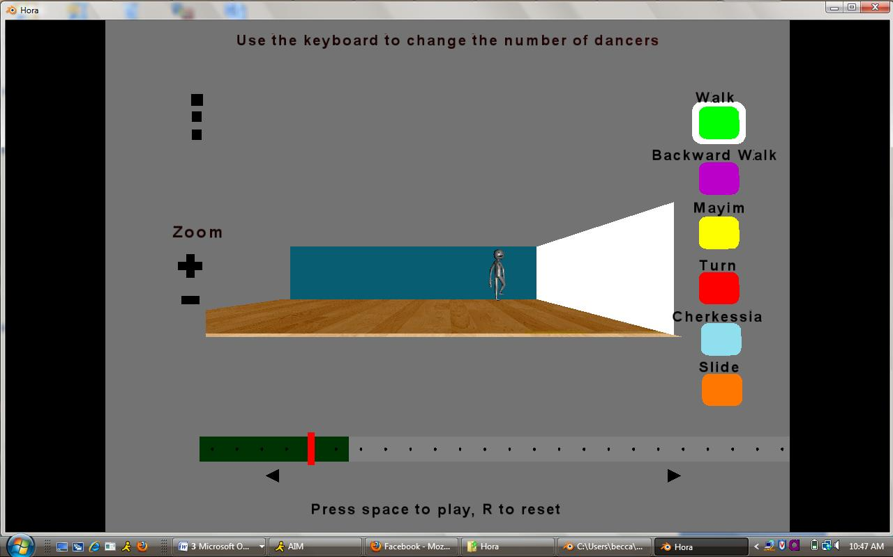
Figure G: Hora as the user is playing the dance. The seekbar indicates that the dance is currently on the fifth beat.

Each step is color coded to allow the user to read the timeline. In Figure H, all of the green spaces represent walks (darker means counterclockwise; lighter is clockwise), while the blue spaces mark a cherkessia step done towards the center. The user can also hover the mouse over a section of the timeline and a label indicating the dance step placed there will appear.

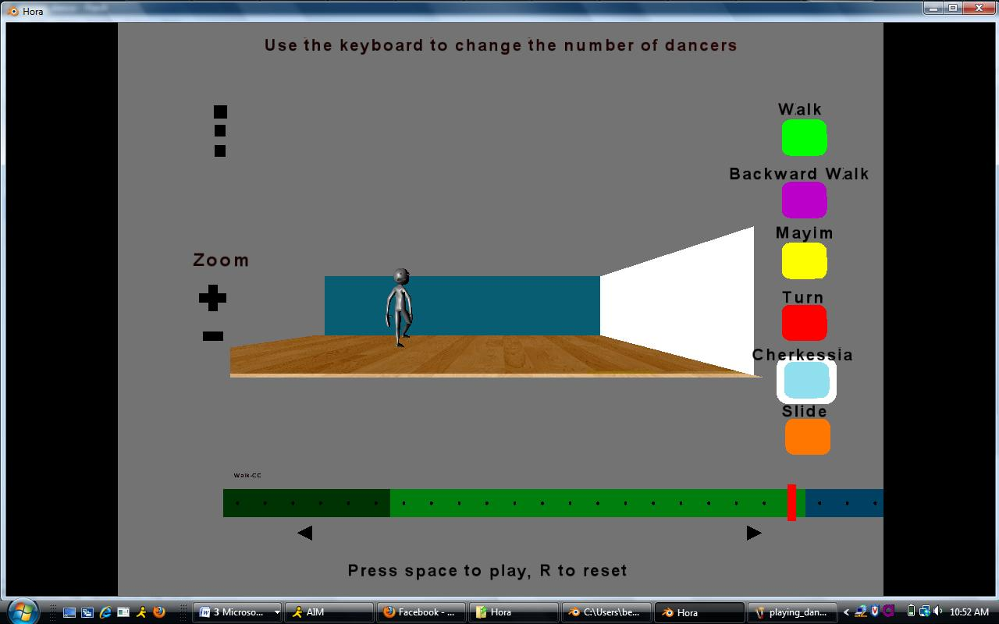
Figure H: Hora as the user is playing a more fully-choreographed dance: six counterclockwise walks (dark green), fifteen clockwise walks (lighter green), and a cherkessia facing the center (blue). The seekbar indicates that the dance is currently on the twenty-first beat.

IV. Implementation

This section describes how Hora was implemented using the Blender Game Engine. Understanding the implementation details requires some background on the Blender Game Engine and some of its limitations. After introducing the basic structure of the Blender Game Engine, I will describe how the implementation of Hora uses the features and overcomes the quirks.

A. Blender Game Engine

The Blender Game Engine uses a combination of “Logic Bricks” and Python scripting to create dynamic user interfaces. Logic Bricks allows the designer to create some user interaction sequences without needing to write any code. An example of using Logic Bricks is included as Figure I. In addition to these Logic Bricks, interface designers and animators can attach Python scripts to certain user inputs, manipulating animated objects and their properties using the Game Engine API.

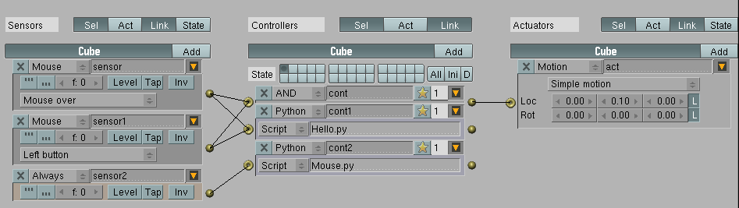
Figure I: Sample Logic Brick configuration in Blender
When the user left-clicks on the “Cube” object, the cube will move 10 units on the Y-axis, and Blender will execute the Hello.py script (the Mouse.py script is necessary to view the cursor during gameplay).

Sensors (the three blocks on the left in Figure I) are essentially event listeners, listening for information from the user or other objects in the program, as well as changes to the object’s properties. A sensor may be activated by user input actions (clicks, keyboard strokes, etc.), messages from another objects, or changes to the state of the object. Here, “sensor” listens for the mouse to be over the cube, while “sensor1” listens for a left click. “Sensor2” is always positive.
Controllers (in the center of Figure I) link sensors to actuators and/or external scripts. They allow the user to combine sensors using simple Boolean operations (and, or, not, nand, nor, and xor) and activate actuators when the operation returns true. Controllers may also link sensors and actuators to external scripts for more fine-tuned control and complex operations. Here, “cont” specifies that both “sensor” and “sensor1” must be positive for the actuator to be activated. “Cont1” and “cont2” do not perform any Boolean logic; they just run their respective scripts.
Finally, actuators (at the right of Figure I) produce some change to the state of the program. In Hora, actuators are used to move and/or rotate objects, play animated sequences, add and remove scenes from view, play, pause, and stop music, update object properties, and send messages to objects in the game. Here, “act” moves the cube 0.1 units along its local y-axis.
The action actuator, which plays animations, is particularly important to Hora and merits further discussion. An action actuator has several properties. The most important ones for Hora are:
a. Action: The name of the animated sequence to be played.
b. Start: The first frame of the sequence.
c. End: The last frame of the sequence.
d. Type: This determines the nature of the playback. In Hora, the types used are
-Play End: The animation plays one time all the way through, disregarding any interruptions
-Property: The animation follows the change in a given integer property (see example below).
e. Frame Property: This specifies the property that will be updated as the animation plays. The value is assigned to the current animation frame.

B. Creating the user interface

Since Blender can only create three-dimensional scenes, the user interface of Hora actually comprises four separate three dimensional scenes superimposed on each other. The “Editing” scene contains the menu of steps and the buttons for camera manipulation, in addition to two invisible controllers. Though it appears flat, it is actually a fully three dimensional scene viewed as an orthographic projection to remove the appearance of perspective (stereographic projection).

Figure J: Orthographic vs. stereographic projection. Orthographic projection (left) does not show perspective [4].

The “Timeline” scene has a similar camera designed to make the scene appear two-dimensional. The scene contains 64 separate cubes arranged to resemble a continuous timeline and a seekbar to allow the user to seek back and forth in the dance.
The “Playback” scene is where the three-dimensional rendition of the dance takes place. Initially, only one character (Laddie) is visible. Several more exist in the scene, but they are left invisible until the user indicates she would like to see more dancers.
The last scene is the “Options” scene, which only becomes visible when the user selects menu items requiring parameterization. Depending on the number of parameters necessary, the options scene will display two or four miniature copies of the playback area (the area labeled 1 in Figure B). When the user clicks one of the scenes, she will see an animation of the selected step with the associated parameter. An invisible controller in the editing scene adds this scene to the foreground and removes the playback scene when a menu item is clicked, then restores the playback scene and removes this scene when the user presses the space key to view the dance.

C. Creating the dance

When a user selects an item from the menu and the associated parameter values, she sets the “SelectedStep” property of an invisible controller in the editing scene, called ChoreolistE (the E stands for empty, which is a Blender object with no graphical properties. There are not many standardized naming conventions in Blender; the E was added to distinguish the controller from the actual list). SelectedStep holds a string representing the name of the animated sequence that is to be played and its orientation. For example, if the user selects a counterclockwise walk, SelectedStep will be the string “Walk-CC,” since Laddie will be facing counterclockwise for a forward walk in the counterclockwise direction.
The full dance is stored as an array of 64 strings, which in turn is stored as another property of the invisible controller. While this number is currently hardwired into the program, it can be changed by changing the “numBoxes” property of ChoreolistE. Every index is initialized to an action called “Still,” which is simply an animation of Laddie standing still for 11 frames (the length of one beat). Every box on the timeline is associated with an index in the array. When the user places the selected step on the timeline, the value of the array at the corresponding index changes to the value of Selected. The controller reads from this array to manage playback.

D. Animating Laddie

Understanding how playback of the dance works requires a brief discussion of animation in Blender. Objects in Blender all have an object center, the point about which the object translated, scaled, or rotated. Every object also has a local coordinate system, which reflects the environment in which it was created. If the object has a “parent”object (another object to which it is linked), its local coordinate system is created in relation to its parent object. Its local position refers to its position relative to its parent. If an object has no parent object, its local and global positions will be the same. The same applies to local and global rotation. When an object is moved or rotated, its local coordinate system moves/rotates as well, so it remains constant with respect to the object, which changing with respect to the global coordinate system. For example, Laddie’s y-axis always faces forward with respect to Laddie, even though it may change relative to the global y-axis.
The basic building blocks of animations in Blender are Interpolations (IPOs), which are keyframe-based animations. An IPO has several different channels, including one for absolute and local location, scale, and rotation for each axis. Users set keyframes in these channels, and then Blender uses interpolation to create smooth curves that transition from one keyframe to the next, thus creating continuous animation. Hora uses different types of animation for different types of objects. Simpler objects, like the seekbar, have only one IPO. The IPO moves or scales the object based on the object center (Figure K). These IPOs change the local and global location of the object, as well as the local and global scale. The location of an object refers to the location of the object center; similarly, an object’s rotation is specified by the direction axes emanating from the center.

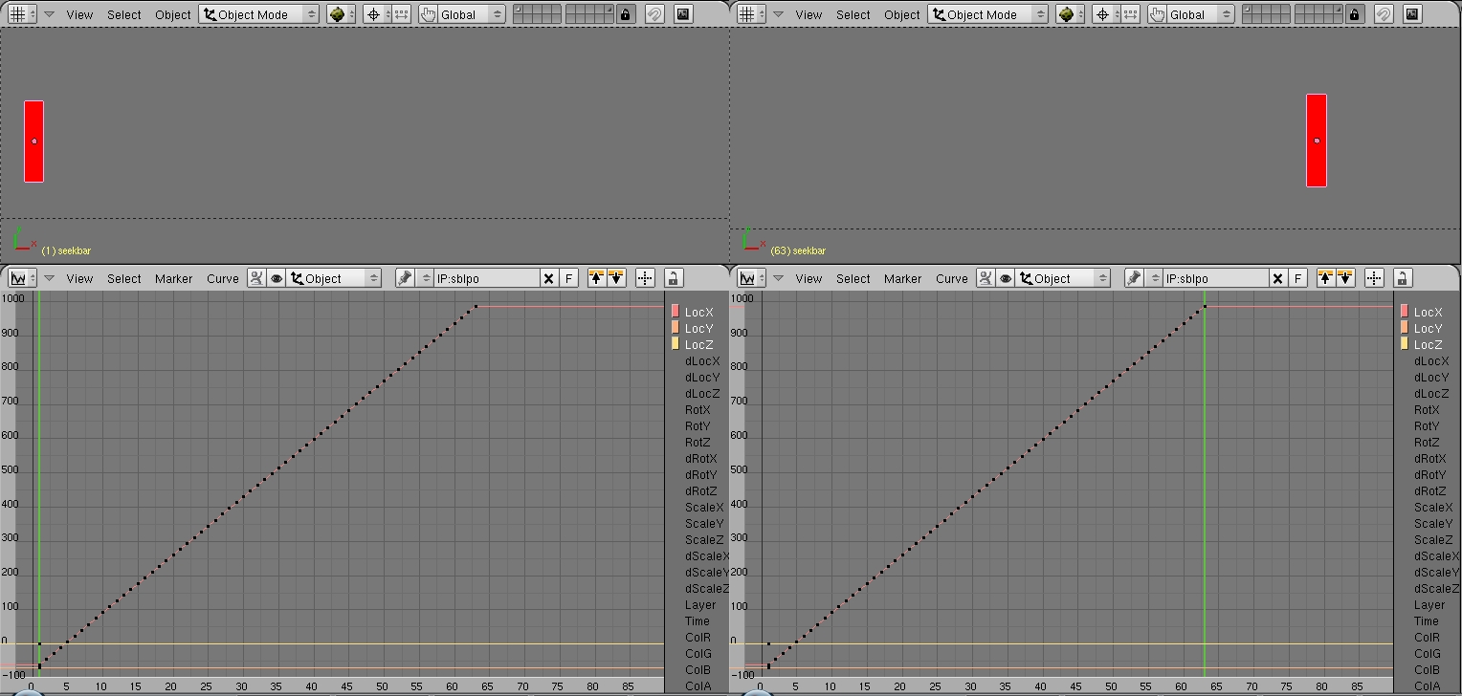
Figure K: The IPO curve acting on the seekbar object. The black squares represent keyframes on the LocX channel, which shows movement along the positive x-axis. At Frame 0, the global (and local, in this case) location of the object center of the seekbar is (approximately) [-60,-68,0]. At frame 63, the global and local location of the object center is [987,-68,0].

Laddie is not a single animated object, but several objects made to move in a way resembling a single figure. His external mesh (essentially his “skin”) is a publicly available figure, created as part of the Blender Summer of Documentation. It can be downloaded from http://wiki.blender.org/index.php/Doc:Tutorials/Animation/BSoD/Character_Animation/Torso_legs_and_feet. Underneath the external mesh is an armature, or skeleton. The armature itself is several individual bones tied together according to a set of rules which make the armature act in a manner similar to a human skeleton. The armature is attached to a mesh via a process called ‘weight painting.’ With weight painting, every vertex of the mesh is attached (“painted on”) to a specific bone, so that when that bone moves, the vertices painted on move as well, maintaining their position relative to the bone. Thus, when the bone moves, it only affects a certain part of the body rather than the entire figure.
Each bone has an IPO attached, which acts on the center of the bone. However, the entire armature also has a general IPO which acts on the entire armature at once, for example moving the entire figure to a different part of the screen. Thus, when a figure is animated using the armature, its global location does not change (the armature moves away from the object center, but object center itself does not move, illustrated in Figure L). This is important for understanding the choreography algorithm.
The rigging and basic walk cycles were done according to the specifications from the Character Animation tutorial from the Blender Summer of Documentation. I created all other animations independently.

E. Multiple Dancers

Hora allows the user to view her choreography with up to four dancers. All of these dancers are present in the playback scene, but are left invisible. Each is assigned a number, and if the number of dancers selected is greater than or equal to their value, they are displayed. All six are exact copies of each other, with the same properties, sensor, and actuators. This means that they all send and receive messages from ChoreolistE simultaneously, so the movements are all synchronized. This feature is problematic, as using multiple dancers slows the animation down considerably, which puts the dance out of time and makes the animation choppy.

F. Playback

The most important aspect of Hora is the ability to combine several small animated sequences into the illusion of one coherent sequence. In reality, the user is actually watching these animated primitives played in rapid succession. It is likely that combining the animated sequences into a single animation would improve the quality of playback, but this would require real-time access to Blender’s non-linear animator (the engine for combining animations), which is currently not supported. Thus, a more complicated playback algorithm is necessary to essentially mimic some of the features of the non-linear animator.
Playback is controlled largely through a system of sensors and actuators attached to Laddie. He has a sensor for receiving messages as well as sensors for determining when he has reached the end of an animation. These latter sensors are activated when an animated primitive reaches its final frame. They signal to ChoreolistE that the step has finished and that Laddie is ready to receive the next step.

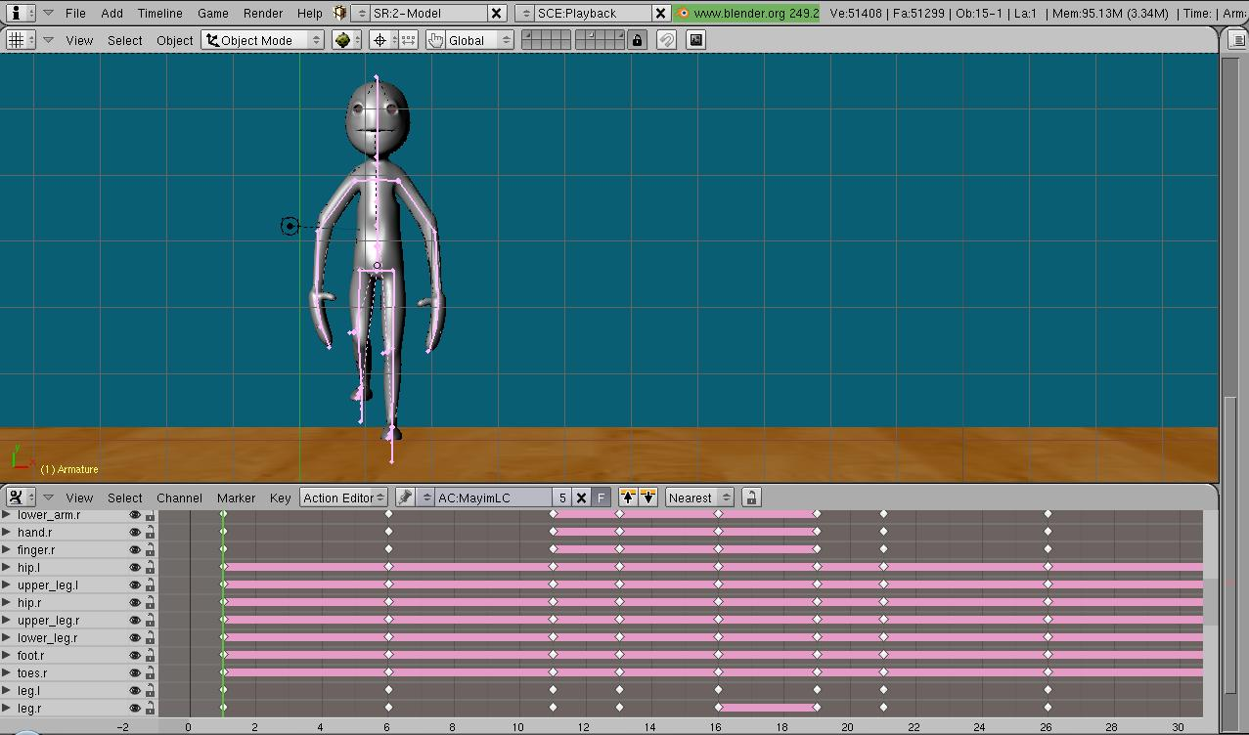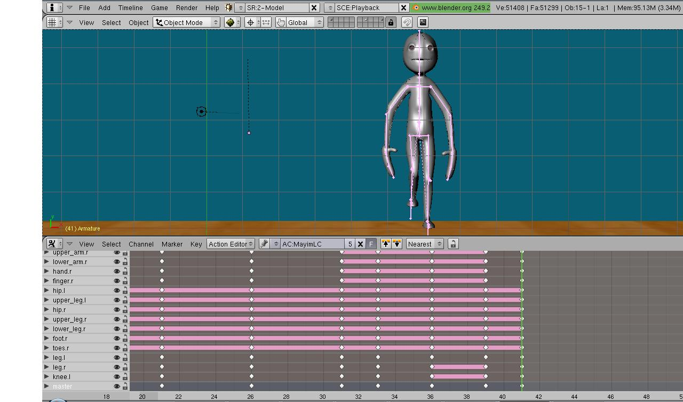
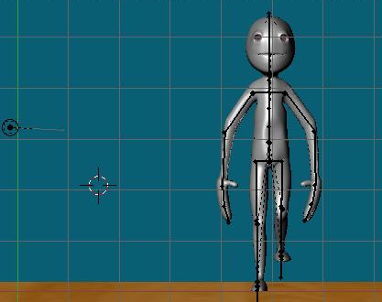
Figure L: Two different types of motion starting from the same initial position on the left. The object center is circled. In the top example, the bones in Laddie’s armature have moved away from the center, but the center has not moved. On bottom, the entire armature, including the center, has been moved (the global location has been changed).
Playback happens through a series of interactions between Laddie (more specifically, the armature that controls Laddie’s motion) and ChoreolistE. For every primitive animation sequence, Laddie has a property storing which frame of the animated sequence is playing. Laddie also stores his current orientation, standing foot, and the direction in which he’s traveling. Both Laddie and ChoreolistE have a counter indicating where they are in the timeline. The default value of both counters is zero, but may be changed if the user manipulates the seekbar (this changes the count to the value corresponding to selected beat on the timeline). When the user presses space, the following sequence occurs:
1. ChoreolistE changes Laddie’s count property to match its own.
2. ChoreolistE looks up the step to be played in the array at index count.
3. ChoreolistE looks up the step in a dictionary, where every step is keyed to the default number of beats.
4. ChoreolistE adds this number to its own count (not affecting Laddie’s count).
5. ChoreolistE sends a message to Laddie to begin playing.
6. When Laddie receives the message, he looks up the step corresponding to his current count (as set by ChoreolistE).
7. Laddie parses the string to determine the desired step, orientation, and direction.
8. Laddie rotates to face the desired orientation, based on his current orientation, by setting and activating a motion actuator. He then changes his orientation property accordingly. A more detailed explanation of how Laddie rotates in preparation for the next step follows in the next section.
9. Every step has two corresponding animations, one beginning on each foot. Laddie chooses which animation to play based on his current standing foot, then changes the standing foot property if necessary.
10. Laddie sets the animation on his action actuator, and ties it to the appropriate frame property. This way, as the animation plays, the appropriate property storing the frame number will increment accordingly.
11. Laddie plays the animation by activating the action actuator.
12. When the appropriate frame property reaches its maximum value (the number of frames in the animation), it sets off a sensor that tells Laddie to deactivate all motion and action actuators and reset the frame counter to 1. The sensor also sends a message telling ChoreolistE it that Laddie has finished playing the animation.
When ChoreolistE receives the message, the cycle repeats again from step 1 with one change: Laddie also finds the previous step and looks it up in a dictionary, where every step is keyed to the distance traveled in one iteration. Laddie then changes his local position to reflect the distance covered by the animation by setting and activating a motion actuator (see the beginning of this section for a more thorough explanation of changing global and local positioning vs. animated movement). This discrete change in position makes having the camera follow Laddie difficult, as was mentioned earlier.
An example of the animation process for a single step is included as Figure M.

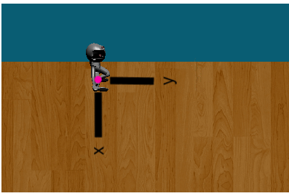 | 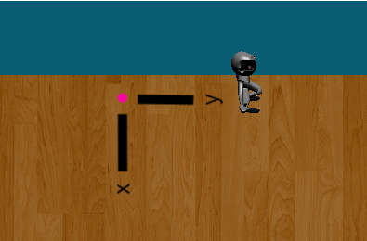 | 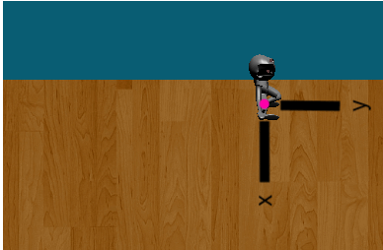 | 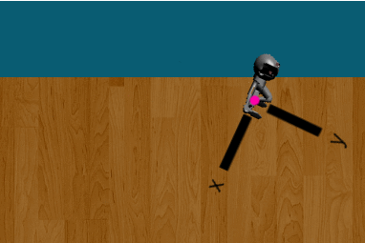
Initial position: object center is the center of the armature | Animation moves armature away from the object center | Translate the object center to match the position of the armature | Rotate the figure (around the object center) in preparation for the next step

Figure M: Animation process for a clockwise walk. The first two figures show the animation for one step, while the latter two show the setup for the next step.

The space key actually toggles a Boolean property of ChoreolistE which keeps track of whether the dance is playing, so if the user presses space again, it will stop the playback process. Pressing ‘R’ resets every element in the array to the still animation and returns Laddie to his original position. If ChoreolistE’s count property reaches 64 without interruption from the space or R keys, it will reset to zero and replay the dance.
The playback scene is duplicated four times in the Options scene. Each of the armatures in this scene is an exact copy of Laddie, but runs a slightly different script since they only need to display a single step, one time. Thus, they do not read from the choreography array, but are told which step to perform directly by the controller. They do not have to change orientations or angle themselves around a circle, and the counter resets after four beats.

G. Circular motion and limitations of the playback algorithm

One of the more significant challenges in playing back the dance is rotating Laddie after each step in such a way as to make him face the appropriate direction and keep the dance moving around the circle (or into and out of the center). In the earliest iteration of the program, when Laddie could only walk forward or cherkessia in place, the rotation algorithm was fairly straightforward; the angle of rotation was solely a function of the previous orientation. For example, if Laddie wanted to move clockwise after going counterclockwise, he would simply rotate 180 degrees around his local Z axis (the axis perpendicular to the floor), or turn 90 to face (approximately) the center of the circle. If he had two counterclockwise steps in a row, he would rotate 15 degrees between the steps (-15 degrees for two clockwise steps). This ensured that the dance moved around a regular 24-gon, so it approximated a circle. If Laddie moved into or out of the center without returning an equal number of steps, the 24-gon would shift accordingly, but the overall pattern was still fairly regular.
This algorithm became more complicated with the addition of new steps. Since each walking step traveled the same distance, keeping the angle constant ensured a regular 24-gon. New steps, however, such as mayims and four-step turns, did not cover the same distance. Moreover, these steps did not necessarily travel in the same direction as Laddie was facing. For example, mayim steps always face into the circle (in the current implementation of Hora, not necessarily in all Israeli dances), but may travel counterclockwise or clockwise. This presents two particular problems: First, depending on the nature of the previous step, Laddie may need to translate along his local Y axis (forward-back) or along the local X axis (side to side). Second, keeping the same angle no longer produces a regular 24-gon since the side lengths are different. For steps that cover more distance, a larger angle is necessary to keep the movement within the bounds of the floor. The angles for the different steps were determined heuristically rather than by a particular algorithm. Shorter steps (walks, backward walks, and slides) are followed by a rotation of positive or negative 15 degrees, while longer steps (mayims and cherkessias) are followed by a rotation of 30 degrees, since they cover approximately twice as much distance.
The playback algorithm was designed with a very limited menu of steps in mind, and has a few significant limitations. In particular, the path of the dance depends on the sequence of actions, since each action covers a different distance and is followed by a different degree of rotation. The rotation angles were chosen to keep the dance approximately circular. Using the non-linear animator, a sequence of actions can be tied to a curve to ensure the character moves along a certain path. However, since Blender Game Engine does not allow use of the non-linear animator, moving Laddie in a circle requires an alternate approach. Moreover, since the dance is composed of pre-animated, immutable sequences, it is not possible to dynamically adjust the individual animations to create a smooth circle. In light of these difficulties, several more scalable alternatives to the rotation algorithm described above were considered.
One alternative is to store the vertices of a regular n-gon in a queue and aim the armature towards the vertices in succession. The greater n is, the more circular the path will be. The side length of the n-gon must be at least as large as the distance covered by the longest step. The details of the algorithm are as follows:
Look at the vertex at the head queue. Determine the vector from the center of the armature to the vertex using the armature’s local coordinate system. If the previous step moved forward or backward (i.e. a forward or backward walk) and the y component (representing Laddie’s forward/backward direction) of this vector is positive, the armature should continue to aim its y-axis for this vertex (no rotation). Similarly, if the previous step moved side to side (mayim, four-step turn) and x component of this vector is positive, the armature should continue to aim its x-axis for this vertex. Otherwise, the armature has passed this vertex, so it should be dequeued and then enqueued at the end. Depending on if the next step moves forward/backwards or sideways, the armature should then have the y- or x-axis (respectively) aimed towards the (new) vertex at the head of the queue. To reverse the direction, the armature must be rotated 180 degrees and the queue must be reversed.
To rotate the armature to face a new vertex requires determining the vector from the center of the armature to the vertex (locally with respect to the armature), determining the angle between the armature’s y-axis and this vector, then rotating the armature by this angle. An example of this algorithm follows, where Laddie walks around a simple square.

Overhead View | Queue | Notes
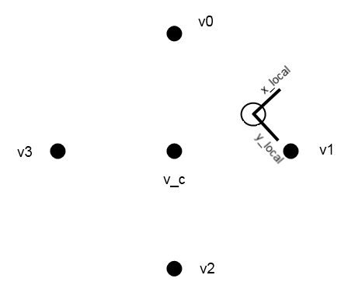 | Head  V1  V2  V3  V0  End | This represents the armature right before beginning its next action. The open circle is the armature, with its local axes labeled. The pink dot represents the object center.
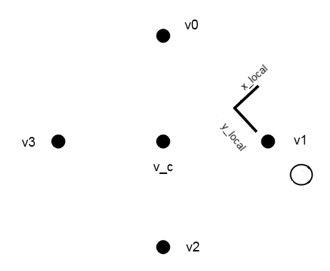 | Head  V1  V2  V3  V0  End | After the animation has played, the armature has moved away from the object center. Note that the object center has not moved.
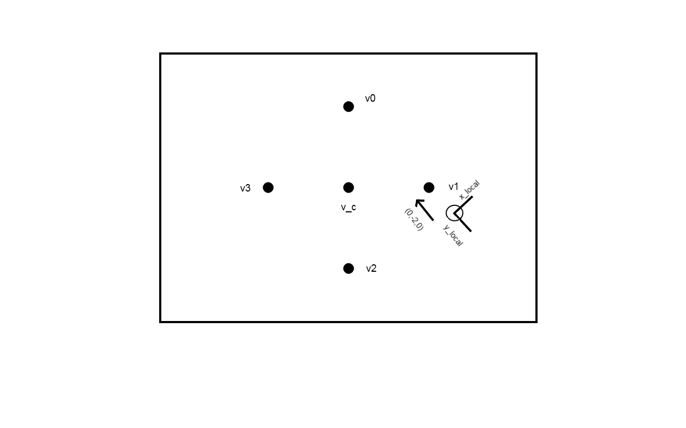 | Head  V1  V2  V3  V0  End | Translate the object center (by moving it on the local y-axis) so it is once again in the center of the armature. Calculate the vector to the vertex at the head of the queue. The vector has a negative y component, take the vertex and put it at the end of the queue.
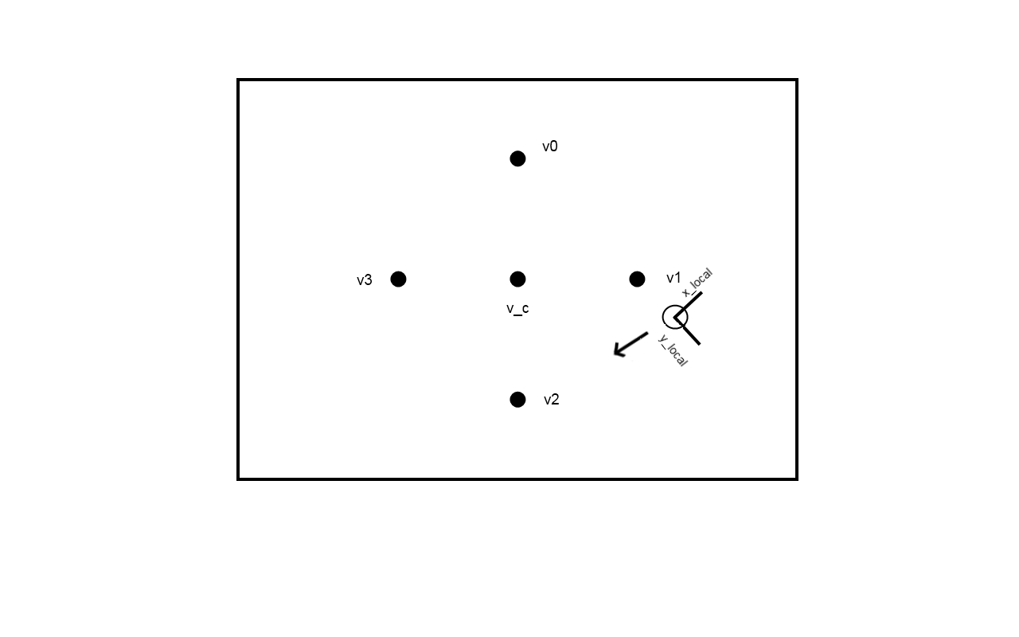 | Head  V2  V3  V0  V1  End | Calculate the vector to the new vertex at the head of the queue.
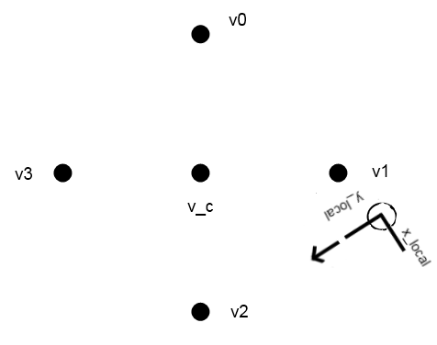 | Head  V2  V3  V0  V1  End | Rotate the armature to face the new vertex.
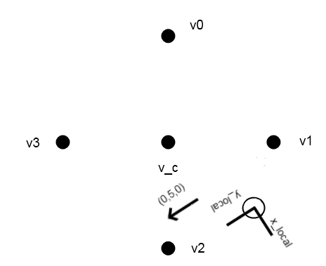 | Head  V2  V3  V0  V1  End | If the armature does not pass V2 after the next action (as shown here), v2 remains at the head of the queue and no rotation occurs.
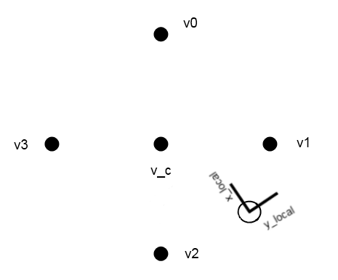 | End  V3  V0  V1  V2  Head | To reverse the direction, rotate the armature 180 degrees around the z-axis. Then dequeue and enqueue the head of the queue, and reverse the direction of the queue.

Moving the armature towards or away from the center requires rotating the armature so the local y-axis faces the vertex at the center or 180-degrees away from it, respectively. Every time the armature moves in or out of the center, new vertices (of the smaller or larger polygon) must be calculated to reflect the new distance from the center.
A more general form of the algorithm described above would be to create an actual circular path with a radius equal to the armature’s initial distance from the center. After each

step, calculate the point on the path closest to the armature, and rotate the armature so that its local y-axis is parallel to the tangent at this point (facing clockwise or counterclockwise as necessary). Like the polygonal path, this circular path would have to be recalculated every time the armature moves towards or away from the center (Figure F).
These algorithms proved particularly difficult to implement in a timely manner, so they were left as possibilities for improvement in a future iteration of Hora.

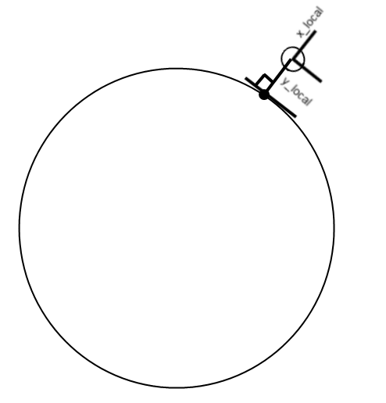
Figure N: The geometric representation of an alternate algorithm for ensuring Laddie travels in a circle. The local axes meet at the object center, with the local axes labeled, and the empty circle represent the armature. The point on the circle is the closest to the object center.

V. User Testing

Hora was tested with three beginner social dancers and one experienced choreographer. Beginner social dancers had been to a few Israeli dance sessions and thus had some idea of the nature of the dance, but may not have known all the steps. These users were all interested in learning more about Israeli dances and Israeli dance choreography. The experienced choreographer regularly goes to dance sessions and had been going for many years. She had also choreographed for an Israeli dance group for several years in high school.
Comments on functionality were fairly similar across the beginner social dancers. Most liked the idea of being able to choreograph their own dances despite having limited knowledge. They liked being able to preview the steps before adding them to a timeline, since some of the steps were unfamiliar to them. One felt Hora was, “a good learning tool” for beginners interested in Israeli dance. They also appreciated the simplicity of both the character and the interface; they felt it made it easier to concentrate on the dance and therefore learn more.
The experienced choreographer was more hesitant about the basic functionality of the program. While she enjoyed watching Laddie, she felt more like she was playing a game than learning a new tool. She noted that it is important to her to feel her choreography rather than see it, so she doubted the overall prospects for computer-aided choreography. She also felt that many steps and sequences were complex and difficult to put into words, and thus would be difficult to form from even the most extensive menu.
Users had several suggestions for additional functionality. One user mentioned that he would have liked additional editing tools, like removing steps from the timeline (rather than replacing them). Indeed, many users had suggestions for additional timeline functionality, such as being able to zoom in and out, being able to only play certain sections of the dance, and copying and pasting sections of the dance onto another area of the timeline. One beginner social user had noted the variety of arm movements in Israeli dance and wanted to be able to control the characters’ arm motions as well as the legs. The experienced choreographer echoed this sentiment, and added a desire to manipulate all body parts to achieve a particular style.

VI. Future Work

Based on the goals of the project and user feedback, the avenues for future work are clear. Probably the most important addition would be a playback algorithm better suited for more complex dances. More research into non-linear animation is needed to figure out a way to ensure that Laddie’s motion models the circular motion of Israeli dances.
The timeline functionality could be augmented to allow easier editing of steps. As mentioned in the previous section, test users wanted to be able to delete steps on the timeline without replacing them, as well as copy and paste sequences from one part of the timeline to another, so these would be worthwhile additions. In addition, users expressed a desire for a clearer representation of a single step (in particular steps that take multiple beats) and constraints for preventing overlapping steps (for example, placing a beat of walking after only two beats of a cherkessia, which is a four-beat step.). One possibility for implementing this would be to demarcate the area of the timeline with a dark outline around individual steps to make clear where one ends and another begins. Another would be to represent steps as blocks and place them above the timeline (so the users could still see the beats) instead of re-coloring the timeline itself.
Since many users wanted more direct control of the figures for incorporating arm actions or their own variations on a step, this would be a useful area for further study. Indeed, early iterations of Hora used motion capture data to create animations; users may wish to use motion capture to create and record entirely new steps to include in the menu. Finally, at the moment, Hora only allows the user to choreograph for one song. This is an obvious limitation; future iterations should be able to load songs at the users’ request and match the playback to the beat. This in itself would require more research into ways to improve Hora’s performance, as it performs differently (faster or slower animation) on different systems.

VII. Conclusion

Hora is certainly not a fully-implemented tool. The limitations on the playback algorithm and the limited number of steps and parameterizations available make it unsuitable for choreographing anything but extremely simple Israeli dances. However, it is powerful enough to model the choreography of at least one real folkdance, Od Lo Ahavti Dai. Moreover, even in its simplest form, it was recognized by Israeli dancing novices as a useful tool for learning more about Israeli dance. Thus, as a proof-of-concept implementation, while Hora has not yet successfully achieved its goal of assisting amateur choreographers, it opens the possibility of helping beginner Israeli dancers by allowing them to view different kinds of steps and experiment with their own simple combinations.
Hora leverages the power of technology to increase participation in and thus improve the art of Israeli folk-dancing. It speaks the language of dancers and choreographers rather than that of computer scientists. Hora was not meant to replace the traditional, non-computerized methods of choreography and dance education, but rather to provide alternate tools for choreographers and amateurs, who struggle with or do not have access to these traditional methods. This kind of technology for creating and recording dances will hopefully extend the physical and emotional benefits of dance to a larger population and ensure the continuation of the art form.

VIII. Bibliography

1. Andaur, Claudio. How to Setup a Walkcycle Using NLA. Blender Foundation. <http://www.blender.org>. [Accessed Oct 2010].
2. Beck, Jill. The Dancing History Collection: Cultural Dances, Part 1. Chapter 1: Four Israeli Folk Dances. UC Irvine: Center for Learning through the Arts and Technology
<http://www.escholarship.org/uc/item/8s26r6zs> [Accessed Oct 2010]
3. Biovision BVH. University of Wisconsin Computer Graphics and Vision Lab. <http://www.cs.wisc.edu/graphics/Courses/cs-838-1999/Jeff/BVH.html> [Accessed Oct 2010]
4. Bradley E, Stuart J. Using Chaos to Generate Variations on Movement Sequences. Chaos 1998; 8: 800-807.
5. Bradley E, Capps D, Rubin A. Can Computers Learn to Dance? In Proceedings of International Dance and Technology. Tempe, AZ: February 1999.
6. Calvert T, Wilke L, Ryman R, Fox, I. Applications of Computers to Dance. IEEE Computer Graphics and Applications 2005; 25(2): 6-12.
7. Calvert T, Wilke L, Ryman R, Fox, I. From Dance Notation to Human Animation: The LabanDancer Project. Computer Animation and Virtual Worlds 2005; 16(3-4) : 201-11.
8. Character Animation. Blender Foundation<http://wiki.blender.org/index.php/Doc:Tutorials/Animation/BSoD/Character_Animation> [Accessed October 2010].
9. Ebenreuter, N. Dance Movement: A Focus on the Technology. IEEE Computer Graphics and Applications (2005). 25(6) :80-83.
10. "Introduction to the Game Engine." Blender Foundation <http://wiki.blender.org/index.php/Doc:Tutorials/Game_Engine/BSoD> [Accessed Dec 2010].
11. Sinha A, Udai A. Computer Graphics. Tata McGraw-Hill: New Delhi, 2008.

