Customer SQL Scope

|  |  |
| --- | --- |
|  |  |
| Customer | Internal – Customer Success Team |
| Customer On Premise / Online? | CRM Hub 2.0 – Cloud Hosted |
| Primary Contact/Phone/Email | Matt Sayler, CC: Brian Kincaid |
| Date (and revision) | 8.23.16 |

# Overview - DB Scheduler Event

*The Customer Success team is interested in implementing a similar process that is already in place for the Implementation Consultants, with regards to an automatic action when there has been no contact for at least 90 days.*

*The ICs currently have the below DB Job Schedule in place to move customers from the existing asset.status to a different one, based upon there being no AssetNote or WOLabor entries from that individual for a specified period of time. See below for DB Job Schedule Name which is currently in use within the CRM Hub 2.0.*

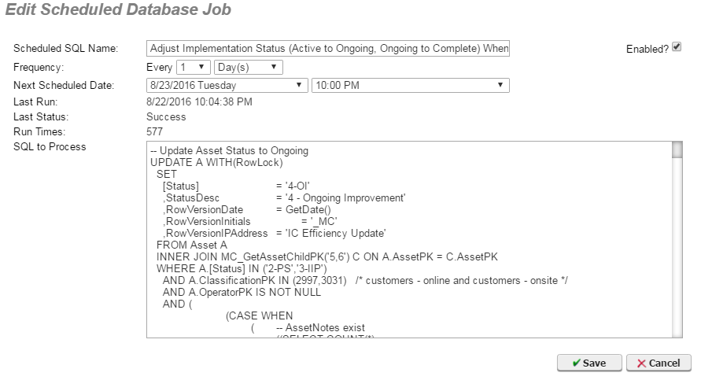

# *Recently (within the past couple weeks), Calvin assisted Adam with SQL scripting which he applied within several reports to limit the dataset. Please see the last page below for this particular SQL script. I will also send it via email.*

# DB Scheduler Event

|  |  |
| --- | --- |
| **Description of Desired Result/Effect** | *Please convert the below SQL script into a Database Job Schedule “Update” that sets (AssetSpecification.SpecificationPK = 320) to be NULL within all values: ValueText, ValueDate, ValueNumeric.*  *Specification 320, named “Customer Success Manager”, is already set to “track history”. We would like to make sure that a historical entry is logged for this change so that we can reference if/when this adjustment takes place and who was assigned previously.* |
| **Name of DB Job** | *Adjust Specification Value (Set Null) When No CSM Contact for 90 Days* |
| **Frequency** | *Every 1 Day at 10:00pm* |
| **Fields Used To Calculate** | *Labor, WOLabor, AssetNote, AssetSpecification.SpecificationPK = 320,* |
| **Special Criteria (inclusion/exclusion of data to update, etc.).** | *See below SQL script for more context.* |

# select asset.assetname, assetspecification.valuetext

from asset

inner join assetspecification on assetspecification.assetpk = asset.assetpk

inner join labor on labor.laborID = assetspecification.valuetext

where assetspecification.specificationpk = 320

AND valuetext is not null

AND

(

(

((SELECT

DATEDIFF(dd,

(SELECT TOP 1 NoteDate

FROM AssetNote WITH (NOLOCK)

LEFT JOIN Labor on AssetNote.LaborPK = Labor.LaborPK

WHERE AssetNote.AssetPK = Asset.AssetPK AND

Labor.JobTitle like '%Success%'

ORDER BY NoteDate DESC)

,GETDATE() )

) > 90

)

OR

(

NOT EXISTS(

(SELECT NoteDate

FROM AssetNote WITH (NOLOCK)

LEFT JOIN Labor on AssetNote.LaborPK = Labor.LaborPK

WHERE AssetNote.AssetPK = Asset.AssetPK AND

Labor.JobTitle like '%Success%')

)

)

)

AND

(

((SELECT

DATEDIFF(dd,

(SELECT TOP 1 WorkDate

FROM WOLabor WITH (NOLOCK)

INNER JOIN WO ON WO.AssetPK = Asset.AssetPK

LEFT JOIN Labor on WOLabor.LaborPK = Labor.LaborPK

WHERE WOLabor.WOPK = WO.WOPK AND

Labor.JobTitle like '%Success%'

ORDER BY WorkDate DESC)

,GETDATE() )

) > 90

)

OR

(

NOT EXISTS(

(SELECT WorkDate

FROM WOLabor WITH (NOLOCK)

INNER JOIN WO ON WO.AssetPK = Asset.AssetPK

LEFT JOIN Labor on WOLabor.LaborPK = Labor.LaborPK

WHERE WOLabor.WOPK = WO.WOPK AND

Labor.JobTitle like '%Success%')

)

)

)

)