Customer Project Scope

|  |  |
| --- | --- |
|  |  |
| Customer | Maicom |
| Primary Contact | Erlir Mezini |
|  | [e.mezini@maicomcs.com](mailto:e.mezini@maicomcs.com) |
|  | 978-777-7786 Ex203 |
| MC IC/CC | Brandon Palana |
| Deliver Code To | Customer |
| Date (and revision) | 11/28/2016 v6 |

# Overview

*Maicom would like to bulk load/attach documents directly to their Assets. Currently they have roughly 35,000 documents (16 GB of storage) that are stored on Google docs but they would like to eliminate the use of Google docs and store the docs directly within MC. They can supply a flash drive with the docs if needed. They also have the folder path for each file and the path contains the Asset ID in a csv file (see below).*

*Need to develop a tool to handle moving the docs into MC and attaching them to the correct asset. Below is a screen shot of the file path in Google Doc, as well as a, mapping guide of the Asset information in the path.*

*Document mapping file (attached to WO) contains full document path, Document folder, Document Name, Asset UDFChar1 (used for initial Mapping), AssetPK, AssetID and AssetName.*

**Configuration/Setup Details**

* Document mapping completed by IC and site team so the development team will only need to handle the storage and link detail. The mapping document will be broken down into separate columns to identify the AssetID, document file location in separate cells as well as any other supporting information.
* Documents should only be stored as Asset Attachments.
* Document Name should remain what it currently is, as listed after the last forward slash.
* Documents should not be listed in the Documents Module.
* Default indicators should not be checked.

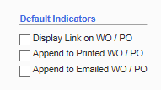

*Document Mapping File*

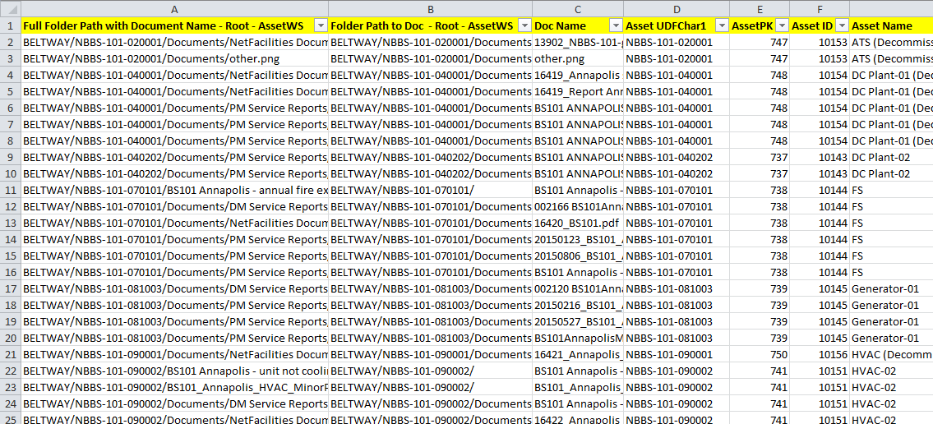

*Excel File is broken into 2 worksheets – one for Equipment (Type A Assets) and one for Locations (Type L Assets)*

**