Figures.

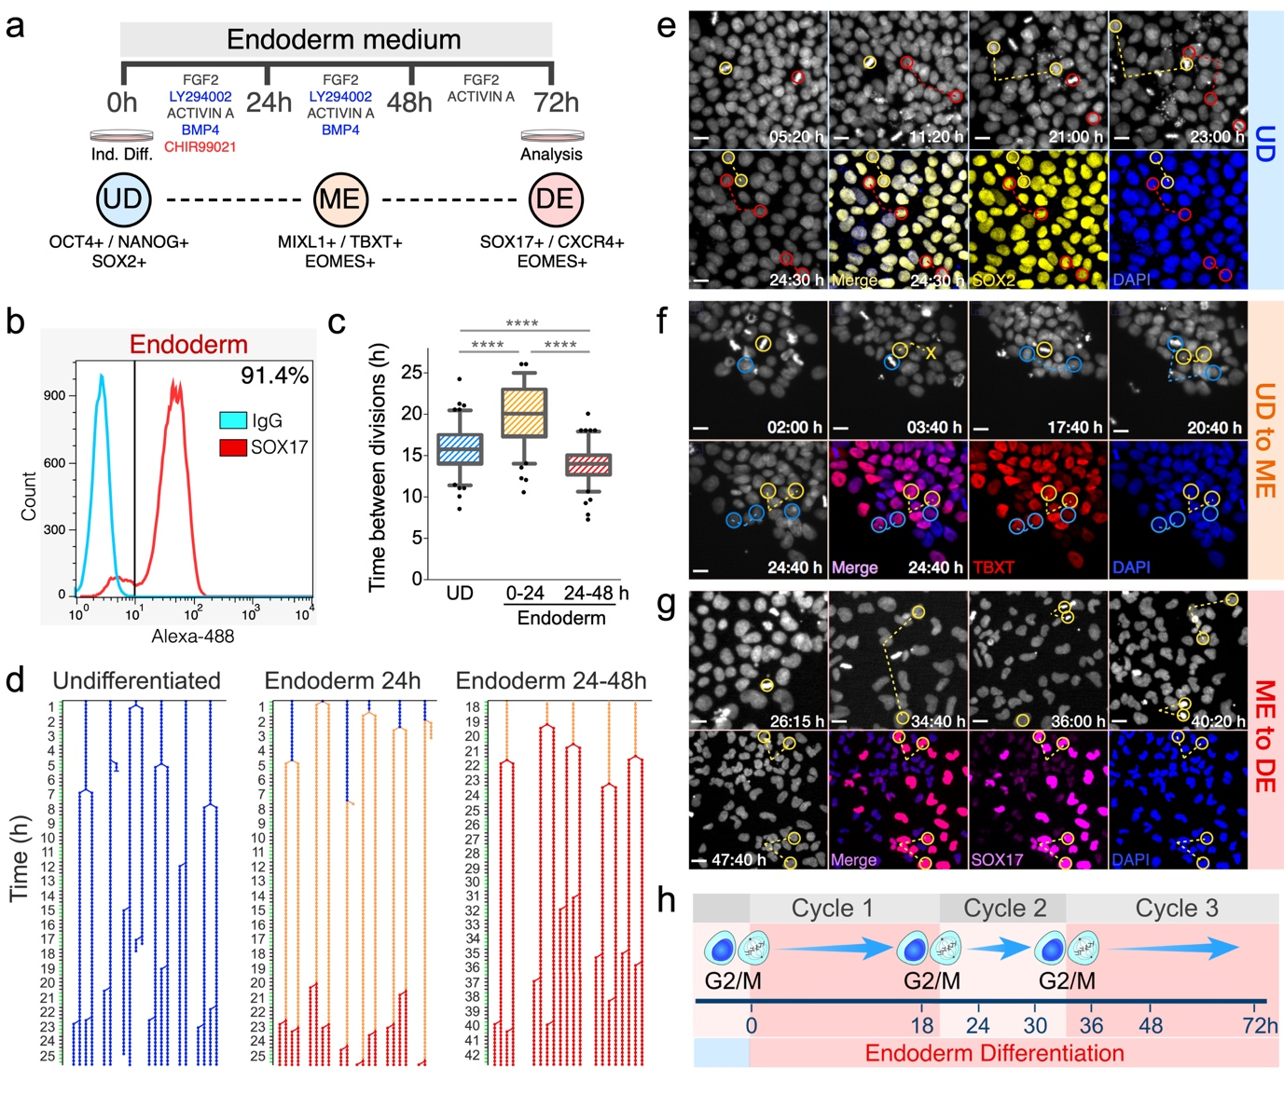

Figure 1. Pluripotent Cells Continue Dividing after Initiation of Differentiation. a) Schematic of the protocol used to generate DE cells. UD, Undifferentiated; ME, mesendoderm; DE, definitive endoderm. b) Flow cytometry analysis of cell expressing the endoderm marker SOX17 after 72h of differentiation. c) Cell division times for hESCs undergoing self-renewal or differentiation. Time-lapses movies of hESC-H2Bv undergoing self-renewal or differentiation were produced. Maps of the history of cell divisions (see d) were generated and used to calculate the time between cell divisions (time between splits). Statistical significance was assessed by performing One-way ANOVA, Tukey's multiple comparisons test (****, p≤0.0001). d) Representative Maps of the history of cell divisions obtained after tracking 100 cell division in each condition. Data was obtained from 3-5 different experiments. Immunofluorescence ¹⁹ images showing the expression of key gene markers at end of each time-lapse. By the end of every imaging experiment cells were quickly fixed and stained for immunofluorescence analysis. IF images were matched to the last frame of the time-lapse movies. e) Undifferentiated: SOX2. f) ME: TBXT. g) DE: SOX17. h) Diagram summarizing the findings shown in figure 1.

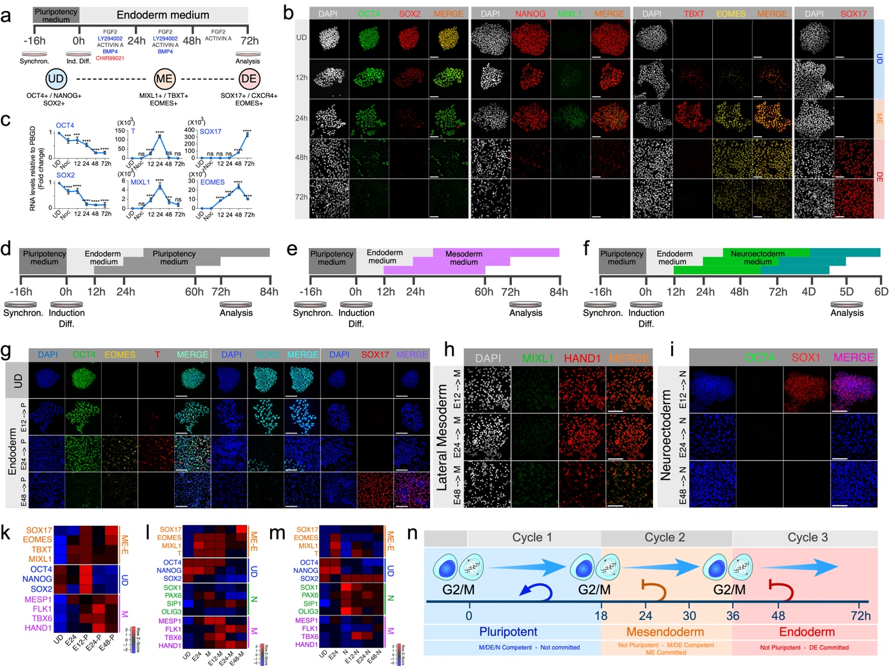
Figure 2. Cell division marks acquisition of a new cell identity and cell fate commitment. a) Schematic representation of the protocol used to generate DE cells after synchronization. UD, Undifferentiated; ME, mesendoderm; DE, definitive endoderm. b) Immunofluorescence showing the expression of differentiation markers during the DE differentiation process. c) RNA expression profiles of genes critical for DE formation. Data represent the average of three different experiments. Statistical significance was assessed by performing multiple comparisons using One-Way ANOVA (n=3; ns, p > 0.05; **, p≤0.01; ***, p≤0.001 ****, p≤0.0001). d) Schematic representation of the experimental conditions used to assess the level of cell fate commitment of cells at different stages of DE differentiation. Cells were Synchronized at G2/M, then released into DE-induction medium. At the specified time points, cells were put back into pluripotency medium (P: E8 medium) for another 48h. e) Similar to “d”, but instead, cells were switched from DE-induction medium to Mesoderm-induction medium (M). f) In this case, cells were changed from DE-induction medium to Neuroectoderm-induction medium (N) and incubated for another 4 days. Changes in gene expression in cells treated as described in d, e, and f, were assessed by immunofluorescence analysis. g) EOMES/TBXT for Mesendoderm, OCT4/SOX2 for pluripotency, and SOX17 for DE. h) HAND1 and MIXL1 for Lateral Mesoderm (LM). i) SOX1 for Neuroectoderm. RNA expression levels were assessed by qPCR and plotted as heat maps. k, l, m) Show results obtained from cells treated as described in d, e, and f respectively. Heat maps show the z-scores of the average log2 fold change obtained from three independent experiments. UD: Undifferentiated, M: Mesoderm, N: Neuroectoderm. n) Summary of the findings shown in figure 2. UD: Undifferentiated, E12-P: 12h of endoderm differentiation, then cells were put back into pluripotency medium for 48h; E24-P: 24h of endoderm differentiation, then cells were put back into pluripotency medium for 48h; E48-P: 48h of endoderm differentiation, then cells were put back into pluripotency medium for 48h. E12-M, E24-M, E48-M, E12-N, E24-N, E48-N: Same as for Endoderm to Pluripotency, but instead the cells were transfer to either Mesoderm or Neuroectoderm induction medium, respectively.

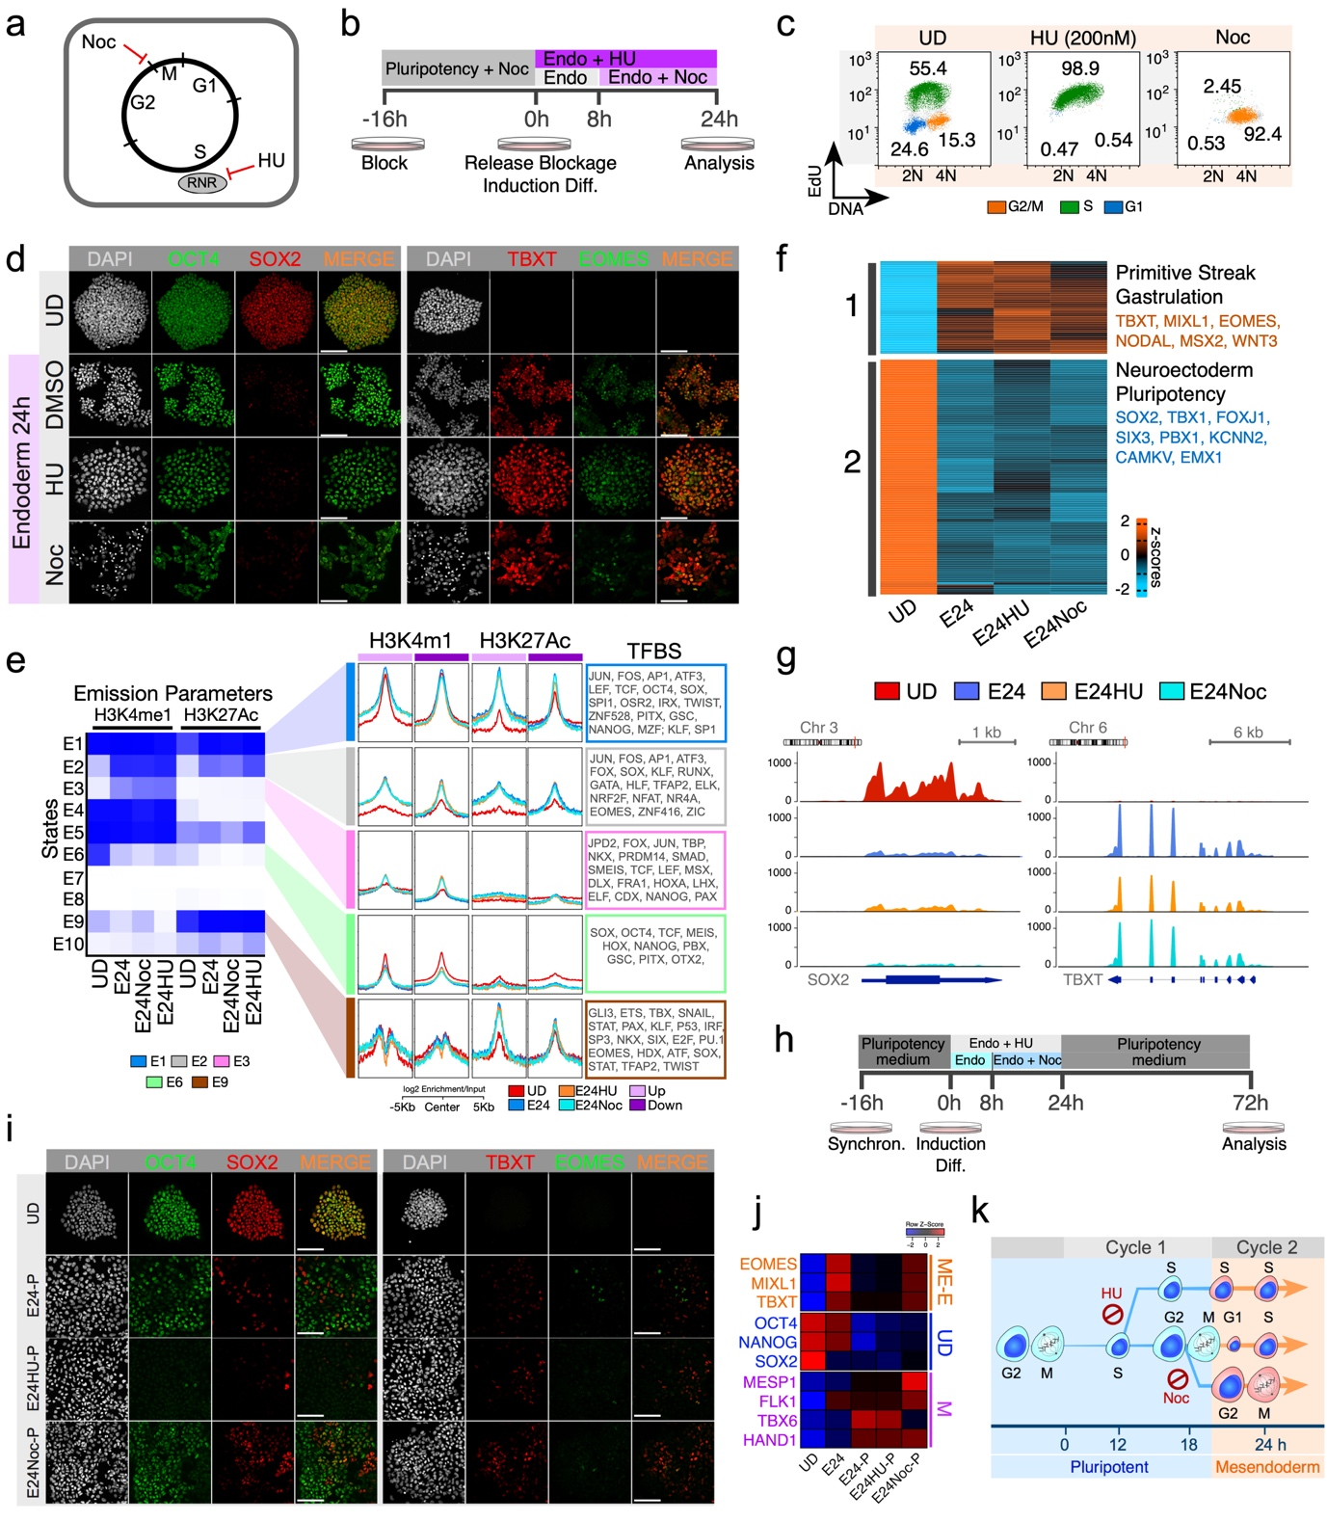
Figure 3. Cell Division is not Required for Cell Differentiation nor epigenetic remodeling. a) Diagram depicts the cell cycle phases that are targeted by Nocodazole (Noc) and Hydroxyurea (HU). b) Schematic representation of the experimental conditions used to assess the differentiation potential of cells after blocking their capacity to divide. c) Flow cytometry plot shows the cell cycle distribution of hESCs before and after being treated with either Noc or HU. d) Immunofluorescence analysis of key markers in cells treated as described in b. e) Left Panel: Chromatin states for the UD and ME differentiated hESCs are defined by chromHMM based on a 10-states. Colour scale measures the normalized probability of finding a specific histone mark in a particular chromatin state, and each state is annotated based on the levels of enrichment of each histone mark. The intensity of the color in each cell reflects the frequency of occurrence of that mark in the corresponding chromatin state on the scale from 0 (white) to 1 (blue). Middle panel: Average enrichment over input of each histone mark was calculated for selected states, which were annotated to the closest gene and segregated based on level of expression. Right Panel: Enrichments of putative TFBS were calculated for the same chromatin regions using the software HOMER. Up: Up-regulated genes; Down: Down-regulated genes. E1-E9: Chromatin states. f) Heatmap of the RNA-seq levels of differentially expressed genes between undifferentiated (UD) vs. ME samples (UD vs. E24, UD vs. E24HU, and UD vs. E24Noc; log2 |FC ≥2|, FDR ≤ 0.01, n = 2). Only clusters 1-2 are displayed. See extended data fig.2f for remaining clusters. g) RNA expression coverage tracks for two key gene markers of either pluripotency (SOX2) or Mesendoderm (TBXT). Plots show the normalized reads per genome coverage. h) Schematic representation of the experimental conditions used to assess the degree of commitment reached by cells that were differentiated in presences of HU or Noc. Briefly, following the protocol described in b, cells were put back into pluripotency medium for 48h and analyzed. i) Immunofluorescence analysis of key markers for cells treated as in h. j) qPCR analysis of key genes for cells treated as in h. The Heatmap shows the z-scores of the average log2 fold change obtained from three independent experiments. k) Summary of the findings shown in figure 3.

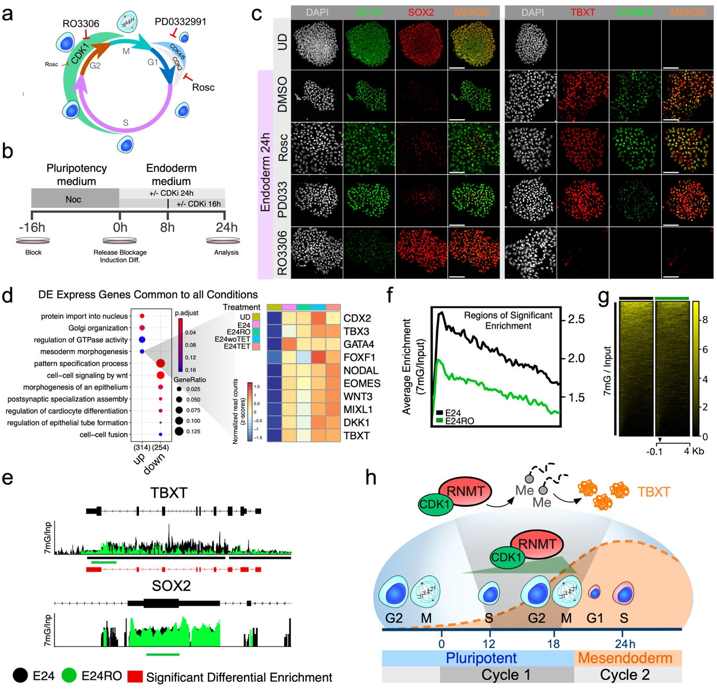
Figure 4. The Cell Cycle Regulator CDK1 controls the Acquisition of a New Cell Identity During Differentiation by Modulating RNA-m7G Deposition on Key Genes During Differentiation. a) Cartoon depicting places of action of different CDK inhibitors and their point of action. RO3306: CDK1 inhibitor. PD0332991: CDK4/6 inhibitor; Rosc (Roscoivitine): Strong CDK2 inhibitor and weak CDK1 inhibitor. b) Schematic representation of the experimental conditions used to assess the role of the cell cycle regulator CDK1 during differentiation. c) Immunofluorescence analysis of key gene markers in cells subjected to depletion of CDK1 function during ME differentiation, as described in b. d) GO enrichments for biological functions on genes significantly up-regulated or down-regulated during ME differentiation in presence or absence of normal CDK1 function. RNA expression levels were assessed by RNA-seq and differential expression (DE) determined by DESeq2. Common genes significantly up or down regulated (p-adj ≤ 0.01, |log2FC ≥ 2|, See Extended methods for details) in both CDK1 inhibited or CDK1 knock-down cells were used to determined GO enrichments. The heatmap highlights a subset of genes involved in ME differentiation to indicated that the overall expression levels for these genes are not significantly affected by the lack of CDK1 function. e) RNA-IP coverage tracks for two key gene markers of either pluripotency (SOX2) or Mesendoderm (TBXT). Cells were differentiated towards the ME lineage in the presence or absence of the CDK1 inhibitor RO3306 (E24RO). Plots show the overlay of the normalized ratio for 7mG over input. Control (E24) vs treated (E24RO). Red bars represent regions of significant differential enrichment (FDR=0.05). Colored lines under tracks: peaks identified by MACS2. f) Average enrichment profile of RNA-IPs. Regions of significant enrichment were used to calculate the average enrichment over input of the 7mG. Black line represents the 7mG enrichment on RNAs obtained during control differentiation (E24). The green line is the average enrichment for RNAs during CDK1 inhibited ME differentiation. g) Heatmap of RNA-IP enrichment over input for all the genes with significant enrichment of 7mG. Black line: E24; Green line: E24RO. Arrow head: TSS. h) Schematic Summary of the finding present here.

