

VECT.AI — Technical Whitepaper
Status: Draft for engineering & audit review
Network: Solana Mainnet-Beta
Standards: SPL / Token-2022 compatible
Scope: Protocol architecture, on-chain programs, oracle design, risk controls, governance, token utility, operations, and compliance guardrails.

Version | Date | Author | Changes
v0.1 | 2025-10-18 | Stefano Della Valle - CTO | Initial technical whitepaper and investor documents.

Contents
1 Abstract 4
2 Design Goals & Constraints 5
3 System Architecture 6
3.1 Strategy Vault Program (SVP) 7
3.2 Recipe Registry Program (RRP) 7
3.3 IntelliOracle 7
3.4 Keepers 8
3.5 Governance 8
3.6 On-Chain Accounts & PDAs (SVP) 8
3.7 Recipe Storage (RRP) 11
4 Instruction Set (SVP) 13
4.1 Common Account Checks 13
4.2 open_position(owner, strategy_id, base_mint, amount) 13
4.3 apply_recipe(position, expected_version) 14
4.4 withdraw(position, amount_or_all) 15
4.5 skim_fees() 16
5 Risk Engine & Portfolio Math 18
5.1 Drift & Rebalance 18
5.2 Slippage & Liquidity 19
5.3 Exposure & Concentration 20
5.4 Oracle & Price Sanity 22
6 IntelliOracle (Off-Chain) 24
6.1 Inputs 24
6.2 Modeling Approach 24
6.3 Publication 25
7 DeFi Integrations (Initial Set) 27
7.1 Swaps & Liquidity (DEX) 27
7.2 Liquid Staking (LST) 27
7.3 Lending (Phased, post-audit) 28
7.4 Adapter Pattern & Whitelists 29
7.5 Route Composition & Atomicity 29
7.6 Monitoring & Incident Response 30
8 Security Model & Threat Analysis 31
8.1 Invariants 31
8.2 Threats & Mitigations 32
8.3 Upgradability & Administration 33
9 Fees & Economics 34
9.1 Fee Types 34
9.2 Accrual & Crystallization 34
9.3 Treasury & Distribution — Summary 35
9.4 Parameters & Governance 35
9.5 Accounting & Reporting 35
10 Fees & Economics 36
10.1 Fee Types 36
10.2 Accrual & Crystallization 37
10.3 Treasury & Distribution 39
10.4 Parameters & Governance 40
10.5 Accounting & Reporting 41
10.6 Errors & Edge Cases 42
11 Token Utility & Governance 44
11.1 Governance Model 44
11.2 Voting Mechanics 44
11.3 Staking & Incentives 45
11.4 Treasury & Grants 46
11.5 Upgradability & Key Management 46
11.6 Parameters Under Governance 47
11.7 Proposal Lifecycle 48
11.8 Vesting & Locks 48
11.9 Compliance & Policy Notes 49
12 Migration: Temporary Mint → Final VECT.AI 50
12.1 Target State 50
12.2 Program Architecture 50
12.3 Migration Flow (Burn → Mint) 51
12.4 Conversion & Decimals 51
12.5 Governance Controls 52
12.6 Liquidity & Exchange Coordination 52
12.7 UX & Communications 52
12.8 Risk Management & Edge Cases 52
13 Client & SDK 54
13.1 User Flow 54
13.2 User Interface Overview 55
14 Technical Roadmap 58
14.1 MVP (Q4-2025) — Deposits/Withdrawals, Core Strategies, Initial Integrations, Audits 58
14.2 Q1-2026 — Governance Launch, Emissions Policy, Token-2022 Evaluation 59
15 H1-2026 — Lending (Post-Audit), RWA Rails, Cross-Chain (EVM) 60
15.1 Cross-Phase Engineering Tracks 61
15.2 Milestone Exit Criteria (Roll-up) 61
16 Compliance & User Protection (EU-centric) 62
16.1 MiCA Alignment 62
16.2 KYC/AML & Travel Rule — Expanded 62
16.3 Data Protection (GDPR) 63
16.4 Marketing, Disclosures & User Warnings 64
16.5 User Protection Mechanics 64
16.6 Sanctions, Screening & Jurisdiction Controls 65
16.7 Record-Keeping, Audit & Governance 65
16.8 Roadmap & Ownership 65
16.9 Canonical Disclaimers 65

Abstract
VECT.AI is a non-custodial strategy-vault protocol on Solana. Users deposit assets into vaults mapped to strategies (Aggressive, Conservative, DeFi, RWA, …). An AI-assisted oracle (“IntelliOracle”) publishes signed recipes—target allocations and execution routes—periodically (e.g., daily). On-chain, the Strategy Vault Program (SVP) executes recipes via CPI into vetted DeFi protocols. Users can withdraw at any time; funds are returned only to the depositing owner’s address, enforced at the program level. Governance and incentives are coordinated by the VECT.AI token.

Design Goals & Constraints
- Non-custodial by construction; verifiable on-chain invariants.
- Composable with Solana DeFi via audited CPIs.
- Deterministic rebalancing driven by signed recipes under risk bounds.
- Minimize tail risk (oracle faults, integration failures) with layered guards.
- Upgradable-but-safe: timelocked multisig → DAO.
- Auditability: clear state model, small attack surface, metrics.

System Architecture
VECT.AI consists of:
- SVP (Strategy Vault Program): on-chain core that manages user positions and performs CPIs into whitelisted DeFi integrations.
- RRP (Recipe Registry Program): on-chain registry of signed strategy “Recipes” (target weights + route).
- IntelliOracle (off-chain): AI pipeline that produces targets and routes, simulates them, and publishes signed updates to RRP.
- Keepers/Cranks: permissionless executors that call apply_recipe() when positions drift out of tolerance.
- Governance: SPL Governance (Realms) controlling parameters, allowlists, oracle keys, treasury, and upgrades.

A user connects a wallet and deposits into a chosen strategy. The Strategy Vault Program (SVP) receives the tokens and either opens a new Position (a PDA bound to the depositor) or updates an existing one—recording immutable ownership, the payout invariant (return_to == owner), and the current holdings snapshot. Separately, the Recipe Registry Program (RRP) acts as the source of truth for intent: when the off-chain IntelliOracle has fresh targets and a route, it publishes a new Recipe to RRP, cryptographically signed by the registered oracle key and stamped with a validity window and version.
Permissionless keepers watch for drift and for new Recipe versions; when a Position is outside tolerance, they call apply_recipe(position, expected_version). SVP verifies the preconditions—monotonic version, valid signature, within-time window, and policy compliance—and then executes a bounded sequence of steps (swap, stake, lend, unstake, withdraw, harvest) via CPIs to whitelisted adapters. Each step is sized and guarded: slippage caps, per-route size limits, per-protocol TVL caps, compute-unit ceilings, and oracle freshness checks. If a guard would be breached, SVP aborts or truncates safely; on success, it updates the Position’s holdings and advances last_recipe_version, emitting events so the UI and indexers can reflect the change.
At any time, the user can unwind partially or fully. A withdrawal triggers the necessary unstakes/withdrawals/swaps—again under the same guardrails—and always returns assets to the depositor’s own token accounts, never to third parties. The result is a tight loop: intent published in RRP, execution mediated by SVP under risk rails, and user custody preserved end-to-end.
In the following chapters we describes each component in details.

Strategy Vault Program (SVP)

The Strategy Vault Program (SVP) is the on-chain heart of VECT.AI. It owns the vault logic, creates and manages user positions as Program-Derived-Address (PDA) accounts, and is the only actor allowed to mutate that state. When a user deposits into a strategy, SVP mints or updates a Position PDA bound to the depositor’s public key and executes the strategy’s instructions by calling out—via Solana cross-program invocations (CPI)—to a small, vetted set of DeFi protocols (DEXs for swapping and liquidity, staking programs, and—later—lending). SVP enforces core invariants (e.g., withdrawals can only return to the origin address) and applies risk limits such as per-step slippage caps, per-protocol exposure caps, and compute-unit budgets.

Recipe Registry Program (RRP)

The Recipe Registry Program (RRP) acts as the protocol’s source of truth for strategy targets. For each strategy, it stores the latest Recipe—a signed payload describing target weights, constraints, and the ordered set of execution steps. RRP accepts an update only if it is signed by the registered oracle public key and conforms to governance-approved policy (e.g., staleness window, maximum turnover, and allowed asset/protocol lists). By separating the registry from the vault executor, we reduce the attack surface and make “what the strategy intends to do” auditable independent of “how the vault executes it.”

IntelliOracle

IntelliOracle is an off-chain, AI-assisted pipeline that turns market data into actionable recipes. It ingests on-chain data (DEX volumes, pool depth, realized slippage), trusted price feeds, and—optionally—macro signals for RWA-oriented allocations. A constraint layer hard-limits risk (whitelists, no leverage at launch, turnover bounds), and the optimizer emits target weights and routes that respect those constraints. Before publication, IntelliOracle simulates the plan on a shadow environment; only if checks pass does it sign the recipe with an HSM-protected key and push it on-chain through RRP.

Keepers

Keepers (Cranks) are permissionless transaction senders that keep the system moving. When RRP advances the recipe version for a strategy, keepers call apply_recipe() on positions that are out of tolerance with the new targets. On Solana, they can optionally bundle steps using priority fees or Jito to improve execution quality. Keepers hold no special privileges—they merely pay gas and trigger publicly callable instructions—so liveness is decentralized and censorship-resistant.

Governance

Finally, Governance (via SPL Governance / Realms) coordinates long-term control. Token holders can propose and vote on protocol parameters (fees, slippage limits, risk caps), the allow-list of external program IDs, oracle key rotations, treasury spend, and the staged hand-over of upgrade authority from a timelocked multisig to the DAO. Governance actions are transparent, time-delayed where appropriate, and designed to minimize operational risk while preserving the community’s ability to evolve the protocol.

On-Chain Accounts & PDAs (SVP)

Terminology & Solana Account Model
On Solana, on-chain accounts are persistent state objects owned by a specific program. They store structured data (not just token balances) and can be modified only by their owner program. To make addresses deterministic and auditable, programs derive special addresses called PDAs (Program-Derived Addresses) from constant seeds plus the program_id. PDAs have no private keys; only the owning program can “sign” for them, which is perfect for protocol state like configs, vaults, and user positions.
Seeds and PDAs in VECT.AI
- GlobalConfig (PDA: ["sv_config", program_id])
A single configuration account for the Strategy Vault Program (SVP). Its fields define protocol-wide policies and safety rails:
  - governance: Pubkey — The governance authority (initially a timelocked multisig, later the DAO). Only this key can change critical parameters or rotate admin keys.
  - oracle_pubkey: Pubkey — The only public key allowed to publish new strategy “recipes” (via the RRP). SVP mirrors it locally for fast checks and to reduce cross-program lookups.
  - protocol_whitelist: Vec<ProgramId> — The allowlist of external program IDs (DEX, staking, lending) that SVP may call via CPI. Anything not on this list is refused, eliminating a large class of integration risk.
  - fee_params: { mgmt_bps, perf_bps, fee_vault } — Fee configuration:
    - mgmt_bps: management fee in basis points per year (streamed/periodic).
    - perf_bps: performance fee on realized PnL (high-water-mark aware).
    - fee_vault: PDA where fees are accrued (see FeeVault below).
  - limits: { max_slippage_bps, per_protocol_tvl_cap, max_cu_per_tx } — Hard risk and operational limits enforced by SVP:
    - max_slippage_bps: per-step price impact cap on swaps or exits.
    - per_protocol_tvl_cap: upper bound on exposure to any single integration.
    - max_cu_per_tx: compute-unit budget guard to avoid overlong transactions.
- StrategyVault (per strategy & base mint) — PDA: ["sv_vault", strategy_id, base_mint]
An operational “pool” account that temporarily holds assets while SVP executes a recipe (e.g., swapping, staking). Splitting vaults by strategy_id and base_mint keeps flows clean and enforces per-strategy accounting. These vaults never hold user private keys; they are PDA-owned escrow under SVP control only.
- Position (per user) — PDA: ["sv_pos", owner, strategy_id, base_mint]
A user’s persistent state for a given strategy and base asset. It encodes identity, asset mix, and execution progress. Key fields:
  - owner: Pubkey (immutable) — The depositor’s address; the only key authorized to withdraw/close.
  - return_to: Pubkey — Must always equal owner; SVP enforces the invariant return_to == owner, ensuring funds can only flow back to the depositor’s address.
  - base_mint: Pubkey; decimals: u8; strategy_id: u8 — Strategy and denomination metadata. The base_mint defines the accounting currency for deposits/PNL.
  - holdings: Vec<TokenBalance> — The current asset mix after execution (each item: { mint: Pubkey, amount: u64 }). Updated atomically when recipes are applied.
  - last_recipe_version: u64 — The last Recipe version from the Recipe Registry Program (RRP) that was successfully applied. Prevents replays and stale updates.
  - created_at, updated_at: i64 — Timestamps for audibility and monitoring.
  - nonce/version: u64 — Internal counter for replay protection and migration safety.
- FeeVault (PDA)
A program-owned destination where protocol fees accumulate. It’s a pure accounting sink—never user-spendable—and can only be swept by fee distribution routines controlled by governance. Keeping fees in a segregated PDA clarifies treasury flows and simplifies audits.
Why this structure?
- Determinism & Auditability: Given the seeds, anyone can recompute PDAs off-chain and verify that a particular Position or Vault is exactly where it should be.
- Least Privilege: Users never hand over keys. SVP owns PDAs and enforces all invariants; users only sign their own deposit/withdraw instructions.
- Risk Containment: protocol_whitelist and limits reduce blast radius. Even if a downstream integration misbehaves, SVP won’t exceed approved slippage, exposure, or compute.
- Clear Upgrade Path: governance and oracle_pubkey are rotatable under timelock/DAO control, so the system can evolve without sacrificing safety.

Recipe Storage (RRP)

The Recipe Registry Program (RRP) is the canonical, on-chain source of truth for each strategy’s target allocation and execution plan. It keeps a compact, auditable record of what the strategy intends to do, independent from how the vault executes it. Each recipe update is append-only in spirit (via a strictly increasing version) and must pass cryptographic and policy checks.
Core fields
- strategy_id: u8 • version: u64 (monotonic)
Every strategy has its own monotonically increasing version counter. RRP rejects any update where version ≤ current. SVP will only apply a recipe if recipe.version > position.last_recipe_version, preventing replay and “time travel.”
- target_weights: Vec<{ mint: Pubkey, weight_bps: u16 }> (sum ≈ 10,000)
Desired portfolio weights in basis points per asset mint. The validator enforces:
  - weights ≥ 0, sum within [9,995 … 10,005] bps (tolerance for rounding),
  - unique mints, whitelisted assets only,
  - optional per-asset min/max caps (governance-set).
SVP uses these to compute drift and decide whether to rebalance.
- constraints: { max_slippage_bps, per_route_cap, price_feed_ids[] }
Guardrails baked into the recipe itself:
  - max_slippage_bps: upper bound per execution step; SVP aborts if breached.
  - per_route_cap: hard ceiling (in base units) for a single step to limit market impact.
  - price_feed_ids[]: required oracle feeds (e.g., Pyth) to sanity-check quotes and staleness.
- routes: Vec<RouteStep>
A minimal, typed plan that SVP can deterministically execute via CPI. Typical step variants:
  - Swap { dex_id, from_mint, to_mint, amount_pct_bps | absolute }
  - Stake { protocol_id, from_mint, to_derivative_mint, amount_pct_bps }
  - Lend / Repay / Withdraw { protocol_id, mint, amount… }
  - Unstake / Claim / Harvest { protocol_id, details… }
Each step must reference whitelisted program IDs and pass preflight checks (slippage, TVL caps, price freshness, compute budget). SVP may truncate a route if a guard fails—never exceeding constraints.
- valid_until: i64 (epoch seconds)
Soft expiry window. SVP refuses to apply recipes past this timestamp to avoid acting on stale signals. Keepers use it to prioritize rebalances before expiry. Governance can define a grace policy (e.g., allow no-op updates or freeze until a fresh recipe arrives).
Security & update flow
- Signature: Every recipe is signed by oracle_pubkey (kept in RRP; mirrored in SVP). RRP verifies signatures over a canonical serialization (e.g., Borsh/Anchor-IDL layout) to prevent malleability.
- Authz: Only the registered oracle_pubkey can update a strategy’s recipe.
- Rotation: Governance can rotate oracle_pubkey via a timelocked proposal. Rotation emits events and can require a grace period to prevent surprise key flips.
- Events: RecipeUpdated { strategy_id, version, valid_until, hash } is emitted for indexers/dashboards and to simplify downstream monitoring.
Validation & policy checks
- Monotonicity: version strictly increases per strategy_id.
- Bounds: weights sum within tolerance; all assets and protocols must be on allowlists; turnover vs previous weights may be capped (policy).
- Oracle sanity: price_feed_ids must exist and be live; SVP cross-checks during execution (status, conf interval, staleness).
- Complexity limits: maximum route length and maximum per-step compute to avoid pathological recipes.

Instruction Set (SVP)

Common Account Checks
- Purpose
Baseline validations applied by SVP before any state change or CPI.
- PDA & signer
- Recompute all PDAs from seeds; addresses must match.
- User-initiated ops require owner as a signer.
- Rent & layout
- Writable accounts must be rent-exempt and match the expected data size/layout.
- CPI allowlist
- Cross-program calls limited to whitelisted program IDs (DEX, staking, etc.).
- Compute & route caps
- Enforce max_cu_per_tx and maximum route length; abort or truncate safely if exceeded.
- Priority fees
- Under congestion, clients should set adequate priority fees; SVP fails fast if transactions are unlikely to land.
- Ownership & token checks
- State accounts must be owned by SVP; token accounts by SPL Token and match the expected mint.
- Oracle freshness (if used)
- Price feeds must be live, within staleness and confidence bounds; otherwise abort.
- Replay/idempotency
- Require expected_version ≥ position.last_recipe_version; prevent re-applying the same recipe version.

open_position(owner, strategy_id, base_mint, amount)

Purpose
Create (or top up) a user Position for a given strategy and base asset, moving funds from the user’s ATA into the StrategyVault under program custody (non-custodial escrow).
Inputs
owner (signer), strategy_id, base_mint, amount.
Accounts: OwnerATA(base_mint), StrategyVaultPDA, PositionPDA, GlobalConfigPDA, SPL Token, System/Rent.
Pre-checks
- Signer: owner must sign.
- Seeds/PDA: recompute StrategyVaultPDA and PositionPDA from seeds; must match.
- Mint/ATA: OwnerATA.mint == base_mint and owned by owner.
- Amount: amount > 0 and balance sufficient.
- Policy: base_mint allowed for strategy_id; vault not paused.
Execution
- Transfer: move amount from OwnerATA → StrategyVaultPDA (SPL transfer_checked).
- Position:
  - if absent → initialize (owner immutable, return_to = owner, metadata, timestamps).
  - if present → increment the base_mint line in holdings.
State update
Persist holdings, set updated_at; return_to remains owner.
Emit PositionOpened { owner, strategy_id, base_mint, amount_deposited, position_pda, ts }.
Client notes
Pre-create OwnerATA if missing; optionally prepend ComputeBudget and set a priority fee under congestion; surface PositionOpened (with position_pda) in the UI.

apply_recipe(position, expected_version)

Purpose
Align the user’s Position with the latest Recipe; if already within tolerance, do nothing.
Inputs
expected_version; accounts: PositionPDA, StrategyVaultPDA, GlobalConfigPDA, RRP access, relevant token/oracle accounts.
Pre-checks
- Version: expected_version ≥ position.last_recipe_version.
- Recipe: valid signature by oracle_pubkey, now ≤ valid_until.
- Policy: only whitelisted program IDs; route length and CU within caps.
- Prices (if used): feeds live, non-stale, confidence acceptable.
Drift test
Compute D=12∑i∣wi−wi∗∣D = \tfrac12 \sum_i |w_i - w_i^{*}|D=21​∑i​∣wi​−wi∗​∣.
If D ≤ tolerance → no-op.
Execution (bounded CPI)
For each RouteStep (swap/stake/lend…):
- size amounts (respect per_route_cap),
- enforce slippage/TVL/CU guards,
- CPI to whitelisted program,
- update in-memory holdings view.
Abort or truncate safely if a guard fails.
State update
Persist holdings, set last_recipe_version = recipe.version, update updated_at, emit RecipeApplied.
Client notes
Use priority fees under congestion; on ComputeBudgetExceeded or limited liquidity, reduce step size or split across txs; surface RecipeApplied and pre/post drift in the UI.

withdraw(position, amount_or_all)

Purpose
Redeem a user’s position—partial or full—and return assets only to the depositor’s address (return_to == owner).
Inputs
amount_or_all (partial amount in base units, or full close).
Accounts: PositionPDA, StrategyVaultPDA, owner’s payout ATAs, GlobalConfigPDA, SPL Token, relevant CPI adapters.
Pre-checks
- Signer: owner must sign (matches PositionPDA.owner).
- Invariant: return_to == owner.
- Liquidity/Policy: sufficient assets; only whitelisted programs/mints; route length and CU within caps.
Execution (bounded CPI)
- Compute unwind (pro-rata for partial; full unwind for close).
- For each required step (unstake/withdraw LP/swap to base, etc.):
  - size amounts (respect per_route_cap),
  - enforce slippage/TVL/CU guards,
  - CPI to whitelisted program,
  - update in-memory holdings view.
- Transfer resulting tokens only to the owner’s ATAs (create via ATA program if needed).
State update
- Persist updated holdings.
- If fully redeemed → zero balances, reclaim rent, close PositionPDA; else update updated_at.
- Emit PositionWithdrawn (and PositionClosed on full close).
Client notes
Ensure destination ATAs exist; consider priority fees under congestion; for large withdrawals, split across txs to respect CU and per-route caps; surface events and payout breakdown in the UI.

skim_fees()

Purpose
Accrue protocol fees from positions/vaults into the FeeVault PDA according to policy (management bps, performance bps with HWM).
Inputs
No user params.
Accounts: GlobalConfigPDA, FeeVaultPDA, relevant vault/position accounts, SPL Token (and any intermediate token accounts if conversion is required).
Pre-checks
- FeeVaultPDA and other PDAs recomputed from seeds.
- Fee policy present and valid: { mgmt_bps, perf_bps }.
- Caller authorized if governance restricts skimming to keepers (optional).
Execution
- Management fee: compute pro-rata accrual over elapsed time and move due amounts from vault/position accounting into FeeVault (in base asset).
- Performance fee: if realized PnL crystallization point (e.g., on rebalance/withdraw epoch), compute delta over the high-water mark, transfer due amount to FeeVault.
- Optional conversion step (e.g., consolidate to a treasury asset) must respect slippage/caps and call only whitelisted programs.
State update
- Update fee counters / high-water marks in affected positions/vaults.
- Emit FeesSkimmed { strategy_id, base_mint, mgmt_collected, perf_collected, ts }.
Client/ops notes
Run skim_fees() on a cadence (e.g., by keepers) to avoid large one-off accruals; expose FeesSkimmed events in monitoring and show accrued protocol fees in dashboards.

Risk Engine & Portfolio Math
Here, we detail the protocol’s risk engine—quantifying portfolio drift against targets, enforcing slippage and liquidity thresholds, managing exposure and concentration, and validating oracle prices—to ensure every rebalance executes within rigorous, auditable parameters.

Drift & Rebalance

Purpose
Quantify how far a position’s current weights w are from target weights w*, and decide whether to rebalance.
Definition
Use L1 drift:
$$D=1/2\sum_{i}{\left|ω_{i}-ω_{1^{*}}\right|}$$
D ∈ [0, 1] (interpretable in bps if you scale by 10,000).
Inputs
- w: current normalized weights from holdings (by value).
- w*: target weights from the latest Recipe.
- tolerance: governance/policy threshold (e.g., 50–150 bps).
Decision rule
- If D ≤ tolerance → no-op (skip rebalance).
- If D > tolerance → attempt to reduce to below tolerance/2 to avoid churn.
Sizing & routing
- Prefer smallest set of steps that most reduce D first (greedy-by-impact).
- Respect per-step slippage, per_route_cap, TVL caps, and CU budget.
- Split large moves across steps/txs under congestion.
Pricing & sanity
- When estimating trade effects, use oracle-checked quotes (status, staleness, confidence).
- Abort if projected or realized impact exceeds max_slippage_bps.
Edge cases
- Illiquid assets: cap step size; allow partial progress and re-attempt later.
- Stale recipe/price: refuse rebalance until fresh valid_until and live feeds.
- Fee-awareness: optionally include fee drag in the benefit test (skip tiny rebalances).
State & events
- On success: persist updated holdings; record drift_before, drift_after; emit RecipeApplied.
- On no-op: record a lightweight event or metric for liveness.
Client notes
Show pre/post drift in the UI; under heavy load, use priority fees or split actions; re-try periodically if guards (liquidity/CU) block full convergence.

Slippage & Liquidity

- Purpose
Bound execution price impact and ensure sufficient market depth when applying routes; abort safely if conditions would degrade execution quality.
- Definitions
- Slippage (bps): deviation between expected quote and executed price.
- Price impact: pool depth–driven move in AMM price due to trade size.
- Liquidity: available depth/TVL in the target venue (DEX pool, staking queue, lending market).
- Inputs
- From Recipe: max_slippage_bps, per_route_cap.
- From Config: per-venue TVL caps, per-asset exposure caps, whitelisted program IDs.
- Market data: pool reserves/quotes (DEX), queue caps (staking), utilization/borrow caps (lending), oracle feeds for sanity.
- Guards (must-pass checks)
- Slippage guard: realized_slippage_bps ≤ max_slippage_bps.
- Size guard: trade amount ≤ per_route_cap and ≤ venue’s safe depth fraction.
- TVL/Exposure: post-step exposure under protocol/asset caps.
- Oracle sanity: price feeds live, not stale; confidence within bounds.
- Execution rules
- Quote before trade (SDK simulation or read-only CPI); bail if projected impact exceeds guard.
- Chunk large trades into smaller steps (multiple txs if needed) to fit depth/CU.
- Prefer deepest venues (best reserves, lowest fee tier) when route offers alternatives.
- Use priority fees to minimize partial fills/timeouts under congestion.
- Liquidity-aware sizing
- Compute max safe size from pool reserves (AMM invariant) or venue-limits; use the min of: per_route_cap, safe-depth %, CU-constrained step size.
- For thin markets, execute a partial and re-attempt later.
- Edge cases
- Volatile periods: widen confidence checks and require fresher oracle timestamps.
- Pegged/derivative assets (e.g., LST <-> SOL): use protocol-recommended routes to avoid hidden penalties.
- Venue degradation (halted pool, paused program): skip step and continue with remaining safe steps or abort the tx.
- State & events
- On success: update holdings; record slippage_bps, venue ID, and size in RecipeApplied.
- On skip/abort: emit explicit error/code to aid retry logic.
- Client notes
- Surface projected vs realized slippage in the UI.
- Under congestion, raise priority fees or split routes.
- Retry with smaller chunks if liquidity or CU limits block full execution.

Exposure & Concentration

Purpose
Prevent overexposure to any single asset, protocol, or risk bucket; keep portfolios diversified within governance-defined bounds.
Definitions
- Exposure: portfolio share (by value) allocated to an asset/protocol/venue.
- Concentration cap: maximum allowed exposure per item (e.g., asset ≤ 40%, protocol ≤ 30%).
- Bucket: grouped risks (e.g., LSTs, stablecoins, DEX LPs, lending).
Inputs
- From Config: per_protocol_tvl_cap, per-asset caps, per-bucket caps, deny/allow lists.
- From Recipe: target_weights and candidate routes.
- Market data: protocol TVL/utilization, asset liquidity/volatility flags.
Guards (must-pass checks)
- Per-asset cap: post-step weight for a single mint ≤ asset cap.
- Per-protocol cap: post-step exposure to a venue ≤ per_protocol_tvl_cap.
- Per-bucket cap: sum of assets in a risk bucket ≤ bucket cap.
- Denylist: reject any asset/program not explicitly allowed.
Execution rules
- Size steps so that post-trade exposures remain within all caps (asset, protocol, bucket).
- Prefer diversification when multiple equivalent routes exist; bias flows toward underweight assets/venues.
- Throttle growth into newly added integrations with staged limits (warm-up caps).
Monitoring & drift interaction
- Recompute exposures after each step; if a planned step would breach a cap, reduce or skip it and continue with safe steps.
- When caps block full drift reduction, accept partial progress and re-attempt later.
Edge cases
- Correlated assets (e.g., multiple LSTs): enforce bucket caps even if individual caps are free.
- Protocol incidents (paused/halted): set exposure cap to zero until cleared by governance.
- Stablecoin depeg risk: apply stricter caps or dynamic caps based on health indicators.
State & events
- Persist updated holdings; include exposure snapshot (top N assets/protocols) in RecipeApplied metadata for observability.
Client notes
Show current vs. capped exposures in the UI; explain when partial execution occurs due to caps; allow users to inspect bucket definitions and governance-set limits.

Oracle & Price Sanity

- Purpose
Ensure trades use trustworthy prices; abort or defer execution when feeds are stale, unhealthy, or inconsistent with venue quotes.
- Inputs
- Oracle feeds (e.g., Pyth): price, confidence interval, status, publish time.
- Recipe constraints: price_feed_ids[].
- Policy: staleness window (max age), max confidence (basis points), fallback rules.
- Venue quotes (DEX sims/SDK) for cross-check.
- Sanity checks (must-pass)
- Liveness: status == TRADING (or equivalent healthy state).
- Staleness: now - publish_time ≤ max_staleness.
- Confidence: conf_bps ≤ max_confidence_bps.
- Cross-check: venue quote within tolerance of oracle mid; otherwise flag discrepancy.
- Execution rules
- Use oracle midprice for slippage limits; treat conf as uncertainty buffer.
- If quote–oracle gap exceeds tolerance, skip or reduce the step.
- Refresh feeds for multi-step routes if time/slot threshold exceeded.
- Never rely on a single feed for critical checks when redundancy is available.
- Fallbacks
- If feed is stale/unhealthy:
  - try an alternative feed (if configured),
  - otherwise freeze rebalancing for affected assets and proceed with safe steps only.
- Edge cases
- Volatility spikes: tighten staleness; require smaller per_route_cap.
- Thin markets: rely more on conservative oracle bounds; allow partial progress.
- Derivative/pegged assets: use protocol-specific reference feeds (e.g., LST to SOL fair value).
- State & events
- Record oracle snapshot (price, conf, ts) used for the step.
- Emit explicit errors or warnings on skipped steps due to oracle issues.
- Client notes
Surface oracle status and last update time in the UI; explain when rebalances are deferred due to price sanity guards; allow users to see which feeds back each asset.

IntelliOracle (Off-Chain)
Here, we outline the off-chain IntelliOracle: the data it ingests, the modeling approach that turns signals into allocatable targets, and the signed-publication flow that delivers enforceable recipes to the chain.

Inputs

Purpose
Aggregate high-quality, timely market data to inform strategy targets and routes.
Sources
- On-chain: DEX quotes/volumes, pool reserves/TVL, realized slippage, staking queue metrics.
- Oracle feeds: reference prices (with status, confidence, timestamp).
- Venue metadata: protocol health flags, program versions, allow/deny lists.
- (Optional) Exogenous: funding rates, implied volatility, macro/regime indicators for RWA overlays.
Normalization & QA
- De-duplication, outlier clipping, clock sync, cross-venue sanity checks.
- Staleness thresholds per source; fallbacks and “last-good” caching with expiry.
Outputs to modeling
Cleaned time-series and snapshots with uniform schemas (assets, venues, costs, constraints).

Modeling Approach

- Purpose
Transform inputs into target weights and a minimal execution route, within risk and policy constraints.
- Signal stack
- Momentum / mean-reversion with regime detection.
- Risk parity / volatility targeting to stabilize allocations.
- Liquidity-aware sizing to limit price impact ex-ante.
- Cost model for fees, slippage, and CU budget penalties.
- Constraint layer (hard guards)
- Asset/protocol allowlists, per-asset and per-bucket caps.
- Turnover bounds; no leverage at launch; per-route size caps.
- Oracle health prerequisites (status, confidence, staleness).
- Optimizer
- Objective: maximize risk-adjusted utility subject to constraints (QP/heuristic).
- Produces target_weights (bps) and a compact routes plan (Swap/Stake/Lend/…).
- Robustness
- Cross-validation on rolling windows; stress tests under volatility spikes.
- Skip tiny reallocations (fee-aware thresholding) to avoid churn.
- Outputs
Recipe { strategy_id, version↑, target_weights, constraints, routes, valid_until }

Publication

Purpose
Publish authenticated, policy-compliant recipes to chain; enable deterministic, bounded execution on SVP.
Pre-publish checks
- Backtest & sim on a shadow fork; verify guard compliance (slippage/TVL/turnover).
- Diff review vs. previous recipe; alert on large weight jumps.
Signing & serialization
- Canonical encoding (e.g., Borsh/IDL layout); SHA-256 digest.
- Signature via HSM-protected oracle_pubkey; audit log with version and hash.
On-chain update (RRP)
- Submit RecipeUpdated with strategy_id, version, valid_until.
- RRP verifies signature, monotonic version, and basic policy; emits event.
- SVP mirrors oracle_pubkey for fast validation at execution time.
Liveness & rotation
- Keepers prioritize rebalance calls before valid_until.
- Governance may rotate oracle_pubkey under timelock; rollout with overlap window.
Failure & fallback
- If verification fails or feeds are unhealthy: hold last valid recipe; publish a no-op or reduced-risk recipe.
- If route compilation fails constraints: emit a diagnostics bundle; retry with smaller steps/extended horizon.
Operator notes
- Maintain time-synced clocks and deterministic builds; pin model artifacts per version.
- Expose metrics (publish latency, rejection rate, drift after apply) for dashboards and alerts.

DeFi Integrations (Initial Set)
Here, we describe the protocol’s DeFi integrations on Solana—how swaps, staking, and (later) lending are invoked via audited adapters, with strict allowlists and guardrails for safe composition.

Swaps & Liquidity (DEX)

Purpose
Execute asset exchanges and liquidity moves (e.g., Orca CLMM, Raydium AMM) to reach target weights.
Interfaces
Adapter CPIs for Swap, AddLiquidity, RemoveLiquidity; pool discovery via known IDs.
Pre-checks
- Program ID on whitelist; pool/mints match expected.
- Slippage ≤ max_slippage_bps; per_route_cap respected.
- Oracle sanity: live, non-stale, confidence within bounds.
Execution
- Quote via SDK/read-only CPI; size trade to safe depth; perform swap/add/remove.
- Prefer deepest pools / lowest fee tiers when alternatives exist.
Risk controls
- Abort on projected/realized slippage breach; enforce per-asset and per-protocol caps.
- Track CU; split into smaller steps if needed.
Client notes
Use priority fees under congestion; surface projected vs realized slippage in the UI.

Liquid Staking (LST)

Purpose
Convert base assets (e.g., SOL) into staked derivatives (e.g., mSOL) to capture staking yield while retaining composability.
Interfaces
Adapter CPIs: Stake, Unstake, Claim (protocol-specific flows, e.g., Marinade).
Pre-checks
- Program ID and derivative mint whitelisted.
- Unstake cooldown/queue capacity checked when planning withdrawals.
- Oracle sanity on SOL/LST fair value if used for slippage checks.
Execution
- Stake SOL → LST during allocation; on unwind, Unstake then swap LST→SOL if policy requires base settlement.
Risk controls
- Cap LST exposure (per-asset and bucket caps).
- Use protocol-recommended routes for exits to avoid penalties.
Client notes
Expose LST-specific timelines (e.g., delayed unstake vs instant with fee) and expected exit costs.

Lending (Phased, post-audit)

Purpose
Supply assets to lending markets (and later, optionally borrow within strict policy) to enhance yield/diversification.
Interfaces
Adapter CPIs: Supply, Withdraw, Borrow, Repay (borrow disabled at launch).
Pre-checks
- Market/program whitelisted; utilization and collateral factors within safe bounds.
- Health factor sim ≥ policy threshold; borrow route disabled unless explicitly enabled by governance.
Execution
- Supply idle assets up to exposure caps; withdraw on rebalance/withdrawal requests.
Risk controls
- Hard disable leverage at launch; per-market and per-bucket caps; utilization ceilings.
- Continuous health monitoring; immediate throttle if market health degrades.
Client notes
Show venue health metrics (utilization, oracle status) and effective APY after fees.

Adapter Pattern & Whitelists

Purpose
Isolate protocol-specific logic behind minimal, audited adapters and restrict CPIs to approved program IDs.
Design
- One adapter per integration with a stable ABI (Swap/Stake/Lend primitives).
- Central protocol_whitelist in GlobalConfig; updates via governance/timelock.
- Unit/integration tests per adapter; version pinning of external program IDs.
Operational guardrails
- Denylist on incidents; staged caps for new integrations; canary vaults before full scale.

Route Composition & Atomicity

Purpose
Chain multiple steps (swap, stake, etc.) deterministically while respecting compute and risk limits.
Rules
- Honor max_cu_per_tx and max_route_len; truncate safely or abort on breach.
- Optional Jito bundles for atomic multi-instruction landing under congestion.
- Record per-step telemetry (venue, size, realized slippage) for post-trade analysis.
Failures
- If a mid-route guard fails, abort the tx (no partial state) or complete a safe prefix—behavior documented and consistent.

Monitoring & Incident Response

Purpose
Detect integration regressions early and react with minimal user impact.
Signals
- Error rate by adapter/opcode, slippage spikes, oracle mismatches, pool health, halted programs.
Actions
- Auto-throttle or zero caps on affected venues; flip to denylist via governance fast-path.
- Publish status to dashboards; include incident IDs in on-chain events.
Postmortems
- Keep regression tests; require green canary runs before re-enabling venues.

Security Model & Threat Analysis
This chapter define the protocol’s non-negotiable invariants, enumerate key threats with concrete mitigations, and describe upgradability and administrative controls designed to minimize operational risk while preserving evolvability.

Invariants

Purpose
Declare properties that must always hold; any violation halts execution.
Ownership & payouts
- owner is immutable for a Position.
- return_to == owner always; withdrawals can pay only to the depositor’s token accounts.
Authority & mutability
- Only SVP (the program) may mutate SVP state accounts.
- External CPIs restricted to whitelisted program IDs.
Monotonicity & idempotency
- recipe.version strictly increases per strategy_id.
- position.last_recipe_version advances only on success; re-applying the same version is a no-op.
State integrity
- State accounts are rent-exempt and match expected layout.
- Token accounts match the expected mint and owner.
Determinism
- PDAs derived from documented seeds; must match recomputation.
- Instruction effects are deterministic under validated inputs/quotes.
Safety bounds
- Enforce per-step slippage, exposure (TVL) caps, compute limits, and route length before any state write.
Oracle sanity
- If prices are required, feeds must be live, non-stale, and within confidence thresholds.
Eventing & auditability
- State-changing ops emit events (PositionOpened, RecipeApplied, PositionWithdrawn/Closed) with sufficient metadata.

Threats & Mitigations
- Oracle poisoning / stale data
- Mitigations: require healthy feed status, staleness & confidence checks; cross-check venue quotes; freeze affected steps if feeds fail.
- CPI integration bugs
- Mitigations: audited adapters, program-ID allowlists, version pinning; canary vaults; denylist + caps to throttle exposure.
- MEV / adverse selection / congestion
- Mitigations: priority fees; optional bundled submission (e.g., Jito) for atomic multi-step routes; conservative pre-trade sims and per-step caps.
- Key compromise (oracle or governance)
- Mitigations: HSM-backed keys; timelocked governance for rotations; scoped, time-limited emergency pause; transparent events.
- Liquidity crunch / pool incidents
- Mitigations: per-route caps, venue TVL caps, liquidity-aware sizing; automatic denylist on incidents; partial progress with retries.
- Replay / reentrancy-style issues
- Mitigations: monotonic recipe.version, position nonces, idempotent handlers; strict instruction ordering; no untrusted callbacks.
- Resource exhaustion (compute, account limits)
- Mitigations: max_cu_per_tx, max_route_len, early truncation with deterministic errors; client-side chunking.
- Configuration drift / mis-ops
- Mitigations: governance-gated changes under timelock; config snapshots and events; read-only “dry-run” endpoints for operators.
- Sensitive data / custody risks
- Mitigations: non-custodial design (no private keys); withdrawals only to owner; PDAs have no private key.

Upgradability & Administration
- Upgrade authority
- Held by a timelocked multisig;
- All upgrades announced via on-chain events; minimum notice window before activation when feasible.
- Governance controls
- Proposals can adjust: program allowlists, caps/fees, oracle key, keeper cadence, and incident deny/allow lists.
- Critical changes use longer timelocks and higher quorum/thresholds.
- Emergency procedures
- Narrow pause switches (per-strategy or per-adapter) that block new executions without freezing withdrawals.
- Automatic tripwires (error-rate spikes, halted pools) reduce caps to zero and emit incident events.
- Key management
- Oracle and admin keys secured via HSM, with rotation procedures and overlapping validity windows to avoid downtime.
- Operational transparency
- Emit configuration and upgrade events; publish release notes and adapter versions; maintain dashboards for liveness, error rates, and exposure.
- Roll-forward / roll-back
- Versioned adapters and config; ability to roll forward to hot-fixes or roll back to last-known-good under governance control.

Fees & Economics
This chapter defines how protocol fees are computed, accrued, crystallized, and distributed—while keeping user custody intact and accounting auditable. Two primary levers: management fee (mgmt_bps) and performance fee (perf_bps) with a high-water mark (HWM) per Position. Fees accrue in the base asset and flow to the FeeVault PDA.

Fee Types
- Management fee
- Continuous/time-based charge on position value, parameterized by mgmt_bps (annualized).
- Accrued pro-rata over elapsed time since last accrual event (open, rebalance, withdraw, or periodic skim).
- Performance fee
- Charged on realized gains above the per-position HWM.
- Parameterized by perf_bps. Only the portion of PnL above the last crystallized HWM is fee-bearing.
- Fee switch (governance)
- Governance may set either fee to zero or adjust bounds within pre-defined caps.

Accrual & Crystallization
- Accrual clock (mgmt)
- At each accrual point, compute:
mgmt_due = value * mgmt_bps * (Δt / year_seconds)
- Deduct mgmt_due from the Position (in base asset) and credit FeeVault.
- HWM & crystallization (perf)
- Track hwm_base_value per Position.
- At crystallization (e.g., during rebalance/withdraw or periodic quarter-end):
  - gain = max(0, value - hwm_base_value)
  - perf_due = gain * perf_bps
  - Set hwm_base_value = max(hwm_base_value, value) after fee transfer.
- No fee on losses or recoveries up to the previous HWM.
- When crystallize
- On withdraw (pro-rata for partial).
- On apply_recipe if policy requires periodic crystallization.
- On explicit skim_fees() cadence (keeper-driven).

Treasury & Distribution — Summary
- FeeVault (PDA)
- Single sink for fee inflows, denominated in the position’s base asset.
- Read-only to users; sweepable only by governance-authorized routines.
- Optional consolidation
- If governance opts to hold a treasury asset (e.g., USDC), fees may be periodically swapped via whitelisted venues under slippage caps.
- All conversions emit events with venues, sizes, and realized costs.
- Use of proceeds
- Governance-controlled: audits, liquidity programs, grants, buybacks, runway.

Parameters & Governance
- Bounds & changes
- mgmt_bps and perf_bps constrained by protocol caps.
- Changes require governance proposal, quorum, and timelock; effective only for accruals after activation.
- Strategy-specific overrides
- Governance may set per-strategy fee schedules (e.g., lower mgmt for conservative strategies).
- Overrides are versioned; Positions reference the schedule active at accrual time.
- Transparency
- All parameter changes emit FeePolicyUpdated events with effective timestamps.

Accounting & Reporting
- Per-position fields
- hwm_base_value, last_accrual_ts, mgmt_accrued_unpaid (if deferred), perf_crystallized_last_epoch.
- Events
- FeesSkimmed { strategy_id, base_mint, mgmt_collected, perf_collected, ts }
- PerformanceCrystallized { position_pda, gain, perf_due, new_hwm, ts }
- FeePolicyUpdated { mgmt_bps, perf_bps, strategy_id?, effective_ts }
- UI/analytics
- Show lifetime fees, current HWM, last accrual time, and next expected skim.
- Attribute fees by type and by epoch/strategy for dashboards.

Fees & Economics
This chapter defines how protocol fees are computed, accrued, crystallized, and routed—while keeping custody non-custodial and accounting auditable. Two primary levers: management fee (mgmt_bps) and performance fee (perf_bps) with a high-water mark (HWM) per Position. Fees accrue in the base asset and flow to the FeeVault PDA.

Fee Types
Management fee (mgmt_bps)
A continuous, time-based charge on the gross market value of a Position, expressed in annualized basis points and accrued proportionally to elapsed time. Think of it as the protocol’s “AUM fee,” computed in the Position’s base asset to minimize accounting noise.
- Economic intent: compensate ongoing operations (oracle infra, keepers, audits) independent of performance.
- Accrual cadence: calculated at discrete events (open, rebalance, withdraw, skim_fees()), but conceptually accruing every second.
- Compounding: fees reduce the Position’s base asset balance when crystallized; there’s no fee-on-fee hidden compounding between events.
- Bounds: governance sets upper/lower caps for mgmt_bps; can be zeroed during bootstrap or promotional periods.
Performance fee (perf_bps) with High-Water Mark (HWM)
A success fee charged only on realized gains above the Position’s last recorded HWM. This aligns incentives and avoids charging for recovery from drawdowns.
- High-Water Mark: the highest post-fee value a Position has ever reached at crystallization time, denominated in base asset.
- What’s fee-bearing: only the increment above the previous HWM during the period; losses do not reset the clock in the user’s disfavour.
- Crystallization events: on withdraw (pro-rata for partial), optionally on rebalance (policy-based), or on periodic skim_fees() cycles.
- Edge cases: If value ≤ HWM → no performance fee. If a strategy migrates its base mint, the HWM is converted using an oracle midprice at the cutover and recorded on-chain.
Fee switch (governance)
Governance may set either fee to zero, or adjust within predefined caps, via a timelocked proposal. All changes emit FeePolicyUpdated with an effective timestamp and are non-retroactive.

Accrual & Crystallization
Management fee accrual
At an accrual event, compute the time-weighted fee since the last accrual:
$$\text{mgmt_due}=\text{value}×\frac{\text{mgmt_bps}}{10,000}×\frac{Δt}{\text{year_seconds}}$$
- Inputs:
  - value: Position’s base-asset value at the event (if multi-asset, use oracle midprice to base).
  - Δt: seconds since last_accrual_ts.
- Action: deduct mgmt_due from the Position (in base asset) and credit the FeeVault.
- Dust handling: if mgmt_due < minimum quantum, carry it forward in mgmt_accrued_unpaid and settle when above threshold.
Performance fee crystallization with HWM
At a crystallization event (e.g., withdraw, policy-based rebalance, scheduled skim):
$$\begin{matrix}\text{gain} & =max⁡(0,\text{ value}-\text{hwm_base_value}) \\ \text{perf_due} & =\text{gain}×\frac{\text{perf_bps}}{10,000} \\ {\text{hwm_base_value}}^{\text{new}} & =max⁡(\text{hwm_base_value},\text{ value})\end{matrix}$$
- Action: transfer perf_due (base asset) to FeeVault; update HWM to the higher of old HWM and current value.
- Loss periods: when value ≤ hwm_base_value, perf_due = 0; HWM stays unchanged.
- Transparency: emit PerformanceCrystallized { position_pda, gain, perf_due, new_hwm, ts }.
Partial withdrawals (pro-rata)
When a user withdraws a fraction α of the Position (0 < α < 1):
- First crystallize performance on the full value using the formula above.
- Then distribute the post-fee amounts:
  - Payout to user = α × (post-fee position value).
  - Remaining Position value = (1 − α) × (post-fee position value).
- HWM adjustment: set
$${\text{hwm_base_value}}^{\text{new}}=(1-α)×{\text{hwm_base_value}}^{\text{post-crystallization}}$$
so that the per-token HWM is preserved for the remainder (avoids over- or under-charging later).
Numerical illustration (simple)
- Inputs: mgmt_bps=200 (2%/yr), perf_bps=2000 (20%), Δt=30 days ≈ 2,592,000 s, year_seconds≈31,536,000.
- Position value at event: 10,000 base units; hwm_base_value = 9,000.
- Management
$$\text{mgmt_due}=10,000×0.02×\frac{2,592,000}{31,536,000}≈164$$
- Performance
$$\text{gain}=10,000-9,000=1,000,\text{perf_due}=1,000×0.20=200$$
Post-fee value = 10,000 − 164 − 200 = 9,636. New HWM = max(9,000, 10,000) = 10,000.
- Partial withdrawal at 40% (α=0.4)
- User receives 0.4 × 9,636 = 3,854.4.
- Remaining position = 5,781.6.
- New HWM = 0.6 × 10,000 = 6,000.
When to accrue/crystallize
- Management: always at state-changing events and on skim_fees() cadence (e.g., daily).
- Performance: on withdraws (mandatory), optionally on rebalances (policy), and/or scheduled (e.g., quarterly) to avoid “surprise” large crystallizations.
Accounting notes
- All amounts and HWMs are stored in base units (integer math) to avoid rounding drift; bps conversions done carefully.
- Events include pre/post values for auditability; dashboards can reconstruct fee history exactly.
Error handling & guards
- If oracle pricing is needed to compute value, require healthy feeds; else defer accrual.
- Respect slippage/caps when swaps are needed for treasury consolidation after fee collection (otherwise leave fees in base asset until safe).

Treasury & Distribution
FeeVault (PDA) as the canonical sink
All fees (management and performance) accrue in the base asset of the originating strategy and are transferred to a program-owned FeeVault PDA. The FeeVault is write-restricted to SVP routines and sweepable only by governance-approved distribution instructions. Users cannot withdraw from FeeVault.
Accounting principles
- Source tagging: every inflow carries metadata: {strategy_id, base_mint, fee_type, epoch} to support granular reporting.
- No cross-subsidy by default: assets remain segregated by base_mint unless governance authorizes consolidation.
- Integer math: balances stored in base units; conversions performed explicitly with oracle-checked rates.
Distribution flows
- Operating budget: periodic transfer from FeeVault to a treasury wallet (multisig/DAO-controlled) for audits, infra, keepers.
- Incentives: optional routing to emission contracts (e.g., staking rewards) if governance enables rebates.
- Liquidity programs: earmarked allocations for market making or protocol-owned liquidity, executed via whitelisted venues with strict slippage caps.
Conversion (optional consolidation)
If governance prefers a common treasury asset (e.g., USDC), a consolidation routine may periodically swap non-USDC fee inflows:
- Pre-checks: venue whitelisted, max_slippage_bps, per_route_cap, healthy oracles.
- Execution: chunked swaps to respect depth/CU; emit FeesConsolidated { from_mint, to_mint, amount_in, amount_out, venue }.
- Fallback: defer conversion under poor liquidity or unhealthy feeds.
Transparency
All sweeps and conversions emit events with txids, venues, realized costs, and post-action balances to enable exact reproduction in dashboards.

Parameters & Governance
Governable fee parameters
- mgmt_bps: annualized management fee; bounded by protocol caps (e.g., 0–300 bps).
- perf_bps: performance fee on realized gains; bounded (e.g., 0–2,500 bps).
- Fee switch: ability to set either fee to zero for a defined period.
Per-strategy schedules
- Governance may set overrides per strategy_id (e.g., lower mgmt for Conservative, higher perf for Aggressive).
- Schedules are versioned; a Position accrues under the schedule version active at the accrual event (recorded on-chain for auditability).
Change management
- Proposal & review: changes proposed via Realms; attach rationale, backtests, and revenue impact.
- Quorum/thresholds: critical changes (perf fee increase) require higher thresholds.
- Timelock: minimum notice window before activation; effective_ts recorded.
- Events: FeePolicyUpdated { strategy_id?, mgmt_bps, perf_bps, effective_ts, schedule_version }.
Safety rails
- Hard caps enforced at program level; proposals outside caps are rejected on-chain.
- Grace policy: if a schedule is lowered, effects apply immediately to future accruals (non-retroactive); if raised, timelock ensures user notice.

Accounting & Reporting
Per-position state
- hwm_base_value: last crystallized HWM (base units).
- last_accrual_ts: timestamp of last management accrual.
- mgmt_accrued_unpaid: carried-forward dust below minimum debit quantum.
- perf_crystallized_last_epoch: epoch label for the last performance crystallization (for statements).
Derived metrics (indexer-side)
- Gross vs. net performance by epoch/strategy.
- Fee load (mgmt + perf) as % of average AUM per period.
- Realization ratio: realized/performance vs. unrealized.
Events for audit trail
- FeesSkimmed { strategy_id, base_mint, mgmt_collected, perf_collected, ts }
- PerformanceCrystallized { position_pda, gain, perf_due, new_hwm, ts }
- FeesConsolidated { from_mint, to_mint, amount_in, amount_out, venue, ts }
- FeePolicyUpdated {...} as above.
Reporting artifacts
- User statements (CSV/JSON): per-position line items (date, action, mgmt_due, perf_due, HWM before/after, value before/after).
- Treasury reports: aggregated by strategy/base asset; include conversion slippage and venue fees.
- APIs/SDK: endpoints to fetch fee history paginated by time or version.
UI guidelines
- Display lifetime fees, current HWM, next skim estimate, and effective fee rate over the last 30/90 days.
- Provide an export button for statements and a link to on-chain events for verification.

Errors & Edge Cases
Common error taxonomy
- PolicyNotSet: fee schedule missing for strategy.
- InvalidBps: proposed bps outside allowed caps.
- CpiTargetNotWhitelisted: attempted conversion via non-allowed venue.
- MaxSlippageExceeded: projected or realized slippage > constraint during consolidation.
- ComputeBudgetExceeded: consolidation step exceeds CU cap.
- OracleQuoteMismatch / StaleOraclePrice: unsafe pricing for conversion or valuation.
Edge scenarios & handling
- Zero/negative performance: if value ≤ hwm_base_value, performance fee = 0; HWM unchanged.
- Dust management accrual: accumulate in mgmt_accrued_unpaid until ≥ quantum; avoid tiny token movements.
- Partial withdrawals: crystallize first, then split pro-rata; scale HWM by remaining share (preserves per-token economics).
- Strategy/base-mint migration: remap HWM/value using oracle mid at cutover; emit mapping event with rates and signatures.
- Oracle outage during accrual: defer value-dependent accruals (mgmt/perf) until feeds are healthy; never estimate from last price without marking it as stale.
- Fee switch toggling mid-epoch: accrual uses the schedule in force at the event timestamp; no retroactive recomputation.
Operational best practices
- Run skim_fees() on a predictable cadence (e.g., daily UTC) to smooth revenue and reduce large one-off debits.
- Under network congestion, set adequate priority fees for consolidation transactions; otherwise defer without partial execution.
- Keep an incident playbook for venue issues (denylist, zero caps, and pause conversions affecting that mint).

Token Utility & Governance
In this chatper we define how VECT.AI coordinates protocol control, long-term incentives, and treasury policy. Governance is implemented on SPL Governance (Realms) with a staged hand-off from a timelocked multisig to a DAO. Token utility centers on voting power, optional staking/lock boosts, and governance-directed treasury usage. All sensitive actions are time-delayed and fully auditable on-chain.

Governance Model

Constituents
- Community mint (VECT.AI): base voting unit; may receive boosts from staking/lock duration.
- Council mint (optional): a narrowly scoped, sunset-bound backstop for clearly unsafe proposals (e.g., halting a compromised adapter).
- Timelocked multisig: holds upgrade authority at launch; relinquished to DAO after audits and stability milestones.
Scope of control
- Risk/ops parameters (fees, slippage caps, max_cu_per_tx, per-asset/protocol caps).
- Program allow/deny lists, adapter versions, oracle key rotation.
- Treasury allocation, emissions schedules, grants, and incident responses.
Principles
- Least privilege: emergency powers narrowly scoped and time-limited.
- Transparency: every change emits events; public proposal texts and diffs.
- Reversibility: rollback paths for parameter changes and adapter versions.

Voting Mechanics

Voting power
- Default: 1 token = 1 vote.
- Boosts: optional vote-escrow (ve) model—locking for longer increases weight; decay is linear with remaining lock time.
- Delegation: token holders can delegate to representatives; redelegation is instantaneous but subject to snapshot rules.
Quorum & thresholds
- Quorum: minimum % of total voting power that must participate.
- Approval threshold: minimum % “For” out of participating votes.
- Tiered thresholds: higher bars for upgrades/fee increases vs. routine parameter tweaks.
Lifecycle
- Draft → 2. Voting (N days) → 3. Cool-down (review window) → 4. Execution (on-chain tx).
All phases have minimum/maximum durations; missed windows require resubmission.
Snapshots & sybil resistance
- Voting power snapshot at proposal creation or voting start (configurable) to limit manipulation.
- Blacklist known compromised addresses if mandated by compliance policies (app-layer enforcement).

Staking & Incentives

Staking/locking
- Users lock VECT.AI for T ∈ [min, max] to obtain boosted voting power and optional rebates/emissions.
- Boost formula is monotone in T; early unlocks disabled or penalized per policy.
Rewards
- Emissions: governance-directed, with cliffs/taper; may target active voters or strategy depositors (via merkle/claim).
- Fee rebates: optional share of protocol fees routed to stakers (bounded, transparent schedule).
Risk controls
- No validator-style slashing at launch; misbehavior addressed via vesting revocations and governance sanctions.
- Emission budgets published per epoch with upper caps.

Treasury & Grants

Treasury sources
- Fee inflows (via FeeVault sweeps), token reserves allocated at TGE, external revenue (e.g., integrations).
Uses
- Security (audits, bounties), liquidity/market-making, R&D, ecosystem grants, runway.
- All movements are proposal-backed and executed by multisig/DAO with on-chain receipts.
Grants framework
- Milestone-based with KPIs, vesting, and clawbacks.
- Deliverables stored off-chain (IPFS/Arweave) with on-chain hash references.
- Periodic reporting; non-compliance triggers clawback proposals.

Upgradability & Key Management

Upgrade path
- Program upgrade authority sits with timelocked multisig (transferred to DAO post-audit).
- Version pinning: adapters and external program IDs are pinned; upgrades require explicit proposals.
Key rotation
- Oracle key and admin keys held in HSM; rotations under timelock with overlap windows to avoid downtime.
- Events: OracleKeyRotated { old, new, effective_ts }.
Emergency controls
- Scoped pause: per-strategy/per-adapter halt of new actions (withdrawals remain open).
- Incident denylist: sets exposure caps to zero for affected venues.

Parameters Under Governance

Risk/ops
- max_slippage_bps, per_route_cap, max_cu_per_tx, per-asset/protocol/bucket caps, keeper cadence.
Fees
- mgmt_bps, perf_bps, fee switch, strategy-specific schedules.
Lists & versions
- protocol_whitelist, asset allow/deny lists, adapter program IDs & versions.
Emissions
- Total budget, per-strategy allocations, vesting/taper rules, eligibility criteria.
Compliance knobs
- Regional restrictions (app-layer), disclosures cadence; no on-chain storage of PII.

Proposal Lifecycle

Stages
- Create: proposer meets min stake/delegate threshold; includes spec, rationale, risk section.
- Review: optional council “safety screen” for obviously dangerous actions.
- Vote: open N days; tallies visible; off-chain discussion encouraged.
- Queue (timelock): ≥ M hours; allows audit and abort mechanisms.
- Execute: on-chain calls; emits ProposalExecuted.
- Monitor: dashboards track impact; post-mortem for contentious changes.
Amendments/cancellations
- Allowed with stricter thresholds; must reference the parent proposal and include justification.
Required artifacts
- Parameter diff (old → new), blast radius analysis, and rollback instructions.

Vesting & Locks

Team/partner vesting
- On-chain schedules with cliff and linear unlock; DAO may revoke unvested on cause (security/ethics breaches).
- Voting power for unvested tokens can be disabled or capped (governance setting).
Investor locks
- Time-bound locks aligned with disclosures; early unlocks require DAO vote (supermajority) with timelock.
Transparency
- All schedules published and queryable via SDK; events on grant/vesting/revocation.

Compliance & Policy Notes

Public process
- Proposals, votes, and executions are public; key decisions carry timelocks for auditability.
Jurisdictional posture
- App-layer geofencing and disclosures (e.g., MiCA) where applicable; governance proposals must not mandate actions that contravene platform policies or law.
Communications
- Release notes accompany parameter and adapter changes; incident reports linked in proposals.

Migration: Temporary Mint → Final VECT.AI

This chapter defines a deterministic, auditable path to replace the temporary Vectorium SPL token with the final VECT.AI token through a deterministic, auditable burn-and-mint flow fully executed on-chain. A user invokes the migration instruction; the program burns the specified Vectorium amount from the user, then, using temporary mint authority for VECT.AI, mints the equivalent amount to the same owner address.

Target State

Final VECT.AI mint
- SPL Mint with decimals aligned to Vectorium; if decimals differ, a fixed conversion_rate is enforced on-chain.
- mint_authority: held by a program-derived address (PDA) of the Migration Program (or a timelocked multisig) only during the migration window, then set to None.
- freeze_authority: preferably None post-cutover; if retained, scope is narrow and governed.
- Metadata (Metaplex): verified collection, symbol, logo, URI; content hash pinned to IPFS/Arweave.

Legacy Vectorium mint
- Burn permitted by design (SPL Token burn) with the owner as signer.
- After migration: revoke mint authority; optionally freeze or clearly flag as deprecated in UI/SDKs.

Program Architecture

Accounts & PDAs
- MigrationConfigPDA — canonical config:
  - vectorium_mint, vectai_mint, conversion_rate (e.g., 1:1),
  - start_ts, end_ts (migration window),
  - mint_authority_holder (PDA or timelocked multisig),
  - paused: bool, optional fee_bps (default 0).
- FeeVaultPDA (optional) — only if a migration fee is enabled; default not used.

Required permissions
- Burn path: SPL Token burn requires the owner of the Vectorium ATA to sign.
- Mint path: Program holds temporary mint authority for VECT.AI via mint_authority_holder.

Security principle: the program never retains user funds; it burns first, then mints in the same transaction flow.

Migration Flow (Burn → Mint)

Instruction: swap_vectorium_for_vectai(amount: u64)
- Pre-checks
  - Window open: start_ts ≤ now ≤ end_ts and paused == false.
  - amount > 0; caller is signer and owns OwnerATA_Vectorium.
  - conversion_rate fixed; decimals compatibility validated.
  - OwnerATA_VectAI exists or will be created.
- Burn Vectorium
  - Invoke SPL burn from OwnerATA_Vectorium for amount (caller signs).
  - Record amount_burned.
- Mint VECT.AI to same owner
  - Compute amount_out = amount_burned × conversion_rate (integer math; handle decimals deterministically).
  - Create OwnerATA_VectAI if missing; call SPL mint_to using mint_authority_holder.
  - Destination is the caller’s ATA (same owner).
- Events & completion
  - Emit Migrated { owner, amount_in_vectorium, amount_out_vectai, ts }.
  - No escrow, no residual balances left under the program.

Key property: delivery is to the same address that invoked the instruction; no third-party redirection is allowed.

Conversion & Decimals
- 1:1 path: if decimals(Vectorium) == decimals(VECT.AI), conversion_rate = 1.
- Different decimals: set conversion_rate = 10^(decimals(VECT.AI) - decimals(Vectorium)); enforce at the program level.
- Rounding: only integer token units are minted; if fractional remainder would occur, reject the tx with a clear error (AmountNotQuantized) rather than silently truncating.

Governance Controls
- Timelocked authority for mint_authority_holder; migration window configured via proposal (start/end timestamps).
- Pause switch scoped to the migration instruction only; withdraws and normal protocol ops remain unaffected.
- After window close, governance executes an authority revocation for VECT.AI (mint_authority = None) and marks Vectorium as deprecated.

Liquidity & Exchange Coordination
- DEX pools: seed VECT.AI liquidity (e.g., VECT.AI/USDC) before or at window open; guard the app router to avoid routing through legacy Vectorium once migration is live.
- Legacy pools: retire after window + grace; publish clear warnings if users still hold Vectorium.
- CEX: coordinate a venue-side burn-and-credit process or a batched on-chain migration using exchange custodial addresses as callers.
- Bridges: if applicable, update token registries and bridge lists before enabling cross-chain routes for VECT.AI.

UX & Communications
- Timeline: announce T-0 (window open), T-1 (reminder), T-2 (window close), T-3 (legacy wind-down).
- UI flow: detect Vectorium balance → present “Swap to VECT.AI” → show preview (burn in, mint out) → confirm → link to explorer tx.
- Tooling: provide a CLI for power users; support sponsored transactions for users short on SOL fees.
- Accessibility: multi-language notices; step-by-step guides; highlight that minted VECT.AI lands in the same wallet.

Risk Management & Edge Cases
- Mismatched mints: hard fail if user supplies wrong mint/ATA.
- Decimals drift: protected by on-chain checks at MigrationConfigPDA.
- Oracle not required: no pricing dependency; pure 1:1 (or fixed-rate) mechanical swap.
- Fee (if any): if fee_bps > 0, compute on amount_out and mint amount_out − fee to the user, fee to FeeVaultPDA; default is 0.
- Window expiry: after end_ts, instruction returns MigrationClosed.
- Spam/DoS: enforce sane amount bounds and CU limits; no state growth per call beyond events.

Client & SDK
This chapter Define how users and integrators interact with VECT.AI: wallet connection, strategy selection, deposits/withdrawals, status polling, and rebalancing visibility. The SDK offers typed, deterministic helpers around PDAs, instruction building, and read models. UX emphasizes non-custodial flows, clear risk/fee surfaces, and explainable state (events, drifts, versions).

User Flow

Connect & discover
- Connect a Solana wallet (Phantom, Backpack, etc.).
- Read GlobalConfig (risk limits, program IDs) and list strategies (ID, description, base mint, supported assets, risk labels).
Select & simulate
- Choose a strategy and base asset; SDK simulates a dry-run deposit: expected ATA creation, estimated fees, and post-deposit holdings baseline.
Approve & deposit (open_position)
- User signs a single tx:
  - (optional) Create ATAs,
  - Transfer amount to StrategyVault,
  - Initialize/Upsert PositionPDA (owner immutable, return_to == owner).
- UI confirms PositionOpened event and stores the position_pda.
Track position
- Dashboard shows: base value, P&L, last recipe version, current drift, top holdings, accrued fees (info-only), and recent events.
Withdraw (partial/full)
- Wizard computes unwind steps (unstake, remove LP, swap to base).
- User signs a tx (or a short sequence if CU-limited). Funds return only to the owner’s ATAs.
- UI shows PositionWithdrawn / PositionClosed.
Rebalance visibility
- When keepers apply recipes, the UI surfaces RecipeApplied events, pre/post drift, and realized slippage, with links to explorer.

User Interface Overview
The following screens illustrate the non-custodial dApp UI. They align with the flows described above and highlight risk labeling, allocation views, and reversible actions.
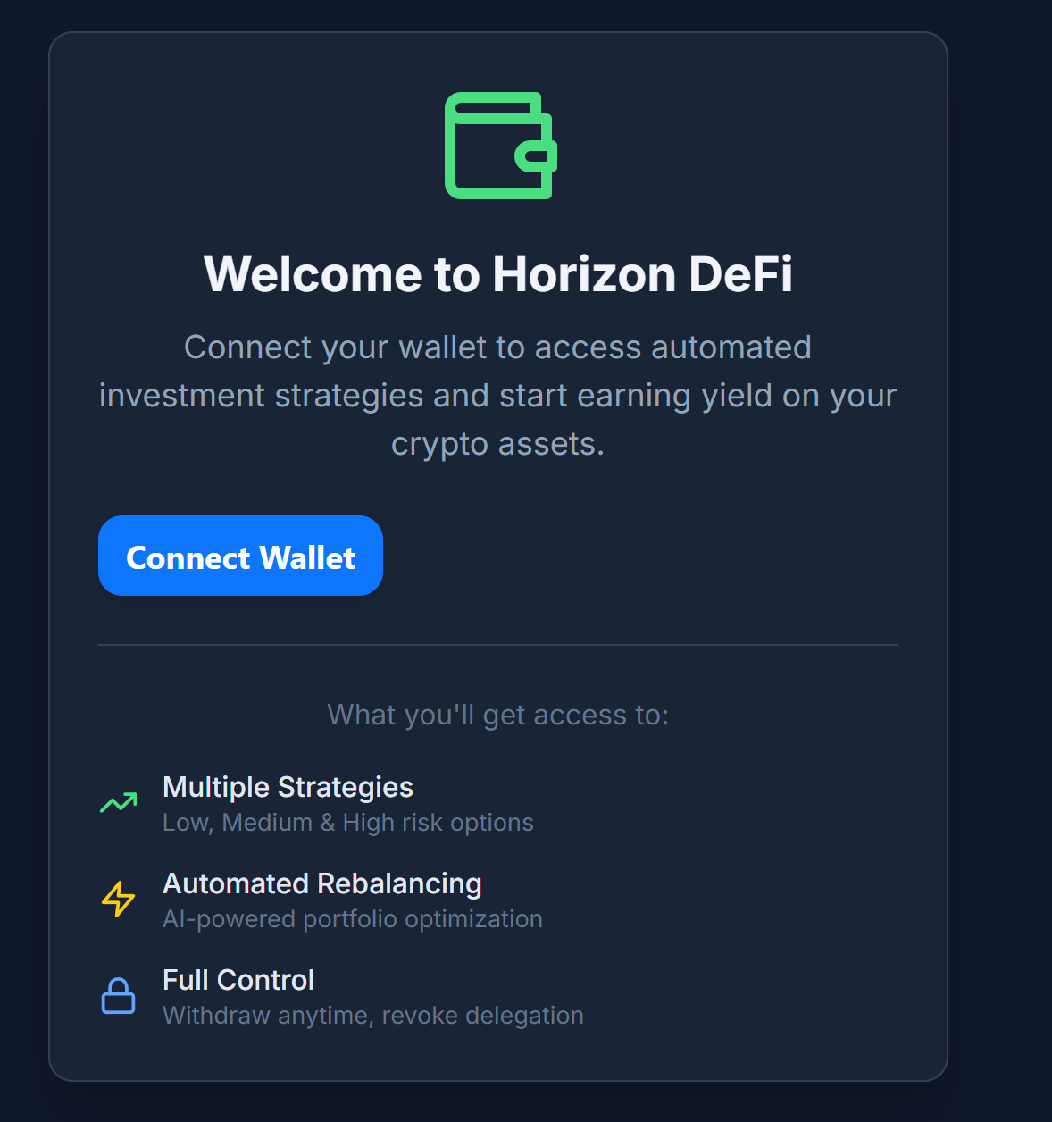
Figure 1 — Welcome & Wallet Connect. The landing card invites users to connect their wallet and highlights core benefits.
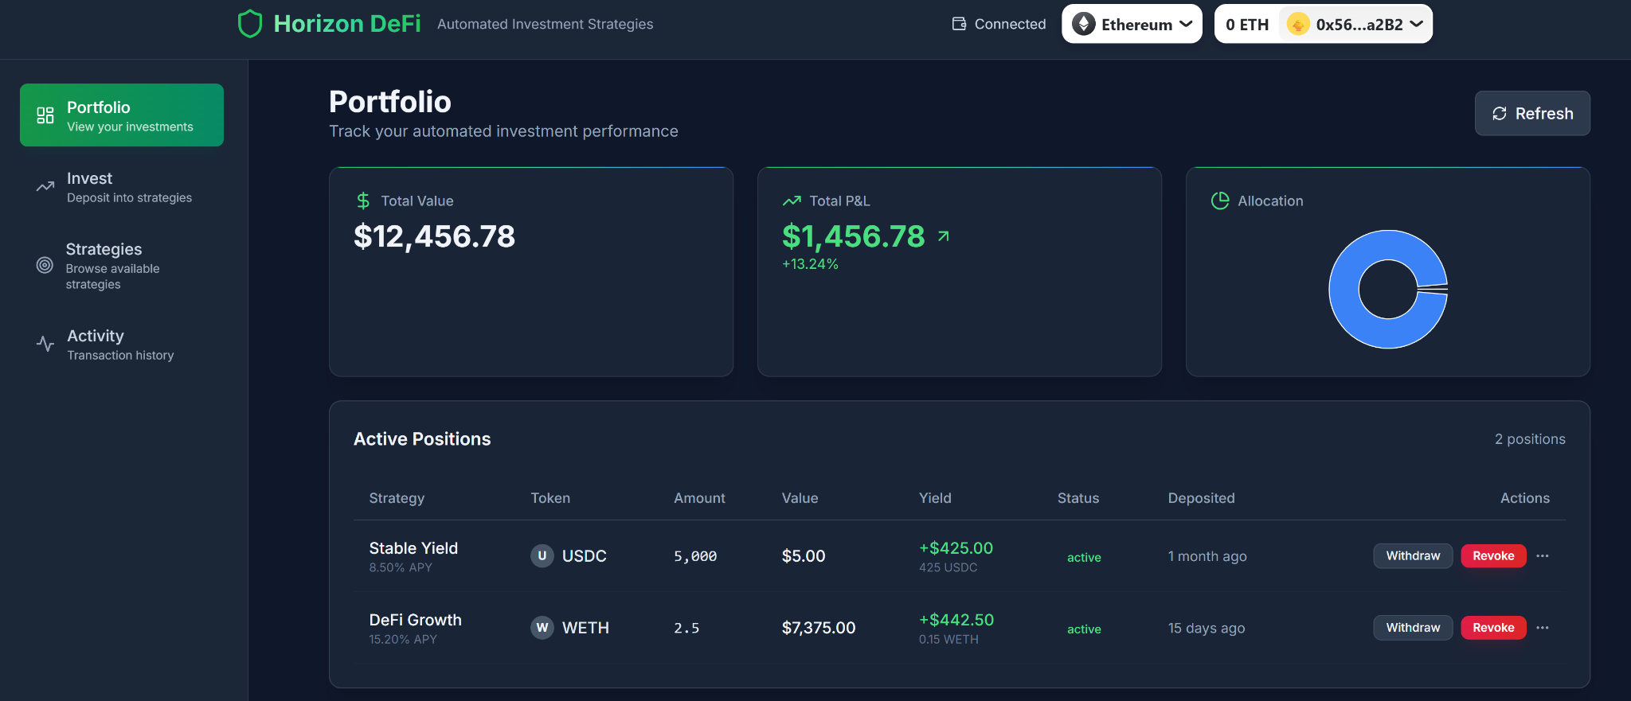
Figure 2 — Portfolio Dashboard. Total value, P&L, allocation, and active positions with Withdraw/Revoke actions.
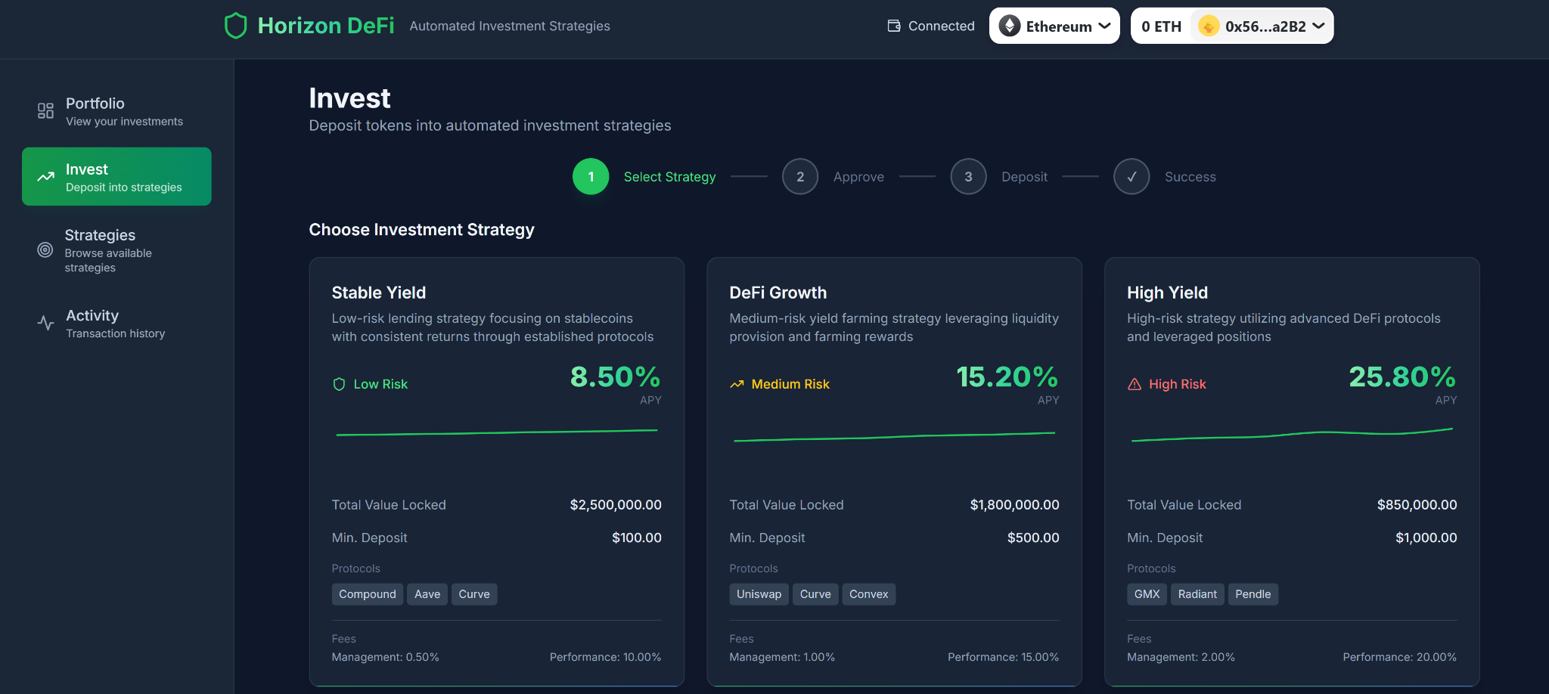
Figure 3 — Invest Flow. Step-by-step wizard: select strategy, approve, deposit, success.
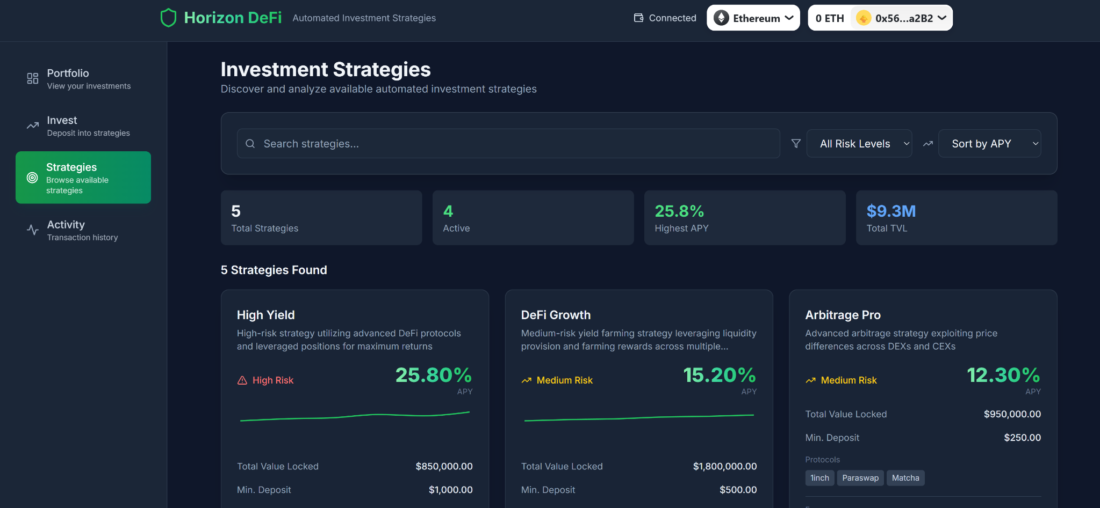
Figure 4 — Strategies Explorer. Search, filter by risk level, sort by APY, and inspect TVL and min deposit.
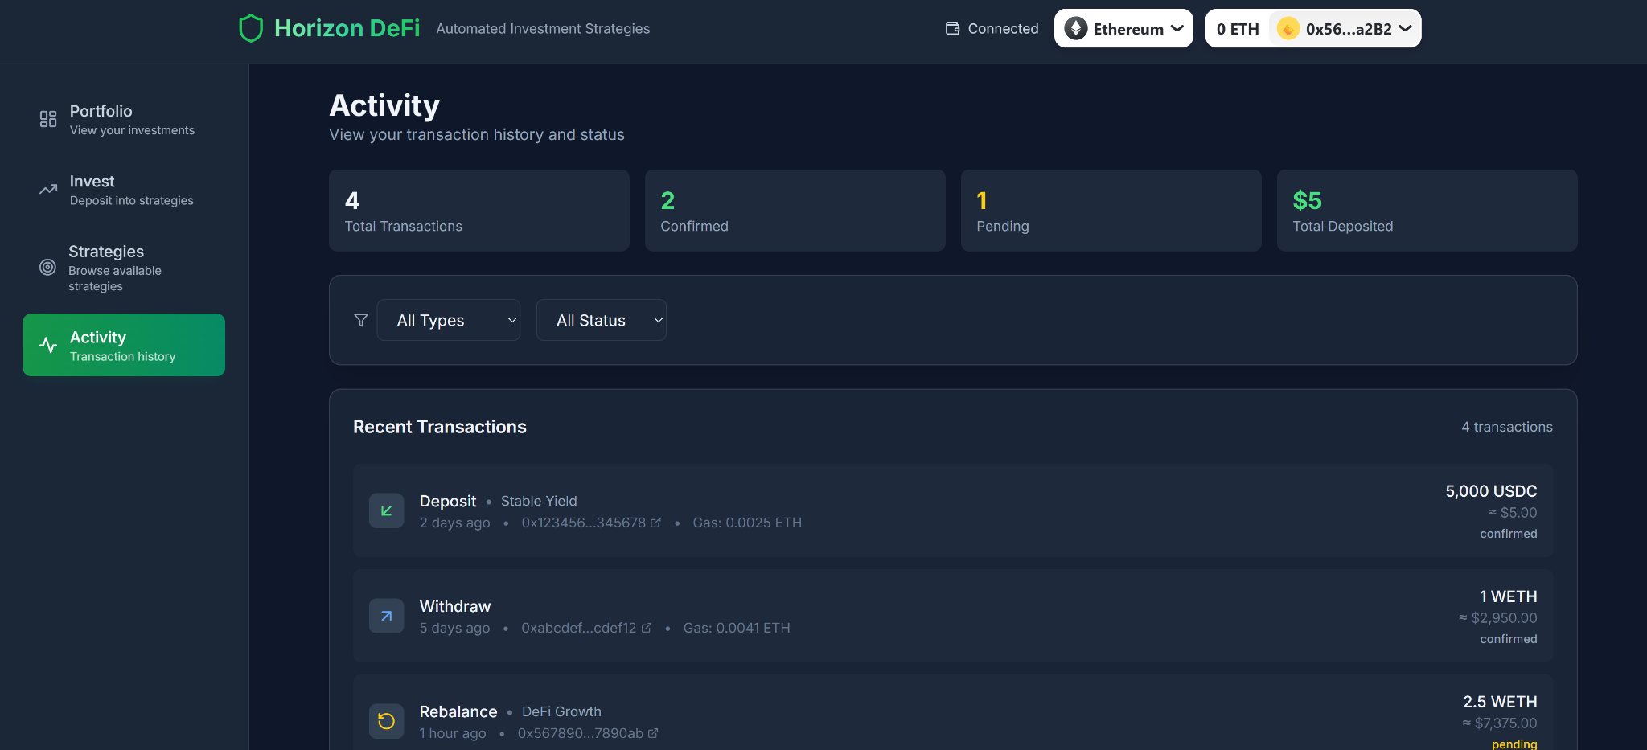
Figure 5 — Activity & Transactions. Unified log of deposits, withdrawals, and rebalances with statuses.
Accessibility & UX: consistent contrast and typography; explicit risk badges; all state-changing operations require wallet signatures; no private keys are ever shared with the platform.

Technical Roadmap

MVP (Q4-2025) — Deposits/Withdrawals, Core Strategies, Initial Integrations, Audits

Scope
- Programs: Strategy Vault Program (SVP) v0, Recipe Registry Program (RRP) v0.
- Flows: open_position, withdraw (partial/full), apply_recipe with drift test.
- Strategies: 2–4 templates (Aggressive, Conservative, DeFi, LST-focused).
- Integrations: Orca CLMM (swap/add/remove), Raydium AMM (swap), Marinade (stake/unstake).
- Oracle: IntelliOracle v0 (daily recipes, signed, validity window, constraints).
- Client/SDK: TS SDK v0, dApp with portfolio, invest, withdraw, basic activity feed.
- Security: External audits for SVP/RRP and adapters; canary vaults; bug bounty (limited scope).

Deliverables
- Mainnet programs (SVP/RRP) with protocol_whitelist, slippage/TVL/CU caps.
- Events: PositionOpened, RecipeApplied, PositionWithdrawn/Closed, FeesSkimmed.
- Risk engine v0 (drift L1; tolerance/hysteresis).
- Indexer + dashboards (positions, drift, events, error taxonomy).
- Audit reports and remediations merged; upgrade authority on timelocked multisig.

Acceptance criteria
- End-to-end deposit→rebalance→withdraw works on mainnet, ≥99% success under nominal load.
- Recipe latency (publish→apply) p50 < 10 min, p95 < 30 min.
- Realized slippage within caps for ≥99% of steps in canary vaults.
- No critical (High) audit findings open.

Non-goals
- Lending/borrowing; cross-chain; Token-2022 features; advanced emissions.

Risks & mitigations
- DEX liquidity variance → chunk trades, priority fees, route selection heuristics.
- Oracle hiccups → staleness/confidence guards; recipe no-op fallback.
- CU ceilings → split routes; Jito bundles optional.

Q1-2026 — Governance Launch, Emissions Policy, Token-2022 Evaluation

Scope
- Governance: SPL Governance (Realms) realm live; timelocked proposals control: fee params, allowlists, oracle key rotation, caps.
- Voting: token-based voting; optional vote-escrow (lock-based boosts) design finalized (implementation may slip to Q2 if needed).
- Emissions: initial policy (caps, schedules, recipients); on-chain events and reporting.
- Token-2022: evaluation of metadata/transfer hooks; no behavioral changes to custody.

Deliverables
- Governance UI: proposal create/vote/queue/execute; param diffs and blast-radius preview.
- Events: ProposalCreated, ProposalExecuted, GovernanceParamUpdated, OracleKeyRotated.
- Emissions contracts (if enabled) with audit; FeeVault routing optionality.
- Token-2022 spike results + RFC; decision record (adopt/park).

Acceptance criteria
- ≥3 successful governance proposals executed on mainnet (params, allowlist, oracle rotation dry-run).
- Emissions (if enabled) account for <X% inflation per epoch; transparent reports.
- Zero downtime during governance-driven param changes.

Non-goals
- DAO-controlled program upgrades (full hand-off) before second audit cycle.
- Complex hooks that affect token transfers.

Risks & mitigations
- Governance capture → quorum/threshold tuning, council mint (narrow scope, sunset).
- Emission mis-targets → caps + taper, periodic review votes.

H1-2026 — Lending (Post-Audit), RWA Rails, Cross-Chain (EVM)

Scope
- Lending: supply/withdraw integration (no leverage at launch), per-market caps, utilization ceilings; health checks; adapters audited.
- RWA rails: off-chain attestation plumbing + oracle fields for whitelisted RWA exposures (no custody of off-chain assets on-chain).
- Cross-chain: ERC-20 representation of VECT.AI, canonical bridge path, token registry updates; single-source governance on Solana with mirrored signaling.

Deliverables
- Lending adapters (supply/withdraw) with MarketUnsafe/UtilizationTooHigh guards.
- Risk engine v1: exposure bucket caps (LST/Stable/DEX LP/Lending), per-bucket telemetry.
- RWA metadata schema + oracles; deny/allow lists governed; disclosures surfaced in UI.
- EVM token contract(s) + bridge configs; indexer updates for multi-chain supply and events.

Acceptance criteria
- Lending supply/withdraw passes audits; canary vaults show <1% guard-fail rate under normal conditions.
- Cross-chain mint & burn reconcile 1:1 with Solana supply; no orphaned balances; explorer parity across chains.
- RWA positions gated by policy; all updates carry attestations and are visible in dashboards.

Non-goals
- Borrowing/leverage; synthetic or perpetual products; unrestricted RWA onboarding.

Risks & mitigations
- Market health shocks → auto-throttle caps to zero, incident denylist, keeper alerts.
- Bridge risk → canonical route only; pause switch; supply reconciliation monitors.
- Regulatory drift for RWA → app-layer geofencing, disclosure cadence, fast governance killswitch.

Cross-Phase Engineering Tracks
- Security: recurring audits before enabling new adapters; bug bounty expansion; version pinning.
- Observability: error-rate SLOs, slippage SLOs, keeper/oracle liveness; Grafana dashboards.
- Reliability: CI/CD with reproducible builds; simulation testnets; chaos drills (oracle stale, pool paused).
- Docs: living spec of PDAs, seeds, error codes; SDK versioned docs; public runbooks.

Milestone Exit Criteria (Roll-up)
- MVP exit: audited core, stable rebalances, non-custodial guarantees verified.
- Q1-2026 exit: governance in control of parameters; emissions (if any) transparent; Token-2022 decision locked.
- H1-2026 exit: lending supply live post-audit; cross-chain supply reconciles; RWA rails gated and observable.

Compliance & User Protection (EU-centric)
This chapter outlines a compliant operating posture for VECT.AI in the EEA: classify the token and activities under MiCA, implement KYC/AML with the EU Transfer of Funds Regulation (crypto Travel Rule), apply GDPR data protection, and provide clear risk/fee disclosures and complaints handling. This section is operational—not legal advice—and describes controls we will implement and evidence on audit.

MiCA Alignment
Scope & classification
- Perform a written token classification under MiCA to determine whether VECT.AI is a utility crypto-asset (likely) or falls into asset-referenced or e-money categories (unlikely by design).
- Document protocol activities (issuance, admission to trading, marketing, and potential staking incentives) and whether they trigger crypto-asset whitepaper obligations or CASP permissions.
Whitepaper & disclosures
- If required, prepare a MiCA-aligned crypto-asset whitepaper covering: project, rights/risks, tokenomics, technology, governance, incident history, and complaints channels.
- Notify the competent authority and publish the whitepaper prior to any EEA public offer/admission, observing marketing rules (fair, clear, non-misleading).
Ongoing obligations
- Maintain a change log for material updates (protocol, token supply, governance) and republish disclosures.
- Track country-level guidance (gold-plating) and implement jurisdiction switches in the app.

KYC/AML & Travel Rule — Expanded

On/Off-ramp KYC
- Use registered CASPs (MiCA) / licensed VASPs to perform KYC for fiat/crypto on-ramps where legally required.
- Verify identity (POI/POA), PEP/sanctions checks, and source-of-funds for higher-risk tiers.
Ongoing AML
- Transaction monitoring (rule- and risk-based) for layering/mixing patterns; escalate alerts to CASP compliance.
- Travel Rule compliance in the EU per Regulation (EU) 2023/1113 (Transfer of Funds/crypto transfers): exchange originator/beneficiary data with obliged entities; block/flag transfers lacking required information.
Jurisdictional controls
- Geo-fencing of restricted/high-risk jurisdictions; IP + residency checks; wallet screening (sanctions, exposure to illicit services).
- Document exemptions (e.g., view-only access) and log enforcement actions.

Data Protection (GDPR)
Lawful basis & minimization
- Define lawful basis (Art. 6) for each processing purpose (KYC, fraud prevention, analytics).
- Collect minimum necessary data; segregate on-chain pseudonymous data from off-chain personal data.
Security & retention
- Encryption at rest/in transit; restricted access; vendor DPAs.
- Retention schedules: KYC per statutory AML periods; purge non-essential telemetry on rolling windows.
Data subject rights
- DSAR process (access/erasure/rectification), identity verification, and response SLAs.
- Breach response: detect, assess, and notify within 72 hours to authorities/data subjects when required.
Privacy by design
- DPIA for high-risk features (e.g., wallet analytics); log privacy reviews for product changes.

Marketing, Disclosures & User Warnings
Fair, clear, non-misleading
- Standardized risk factors in-app and in marketing (volatility, smart-contract risk, oracle risk, liquidity risk, slashing/queue risk for LSTs, bridge risk).
- Prominently display fees (mgmt/perf), caps/limits, and withdrawal constraints (e.g., cooldowns for staking exits).
Performance representations
- No promised returns; label any APY figures as modelled/backtested with assumptions and variability ranges.
- Include scenario analysis and fee impact.
Not investment advice
- Present a clear, persistent disclaimer: “This information is not investment advice.” Encourage independent assessment.

User Protection Mechanics
Non-custodial guarantees
- Enforce on-chain invariant return_to == owner; withdrawals return only to the depositor’s ATAs.
- Publish invariants and error codes for transparency.
Operational resilience
- Scoped pause switches (per-adapter/strategy) that never block user withdrawals.
- Incident runbooks; status page; public post-mortems for material events.
Complaints & support
- Ticketed complaints process with escalation path; record outcomes and remediation actions.
- Cooling-off UI affordances (confirmations for high-risk actions; clear reversal paths where possible).

Sanctions, Screening & Jurisdiction Controls
- Screen wallets and counterparties against EU/UN (and where applicable OFAC) sanctions; block/flag matches.
- Denylist compromised protocols/bridges; exposure caps set to zero upon incidents until governance re-enables.
- Maintain country rulesets and apply consistent enforcement logs for audit.

Record-Keeping, Audit & Governance
- Keep immutable logs/events on-chain plus off-chain audit trails (config changes, oracle key rotations, fee policy updates).
- Periodic third-party audits (smart contracts, key management, AML/Travel Rule implementation, privacy).
- Governance artifacts: proposal texts, diffs, timelocks, execution txs; exportable compliance reports (CSV/JSON).

Roadmap & Ownership
- Phase-in obligations with product milestones (e.g., governance launch → expanded disclosures; lending → enhanced risk warnings).
- Assign RACI: Compliance (policy), Engineering (controls), Data (GDPR), Security (incidents), Support (complaints), Governance (public disclosures).

Canonical Disclaimers
- No investment advice: materials are informational; users should conduct independent due diligence.
- Jurisdictional restrictions: features may be limited or unavailable in certain regions.
- Smart-contract & market risk: users may lose value due to volatility, protocol failures, or oracle/liquidity conditions.

