Computer Vision Homework4

Name : 蔡孟庭

Student ID :R05922078

1:Dilation :

對每個圖中白色的點將kernel蓋上去

def dilation(y,x,src,dst):

if checkbound(x,y):

for i in range(kheight):

for j in range(kwidth):

if dst.getpixel((x+j-2,y+i-2))==0:

dst.putpixel((x+j-2,y+i-2),kernel[i][j])

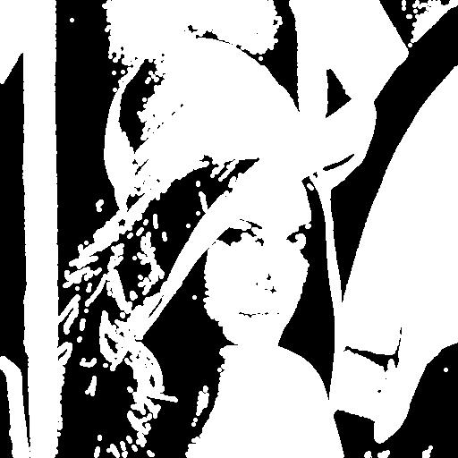

2.Erosion:

對每個A中白色點去match B中所有的點，如果match,則該點為白色否則為黑

if checkbound(x,y)== False or checkmatch() ==False:

dst.putpixel((x,y),0)

else :

dst.putpixel((x,y),255)

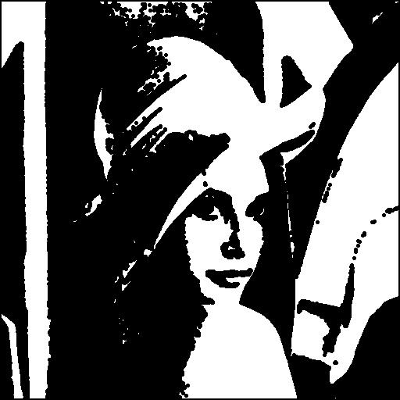

3.Opening:

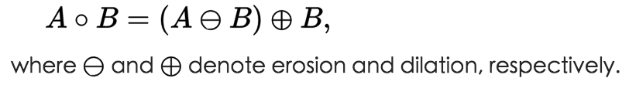

for i in range(height):

for j in range(width):

erosion(i,j,src,tmp)

res=tmp.copy()

for i in range(height):

for j in range(width):

dilation(i,j,tmp,res)

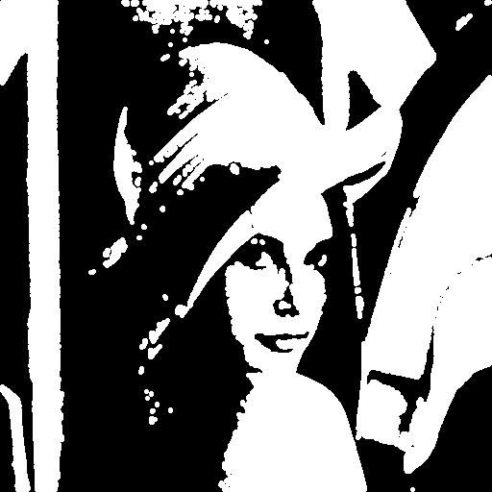

4.Closing:

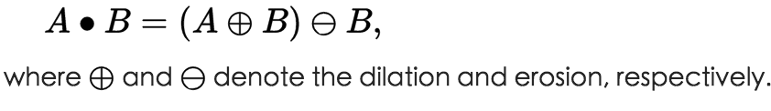

for i in range(height):

for j in range(width):

dilation(i,j,src,tmp)

res=tmp.copy()

for i in range(height):

for j in range(width):

erosion(i,j,tmp,res)

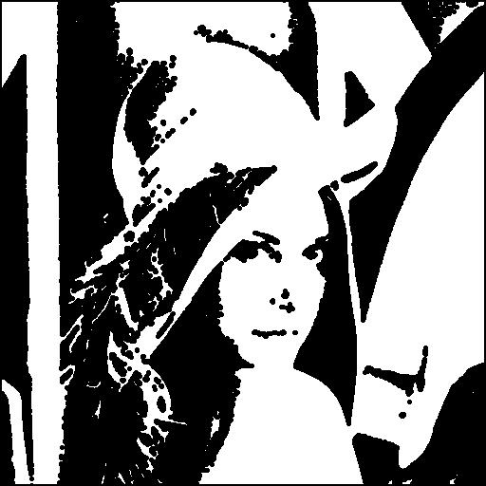

5. Hit and miss:

將A對l kernel Erosion 與C對 l’ kernel Erosion做AND的圖即是(C:A的補圖)

for i in range(height):

for j in range(width):

erosion2(i,j,im2,im7,0)

#make complement

for i in range(height):

for j in range(width):

im8.putpixel((j,i),0 if im8.getpixel((j,i)) else 255)

for i in range(height):

for j in range(width):

erosion2(i,j,im8,im9,1)

for i in range(height):

for j in range(width):

im7.putpixel((j,i), 255 if (im7.getpixel((j,i)) and im9.getpixel((j,i))) else 0)

