Computer Vision Homework1

Name : 蔡孟庭

Student ID :R05922078

1. binarize：

檢查gray scale lena圖中的每個pixel，若該值大於threshold，設為255否則設為0

for i in range(height):

for j in range(width):

im2.putpixel((j,i),255 if im2.getpixel((j,i))>=128 else 0)

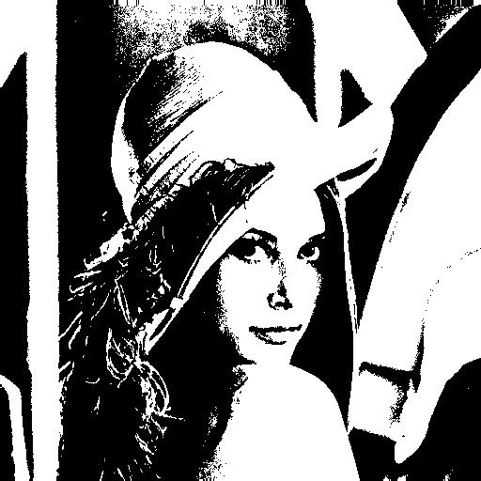

1. histogram

查訪每個pixel並將其值儲存在對應的陣列中，最後再輸出放到excel中畫出histogram

for i in range(height):

for j in range(width):

histogram[im.getpixel((i,j))]+=1

for item in histogram:

print item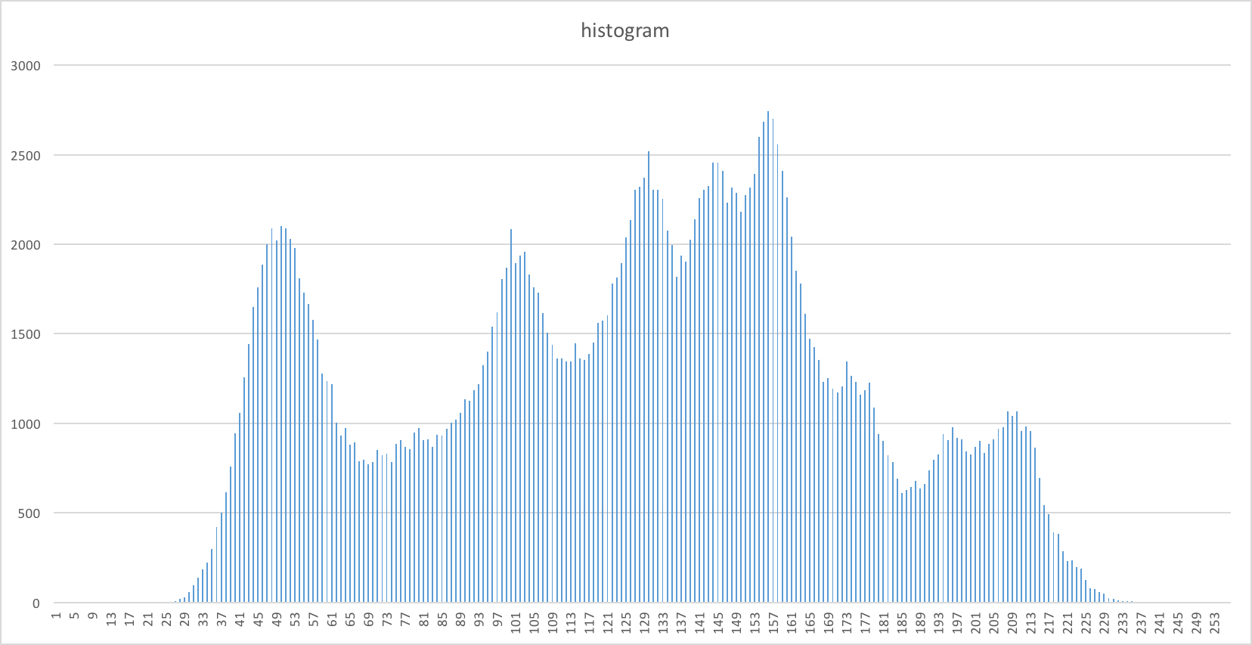

1. connected components

利用iterative algorithm實作connected components

while changed==True:

changed=False

#top-down

for i in range(height):

for j in range(width):

if maps[i][j]==0:

continue

minn=get_min_neighbor(maps,i,j,height,width)

if maps[i][j]!=minn:

maps[i][j]=minn

changed=True

#bottom-up

for i in range(height):

for j in range(width):

x=width-j-1

y=height-i-1

if maps[y][x]==0:

continue

minn=get_min_neighbor(maps,y,x,height,width)

if maps[y][x]!=minn:

maps[y][x]=minn

changed=True

boundlist=[]

#find bound

region=[0 for i in range(0,labelcnt)]

centroid=[]

for i in range(height):

for j in range(width):

region[maps[i][j]]+=1

最後畫的時候 check bound area size >=500才畫出來

