Computer Vision Homework5

Name : 蔡孟庭

Student ID :R05922078

1. Gray-scale Dilation:

根據定義



對某個pixel dilation ，比較該pixel以及其8個neighbor加上對稱kernel的值中最大的填入該pixel

maxval=0

for i in range(kheight):

for j in range(kwidth):

if(checkbound(x,y,j-2,i-2)):

val=src.getpixel((x+j-2,y+i-2))

if val >maxval:

maxval=val

dst.putpixel((x,y),maxval)

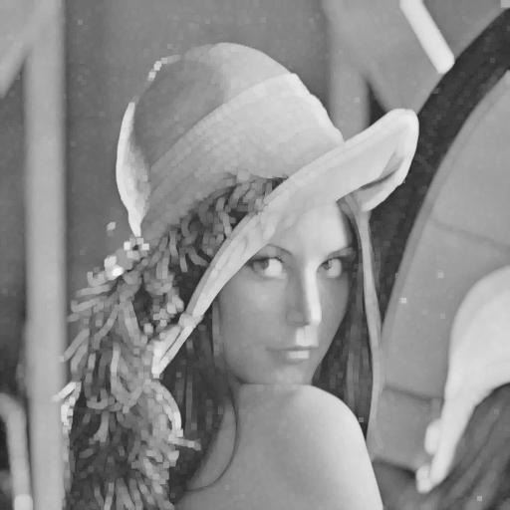

1. Gray-scale Erosion:

根據定義



對某個pixel dilation ，比較該pixel以及其8個neighbor減去對應kernel的值中最小的填入該pixel

minval=255

for i in range(kheight):

for j in range(kwidth):

if(checkbound(x,y,j-2,i-2)):

val=src.getpixel((x+j-2,y+i-2))

if val <minval:

minval=va

dst.putpixel((x,y),minval)

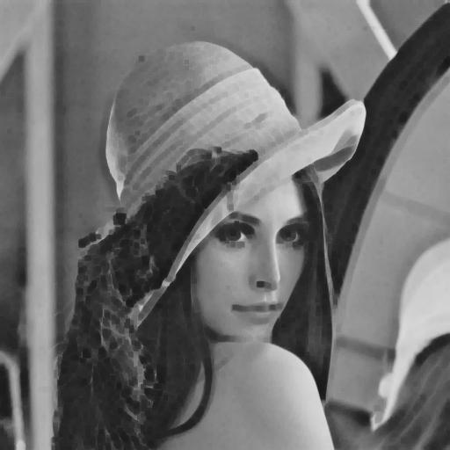

1. Gray-scale Opening:

根據定義，對原圖先做erosion再做dilation即為opening

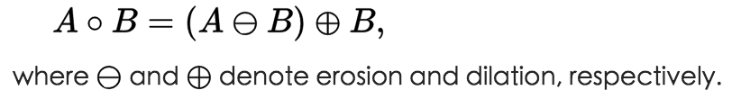

tmp=src.copy()

for i in range(height):

for j in range(width):

erosion(i,j,src,tmp)

res=tmp.copy()

for i in range(height):

for j in range(width):

dilation(i,j,tmp,res)

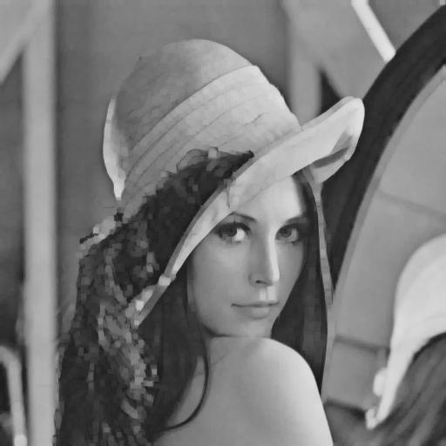

1. Gray-scale Closing:

根據定義，對原圖先做dilation再做erosion即為Closing

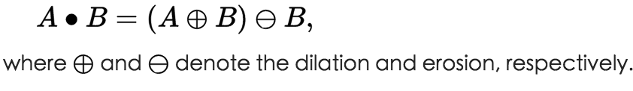

tmp=src.copy()

for i in range(height):

for j in range(width):

dilation(i,j,src,tmp)

res=tmp.copy()

for i in range(height):

for j in range(width):

erosion(i,j,tmp,res)

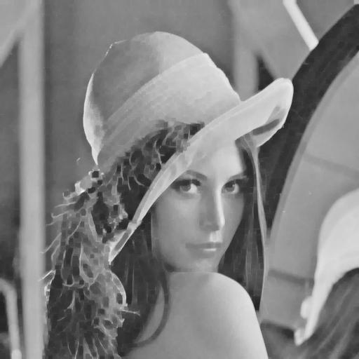

Execution:

Command line: python ./hk5.py