Computer Vision Homework6

Name : 蔡孟庭

Student ID :R05922078

**Yokoi Connectivity Number**

* downsample binary lena to 64x64 and add surround pixel, so create a 66x66 binary lena

**im2=Image.new('1',(66,66),0)**

**for i in range(64):**

**for j in range(64):**

**im2.putpixel((1+j,1+i),1 if im.getpixel((j*8,i*8))>=128 else 0)**

* according to definition of Yokoi function, implement f and h function

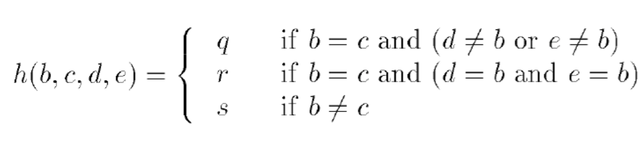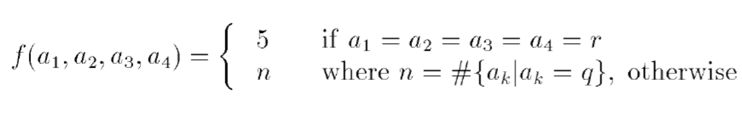

**def h(b,c,d,e):**

**#q=1,r=2,s=3**

**if b == c:**

**if d==b and e==b :**

**return 2 #r**

**elif d!=b or e!=b:**

**return 1 #q**

**return 0**

**else :**

**return 3 #s**

**def f(a,b,c,d):**

**cnt =0**

**if a==b and b==c and c==d and d==2:**

**return 5**

**if a==1:**

**cnt+=1**

**if b==1:**

**cnt+=1**

**if c==1:**

**cnt+=1**

**if d==1:**

**cnt+=1**

**return cnt**

* for each pixel which isn’t background calculate its Yokoi number

**for i in range(64):**

**for j in range(64):**

**p=getpixels(j+1,i+1)**

**if p[0]:**

**l[i][j]=f(**

**h(p[0],p[1],p[6],p[2]),**

**h(p[0],p[2],p[7],p[3])**

**,h(p[0],p[3],p[8],p[4])**

**,h(p[0],p[4],p[5],p[1]))**

**else :**

**l[i][j]=-1**

**return l**

* Execution :

Python hk6.py

And will get a file named “connectivity.txt”

