Computer Vision Homework9

Name : 蔡孟庭

Student ID :R05922078

* Task:

implement Robert, Prewitt, Sobel, Frei & Chen, Kirsch, Robinson, and Nevatia-Babu's edge detectors.

* Using language: matlab

1. Robert:

Using 2 2x2 filter and calculate each pixel’s gradient, then binarize it by challenging threshold. My threshold is 18.

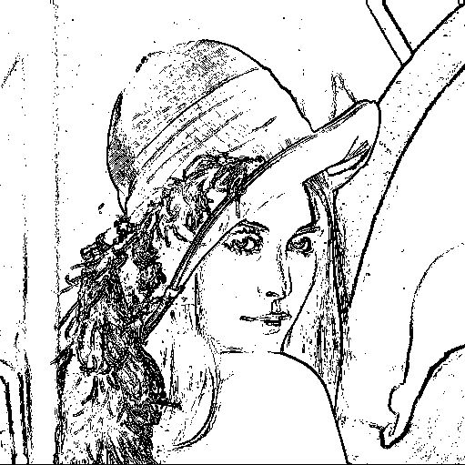

script:

**r1(i,j)=sum(sum(k1.*img(i:i+1,j:j+1)));**

**r2(i,j)=sum(sum(k2.*img(i:i+1,j:j+1)));**

**if sqrt(r1(i,j)^2+r2(i,j)^2) >=18**

**rob(i,j)=0;**

**else**

**rob(i,j)=255;**

**end**

1. Prewitt same as Robert, just replace the filter to 2 3x3 filter.

My threshold is 40

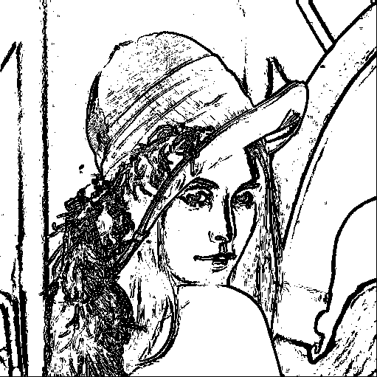

1. Sobel same as Robert and Prewitt, only filter changing.

My threshold is 51

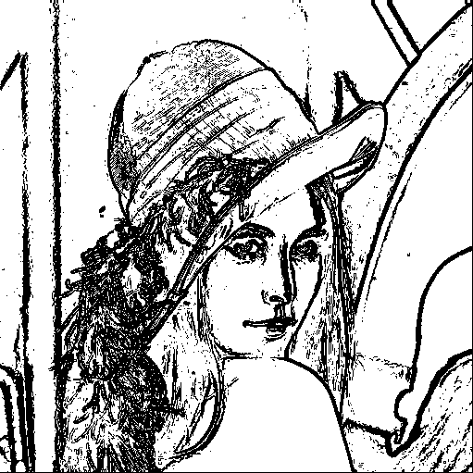

1. Frei & Chen same as Robert, Prewitt and, Sobel, only filter changing.

My threshold is 49

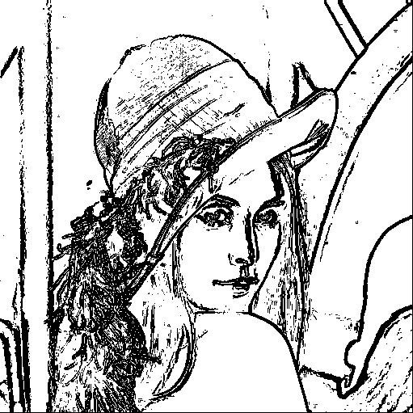

1. Kirsch :Using 8 3x3 filter, find the max filter value as its gradient, then binarize it by challenging threshold.

My threshold is 155

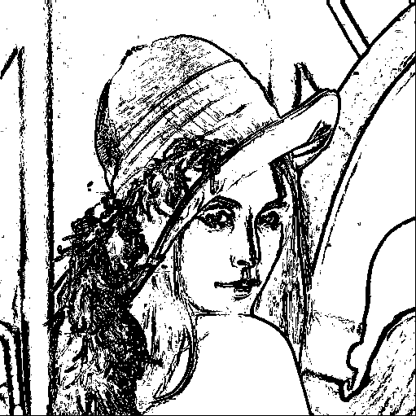

script:

**a=zeros(8,1);**

**a(1,1)=sum(sum(k1.*img(i:i+2,j:j+2)));**

**a(2,1)=sum(sum(k2.*img(i:i+2,j:j+2)));**

**a(3,1)=sum(sum(k3.*img(i:i+2,j:j+2)));**

**a(4,1)=sum(sum(k4.*img(i:i+2,j:j+2)));**

**a(5,1)=sum(sum(k5.*img(i:i+2,j:j+2)));**

**a(6,1)=sum(sum(k6.*img(i:i+2,j:j+2)));**

**a(7,1)=sum(sum(k7.*img(i:i+2,j:j+2)));**

**a(8,1)=sum(sum(k8.*img(i:i+2,j:j+2)));**

**if max(a(:)) >=155**

**kirsch(i,j)=0;**

**else**

**kirsch(i,j)=255;**

**end**

1. Robinson same as Kirsch, only replace the filters.

My threshold is 43

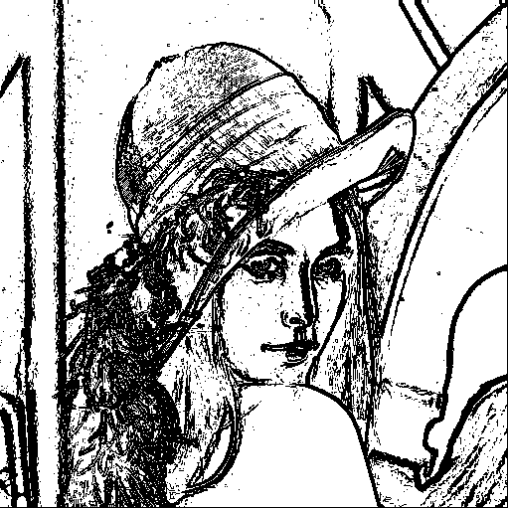

1. Nevatia-Babu same as Kirsch and Robinson, but replace the filter to 6 5x5 filters.

My threshold is 12500

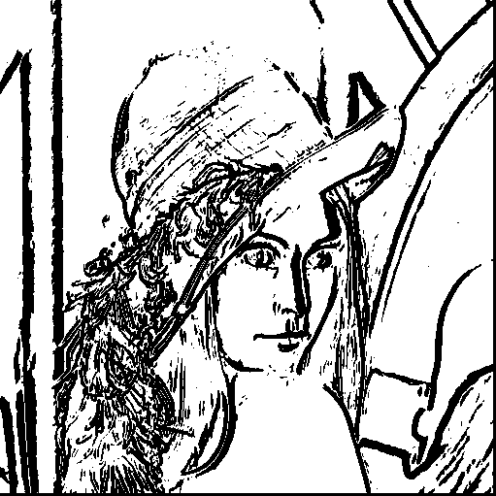

Execute script:

Add hw9.m and lene.bmp to some folder, then open with matlab,

After execute, you will get 7 image.