**THE BATTLE OF NEIGHBORHOODS**

Coursera Capstone Project

Richard Garlock, December 21, 2020

**Introduction**

The number of vegans in the United States (US) increased from 1 percent in 2014 to 6 percent in 2017. US consumers spent almost 1.9 billion US dollars on plant-based milks and over 3 billion US dollars on plant-based foods in 2018. The reasons people are adopting these new vegan and plant-based eating habits range from animal welfare issues to health issues as well as environmental concerns, all of which have led to a rise in the total number of vegan restaurants throughout the US.

New York City, with an estimated population of 8.3 million, is home to a flourishing vegan scene and was rated the best city for vegans in the US by US-News in 2019. This report will explore the boroughs and neighborhoods of New York City and recommend the following business solution: the most ideal locations for opening a new vegan restaurant.

*Sources:*

* Forgrieve, Janet. “Plant-Based Food Sales Continue To Grow By Double Digits, Fueled By Shift In Grocery Store Placement”. Forbes. July 16, 2019. www.forbes.com
* Leins, Casey. “The Best Cities for Vegans and Vegetarians”. US-News. Sept 30, 2019. www.usnews.com.

**Data**

In order to answer the above business problem, data on New York City boroughs, neighborhoods and location coordinates are required. Additionally, obtaining restaurant locations and restaurant ratings are essential.

New York City data containing boroughs, neighborhoods and location coordinates will be obtained via the data source listed below. Data related to the locations and ratings of vegan restaurants will be obtained by utilizing Foursquare’s Application Programming Interface (API). The ratings and locations obtained via Foursquare will be vital to finding the business solution. Please note Foursquare includes both ‘vegan’ and ‘vegetarian’ in the same category (e.g., vegetarian/vegan). Because vegans are almost always able to find vegan food at vegetarian restaurants, the vegetarian/vegan category will be considered ‘vegan’ for the purposes of this research project.

*Data sources:*

* https://cocl.us/new_york_dataset
* Foursquare

**Methodology**

The data will be cleaned and processed into a dataframe. Foursquare’s API will be utilized to locate all venues and then filtered by vegan restaurants. The user ratings per vegan restaurant venue will be added to the dataframe. Data will be sorted by user ratings. Data visualization will be applied to analyze geographical locations via Python libraries.

**Visualizations**

New York City Neighborhoods:

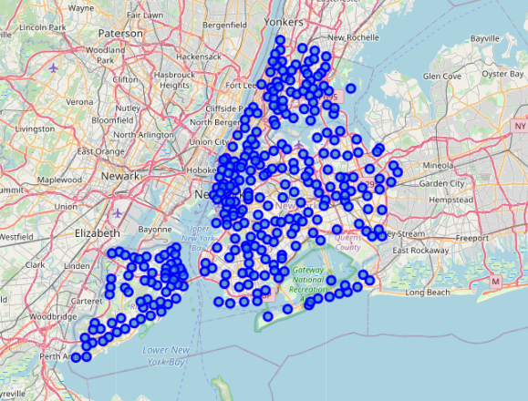

Number of vegan restaurants per Borough in New York City:

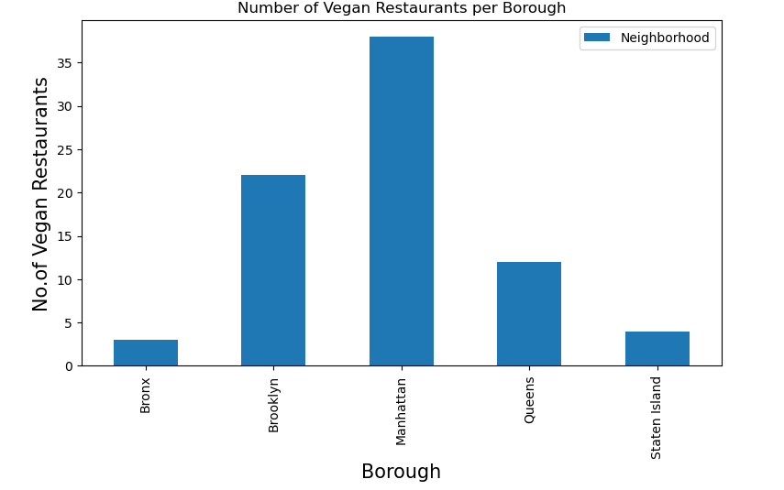

Number of vegan restaurants per Neighborhood in New York City (top 10):

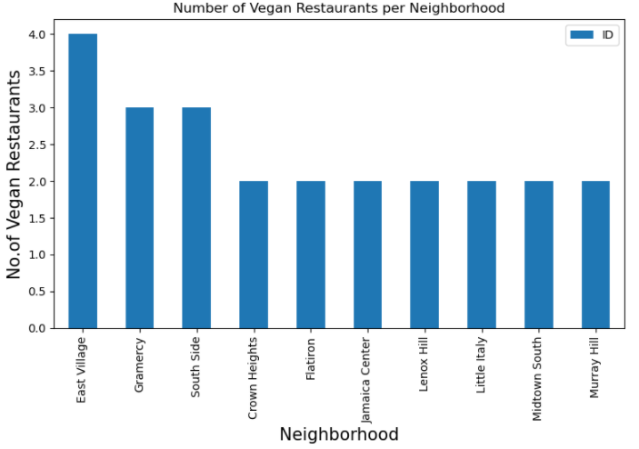

Average rating of vegan restaurants per Borough:

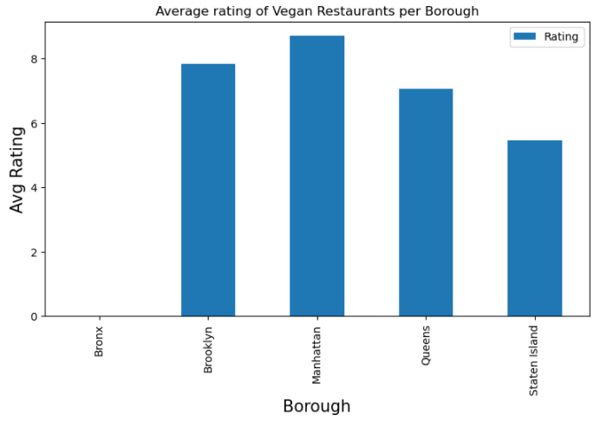

The 48 Neighborhoods in New York City that have an average vegan restaurant rating of greater than 7.5:

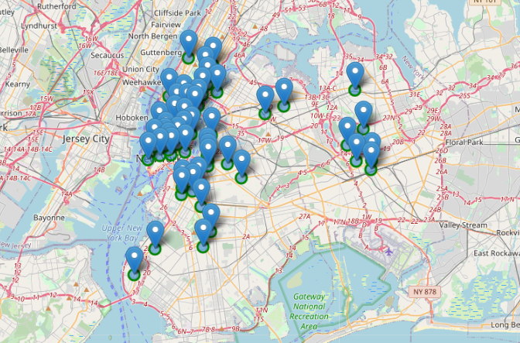

**Results**

The Boroughs of Manhattan and Brooklyn have both the largest number of vegan restaurants and the highest average rated vegan restaurants. The Boroughs of Queens, Staten Island and Bronx had both the least number of vegan restaurants and the lowest average rated vegan restaurants.

**Conclusion**

The recommended business solution, or most ideal locations, for opening a new vegan restaurant are in the Boroughs of Manhattan and Brooklyn. These two Boroughs have numerous successful and highly rated vegan restaurants. As the demand for vegan offerings continue to grow, we believe people seeking vegan food options will continue to flock to these two Boroughs.

With regards to neighborhoods specifically, we recommend avoiding the East Village. The East Village has the most vegan restaurants, but not the highest ratings, therefore we are concerned with too much competition in that neighborhood. We do recommend four possible neighborhoods for starting a new vegan restaurant: Battery Park City, Lower East Side, Chinatown and Civic Center. These four neighborhoods have highly rated vegan restaurants, but a lower number of restaurants, so there is less risk for competition.