COMP3207 – Cloud App Dev
Team M – Documentation

Contents
Project Timeline 2
Team Structure 2
Process Flow 2
Mock-up 3
Architecture 4
Folder structure 4

Project Timeline
See Project Timeline

Team Structure
Person | Job Role | Responsibilities
Christina | Server side | Develop logic and data flow in server side  - Data Processing  - Logic (Calculation)
Jing | Client side | Develop visualisation and logic in client side  - Visualisation  - Logic (User behaviour)
Kan | Client side | Develop visualisation and logic in client side  - Visualisation  - Logic (User behaviour)
Kelvin | Server side | Develop logic and data flow in server side  - Data Processing  - Logic (Calculation)
Marios | Configuration | Manage configuration and application resources  - Server configuration  - Database configuration
Ronald | Man in the middle | Develop both in server and client side  - AJAX/Web socket  - Logic (user behaviour & calculation)
Salingga | Man in the middle | Develop both in server and client side  - AJAX/Web socket  - Logic (user behaviour & calculation)

Process Flow

Mock-up
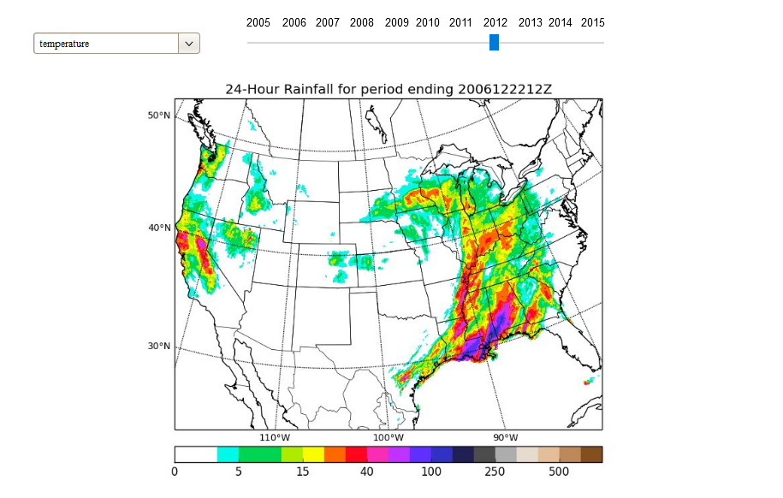
Figure 1. Geo-History
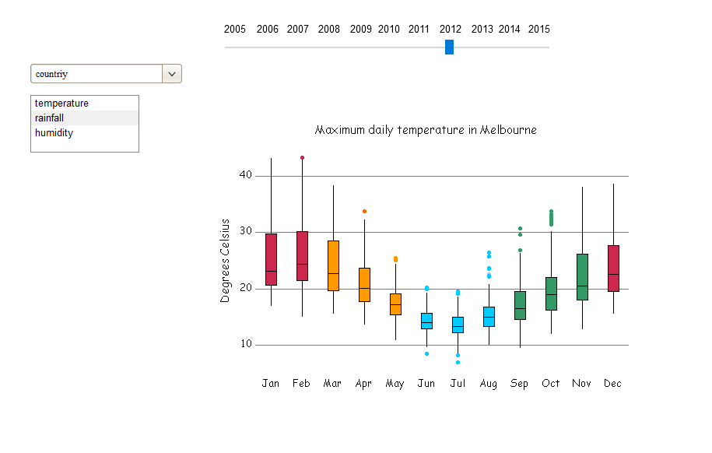
Figure 2. Country Temperature

Architecture

Folder structure
static
template
client
logic
collector
server
config
documentation
tornado
main.py
app.yaml

