Localizing a SCUBA Diver Using Active Sonar
Richard Guilmain and Nabin Sharma
Georgia Tech

1. Problem Description
The threat of an underwater terrorist attack is a concern of the maritime industry, port law enforcement, and luxury and high-profile vessel owners alike. Prevention of such attacks needs to start with the reliable detection of sub-surface threats such as SCUBA and closed-circuit re-breather (CCR) divers. Because these threats are below the water’s surface, traditional detection methods such as radar and visual surveillance are unavailable, making active sonar technology the most effective approach to date. However, because of the inherent noise of the underwater acoustic environment—often rife with mechanical noise, reflective debris, and environmental marine activity—current sonar methods are often inconsistent. Better processing methods are required to manage this low signal-to-noise ratio while still localizing the range and bearing of threatening divers at tactically significant ranges.
Given the noisy range and bearing measurements from an active sonar receiver, the goal is to estimate the range of the target to the sensor, the bearing of the target to the sensor, and the heading direction that the target is moving in. Due to relatively unstable propagation environment, underwater targets like SCUBA divers might not be detected for all measurement steps even if relatively noisier measurements are accepted as valid ones. This leads to the requirement of more robust localization schemes so that we don't lose valid targets just because we missed corresponding measurements intermittently.

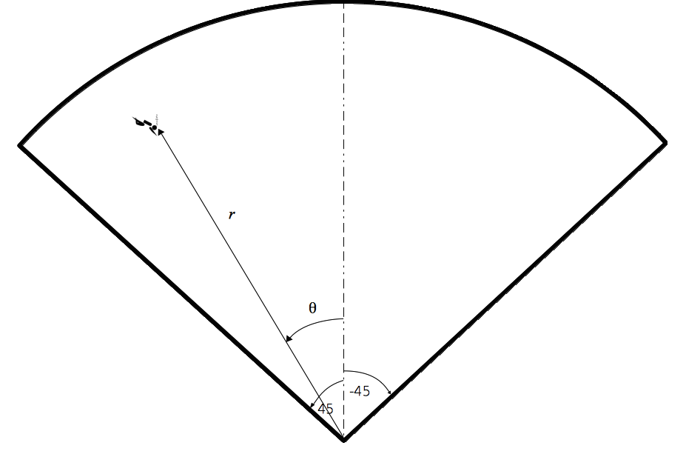Figure 1: Basic graphical representation of a typical diver localization scenario. Sonar measurements provide the range (r) of the target (or diver) from the sonar sensor and bearing (ө) from the sonar sensor axis represented by dashed line. The angular span of the sensor field-of-view is 90 degrees.

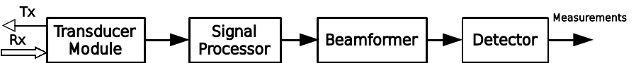Figure 2: Block diagram of the active sonar receiver used to obtain diver measurements.

2. Sensor and Measurements
Figure 1 shows a typical diver localization scenario. Center of the sector in Figure 1 represents the location of active sonar sensor in a ship or boat in a water surface. The sonar system is responsible for providing measurements to our diver localization algorithm. The sonar transmits an acoustic pulse every 1.3 seconds and listens for echo returns via a multichannel receive array. Figure 2 shows the signal and data processing block diagram of the sonar system. Data from receive array passes through several signal processing modules, for example, lowpass filer, digital downconverter, etc., before it gets ready for beamforming. During beamforming, the sonar software combines the signals from all receive array channels in a controlled manner so that the difference time delays experienced by sonar echoes to enter the different receive channels is equalized for desired directions along which sonars want to look for targets. This effectively increases the receiver gain in the desired directions and thus helps in getting better diver or target measurements.
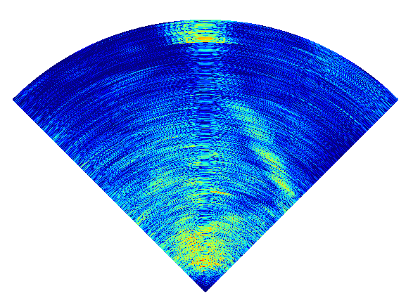Figure 3: A representative sonar sector. As shown in Figure 1, the sonar field-of-view is 90 degrees and maximum range is 500 meters. The relatively stronger patch at around 0 degrees and 450 meters is diver

As shown in Figure 1, we set the sonar, specifically, the beamformer, to look for 45 degrees on both sides of sonar axis. This sets the sonar angular field-of-view to be of 90 degrees. The maximum range up to which the sonar can detect the target is 500 meters. The angular field of view and the maximum detection range of the sonar define the sonar sector as shown in Figure 1 - the only area in front of sonar which can be scanned for detecting targets. Figure 3 shows a sector generated using the range and angular settings as specified in Figure 1. The relatively strong patch around zero degrees and 450 meters is a SCUBA diver swimming towards the sonar. It is evident from Figure 3 that the sector data coming out of beamformer could be quite noisy depending on the conditions of water and surroundings. We have to accept some level of false detections to have true measurements from diver. This leads to the requirement of a probabilistic localization algorithm if we want to detect the diver with high level of confidence.

