Flow Diagram SMS

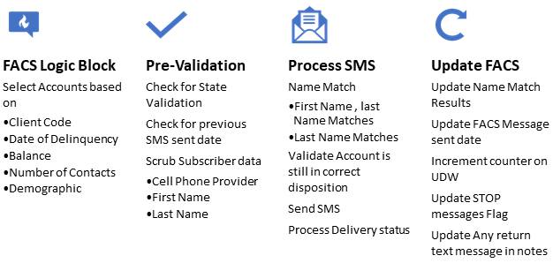

Figure

1. **FACS Logic Block**
   1. Select accounts based on

* Client Code
* Date of Delinquency
* Balance
* Approval from client
  1. The logic block runs in the morning and provides a file containing information about the SMS to be sent for that day.

1. **Sql-Server Processing**
   1. The file is loaded into a sql database by a scheduled task.
   2. The execution of other scheduled sql process gets started automatically after the FACS file is loaded.
   3. “Windows Services” handle tasks in conjunction with the logic on sql server.
2. **Pre-Validation**
3. Check the state for validation. Cannot send SMS to certain states like N.Y.
4. Check for previous SMS send date
5. Scrub debtor data, to ensure we are in compliance with TCPA requirements. The phone number should match the name of the person on file.

* Cell phone provider
* First Name
* Last Name
* Phone number

1. Update name match and name mis-match results in FACS using web-api.
2. **Clicker Web Application**

The data gets placed in a table for a person (“clicker”) to review and “click” each SMS before it is sent.

1. The clicker logs on to a web application.
2. The clicker’s credentials are authenticated from the active directory.
3. The messages are presented to the clicker for review and approval one at a time and then sent.
4. Many clickers can log on the application at the same time.
5. The list of “clickers” is maintained by the supervisor using the web application.
6. **Process and send SMS**
7. The disposition of the account is checked from FACS in real-time using web-api before sending the SMS. Based on the disposition result the SMS is sent.
8. The carrier of the phone number is used to decide if the SMS will be sent using the longcode or shortcode.
9. The delivery status of each SMS is updated in real-time on FACS using web-api.
10. **Update FACS with delivery results**
11. A “webhook” collects status from SMS service provider.
12. Any replies to the SMS message are updated on FACS, using web-api.
    * “STOP” message
    * Any other reply by the receiver of the SMS.
13. FACS is updated with delivery status of the SMS message using web-api.
    * Delivered
    * Un-delivered
    * Un-reachable
14. **Need for in-house development**
    1. Off the shelf products investigated did not have all the functionality needed.

* Example a “Clicker” application – requirement for TCPA compliance was missing in most off-the-shelf-products.
* Most of the products did not have a real time web hooks and web apis to FACS. So a SMS could be sent to a “disposed” account because of a lack of real-time link to FACS.
* The functionality was more generic rather than meeting our specific needs.
  1. With in-house development the need for software upgrades, software support, monthly or annual licensing fees, per-website or installation licenses, and per-seat costs were all eliminated. These costs over time exceed the costs of a customized solution without any of the advantages.
  2. The speed at which new functionality can be added or changed in in-house developed solutions cannot be matched by off-the-shelf software.
  3. The cost of initial development as well as on-going support was greatly reduced by having the software development done in India.
  4. The cost of sending each SMS is much lower for us with in-house solution compared to what the vendors were quoting.