Preparation of reports
for LSBU CSI-7-MAL

Author Student Name and ID 1, Author Student Name and ID 2,
Author Student Name and ID 3, Author Student Name and ID 4

Abstract—These instructions give you guidelines for preparing reports for CSI-7-MAL, according to the template used for submitting papers to IEEE TMI. Use this document as a template if you are using Microsoft Word 2010 or later. Otherwise, use this document as an instruction set. Paper titles should be written in uppercase and lowercase letters, not all uppercase. Avoid writing formulas in the title; short formulas that identify the elements are fine (e.g., "Nd–Fe–B"). Keep the title short. Do not write your names in the author filed, but only the student ID. Define all symbols used in the abstract. Do not cite references in the abstract. Do not delete the blank line immediately above the abstract; it sets the footnote at the bottom of this column. Keep the abstract to 250 words or less.

Index Terms—Enter key about five words or phrases in alphabetical order, separated by commas.

INTRODUCTION
T
HIS document is a template for Microsoft Word 2019 versions or later..

Guidelines For Manuscript Preparation
Do not change the template font sizes or line spacing to squeeze more text into a limited number of pages. The 10-pt Times New Roman font is preferred. Use italics for emphasis; do not underline words.
To insert images in Word, position the cursor at the insertion point and either use Insert | Picture | From File or copy the image to the Windows clipboard and then Edit | Paste Special | Picture (with “float over text” unchecked).
Place your figures in the text as you expect them to appear in print. Add a caption in 8-pt font as shown below.

Abbreviations and Acronyms
Define abbreviations and acronyms the first time they are used in the text, even after they have already been defined in the abstract. Abbreviations such as IEEE, SI, ac, and dc do not have to be defined. Abbreviations that incorporate periods should not have spaces: write “C.N.R.S.,” not “C. N. R. S.” Do not use abbreviations in the title unless they are unavoidable (for example, “IEEE” in the title of this article).

Other Recommendations
Use one space after periods and colons. Hyphenate complex modifiers: “zero-field-cooled magnetization.” Avoid dangling participles, such as, “Using (1), the potential was calculated.” [It is not clear who or what used (1).] Write instead, “The potential was calculated by using (1),” or “Using (1), we calculated the potential.”
Use a zero before decimal points: “0.25,” not “.25.” Use “cm³,” not “cc.” Indicate sample dimensions as “0.1 cm × 0.2 cm,” not “0.1 × 0.2 cm².” The abbreviation for “seconds” is “s,” not “sec.” Use “Wb/m²” or “webers per square meter,” not “webers/m².” When expressing a range of values, write “7 to 9” or “7-9,” not “7~9.”
A parenthetical statement at the end of a sentence is punctuated outside of the closing parenthesis (like this). (A parenthetical sentence is punctuated within the parentheses.) In American English, periods and commas are within quotation marks, like “this period.” Other punctuation is “outside”! Avoid contractions; for example, write “do not” instead of “don’t.” The serial comma is preferred: “A, B, and C” instead of “A, B and C.”
If you wish, you may write in the first person singular or plural and use the active voice (“I observed that...” or “We observed that...” instead of “It was observed that...”). Remember to check spelling. If your native language is not English, please get a native English-speaking colleague to carefully proofread your paper or use a professional editing service.

MATH
If you are using Word, use either the Microsoft Equation Editor or the MathType add-on (http://www.mathtype.com) for equations in your paper (Insert | Object | Create New | Microsoft Equation or MathType Equation). “Float over text” should not be selected.

Equations
Number equations consecutively with equation numbers in parentheses flush with the right margin, as in (1). First use the equation editor to create the equation. Then select the “Equation” markup style. Press the tab key and write the equation number in parentheses. To make your equations more compact, you may use the solidus ( / ), the exp function, or appropriate exponents. Use parentheses to avoid ambiguities in denominators. Punctuate equations when they are part of a sentence, as in

(1)

Be sure that the symbols in your equation have been defined before the equation appears or immediately following. Italicize symbols (T might refer to temperature, but T is the unit tesla). Refer to “(1),” not “Eq. (1)” or “equation (1),” except at the beginning of a sentence: “Equation (1) is ... .”

Units
Use either SI (MKS) or CGS as primary units. (SI units are strongly encouraged.) English units may be used as secondary units (in parentheses). For example, write “15 Gb/cm² (100 Gb/in²).” An exception is when English units are used as identifiers in trade, such as “3½-in disk drive.” Avoid combining SI and CGS units, such as current in amperes and magnetic field in oersteds. This often leads to confusion because equations do not balance dimensionally. If you must use mixed units, clearly state the units for each quantity in an equation.
The SI unit for magnetic field strength H is A/m. However, if you wish to use units of T, either refer to magnetic flux density B or magnetic field strength symbolized as µ₀H. Use the center dot to separate compound units, e.g., “A·m².”

Some Common Mistakes
The word “data” is plural, not singular. The subscript for the permeability of vacuum µ₀ is zero, not a lowercase letter “o.” The term for residual magnetization is “remanence”; the adjective is “remanent”; do not write “remnance” or “remnant.” Use the word “micrometer” instead of “micron.” A graph within a graph is an “inset,” not an “insert.” The word “alternatively” is preferred to the word “alternately” (unless you really mean something that alternates). Use the word “whereas” instead of “while” (unless you are referring to simultaneous events). Do not use the word “essentially” to mean “approximately” or “effectively.” Do not use the word “issue” as a euphemism for “problem.” When compositions are not specified, separate chemical symbols by en-dashes; for example, “NiMn” indicates the intermetallic compound Ni_{0.5}Mn_{0.5} whereas “Ni–Mn” indicates an alloy of some composition Ni_{x}Mn_{1-x}.
Be aware of the different meanings of the homophones “affect” (usually a verb) and “effect” (usually a noun), “complement” and “compliment,” “discreet” and “discrete,” “principal” (e.g., “principal investigator”) and “principle” (e.g., “principle of measurement”). Do not confuse “imply” and “infer.”
Prefixes such as “non,” “sub,” “micro,” “multi,” and “ultra” are not independent words; they should be joined to the words they modify, usually without a hyphen. There is no period after the “et” in the Latin abbreviation “et al.” (it is also italicized). The abbreviation “i.e.,” means “that is,” and the abbreviation “e.g.,” means “for example” (these abbreviations are not italicized).

Guidelines for Graphics Preparation
and Submission

File Formats for Graphics
Format and save your graphics using a suitable graphics processing program that will allow you to create the images as Tagged Image File Format (.TIFF), Portable Document Format (.PDF), or Portable Network Graphics (.PNG) sizes them, and adjusts the resolution settings; when using Joint Photographic Experts Group (JPEG) files, make sure that the compression is low and that you do not have block artefacts.
Place a figure caption below each figure; place table titles above the tables. Please do not include captions as part of the figures, or put them in “text boxes” linked to the figures. Also, do not place borders around the outside of your figures.

Sizing of Graphics
Most charts, graphs, and tables are one column wide (3.5 inches / 88 millimeters / 21 picas) or page wide (7.16 inches / 181 millimeters / 43 picas). The maximum depth a graphic can be is 8.5 inches (216 millimeters / 54 picas). When choosing the depth of a graphic, please allow space for a caption. Figures can be sized between column and page widths if the author chooses, however it is recommended that figures are not sized less than column width unless when necessary.

Accepted Fonts Within Figures
When preparing your graphics, it is suggested that you use of one of the following Open Type fonts: Times New Roman, Helvetica, Arial, Cambria, and Symbol. If you are supplying EPS, PS, or PDF files all fonts must be embedded. Some fonts may only be native to your operating system; without the fonts embedded, parts of the graphic may be distorted or missing.
A safe option when finalizing figures is to strip out the fonts before you save the files, creating “outline” type. This converts fonts to artwork that appear uniformly on any screen.

Using Labels Within Figures

Figure Axis labels
Figure axis labels are often a source of confusion. Use words rather than symbols. As an example, write the quantity “Magnetization,” or “Magnetization M,” not just “M.” Put units in parentheses. Do not label axes only with units. As in Fig. 1, for example, write “Magnetization (A/m)” or “Magnetization (Am⁻¹),” not just “A/m.” Do not label axes with a ratio of quantities and units. For example, write “Temperature (K),” not “Temperature/K.” 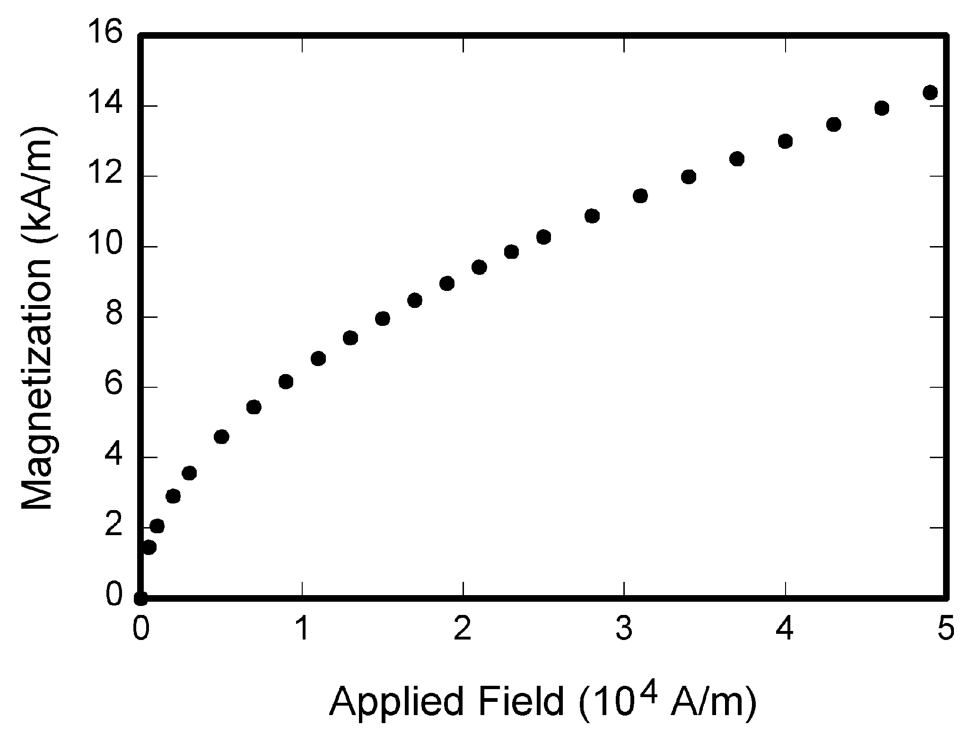
Fig. 1. Magnetization as a function of applied field. Note that “Fig.” is abbreviated. There is a period after the figure number, followed by two spaces. It is good practice to explain the significance of the figure in the caption.

Multipliers can be especially confusing. Write “Magnetization (kA/m)” or “Magnetization (10³ A/m).” Do not write “Magnetization (A/m) × 1000” because the reader would not know whether the top axis label in Fig. 1 meant 16000 A/m
or 0.016 A/m. Figure labels should be legible, approximately 8 to 10 point type.

Subfigure Labels in Multipart Figures and Tables
Multipart figures should be combined and labeled. Labels should appear centered below each subfigure in 8 point Times New Roman font in the format of (a) (b) (c).

Referencing a Figure or Table Within Your Paper
When referencing your figures and tables within your paper, use the abbreviation “Fig.” even at the beginning of a sentence. Do not abbreviate “Table.” Tables should be numbered with Roman Numerals.

Discussion and Conclusion
A conclusion may review the main points of the paper, do not replicate the abstract as the conclusion. A conclusion might elaborate on the importance of the work or suggest applications and extensions.

Appendix and the use of Supplemental files
Appendices, if needed, appear before the acknowledgment.

References and Footnotes

References
All listed references must be cited in text at least once. Use number citations that are placed in square brackets and inside the punctuation. Multiple references are each numbered with separate brackets. When citing a section in a book, please give the relevant page numbers. In text, refer simply to the reference number. Do not use “Ref.” or “reference” except at the beginning of a sentence: “Reference [3] shows ... .”
Reference numbers are set flush left and form a column of their own, hanging out beyond the body of the reference. The reference numbers are on the line, enclosed in square brackets. In all references, the given name of the author or editor is abbreviated to the initial only and precedes the last name. List the names of all authors if there are six or fewer co-authors, otherwise list the primary author's name followed by et al. Use commas around Jr., Sr., and III in names. Abbreviate conference titles. When referencing a patent, provide the day and the month of issue, or application. References may not include all information; please obtain and include relevant information. Do not combine references. There must be only one reference with each number. If there is a URL included with the print reference, it can be included at the end of the reference.
Other than books, capitalize only the first word in a paper title, except for proper nouns and element symbols. See the end of this document for formats and examples of common references.

Footnotes
Number footnotes separately in superscripts (Insert | Footnote). Place the actual footnote at the bottom of the column in which it is cited; do not put footnotes in the reference list (endnotes). Use letters for table footnotes (see Table I).
TABLE I
Units for Magnetic Properties
Symbol | Quantity | Conversion from Gaussian and CGS EMU to SI ª
Φ | magnetic flux | 1 Mx → 10⁻⁸ Wb = 10⁻⁸ V·s
B | magnetic flux density,  magnetic induction | 1 G → 10⁻⁴ T = 10⁻⁴ Wb/m²
H | magnetic field strength | 1 Oe → 10³/(4π) A/m
m | magnetic moment | 1 erg/G = 1 emu  → 10⁻³ A·m² = 10⁻³ J/T
M | magnetization | 1 erg/(G·cm³) = 1 emu/cm³  → 10³ A/m
4πM | magnetization | 1 G → 10³/(4π) A/m
σ | specific magnetization | 1 erg/(G·g) = 1 emu/g → 1 A·m²/kg
j | magnetic dipole  moment | 1 erg/G = 1 emu  → 4π × 10⁻¹⁰ Wb·m
J | magnetic polarization | 1 erg/(G·cm³) = 1 emu/cm³  → 4π × 10⁻⁴ T
χ, κ | susceptibility | 1 → 4π
χ_{ρ} | mass susceptibility | 1 cm³/g → 4π × 10⁻³ m³/kg
μ | permeability | 1 → 4π × 10⁻⁷ H/m  = 4π × 10⁻⁷ Wb/(A·m)
μ_{r} | relative permeability | μ → μ_{r}
w, W | energy density | 1 erg/cm³ → 10⁻¹ J/m³
N, D | demagnetizing factor | 1 → 1/(4π)
Vertical lines are optional in tables. Statements that serve as captions for the entire table do not need footnote letters.
ªGaussian units are the same as cg emu for magnetostatics; Mx = maxwell, G = gauss, Oe = oersted; Wb = weber, V = volt, s = second, T = tesla, m = meter, A = ampere, J = joule, kg = kilogram, H = henry.

References
Basic format for books:
- J. K. Author, “Title of chapter in the book,” in Title of His Published Book, xth ed. City of Publisher, Country if not USA: Abbrev. of Publisher, year, ch. x, sec. x, pp. xxx–xxx.
Examples:
- G. O. Young, “Synthetic structure of industrial plastics,” in Plastics, 2nd ed., vol. 3, J. Peters, Ed. New York: McGraw-Hill, 1964, pp. 15–64.
- W.-K. Chen, Linear Networks and Systems. Belmont, CA: Wadsworth, 1993, pp. 123–135.

Basic format for periodicals:
- J. K. Author, “Name of paper,” Abbrev. Title of Periodical, vol. x, no. x, pp. xxx-xxx, Abbrev. Month, year.
Examples:
- J. U. Duncombe, “Infrared navigation—Part I: An assessment
of feasibility,” IEEE Trans. Electron Devices, vol. ED-11, no. 1, pp. 34–39, Jan. 1959.
- E. P. Wigner, “Theory of traveling-wave optical laser,” Phys. Rev.,
vol. 134, pp. A635–A646, Dec. 1965.
- E. H. Miller, “A note on reflector arrays,” IEEE Trans. Antennas Propagat., to be published.

Basic format for reports:
- J. K. Author, “Title of report,” Abbrev. Name of Co., City of Co., Abbrev. State, Rep. xxx, year.
Examples:
- E. E. Reber, R. L. Michell, and C. J. Carter, “Oxygen absorption in the earth’s atmosphere,” Aerospace Corp., Los Angeles, CA, Tech. Rep. TR-0200 (4230-46)-3, Nov. 1988.
- J. H. Davis and J. R. Cogdell, “Calibration program for the 16-foot antenna,” Elect. Eng. Res. Lab., Univ. Texas, Austin, Tech. Memo. NGL-006-69-3, Nov. 15, 1987.

Basic format for handbooks:
- Name of Manual/Handbook, x ed., Abbrev. Name of Co., City of Co., Abbrev. State, year, pp. xxx-xxx.
Examples:
- Transmission Systems for Communications, 3rd ed., Western Electric Co., Winston-Salem, NC, 1985, pp. 44–60.
- Motorola Semiconductor Data Manual, Motorola Semiconductor Products Inc., Phoenix, AZ, 1989.

Basic format for books (when available online):
- Author. (year, month day). Title. (edition) [Type of medium]. volume (issue). Available: site/path/file
Example:
- J. Jones. (1991, May 10). Networks. (2nd ed.) [Online]. Available: http://www.atm.com

Basic format for journals (when available online):
- Author. (year, month). Title. Journal. [Type of medium]. volume (issue), pages. Available: site/path/file
Example:
- R. J. Vidmar. (1992, Aug.). On the use of atmospheric plasmas as electromagnetic reflectors. IEEE Trans. Plasma Sci. [Online]. 21(3), pp. 876–880. Available: http://www.halcyon.com/pub/journals/21ps03-vidmar

Basic format for papers presented at conferences (when available online):
- Author. (year, month). Title. Presented at Conference title. [Type of Medium]. Available: site/path/file
Example:
- PROCESS Corp., MA. Intranets: Internet technologies deployed behind the firewall for corporate productivity. Presented at
INET96 Annual Meeting. [Online]. Available: http://home.process.com/Intranets/wp2.htp

Basic format for reports and handbooks (when available online):
- Author. (year, month). Title. Comp an y . C ity, State or Country. [Type of Medium]. Available: site/path/file
Example:
- S. L. Tall een. (1996 , Apr . ). The In t r an et Archi -tecture: M a nagi ng i n f o rm at i on i n t h e ne w paradigm. Amdahl Corp., CA. [Online]. Available: http://www.amdahl.com/doc/products/bsg/intra/infra/html

Basic format for computer programs and electronic documents (when available online): ISO recommends that capitalization follow the accepted practice for the language or script in which the information is given.
Example:
- A. Harriman. (1993, June). Compendium of genealogical software. Humanist. [Online]. Available e-mail: HUMANIST@NYVM.ORG Message: get GENEALOGY REPORT

Basic format for patents (when available online):
- Name of the invention, by inventor’s name. (year, month day). Patent Number [Type of medium]. Available: site/path/file
Example:
- Musical toothbrush with adjustable neck and mirror, by L.M.R. Brooks. (1992, May 19). Patent D 326 189
- [Online]. Available: NEXIS Library: LEXPAT File: DESIGN

Basic format for conference proceedings (published):
- J. K. Author, “Title of paper,” in Abbreviated Name of Conf., City of Conf., Abbrev. State (if given), year, pp. xxxxxx.
Example:
- D. B. Payne and J. R. Stern, “Wavelength-switched pas- sively coupled single-mode optical network,” in Proc. IOOC-ECOC, 1985,
pp. 585–590.
Example for papers presented at conferences (unpublished):
- D. Ebehard and E. Voges, “Digital single sideband detection for interferometric sensors,” presented at the 2nd Int. Conf. Optical Fiber Sensors, Stuttgart, Germany, Jan. 2-5, 1984.

Basic format for patents:
- J. K. Author, “Title of patent,” U.S. Patent x xxx xxx, Abbrev. Month, day, year.
Example:
- G. Brandli and M. Dick, “Alternating current fed power supply,”
U.S. Patent 4 084 217, Nov. 4, 1978.
Basic format for theses (M.S.) and dissertations (Ph.D.):
- J. K. Author, “Title of thesis,” M.S. thesis, Abbrev. Dept., Abbrev. Univ., City of Univ., Abbrev. State, year.
- J. K. Author, “Title of dissertation,” Ph.D. dissertation, Abbrev. Dept., Abbrev. Univ., City of Univ., Abbrev. State, year.
Examples:
- J. O. Williams, “Narrow-band analyzer,” Ph.D. dissertation, Dept. Elect. Eng., Harvard Univ., Cambridge, MA, 1993.
- N. Kawasaki, “Parametric study of thermal and chemical nonequilibrium nozzle flow,” M.S. thesis, Dept. Electron. Eng., Osaka Univ., Osaka, Japan, 1993.
Basic format for the most common types of unpublished references:
- J. K. Author, private communication, Abbrev. Month, year.
- J. K. Author, “Title of paper,” unpublished.
- J. K. Author, “Title of paper,” to be published.
Examples:
- A. Harrison, private communication, May 1995.
- B. Smith, “An approach to graphs of linear forms,” unpublished.
- A. Brahms, “Representation error for real numbers in binary computer arithmetic,” IEEE Computer Group Repository, Paper R-67-85.

Basic format for standards:
- Title of Standard, Standard number, date.
Examples:
- IEEE Criteria for Class IE Electric Systems, IEEE Standard 308, 1969.
- Letter Symbols for Quantities, ANSI Standard Y10.5-1968.

This template has been modified from the IEEE Template for Transactions specifically for LSBU MAL coursework

