Urban Planning and Ecology: The health outcomes of poor urban planning

Ricardo Gutierrez-Vallejo

February 10, 2020

# Introduction

Urban planning plays an important role in establishing ecosystem structure for local organisms and can even have cascading effects on human lifestyles. Urban planners utilize their knowledge of the environment and infrastructure to design how cities can be organized to ultimately benefit the individuals that interact with these structures on a daily basis. Ecologist for some time have attempted to integrate theory into the field of urban planning, but not much progress has been made to date. Niemelä describes a three step process for successful integration, which includes a more methodical approach to urban planning resulting in improved conservation efforts (Niemelä 1999). By doing something as simple as going through a checklist, local environments can produce benefits for wildlife and humans. The advantages of these techniques span from improving human lifestyle, to increasing global health in the form of reducing pollutants in various high density areas. To further demonstrate the effect of air toxics, a comparison performed across six U.S. cities depicted that areas with higher levels of toxic compounds often lead to an increased susceptibility to cardiovascular events (Suwa et al. 2002). Cardiovascular events have the potential to lower the overall health and life expectancy of individuals present in effected communities. Studies around these issues have revealed that regions with even the smallest decrease in air pollution can lead to an increase in around half a year of life (Pope III et al. 2009).

Similar to human health effects entire ecosystems can face the detrimental effects of anthropogenic pollution. Urban planning plays an important role in terms of environmental health of a region and the socioeconomic effects on humans. Disorganized urban planning can result in a combination of heavily polluting facilities, which in-turn can lead to an increased prevalence of various diseases. Due to this, individuals living in areas of cheap and accessible land for waste facilities often endure the heavier consequences of pollution. In a paper on environmental justice, Paul Mohai notes that there are socioeconomic effects of poor urban planning, indicating that some minority communities were often common sites for new waste facilities (Mohai et al. 2009). These social concerns led to many questions about the environmental conditions under which some minority communities have been forced into. Urban planning could be a route to resolving these potentially racial issues, but no research has concretely demonstrated that poorer or disadvantaged communities tend to be sites of low environmental health conditions. A journal article published a study using zip codes as areas of interests and demonstrated that race proved to be a critical variable, but not the definitive variable, when determining the location of waste facilities (Cutter 1995). Along with this, researchers have often found that either race or socioeconomic status plays a role in the health and cleanliness of a community indicating that though other variables may have an influence, race seems to be the key to differences in pollution.

One of the many pollutants in disadvantaged communities is the presence of chemical toxins generated by waste facilities, factories, and vehicles. A study of roadside metal contaminants performed in Shanghai, China identified that some toxic metals have potential to become “chemical time bombs” which could alter the urban ecosystem structure and eventually effect human health and safety (Shi et al. 2008). Occurrences similar to this, wherein individuals are affected due to a collective polluting effort have become commonplace around the world regardless of socioeconomic status. The prominent issue stemming from this is that socioeconomically disadvantaged individuals have a much harder time avoiding the negative effects of pollution. Researchers have argued that through the accumulation of property and governmental influence, privileged Americans have constructed a hierarchy of status based on race and class (Hurley 1995). These barriers to economic ascension have enhanced the issue of ecological deterioration as the disadvantaged become more disadvantaged.

There are many San Francisco specific issues that arise when looking at urban ecology. The focus of this study tackles the amount of trees in the prominent regions of the city previously mentioned. A study on tree cover across 20 cities in the U.S. demonstrated that 17 of these cities had a significant decrease in tree cover, indicating not only a decrease in lumber resources for people, but a reduction in biodiversity in these cities as well (Nowak and Greenfield 2012). Decreases in tree density in metropolitan areas has been identified as a common occurrence worldwide for sometime now, with various researchers arguing different perspectives as to why conservation is important. In this research study, conservation of all trees is important because of the benefits that trees provide in terms of air pollution. Furthermore, access to green spaces across the world has become an environmental justice issue. Studies have analyzed the relationship between green space creation and neighborhood health and have determined that although green spaces are beneficial they can be counterproductive and increase housing costs or property values (Wolch et al. 2014).

To further investigate the relationship between economic status and environmental health, I proposed a study involving the quantification of environmental pollutants in the various governmental departments of San Francisco. In this report, I specifically looked at the emissions of various chemicals, classified as toxic (according to the Agency for Toxic Substances and Disease Registry), and whether these play a role in the decreased presence of green life density in selected areas of San Francisco. Recent studies on the nature of modern urban planning have identified that urban densification processes, like consolidation and infill development, have a large influence in the potential green space available or created later on (Haaland and Den Bosch 2015). Based on previous research performed in similar situations, I predicted that areas with a greater density of toxic pollutants will have fewer trees because of the limited ability of plants to establish under harsh (or more toxic) air conditions. To properly assess these questions, I analyzed data sets on housing and demographics found online to identify trends in socioeconomic class in San Francisco. Using this data, correlations were found with usages and emissions from the city departments as well as some data collected in the field on waste, noise, and other types of pollution in the city. This data revealed interesting information about San Francisco such as the evident disparity across communities that are just a few miles apart. Additionally, data revealed the impressive effect that the ecology of a neighborhood plays in day to day live of individuals in metropolitan areas.

# Methods

Data from this report was collected from various online databases. Data was added into the Rstudio project folder and analyzed using ggplot2 as well as some other packages from Rstudio. A difference in social class was established using data collected from the United States Census Bureau and the American Community Survey. In addition to this, data sampled from the field was also used to demonstrate discrepancies among neighboring regions of San Francisco.

Greenhouse gas data on both community-wide and municipal-wide scales were used to determine the relationship among emission values and regions of San Francisco. Data was analyzed using ggplot.

## Field Sampling

To collect data in the field two sites were selected, the Marina and Central Richmond districts. The sampling sites were selected by designating one main street in the district of interest and one perpendicular street. The direction of the perpendicular street was chosen at random via a coin toss. For the coin toss, heads was designated as “right” and tails “left” when facing either north or west. Data was collected at each site on two separate days. At each site data was collected in groups split into cleanliness, cars, noise pollution, and garbage. From these the following protocols were used:

### Cleanliness

Cleanliness was measured using a scale of 1 to 5, with 5 labeled as perfectly clean. To judge the cleanliness of a neighborhood only areas on the sidewalk and streets were taken into account, any individuals that may be present in areas of data collection were not taken into account on the scale. Data assembly began on one extreme of the main street and judge cleanliness based on scale, afterwords researcher’s proceeded to the far end of the perpendicular street. Finally the opposite extreme of the main street was judged based on the scale. Scale ratings were defined as follows: (1) Visible litter seen throughout, stagnant water, dead animals or presence of human waste, pronounced unpleasant odors. (2) Animal waste, overall unpleasant smells, (3) Even distribution of both clean areas and litter. (4) Very minimal smell and litter present. (5) No smell, no litter, no biological waste materials,

### Cars

Two cross streets were used as the area of measurement, counting from both sides of traffic resulting in four total observations. When counting, only cars on the researcher’s side of the road were counted in an effort to avoid double counting. Vehicle status was categorized as either parked or driving, from these vehicles were grouped as: cars, public transportation, scooters/motorcycles, or trucks. All this occurred in a 10 minute time span.

### Noise

Noise pollution was documented using the application NIOSH SLM. When measuring the noise content of a neighborhood, phones were held at arms length to minimize interference from data collector. GPS coordinates were also recorded. Data collection began at one corner of the main street, using NIOSH SLM, data was collected by pointing phone’s microphone towards street median. Noise measurements were collected for seven minutes, and was repeated at opposite corner and middle of the main street. These same three measurements were taken on the perpendicular street as well.

### Trash Count

Counting began at street corners and area counted included both sidewalk and road. Upon beginning the counting date, time, and location were all documented. To collect data, sampling was done walking along the streets on interest. The group was split in half to facilitate the process, with each taking one side of the street. As the group walked along each piece of trash was recorded along with supporting information (type, size, and area found). Size of debris was measured and labeled as small (1-10cm), medium (10-25cm), or large(25cm or larger) relative to the size of data collection journal. Garbage was categorized as landfill, compost, or recycling. Data collection ended when the group reached the next intersection.

## Data Analysis and Statistics

Add text here.

# Results

## Differences in social class among regions in San Francisco

Add a number of code chunks in the Results section. These should read in, subset and plot the data as needed (no need to save any figures to pdf, since they will be put into the rendered document when you click ‘knit’), and, for any hypotheses that you want to test, an appropriate statistical test.

Using data from both field sampling as well as data from the American Community Survey and the Census Bureau, a trend in noise pollution was established. Figure 1 depicts the strong correlation between the maximum level of noise collected in decibels compared to the equivalent (averaged every second) continuous sound levels measured as A-weighted decibels (db(A)). On both field samples collected, a strong positive correlation can be seen. Furthermore, the overall value of both maximum level db and equivalent continuous sound level were notably higher in the Central Richmond district with one outlier towards the lower range. From statistical tests, data was confirmed to have a p-value of “…”, as show in Table 1.

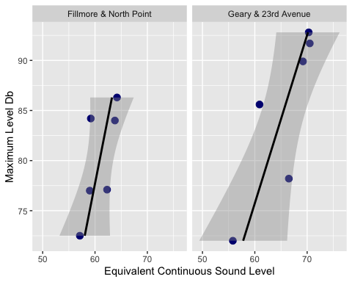

**Figure 1:** Difference in noise pollution from two different locations in San Francisco. Notably, the levels of sound tend to be higher in the Central Richmond area.

## # A tibble: 2 x 23  
## neighborhood streets month day year time observer longitude_degre…  
## <chr> <chr> <dbl> <dbl> <dbl> <tim> <chr> <dbl>  
## 1 Central Ric… Geary … 2 24 2020 14:00 ricky_k… 122  
## 2 Marina Filmor… 3 2 2020 13:50 ricky_k… 122  
## # … with 15 more variables: longtitude_minutes <dbl>, longitude_seconds <dbl>,  
## # latitude_degrees <dbl>, latitude_minutes <dbl>, latitude_seconds <dbl>,  
## # elevation_m <dbl>, temp_f <dbl>, wind_speed_mph <dbl>, cleanliness_1 <dbl>,  
## # cleanliness_2 <dbl>, cleanliness_3 <dbl>, smell_1 <chr>, smell_2 <chr>,  
## # smell_3 <chr>, notes <lgl>

## Gaseous Pollution in SF

Data on greenhouse emission in San Francisco revealed important information about the source of CO2 from various locations and functions. Figure 2 depicts the emission of CO2 directly from City of San Francisco affiliated groups. Data reveal that only the top 2 commodities produce more than 200000 metric tons CO2 emission. On the other hand, there were 16 different kinds of commodities provided by the city that emitted some quantity of CO2, although the bottom six seem to irrelevant compared to other commodities. Surprisingly, the bottom four commodities all corresponded to on-road transportation via MUNI or other public transportation services associated emissions, but on average the data did not appear substantial.

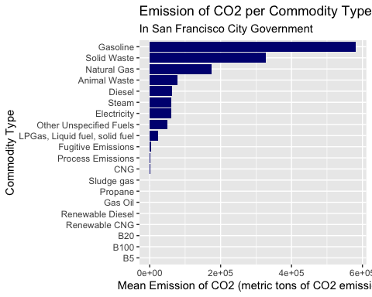

**Figure 2:** There is a large difference in the emission of CO2 between the top 10 commodities and the remaining. Gasoline emits almost twice as much as the next closest commodity, solid waste.

## # A tibble: 18 x 11  
## neighborhood streets year month day hour_pm student_names size_trash  
## <chr> <chr> <dbl> <dbl> <dbl> <chr> <chr> <chr>   
## 1 Central Ric… Geary … 2020 2 24 2 Kate Zhou small   
## 2 Central Ric… Geary … 2020 2 24 3 Maggie Walsh medium   
## 3 Central Ric… Geary … 2020 2 24 4 Eddie Muaddi large   
## 4 Central Ric… Geary … 2020 2 24 2 Kate Zhou small   
## 5 Central Ric… Geary … 2020 2 24 3 Maggie Walsh medium   
## 6 Central Ric… Geary … 2020 2 24 4 Eddie Muaddi large   
## 7 Central Ric… Geary … 2020 2 24 2 Kate Zhou small   
## 8 Central Ric… Geary … 2020 2 24 3 Maggie Walsh medium   
## 9 Central Ric… Geary … 2020 2 24 4 Eddie Muaddi large   
## 10 Marina Filmor… 2020 3 2 2 hrs Kate Zhou small   
## 11 Marina Filmor… 2020 3 2 3 hrs Maggie Walsh medium   
## 12 Marina Filmor… 2020 3 2 <NA> <NA> large   
## 13 Marina Filmor… 2020 3 2 2 hrs Kate Zhou small   
## 14 Marina Filmor… 2020 3 2 3 hrs Maggie Walsh medium   
## 15 Marina Filmor… 2020 3 2 <NA> <NA> large   
## 16 Marina Filmor… 2020 3 2 2 hrs Kate Zhou small   
## 17 Marina Filmor… 2020 3 2 3 hrs Maggie Walsh medium   
## 18 Marina Filmor… 2020 3 2 <NA> <NA> large   
## # … with 3 more variables: item_type <chr>, counts <dbl>, `Size of Trash` <chr>

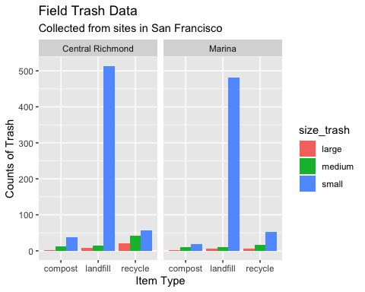

**Figure 3:** Amount of trash seen in cross streets analyzed in Marina and Central Richmond Districts of San Francisco, trash was sorted into compost, landfill, or recyclable.

# Discussion

# Sources Cited

Cutter, S. L. 1995. Race, class and environmental justice. Progress in human geography 19:111–122.

Haaland, C., and C. K. van Den Bosch. 2015. Challenges and strategies for urban green-space planning in cities undergoing densification: A review. Urban forestry & urban greening 14:760–771.

Hurley, A. 1995. Environmental inequalities: Class, race, and industrial pollution in gary, indiana, 1945-1980. Univ of North Carolina Press.

Mohai, P., D. Pellow, and J. T. Roberts. 2009. Environmental justice. Annual review of environment and resources 34:405–430.

Niemelä, J. 1999. Ecology and urban planning. Biodiversity & Conservation 8:119–131.

Nowak, D. J., and E. J. Greenfield. 2012. Tree and impervious cover change in us cities. Urban Forestry & Urban Greening 11:21–30.

Pope III, C. A., M. Ezzati, and D. W. Dockery. 2009. Fine-particulate air pollution and life expectancy in the united states. New England Journal of Medicine 360:376–386.

Shi, G., Z. Chen, S. Xu, J. Zhang, L. Wang, C. Bi, and J. Teng. 2008. Potentially toxic metal contamination of urban soils and roadside dust in shanghai, china. Environmental Pollution 156:251–260.

Suwa, T., J. C. Hogg, K. B. Quinlan, A. Ohgami, R. Vincent, and S. F. van Eeden. 2002. Particulate air pollution induces progression of atherosclerosis. Journal of the American College of Cardiology 39:935–942.

Wolch, J. R., J. Byrne, and J. P. Newell. 2014. Urban green space, public health, and environmental justice: The challenge of making cities “just green enough”. Landscape and urban planning 125:234–244.