Rebuild

Install Google Chrome

LibreOffice office suite.
sudo apt install libreoffice
- Archive Manager (aka file roller).
sudo apt install file-roller
- Shotwell photo manager.
sudo apt install shotwell
- Backups (Déjà Dup Backups).
sudo apt install deja-dup
- Gnome Camera, the new app replaces Cheese.
sudo apt install gnome-snapshot

Remmina remote desktop client.
sudo apt install remmina
- Transmission torrent download app.
sudo apt install transmission
sudo apt install kubuntu-restricted-extras

Enable Flatpak support
Flatpak is a popular package format runs in sandbox environment. Tons of applications support Linux through Flatpak package.
sudo apt install flatpak

Next, you may install local flatpak files by running command:
flatpak install drag-and-drop-flatpak-file-here
Or, add the Flathub repository into system:
flatpak remote-add --if-not-exists flathub https://dl.flathub.org/repo/flathub.flatpakrepo
For choice, add --user flag for current user only. Then, use the command in a Flathub app page to install (click down arrow besides “Install” button).
NOTE: After enabled Flatpak support, you need a log out and back in to apply the variable changes.

7. Enable AppImage support
AppImage is another popular way to run applications in Linux. It’s a portable, non-install package format, that can be run directly (after added executable permission) to launch application.
Since Ubuntu 22.04, user needs to press Ctrl+Alt+T to open terminal, and run command to install the required library for AppImage support:
sudo apt install libfuse2

How to Install Thunderbird as DEB (Not Snap) in Ubuntu 26.04, 24.04
Published: March 22, 2024 — Last updated: July 23, 2026 — 25 Comments

For Thunderbird users who don’t like Snap package, here’s step by step guide shows how to replace the pre-installed snap version of the mail client with classic Deb package in Ubuntu 26.04 and 24.04 LTS.
Like Firefox, the Thunderbird Email Client in Ubuntu since 24.04 has been replaced as Snap package that runs in sandbox! If you don’t like the change, then here are 3 other choices:
- Mozilla Team PPA maintained by Ubuntu members.
- Mozilla-provided DEB package.
- Mozilla’s official Linux Tarball.
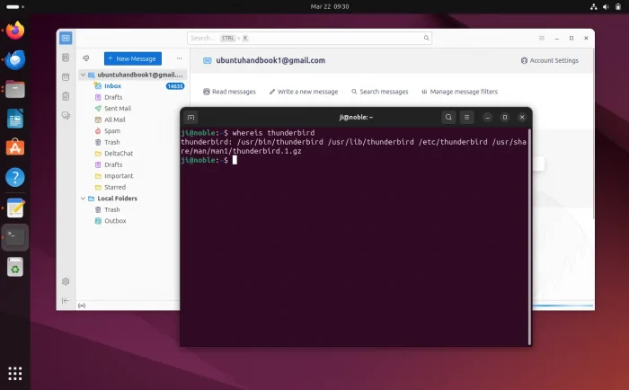
NOTE: This tutorial also works for Ubuntu 20.04 and Ubuntu 22.04 users who want to install the most recent Thunderbird packages.

Remove the pre-installed Snap Package
NOTE: Please backup your important data before uninstalling the Thunderbird package.
It’s OK to keep the Thunderbird Snap package, but after installing the DEB version there will be duplicated app icons in start menu.
To uninstall the Snap package, press Ctrl+Alt+T to open terminal and run command:
sudo snap remove --purge thunderbird
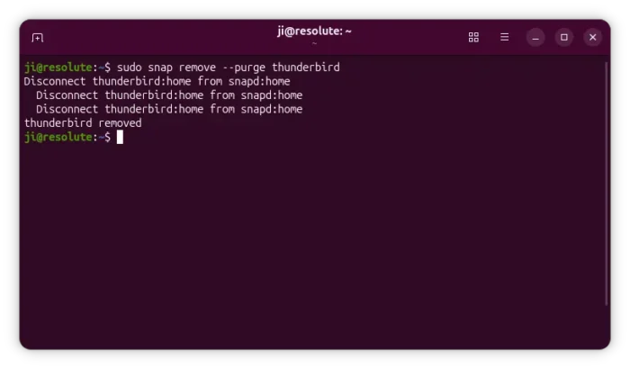
Also, run command to remove the empty .deb package, which is a wrapper that redirects to the Snap package:
sudo apt remove thunderbird
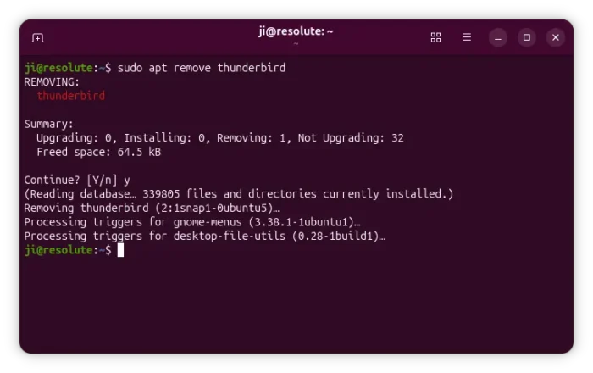

Option 1: Install Thunderbird via PPA
The Ubuntu Team members have been maintaining the “Mozilla Team” PPA for many years. The PPA contains the Thunderbird ESR (v140 so far), Firefox ESR, and Firefox stable as .deb packages.
The PPA is “official” but maintained by Ubuntu Team. So far, it supports Ubuntu 26.04, Ubuntu 25.10, Ubuntu 24.04, Ubuntu 22.04, and Ubuntu 20.04.

1. Add the PPA
First, press Ctrl+Alt+T on keyboard to open up a terminal window. When it opens, run command to add the PPA:
sudo add-apt-repository ppa:mozillateam/ppa
Type user password (no asterisk feedback, so just type in mind) when it asks and hit Enter to continue.
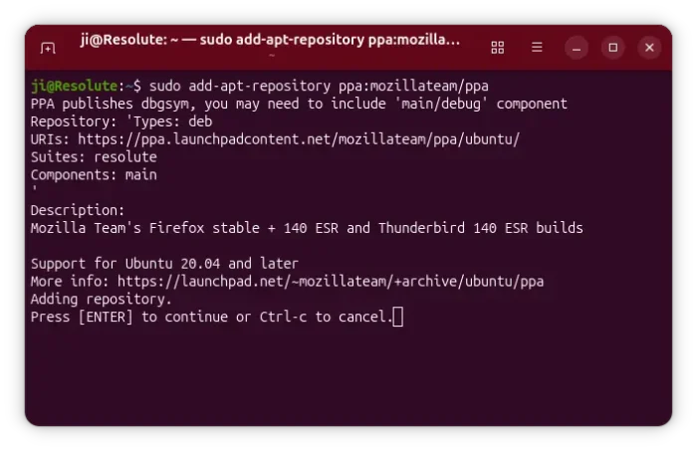

2. Setup PPA Priority
The Thunderbird DEB package in Ubuntu repository is a wrapper for the SNAP, which has higher version number! You need to setup a higher priority for the PPA package.
To do so, run command to create & edit config file:
sudo nano /etc/apt/preferences.d/mozillateamppa
Here I user nano text editor works in most desktops. You may replace it with gnome-text-editor for default GNOME, or other editor depends on your desktop environment.
When file opens, paste following lines and save it:
Package: thunderbird*
Pin: release o=LP-PPA-mozillateam
Pin-Priority: 1001
For choice, you may add 3 more lines below:
Package: thunderbird*
Pin: release o=Ubuntu
Pin-Priority: -1
It sets the priority of thunderbird packages from PPA to 1001, and the one from system repository to -1 which will prevent it from being installed.
When done editing the file, press Ctrl+S to save and Ctrl+X to exit.
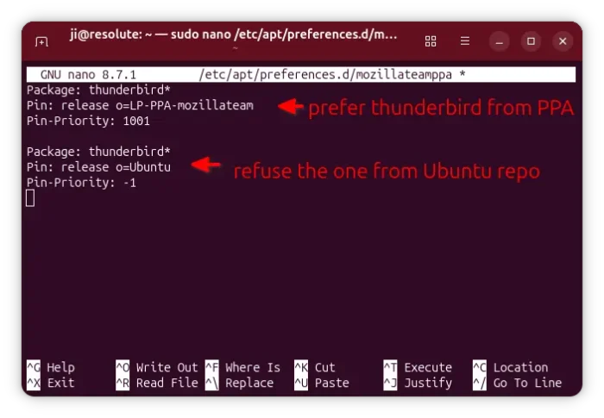

3. Install Thunderbird Deb package
Now, you need to run the command below to manually refresh system package cache:
sudo apt update
Finally, run apt install command to install the .deb package from PPA:
sudo apt install thunderbird
If you everything goes well, it should output that’s getting package from ppa.launchpadcontent.net
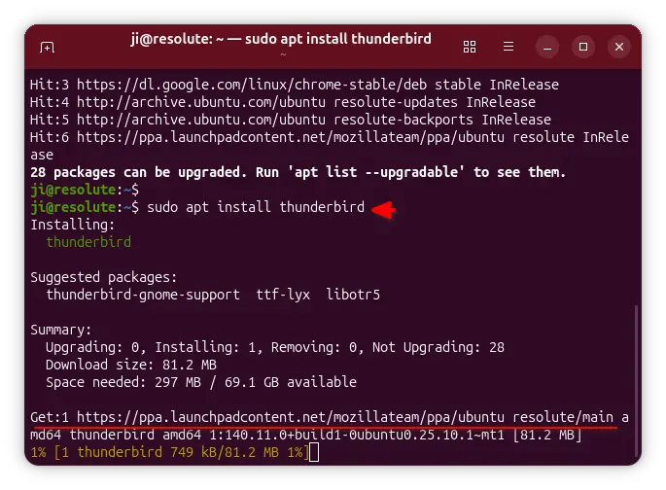

Enable Restricted and Multiverse Repositories

sudo add-apt-repository restricted
sudo add-apt-repository multiverse
sudo apt update

8. Setup Firewall and Security Hardening
Security should be a priority. Ubuntu comes with a built-in firewall manager called ufw (Uncomplicated Firewall), but it is disabled by default.
To enable the firewall and block unauthorized incoming connections:
sudo ufw default deny incoming
sudo ufw default allow outgoing
sudo ufw enable
To verify the status of your firewall rules:
sudo ufw status verbose

9. Install Everyday Essential Apps
With repositories, Flatpak, and Snap set up, you can install your daily driver applications. Here is a quick terminal command to install common utilities:
# General Tools
sudo apt install curl git vlc build-essential gparted -y

# Flatpak Apps (from Flathub)
flatpak install flathub com.visualstudio.code -y
flatpak install flathub com.spotify.Client -y
flatpak install flathub org.mozilla.Thunderbird -y
flatpak install flathub org.telegram.desktop -y

10. Clean Up Unused Packages and Cache
After setting up your system and installing all necessary apps, tidy up system repositories and free up disk space by removing leftover dependencies:
sudo apt autoremove -y
sudo apt clean
flatpak uninstall --unused -y

2. Reduce swappiness for desktop installations like it is suggested for *Ubuntu and like e.g. TUXEDO OS also does it
(= the system will prioritize freeing up parts of physical memory a bit more over using the swap file or partition).
If you are curious you can check the setting before and after the reboot with sudo sysctl vm.swappiness.
- echo -e "# Reduce swappiness for desktop installation (default = 60)\nvm.swappiness=10" | sudo tee /etc/sysctl.d/99-sysswappiness.conf
(this writes the modified value to your system)
The change will be applied with the reboot after step 6. (7.)

3. Reduce systemd timeouts for desktop installations like KDE suggests for Plasma in their Distribution/Packaging Recommendations
(= the system will not "hang" for 90 seconds - which is the default value - from time to time when logging out, rebooting or shutting down).
I am still quite conservative here and use 15 seconds because on older machines it has seldom taken as long as 10–14 seconds for certain processes to quit gracefully by themselves (for example: KDE neon uses 16 seconds, TUXEDO OS and Garuda KDE use 10 seconds).
- sudo mkdir -p /etc/systemd/system.conf.d && echo -e "# Reduce timeout (default = 90s)\n\n[Manager]\nDefaultTimeoutStopSec=15s" | sudo tee /etc/systemd/system.conf.d/99-systemtimeout.conf
(this writes the modified value for the system processes to your system)
- sudo mkdir -p /etc/systemd/user.conf.d && echo -e "# Reduce timeout (default = 90s)\n\n[Manager]\nDefaultTimeoutStopSec=15s" | sudo tee /etc/systemd/user.conf.d/99-usertimeout.conf
(this writes the modified value for the user processes to your system)
The change will be applied with the reboot after step 6. (7.)

4.a) Change GRUB (the boot loader) to show the boot menu for 1 second in single-boot setups
(= only Kubuntu is installed - this makes the boot menu much easier to access whenever you might need it).
- sudo cp /etc/default/grub /etc/default/grub.orig
(this makes a backup of your /etc/default/grub​ file first)​
- sudo sed -i 's/GRUB_TIMEOUT_STYLE=hidden/GRUB_TIMEOUT_STYLE=menu/' /etc/default/grub
(this makes GRUB show the boot menu)
- sudo sed -i 's/GRUB_TIMEOUT=0/GRUB_TIMEOUT=1/' /etc/default/grub
(this writes the timeout value to your system)
- echo -e "\n# Match RECORDFAIL_TIMEOUT to TIMEOUT\nGRUB_RECORDFAIL_TIMEOUT=​\$GRUB_TIMEOUT" | sudo tee -a /etc/default/grub
(this keeps the timeout value if GRUB has "problems" with a partition - could be e.g. Btrfs or LVM)
- sudo update-grub
(this updates your GRUB boot loader with the new values)
OR
4.b) Change GRUB to show the boot menu with all installed systems for 5 seconds in multi-boot setups
(= Kubuntu and another Linux or/and Windows are installed - and make sure to definitely disable Windows fast startup if you intend to access the "C:" drive from Linux).
- sudo cp /etc/default/grub /etc/default/grub.orig
(this makes a backup of your /etc/default/grub​ file first)
- sudo sed -i 's/GRUB_TIMEOUT_STYLE=hidden/GRUB_TIMEOUT_STYLE=menu/' /etc/default/grub
(this makes GRUB show the boot menu)
- sudo sed -i 's/GRUB_TIMEOUT=0/GRUB_TIMEOUT=5/' /etc/default/grub
(this writes the timeout value to your system)
- echo -e "\n# Match RECORDFAIL_TIMEOUT to TIMEOUT\nGRUB_RECORDFAIL_TIMEOUT=​\$GRUB_TIMEOUT" | sudo tee -a /etc/default/grub
(this keeps the timeout value if GRUB has "problems" with a partition - could be e.g. Btrfs or LVM)
- sudo sed -i 's/#GRUB_DISABLE_OS_PROBER=false/GRUB_DISABLE_OS_PROBER=false/' /etc/default/grub
(this makes other systems visible in the boot menu)
- sudo update-grub
(this updates your GRUB boot loader with the new values)
The change will be visible during the reboot after step 6. (7.)

5. Update your system and your programs for the first time
(this is generally one of the first things you should do after installing any operating system).
- sudo snap refresh && sudo systemctl daemon-reload
(this updates the Snaps - not necessary if you have chosen the "Minimal Installation" option)
- sudo apt update && sudo apt full-upgrade
(this updates your installation - except for the Snaps)
- sudo apt autopurge && sudo apt autoclean
(this removes remaining packages from the installation process - if there are any)
In case this is not a fresh Kubuntu 26.04 LTS installation, be careful with the autopurge in step 5. and thoroughly read and understand the output in Konsole !

6. Install missing essential software for desktop installations like
- multimedia codecs etc.
- Microsoft Web and replacement fonts.
You can select with [Tab] and confirm with [Return] in the following dialogues - select "Ok" and "Yes" to install.
- sudo apt install kubuntu-restricted-extras gstreamer1.0-vaapi fonts-crosextra-carlito fonts-crosextra-caladea
(this installs all of the above listed)

7. If you have a DVD or Blu-ray drive, install libdvdcss to be able to play back e.g. encrypted video DVDs.
You can select with [Tab] and confirm with [Return] in the following dialogues - select "Ok" and "Yes" to install.
- sudo apt install libdvd-pkg
(this installs the play back for encrypted media)
- sudo dpkg-reconfigure libdvd-pkg
(this activates the play back for encrypted media)

- reboot and enjoy Kubuntu 26.04 LTS !
Now it is time to begin thinking about a backup strategy for your future user data, e.g. with KUP (-> System Settings -> Backups) or with something more versatile like Back In Time (as in Kubuntu Focus) - or may it even only be regularly "by hand" to an USB stick…

Bonus - 6 individual and potentially less important things to do:
Everything with a grey background behind a single "⦁" is a whole command and has to be copied into Konsole as a whole - even if it is longer than one line.

a. It is possible to remove Snap from Kubuntu 26.04 LTS and/or use the "traditional" Firefox and Thunderbird instead of or additionally to the Snaps
(you could use the following shell scripts).
- Script to get rid of Snap (like e.g. Linux Mint and TUXEDO OS do - can also block Snap in a "Minimal Installation")
- Script to install "traditional" Firefox (the way e.g. Debian suggested formerly, installs as shown on Mozilla.org)
- Script to install "traditional" Thunderbird (installs as shown on Mozilla.org

b. Enable Flatpak instead of or additionally to Snap
(e.g. to increase your pool of available programs).​
- sudo apt update && sudo apt install flatpak plasma-discover-backend-flatpak kde-config-flatpak
(this installs Flatpak for your system, Flatpak support for Discover and Flatpak permission management for System Settings)
- flatpak remote-add --if-not-exists flathub https://flathub.org/repo/flathub.flatpakrepo
(this adds Flathub, currently the largest repository for Flatpaks)
You will have to log out and in again or reboot to apply the change.
If need be, you now have the possibility to adjust the permissions of installed Flatpaks
in -> System Settings -> Application Permissions (section: Security & Privacy) -> “Flatpak name” -> [Manage Flatpak Settings] (this is a button at the top).
Also see Flatpak Kubuntu Quick Setup.

c. Enable the X11 session additionally to Wayland - like openSUSE Tumbleweed does and like TUXEDO OS offers during installation
(e.g. because you encounter problems in Wayland or use certain programs that require a “real” X11 session).
- sudo apt update && sudo apt install plasma-session-x11
(this installs the X11 session)
Next be sure that “Automatically log in:” is off
in -> System Settings -> Colours & Themes (section: Appearance & Style) -> Login Screen (SDDM) -> [Behaviour…] (this is a button at the top).
Now
- reboot
and click on "Desktop Session: Plasma (Wayland)" and choose "Plasma (X11)" in the lower left corner of the log in screen to use X11 instead of Wayland.
From now on you can always switch back and forth between X11 and Wayland simply by logging out and choosing the desired session.
Note: Occasionally switching directly between X11 and Wayland sessions does not work reliably - instead a system restart is required.​

d. Always start with an empty session
(e.g. for stability, performance or security reasons).
Go to -> System Settings -> Session (section: System) -> Desktop Session -> Session Restore
and set “On login, launch apps that were open:”
to “Start with an empty session”.
Click [Apply].
You will have to log out and in again or reboot to apply the change.

e. Disable fast user switching
(e.g. for security or performance reasons in multi-user setups).
- echo -e "\n[KDE Action Restrictions] [\$i]\naction/switch_user=false\naction/start_new_session=false" | sudo tee -a /etc/xdg/kdeglobals
(this writes the modified values for all users to your system)
You will have to log out and in again or reboot to apply the change.

f. Enable a local firewall
(e.g. if you don't connect to the internet via a modern router with an integrated firewall - please check with your router's manufacturer - or if you connect to the internet in a different way).
Go to -> System Settings -> Wi-Fi & Internet (section: Networking) -> Firewall
enter your password
and change the slider at the top from "Disabled" to "Enabled".
Finally, you must enter your password two more times.
The local ufw firewall is now enabled with default settings.

Last edited by Schwarzer Kater; Jun 01, 2026, 06:54 AM. Reason: added claydoh's suggestion to step

Kubuntu 26.04 LTS - essential and advisable things to do directly after an installation

I always perform (and strongly recommend) the following 6 (7) steps directly after any Kubuntu 26.04 LTS desktop installation. These steps usually take 5 to 10 minutes (including restart) if you have at least a little experience with these kinds of things:
To do so
-> open the Konsole terminal emulator from your -> Application Launcher -> System.
Please copy and paste the following commands one by one into Konsole - e.g. with your mouse or with
[Ctrl] [c] and [Ctrl] [Shift] [v] - and execute them with [Return].
Double-check that you did not miss a character or two. ;-)

Everything with a grey background behind a single "⦁" is a whole command and has to be copied as a whole - even if it is longer than one line.

Preliminary remark: I consider the following step 1. important, but - as far as I could test - it is only necessary for a new installation on specific targets such as SATA HDDs, SATA SSDs and certain virtual machines - and all with ext4 file systems.
The bug does not seem to occur if the installation target is an ext4 file system e.g. on an NVMe SSD connected to an M.2 port - as used by the majority of computers produced in recent years.
1. Please correct a possible installation bug for ext4 file systems in the /etc/fstab file first
(= replace the "discard" option with "defaults" because a systemd timer for fstrim is already running)!
Technical background: To not do both is recommended by e.g. Red Hat and the ArchWiki (and openSUSE, Debian or Ubuntu's main distribution also do not do it)!
Furthermore Red Hat and SUSE (openSUSE) also recommend in general to use a timer/fstrim instead of the "discard" option (and Fedora, Debian or Ubuntu's main distribution also use fstrim.timer instead) - except for special cases.
If you are unlucky, using the "discard" option in /etc/fstab may decrease the SSD's lifetime and can lead to performance degradation. Also fstrim can behave unpredictably when the "discard" option is additionally set…
In case you don't know whether you chose the ext4 file system during installation (the chance you did is quite high as it is the default for Kubuntu 26.04 LTS), in case the installation bug did not occur, or if the bug has been corrected in the meantime:
The following cp command in step 1. a) and b) will just make a backup copy of your /etc/fstab file, and neither the following sed command in step 1. a) nor in b) will do anything at all.
a) either
- sudo cp /etc/fstab /etc/fstab.orig
(this makes a backup of your /etc/fstab​ file first)
- sudo sed -i '/ext4/ s/discard/defaults/g' /etc/fstab
(this replaces the wrong option with the right one - only if applicable)
I would even suggest the additional option "noatime" if you don't run any programs (such as certain servers) that specifically need information about when a file or folder was accessed (= opened or read) and therefore to use b).
This makes old HDDs run a tiny little bit faster because it reduces write actions - and thus also wear on SSDs:
OR
b) alternatively
- sudo cp /etc/fstab /etc/fstab.orig
(this makes a backup of your /etc/fstab​ file first)
- sudo sed -i '/ext4/ s/discard/defaults,noatime/g' /etc/fstab
(this replaces the wrong option with the right ones - only if applicable)
For safety reasons don't use the sed commands of step 1. a) or b) in any other context than a fresh Kubuntu 26.04 LTS installation!
Instead check and modify your /etc/fstab file by hand if need be - and back it up first.
The change will be applied with the reboot after step 6. (7.)

2. Reduce swappiness for desktop installations like it is suggested for *Ubuntu and like e.g. TUXEDO OS also does it
(= the system will prioritize freeing up parts of physical memory a bit more over using the swap file or partition).
If you are curious you can check the setting before and after the reboot with sudo sysctl vm.swappiness.
- echo -e "# Reduce swappiness for desktop installation (default = 60)\nvm.swappiness=10" | sudo tee /etc/sysctl.d/99-sysswappiness.conf
(this writes the modified value to your system)
The change will be applied with the reboot after step 6. (7.)

3. Reduce systemd timeouts for desktop installations like KDE suggests for Plasma in their Distribution/Packaging Recommendations
(= the system will not "hang" for 90 seconds - which is the default value - from time to time when logging out, rebooting or shutting down).
I am still quite conservative here and use 15 seconds because on older machines it has seldom taken as long as 10–14 seconds for certain processes to quit gracefully by themselves (for example: KDE neon uses 16 seconds, TUXEDO OS and Garuda KDE use 10 seconds).
- sudo mkdir -p /etc/systemd/system.conf.d && echo -e "# Reduce timeout (default = 90s)\n\n[Manager]\nDefaultTimeoutStopSec=15s" | sudo tee /etc/systemd/system.conf.d/99-systemtimeout.conf
(this writes the modified value for the system processes to your system)
- sudo mkdir -p /etc/systemd/user.conf.d && echo -e "# Reduce timeout (default = 90s)\n\n[Manager]\nDefaultTimeoutStopSec=15s" | sudo tee /etc/systemd/user.conf.d/99-usertimeout.conf
(this writes the modified value for the user processes to your system)
The change will be applied with the reboot after step 6. (7.)

4.a) Change GRUB (the boot loader) to show the boot menu for 1 second in single-boot setups
(= only Kubuntu is installed - this makes the boot menu much easier to access whenever you might need it).
- sudo cp /etc/default/grub /etc/default/grub.orig
(this makes a backup of your /etc/default/grub​ file first)​
- sudo sed -i 's/GRUB_TIMEOUT_STYLE=hidden/GRUB_TIMEOUT_STYLE=menu/' /etc/default/grub
(this makes GRUB show the boot menu)
- sudo sed -i 's/GRUB_TIMEOUT=0/GRUB_TIMEOUT=1/' /etc/default/grub
(this writes the timeout value to your system)
- echo -e "\n# Match RECORDFAIL_TIMEOUT to TIMEOUT\nGRUB_RECORDFAIL_TIMEOUT=​\$GRUB_TIMEOUT" | sudo tee -a /etc/default/grub
(this keeps the timeout value if GRUB has "problems" with a partition - could be e.g. Btrfs or LVM)
- sudo update-grub
(this updates your GRUB boot loader with the new values)
OR
4.b) Change GRUB to show the boot menu with all installed systems for 5 seconds in multi-boot setups
(= Kubuntu and another Linux or/and Windows are installed - and make sure to definitely disable Windows fast startup if you intend to access the "C:" drive from Linux).
- sudo cp /etc/default/grub /etc/default/grub.orig
(this makes a backup of your /etc/default/grub​ file first)
- sudo sed -i 's/GRUB_TIMEOUT_STYLE=hidden/GRUB_TIMEOUT_STYLE=menu/' /etc/default/grub
(this makes GRUB show the boot menu)
- sudo sed -i 's/GRUB_TIMEOUT=0/GRUB_TIMEOUT=5/' /etc/default/grub
(this writes the timeout value to your system)
- echo -e "\n# Match RECORDFAIL_TIMEOUT to TIMEOUT\nGRUB_RECORDFAIL_TIMEOUT=​\$GRUB_TIMEOUT" | sudo tee -a /etc/default/grub
(this keeps the timeout value if GRUB has "problems" with a partition - could be e.g. Btrfs or LVM)
- sudo sed -i 's/#GRUB_DISABLE_OS_PROBER=false/GRUB_DISABLE_OS_PROBER=false/' /etc/default/grub
(this makes other systems visible in the boot menu)
- sudo update-grub
(this updates your GRUB boot loader with the new values)
The change will be visible during the reboot after step 6. (7.)

5. Update your system and your programs for the first time
(this is generally one of the first things you should do after installing any operating system).
- sudo snap refresh && sudo systemctl daemon-reload
(this updates the Snaps - not necessary if you have chosen the "Minimal Installation" option)
- sudo apt update && sudo apt full-upgrade
(this updates your installation - except for the Snaps)
- sudo apt autopurge && sudo apt autoclean
(this removes remaining packages from the installation process - if there are any)
In case this is not a fresh Kubuntu 26.04 LTS installation, be careful with the autopurge in step 5. and thoroughly read and understand the output in Konsole !

6. Install missing essential software for desktop installations like
- multimedia codecs etc.
- Microsoft Web and replacement fonts.
You can select with [Tab] and confirm with [Return] in the following dialogues - select "Ok" and "Yes" to install.
- sudo apt install kubuntu-restricted-extras gstreamer1.0-vaapi fonts-crosextra-carlito fonts-crosextra-caladea
(this installs all of the above listed)

7. If you have a DVD or Blu-ray drive, install libdvdcss to be able to play back e.g. encrypted video DVDs.
You can select with [Tab] and confirm with [Return] in the following dialogues - select "Ok" and "Yes" to install.
- sudo apt install libdvd-pkg
(this installs the play back for encrypted media)
- sudo dpkg-reconfigure libdvd-pkg
(this activates the play back for encrypted media)

- reboot and enjoy Kubuntu 26.04 LTS !
Now it is time to begin thinking about a backup strategy for your future user data, e.g. with KUP (-> System Settings -> Backups) or with something more versatile like Back In Time (as in Kubuntu Focus) - or may it even only be regularly "by hand" to an USB stick…

Bonus - 6 individual and potentially less important things to do:

Everything with a grey background behind a single "⦁" is a whole command and has to be copied into Konsole as a whole - even if it is longer than one line.

a. It is possible to remove Snap from Kubuntu 26.04 LTS and/or use the "traditional" Firefox and Thunderbird instead of or additionally to the Snaps
(you could use the following shell scripts).
- Script to get rid of Snap (like e.g. Linux Mint and TUXEDO OS do - can also block Snap in a "Minimal Installation")
- Script to install "traditional" Firefox (the way e.g. Debian suggested formerly, installs as shown on Mozilla.org)
- Script to install "traditional" Thunderbird (installs as shown on Mozilla.org)

b. Enable Flatpak instead of or additionally to Snap
(e.g. to increase your pool of available programs).​
- sudo apt update && sudo apt install flatpak plasma-discover-backend-flatpak kde-config-flatpak
(this installs Flatpak for your system, Flatpak support for Discover and Flatpak permission management for System Settings)
- flatpak remote-add --if-not-exists flathub https://flathub.org/repo/flathub.flatpakrepo
(this adds Flathub, currently the largest repository for Flatpaks)
You will have to log out and in again or reboot to apply the change.
If need be, you now have the possibility to adjust the permissions of installed Flatpaks
in -> System Settings -> Application Permissions (section: Security & Privacy) -> “Flatpak name” -> [Manage Flatpak Settings] (this is a button at the top).
Also see Flatpak Kubuntu Quick Setup.

c. Enable the X11 session additionally to Wayland - like openSUSE Tumbleweed does and like TUXEDO OS offers during installation
(e.g. because you encounter problems in Wayland or use certain programs that require a “real” X11 session).
- sudo apt update && sudo apt install plasma-session-x11
(this installs the X11 session)
Next be sure that “Automatically log in:” is off
in -> System Settings -> Colours & Themes (section: Appearance & Style) -> Login Screen (SDDM) -> [Behaviour…] (this is a button at the top).
Now
- reboot
and click on "Desktop Session: Plasma (Wayland)" and choose "Plasma (X11)" in the lower left corner of the log in screen to use X11 instead of Wayland.
From now on you can always switch back and forth between X11 and Wayland simply by logging out and choosing the desired session.
Note: Occasionally switching directly between X11 and Wayland sessions does not work reliably - instead a system restart is required.

d. Always start with an empty session
(e.g. for stability, performance or security reasons).
Go to -> System Settings -> Session (section: System) -> Desktop Session -> Session Restore
and set “On login, launch apps that were open:”
to “Start with an empty session”.
Click [Apply].
You will have to log out and in again or reboot to apply the change.

e. Disable fast user switching
(e.g. for security or performance reasons in multi-user setups).
- echo -e "\n[KDE Action Restrictions] [\$i]\naction/switch_user=false\naction/start_new_session=false" | sudo tee -a /etc/xdg/kdeglobals
(this writes the modified values for all users to your system)
You will have to log out and in again or reboot to apply the change.

f. Enable a local firewall
(e.g. if you don't connect to the internet via a modern router with an integrated firewall - please check with your router's manufacturer - or if you connect to the internet in a different way).
Go to -> System Settings -> Wi-Fi & Internet (section: Networking) -> Firewall
enter your password
and change the slider at the top from "Disabled" to "Enabled".
Finally, you must enter your password two more times.
The local ufw firewall is now enabled with default settings.

Google Chrome
# 1. Download the latest stable Google Chrome package
wget https://dl.google.com/linux/direct/google-chrome-stable_current_amd64.deb

# 2. Install the package and automatically set up the official repository
sudo apt install ./google-chrome-stable_current_amd64.deb

