1. Description:
2. Source code SS:
3. test cases SS:

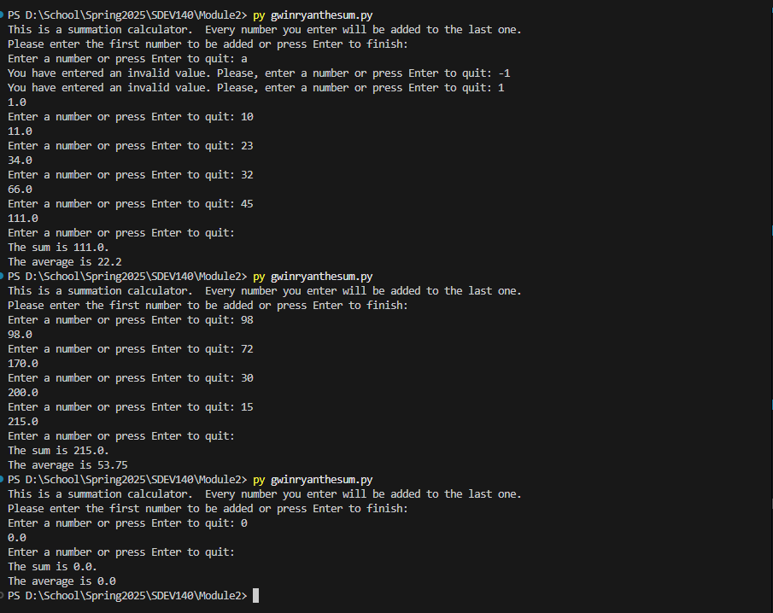

1. Github url: https://github.com/rgwin1/SDEV140/blob/main/Module2/GwinRyantheSum.py