1. Description: The credit plan at TidBit Computer Store specifies a 10% down payment and an annual interest rate of 12%. Monthly payments are 5% of the listed purchase price, minus the down payment. Write a program in a file named tidbit.py that takes the purchase price as input. The program should display a table, with appropriate headers, of a payment schedule for the lifetime of the loan.
2. Source code SS:

1. test cases SS: 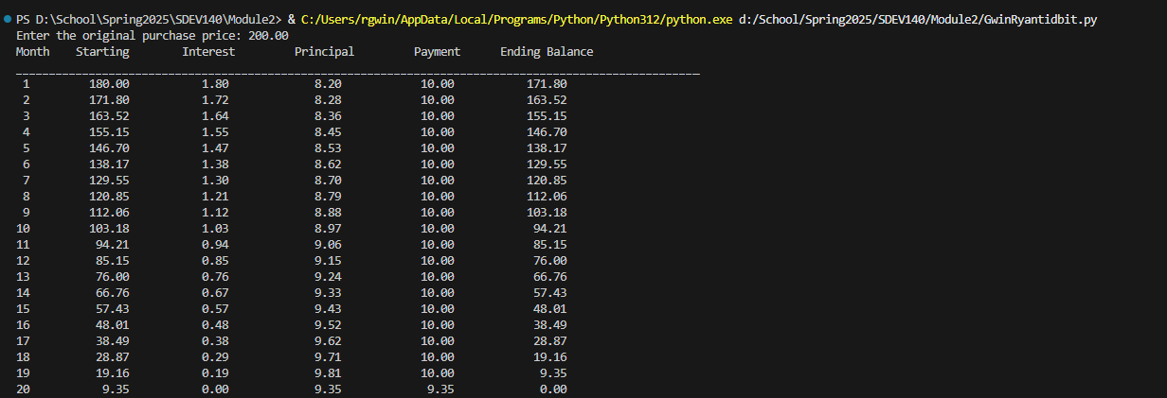

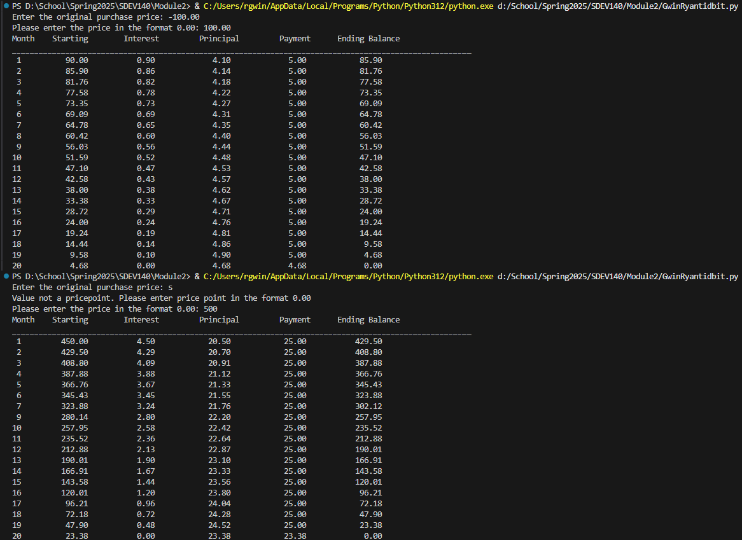

1. Github url: <https://github.com/rgwin1/SDEV140/blob/main/Module2/GwinRyantidbit.py>