1. Description: Find the mistake in Jack’s code that causes the algorithm to miscount the number of syllables in the text.txt file causing Flesch index to be inaccurate.
2. Source code SS: 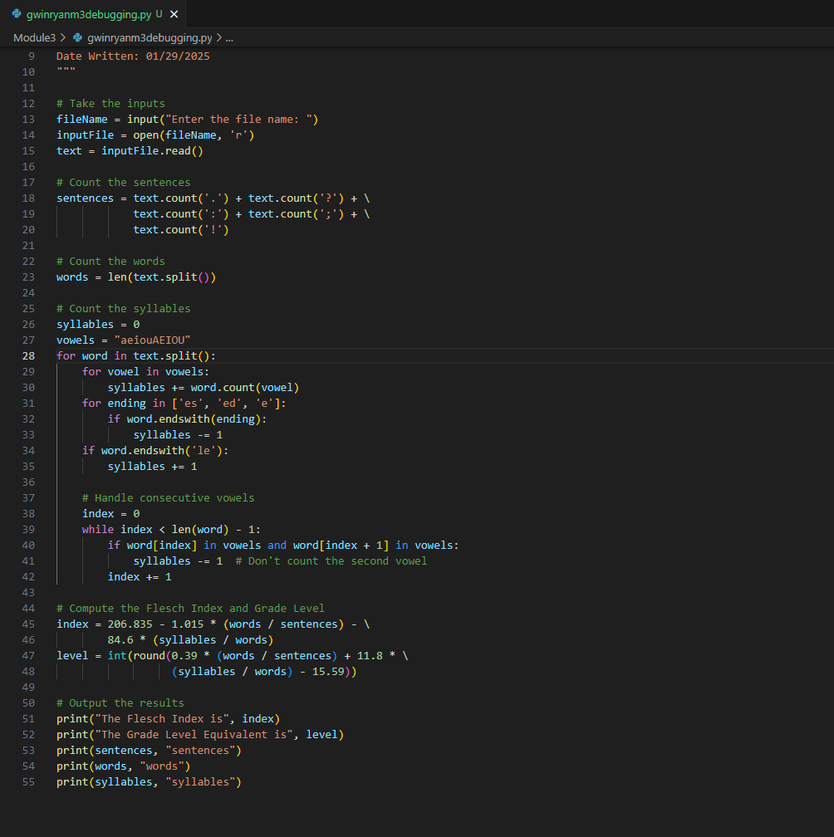
3. test cases SS:

1. Github url: https://github.com/rgwin1/SDEV140/blob/main/Module3/gwinryanM3debugging.py