1. Part 1 Description: Takes a user input as an integer, checks each number up to the user number to see if each number is a prime, if not a prime, does not store it. If a prime, stores it in a list. Prints the list of primes.
2. Part 2 Description: This program finds the top three most expensive items in a shop. It stores item prices in a dictionary, converts it into a sortable list, and sorts the list in descending order using a function. Finally, it prints the three most expensive items with their prices.
3. Part 1 Source code SS:

1. Part 2 Source code SS: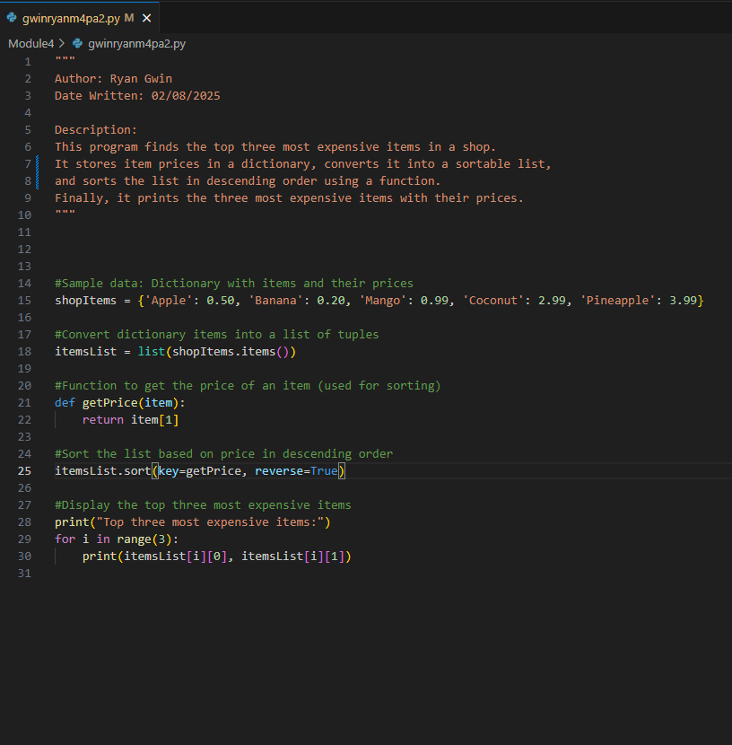
2. Part 1 test cases SS: A screenshot of a computer program

   AI-generated content may be incorrect.
3. Part 2 test cases SS:

1. Part 1 Github url:

<https://github.com/rgwin1/SDEV140/blob/main/Module4/gwinryanm4pa1.py>

1. Part 2 Github url

<https://github.com/rgwin1/SDEV140/blob/main/Module4/gwinryanm4pa2.py>