1. Part 1 Description:

A function that takes total_sales as an argument, and returns the total sales tax (county and state). County tax is 2.5% of total sales, and state is 5% of total sales.

1. Part 2 Description:

Guessing game. Computer generates a random number between 1 and 100.

User guesses number. If number too low, or too high, user guesses again. User guesses, until correct number guessed. User gets to play again if user chooses.

1. Part 1 Source code SS:

1. Part 2 Source code SS: 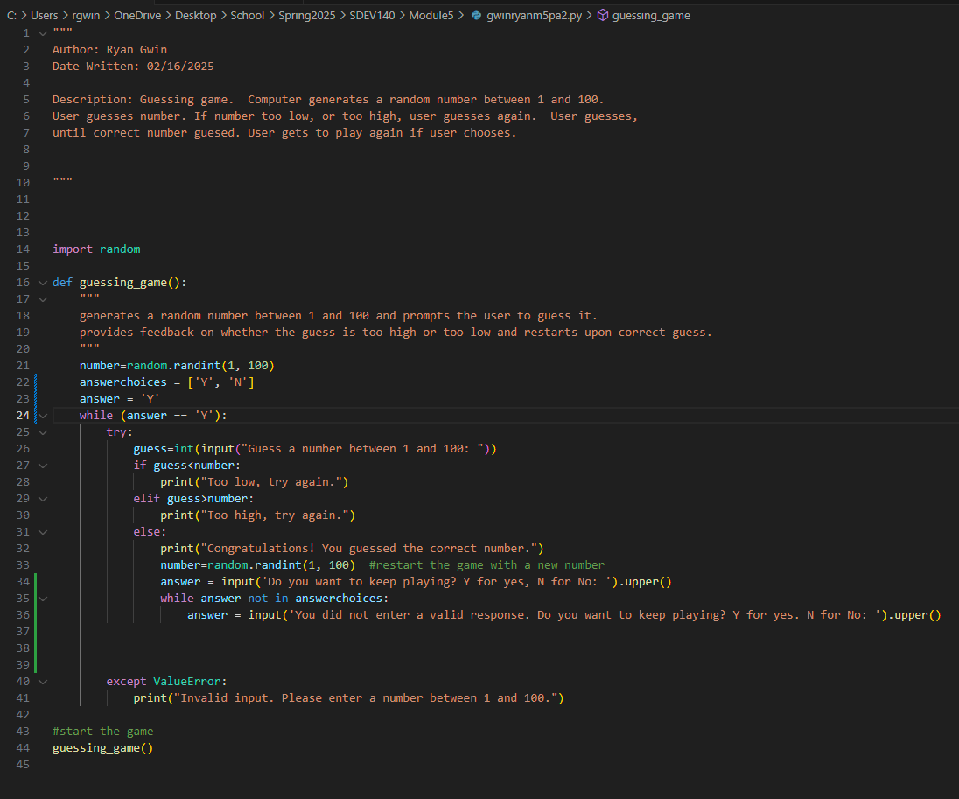
2. Part 1 test cases SS:

1. Part 2 test cases SS:

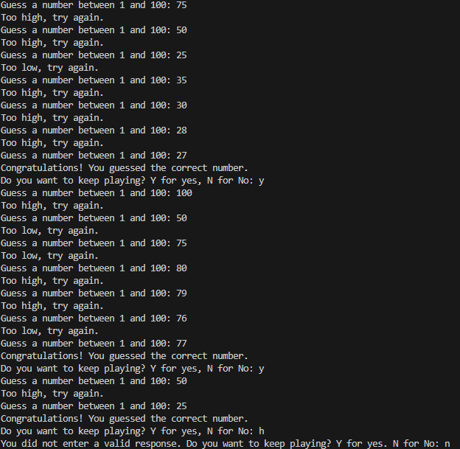

1. Part 1 Github url:

https://github.com/rgwin1/SDEV140/blob/main/Module5/gwinryanm5pa1.py

1. Parst 2 Github url

https://github.com/rgwin1/SDEV140/blob/main/Module5/gwinryanm5pa2.py