1. Description:

recreate the range() function

1. Source code SS:

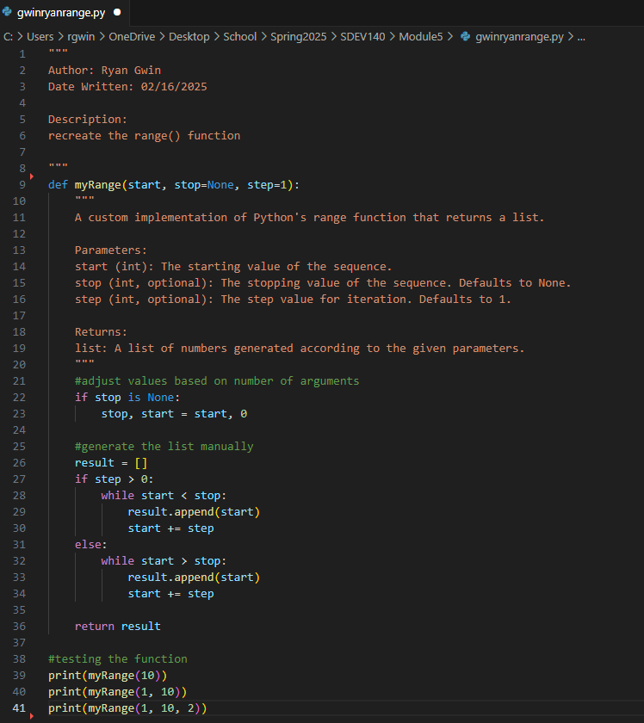

1. Test cases SS:

1. GitHub URL:

https://github.com/rgwin1/SDEV140/blob/main/Module5/gwinryanrange.py