1. Description: User enters a temperature then clicks on either Convert to Fahrenheit or Celsius. Displays underneath options to click
2. Source Code SS:

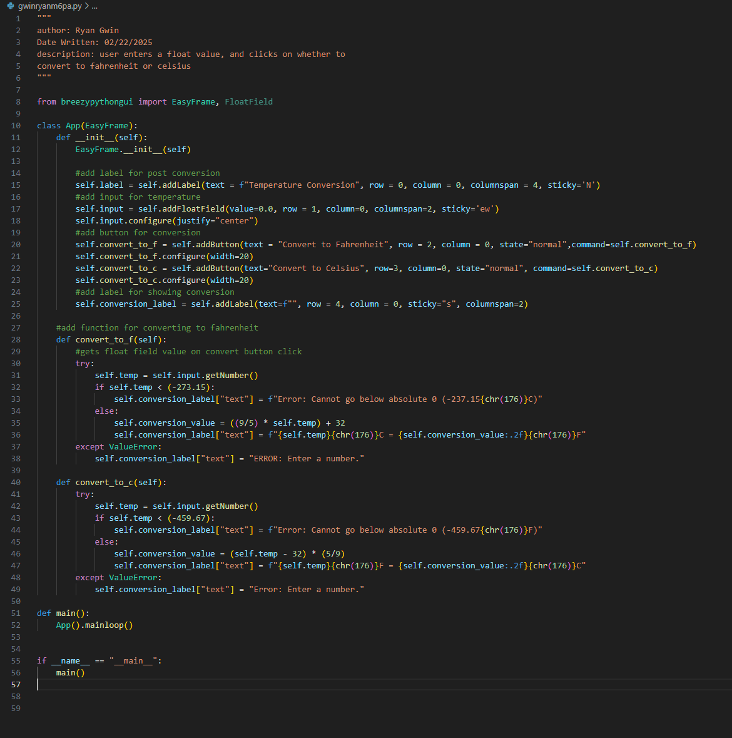

1. Test case ss:

1. Github link: https://github.com/rgwin1/SDEV140/blob/main/module6/gwinryanm6pa.py