Grouping and Chaining with dplyr

#### group_by函數的使用

library(dplyr) ## 導入dplyr套件

cran <- tbl_df(mydf)

rm(mydf)

by_package <- group_by(cran, package)

by_package

summarize(by_package, mean(size))

pack_sum <- summarize(by_package,

count = n(),

unique = n_distinct(ip_id), ## distinct 等價於length(unique(x))

countries = n_distinct(country),

avg_bytes = mean(size))

quantile(pack_sum$count, probs = 0.99) ##0.99樣本分位數

top_counts <- filter(pack_sum, count > 679) ## 經常使用的包/下載的包 top1

top_counts_sorted <- arrange(top_counts, desc(count))

View( top_counts_sorted)

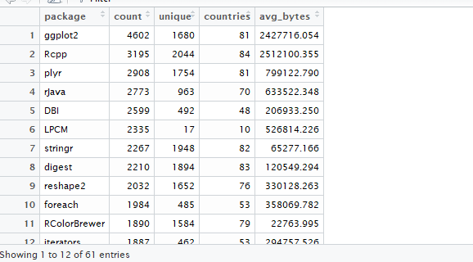

quantile(pack_sum$unique, probs = 0.99) ## 查看unique的0.99分位數

top_unique <- filter(pack_sum,unique>465)

View(top_unique)

top_unique_sorted <- arrange(top_unique, desc(unique))

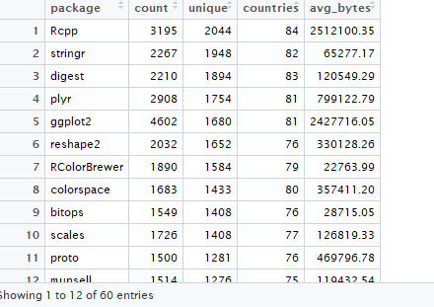

#### chaining

#### 沒有使用piping的程序

by_package <- group_by(cran, package)

pack_sum <- summarize(by_package,

count = n(),

unique = n_distinct(ip_id),

countries = n_distinct(country),

avg_bytes = mean(size))

# Here's the new bit, but using the same approach we've

# been using this whole time.

top_countries <- filter(pack_sum, countries > 60)

result1 <- arrange(top_countries, desc(countries), avg_bytes)

# Print the results to the console.

print(result1)

#### 使用piping的程序

result2 <-

arrange(

filter(

summarize(

group_by(cran,

package

),

count = n(),

unique = n_distinct(ip_id),

countries = n_distinct(country),

avg_bytes = mean(size)

),

countries > 60

),

desc(countries),

avg_bytes

)

print(result2)

####（建議）改進的程序

result3 <-

cran %>%

group_by(package) %>%

summarize(count = n(),

unique = n_distinct(ip_id),

countries = n_distinct(country),

avg_bytes = mean(size)

) %>%

filter(countries > 60) %>%

arrange(desc(countries), avg_bytes)

# Print result to console

print(result3)

cran %>%

select(ip_id,country, package,size) %>%

print

cran %>%

select(ip_id, country, package, size) %>%

mutate(size_mb = size / 2^20)

cran %>%

select(ip_id, country, package, size) %>%

mutate(size_mb = size / 2^20) %>%

filter(size_mb < 0.5)

cran %>%

select(ip_id, country, package, size) %>%

mutate(size_mb = size / 2^20) %>%

filter(size_mb <= 0.5) %>%

arrange(desc(size_mb))