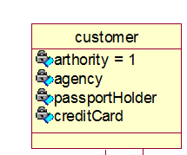Class Name: Customer

Super-classes: People

Attributes:

* Agency.
* PassportHolder.
* CreditCard.

Methods:

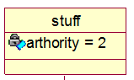Class Name: Staff

Super-classes: People

Attributes:

Methods:

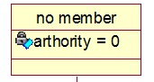Class Name: NonMember

Super-classes: People

Attributes:

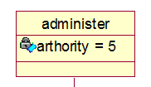Class Name: Administrator

Super-classes: People

Attributes:

Methods:

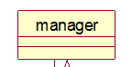Class Name: Manager

Super-classes: People

Sub-classes: Flight Manager, Service Manager

Attributes:

Methods:

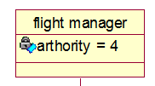Class Name: Flight Manager

Super-classes: Manager

Attributes:

* Authority

Methods:

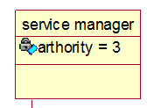Class Name: Service Manager

Super-classes: Manager

Attributes:

* Authority

Methods:

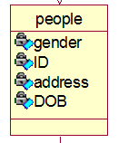Class Name: People

Super-classes: User

Attributes:

* Gender. Male, Female or Other
* ID. 8-digit unique number
* Address. Home address
* DOB. Date of birth, DD-MM-YYYY

Methods:

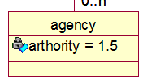Class Name: Agency

Super-classes: User

Attributes:

* Authority

Methods:

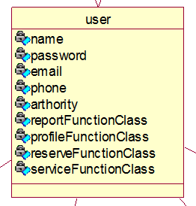Class Name: User

Super-classes: None

Attributes:

* Name.
* Password.
* Email.
* Phone.
* Authority.
* ReportFunctionClass
* ProfileFunctionClass
* ReserveFunctionClass
* ServiceFunctionClass

Methods:

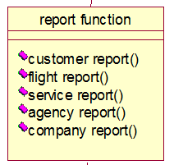Class Name: ReportFunction

Super-classes: None

Attributes:

Methods:

* Customer_report()
  + Allows us to get the customer report
* Flight_report()
  + Allows us to get the flight report
* Service_report()
  + Allows us to get the service report
* Agency_report()
  + Allows us to get the agency report
* Company_report()
  + Allows us to get the company report

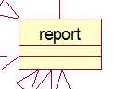Class Name: Report

Super-classes: None

Sub-classes: customer_report, flight_report(), service_report(), agency_report(), company_report()

Attributes:

Methods:

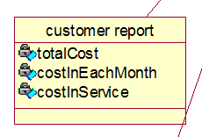Class Name: customer_report

Super-classes: Report

Attributes:

* totalCost. The total amount spent from customers
* costInEachMonth. The total amount spent from customers per month
* costInService. The amount spent on services

Methods:

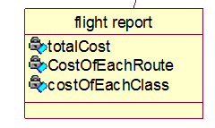Class Name: flight_report

Super-classes: Report

Attributes:

* totalCost.
* costOfEachRoute.
* costOfEachClass.

Methods:

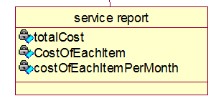Class Name: service_report

Super-classes: Report

Attributes:

* totalCast.
* costOfEachItem.
* costOfEachItemPerMonth.

Methods:

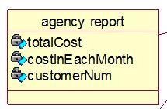Class Name: agency_report

Super-classes: Report

Attributes:

* totalCost.
* costInEachMonth.
* customerNum.

Methods:

Class Name: company_report

Super-classes: Report

Attributes:

* 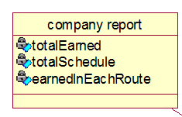totalEarned
* totalSchedule
* earnedInEachRoute

Methods:

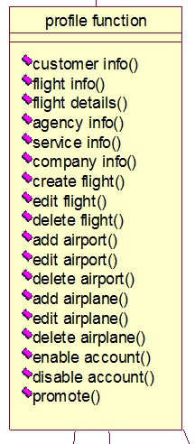Class Name: Profile_Function

Super-classes: None

Attributes:

Methods:

* customer_info()
* flight_info()
* flight_details()
* agency_info()
* service_info()
* company_info()
* create_flight()
* edit_flight()
* delete_flight()
* add_airport()
* edit_airport()
* delete_airport()
* add_airplane()
* edit_airplane()
* delete_airplane()
* enable_account()
* disable_account()
* promote()

Class Name: Reserve_Function

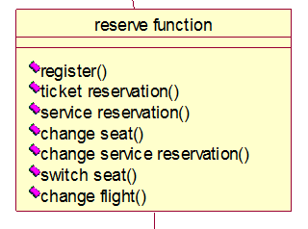Super-classes: None

Attributes:

Methods:

* register()
* ticket_reservation()
* service_reservation()
* change_seat()
* change_service_reservation()
* switch_seat()
* change_flight()

Class Name: Service_Function

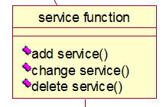Super-classes: None

Attributes:

Methods:

* add_service()
* change_service()
* delete_service()

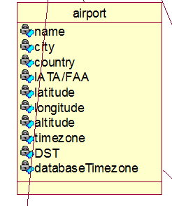Class Name: Airport

Super-classes: none

Attributes:

* name
* city
* country
* IATA/FAA
* Latitude
* Longitude
* Altitude
* Timezone
* DST
* databaseTimezone

Methods:

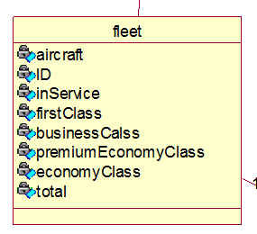Class Name: Fleet

Super-classes: none

Attributes:

* aircraft
* ID
* inService
* firstClass
* businessClass
* premiumEconomyClass
* economyClass
* total

Methods:

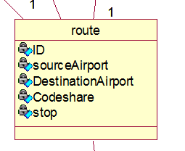Class Name: Route

Super-classes: none

Attributes:

* ID
* sourceAirport
* destinationAirport
* codeShare
* stop

Methods:

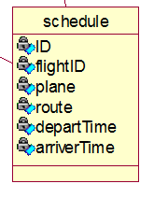Class Name: Schedule

Super-classes: none

Attributes:

* ID
* flightID
* plane
* route
* departTime
* arrivalTime

Methods:

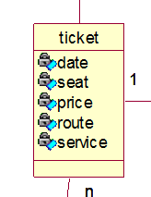

Class Name: Ticket

Super-classes: none

Attributes:

* date
* seat
* price
* route
* service

Methods:

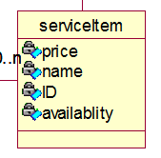Class Name: ServiceItem

Super-classes: none

Attributes:

* price
* name
* id
* availability

Methods: